Self-Efficacy, Experience, and Appraisal of Situations in the Academic and Social Domains of College Life

Kristen M. Sorgi

Additional group project members: Daniel Coppersmith, Daniel Gutierrez-Jimenez, and Eric Robb

Brown University

**Acknowledgments**

This research was conducted for a final project in the Brown University course CLPS1790 Personality and Clinical Assessment. The team of four students worked together to create the hypotheses, materials, and procedure of the study, as well as to analyze the results and construct tables and figures. The written report was the independent work of Kristen Sorgi, and her teammates are listed alphabetically as group members to indicate their equal contributions to the larger project. We would like to thank Professor Jack Wright and teaching assistants Patrick Heck and Andrea Wister for their feedback and support throughout the research process.

Contact: Kristen Sorgi at [KristenMSorgi@gmail.com](mailto:KristenMSorgi@gmail.com)

**Abstract**

This paper investigates the relationship between perceived self-efficacy and several situation-based variables in the academic and social domains of college life. A sample of 99 Brown University undergraduates responded to a series of self-report measures through an online survey. Analyses of these responses revealed fundamentally different relationships between reported levels of self-efficacy, experience with demanding situations, and perceived stress and coping abilities in the academic and social domains. Connections to social learning theory and previous findings, as well as implications for future research, are discussed.

Self-Efficacy, Experience, and Appraisal of Situations in the Academic and Social Domains of College Life

The novel environment of a college campus presents students with a variety of challenges that lend themselves well to the study of perceived self-efficacy. Conceptualized by Bandura (1997), perceived self-efficacy involves “people’s beliefs in their capabilities to produce given attainments” (as cited in Bandura, 2006, p. 307). Rather than a global trait, self-efficacy is a domain-specific construct (Bandura, 2006). In the present paper, *perceived self-efficacy* will refer to an individual’s expectation that his or her behavior will be effective in achieving a goal within a given domain**.** Particularly relevant to the college setting is self-efficacy within the academic and social realms. By extension of Bandura’s theory, academic self-efficacy has been defined as one’s perceived “ability to perform successfully at designated levels” on school-related tasks (Joo, Bong, & Choi, 2000, p. 5). Social self-efficacy describes “an individual’s confidence in his/her ability to engage in the social interactional tasks necessary to initiate and maintain interpersonal relationships” (Smith & Betz, 2000, p. 286).

For perceived self-efficacy to be accurate in its description of one’s true abilities, it should be related to the outcomes of one’s behaviors in the relevant domain.In a meta-analysis, Multon, Brown, and Lent (1991) found a significant positive correlation between perceived academic self-efficacy and performance as measured by standardized t**e**st scores and teacher evaluations. This association was significantly stronger in studies that experimentally manipulated perceived ability than in non-experimental studies, suggesting a causal relationship through which increasing perceived self-efficacy in a given domain may lead to an improvement in the outcome of the action.Since the obtained average correlation is moderate (*r* = .38), however, additional factors must mediate this relationship.

A likely intermediate that facilitates the connection between self-efficacy perceptions and actual behavioral outcomes is one’s experiences with the environment, particularly how one interprets and reacts todemanding situations. Research has investigated the role of self-efficacy in the appraisal of stressful situations, which naturally test the limits of one’s perceived and actual ability in a given domain. According to one influential dichotomy, individuals who deem a stressful situation a *challenge* feel that their coping abilities are sufficient to overcome its demands, whereas those who experience it as a *threat* feel that their coping tendencies are insufficient (Chemers, Hu, & Garcia, 2001). In order to parse out the psychological factors associated with such appraisals, Skinner and Brewer (2002) asked college students to assess their feelings regarding an upcoming exam using two self-report scales: (1) a measure of enthusiasm toward testing knowledge (*challenge* perceptions) and (2) a measure of worries or concerns about exam results (*threat* perceptions). They found positive correlations between challenge perceptions and approach emotions, such as excitement about the upcoming exam,and between challenge perceptions andbeliefs that this affective profile would benefit performance. In contrast, threat ratings were positively correlatedwith both anxiety and the belief that this emotion would harm exam performance. An individual’s appraisal of a particular situation as challenging or threatening is therefore associated with a specific affective state.This finding helps distinguish the challenge-threat dichotomy from the concept of self-efficacy, which focuses more on one’s overall ability in a given domain.

Although distinguishable concepts, research suggests that situation appraisal and self-efficacy are indeed related. In one such study, Chemers et al. (2001) asked college students to rate their confidence in performingseveral academic tasks (such as taking notes and exams), the level of “pressure or demand” they anticipated from their schoolwork in the coming year, and their expected ability to cope with this stress (p. 59). Each participant’s rating of expected pressure was subtracted from his or her coping score. This difference score was used to measure appraisal, with positive values indicating a perceived challenge and negative values indicating a perceived threat. Chemers et al. (2001) found that compared to students reporting low self-efficacy, those with high self-efficacy achieved significantly higher difference scores, appraising expected academic demands as challenging rather than threatening. Theresultsalso revealed a positive correlation between reported self-efficacy and coping ability, suggesting that there is an underlying relationship between the former and the coping-related aspect of the challenge-threat appraisal construct. Moreover, Zajacova, Lynch, and Espenshade (2005) found a negative correlation between college students’ self-efficacy and stress perceptions regarding a given set of academic tasks. Structural equation analyses indicated that a model including both self-efficacy and stress ratings best accounted for between-subjects variance in behavioral outcome measures like grade point average, suggesting that perceived stress partially underlies the relationship between self-efficacy and domain-specific performance. The work of Chemers et al. (2001) and Zajacova et al. (2005) together indicates that self-efficacy in a given domain is associated with perceptions of both environmental stressors and individual coping ability,mediating its relation to situation appraisal.

The current study will further investigate several factors related toperceived self-efficacy in college students through a series of self-report measures. Academic and social situations are among the most salient aspects of college life, yet previous research investigating self-efficacy in these two domains has often focused on only one or the other. We thus chose to investigate both the academic and social self-efficacy of a single sample of college students using a common protocol. Furthermore, few if any previous studies have accounted for the frequency with which individuals encounter stress-inducing events in each domain, which likely has implications for their subsequent assessments of similar situations and their perceived ability to handle them.We thus measured students’ prior experience with stressful situations, along with their current appraisals of similar occurrences, in terms of both perceived stress and expected coping ability. In addressing these gaps in previous research, we tested a set of predicted relationships between self-efficacy and its mediating variables that should appear in both the academic and social domains.

We propose four main hypotheses about the relations between perceived self-efficacy, prior experience with stressful situations, and appraisals of stress and expected coping in the academic and social domains. First,since self-efficacy is negatively related to perceived stress and positively related to behavioral outcome and thus coping ability (e.g. Multon et al., 1991), students reporting low self-efficacy should rate the level of stress associated with given situations as greater than their perceived ability to cope with them, regardless of their levels of prior experience with similar scenarios. Second, individuals reporting high self-efficacy and highly frequent encounters with stressful situations should rate their ability to cope with them as greater than levels of associated stress. This hypothesis is based on the finding that high self-efficacy predicts effective performance within a domain, but that accurate efficacy beliefs are rooted in experience (Multon et al., 1999; Smith & Betz, 2000).

Predictions for individuals reporting high self-efficacy but low situation frequency are less clear, and we thus propose two alternative hypotheses to address this circumstance.Given the potential for high self-efficacy beliefs to reflect self-enhancement when not based on ample experience (Bandura, 2006), one possibility is that these individuals will report correspondingly inflated coping expectancies that exceed their ratings of perceived stress. Another plausible explanation is that, compared with overall self-efficacy within a domain, situation-specific appraisal is more removed from core beliefs about personal competence, suggesting that one’s assessment of a situation may be less vulnerable to self-enhancement effects. Therefore, students reporting high self-efficacy but few encounters with stressful situations should exhibit ill-supported efficacy beliefs, with subsequent perceptions of stress exceeding their coping ability in novel situations.

**Methods**

**Participants**

The participants of this study were Brown University undergraduates (ages 18 to 23). Of the original 146 students who responded, 33 were excluded because they did not complete all parts of the survey. Another 13 participants were removed for taking an unreasonable amount of time (an hour or more) to respond, and one was excluded because box-and-whisker plots revealed that his or her responses to several scales were clear outliers. Data from the remaining 99 participants (39 male, 60 female) were used in the following analyses.

The students conducting this study recruited participants by emailing a link to the online survey to friends and acquaintances within the Brown community. Email recipients were asked to complete a 15-minute survey as part of a final project for the course CLPS1790 Personality and Clinical Assessment. These individuals were told that they would be eligible to win a raffle of one of two $20 Visa gift-cards if they chose to participate and that they would enter all necessary contact information through a form separate from their survey responses in order to maintain anonymity. Prospective participants were asked to forward the email to any other Brown undergraduates they knew who might be interested in participating.

**Materials**

The electronic survey employed in this study was designed and administered online using Qualtrics Online Survey Software. It consisted of six measurement scales (see Appendix), an informed consent form, a debriefing page, and a set of demographic questions. One scale measured academic self-efficacy using items compiled from the College Self-Efficacy Scale (Barry & Finney, 2009) and the College Academic Self-Efficacy Scale (Owen & Froman, 1998). Another assessed social self-efficacy using items from the College Self-Efficacy Scale (Barry & Finney, 2009) and the Perceived Social Self-Efficacy Scale (Smith & Betz, 2000). The self-efficacy items asked participants to rate, on scale of one to seven, how certain they are that can accomplish several tasks within the relevant domain such as the ability to “get the grades I want” (academic self-efficacy) or to “ask a potential friend out for coffee” (social self-efficacy). The next two scales assessed academic and social experience by asking students to consider themselves as they have been since starting college and to rate, on a one to seven scale, how frequently they have encountered each of the listed or similar situations within the relevant domain. An example of an academic situation that was asked was, “It is the night before an exam, which you realize will cover several chapters that you had forgotten about,” while a social situation example was “You join a table of new acquaintances at the dining hall and they completely exclude you from the conversation.” The prompt for this section was adapted from protocol used by Vansteelandt and Van Mechelen (1998), and the items were created by the experimenters for the purpose of this study. The final two scales presented students with the same academic and social situations, now asking them to rate, on a scale of one to seven, the level of stress they would feel during each situation and their expected ability to cope with each situation if faced with it.

**Procedure**

Upon opening the electronic survey, participants read an informed consent form providing them with an overview of the study, the potential risks or benefits they might experience by participating, and the contact information of the experimenters. They were told that their responses would be anonymous and confidential, and that they could discontinue their participation at any time. Once they provided consent, participants were presented with the measurement scales. The self-efficacy items appeared first, followed by the frequency ratings, and then the stress/coping measures. Within each of these sections, participants received the academic and social scales in a random order. Finally, participants entered demographic information, read a debriefing page explaining the goals of the study, and were directed to a Google Form that asked them to enter their email address into the raffle. The survey remained active for eight days, during which participants could respond at any time.

**Results**

**Preliminary Analyses**

Before proceeding with statistical tests, several variables were created from the data collected. For each participant, average scores were computed for the following sets of items: academic self-efficacy, social self-efficacy, frequency of academic situations (academic frequency), frequency of social situations (social frequency), perceived stress in academic situations (academic stress), perceived stress in social situations (social stress), perceived coping in academic situations (academic coping), and perceived coping in social situations (social coping). Table 1 displays descriptive statistics regarding some of these measures. We found similar mean scores for the academic and social components of both self-efficacy and situation frequency, indicating no systematic difference in these measures from either domain.

The internal consistency of the academic self-efficacy (α = .90), social self-efficacy (α = .88), academic coping (α = .84), and social coping (α = .84) scales were acceptable at the .80 threshold. The academic stress (α = .78) and social stress (α = .76) scales were near adequate.

Table 1

*Descriptive Statistics*

|  |  |  |  |  |  |
| --- | --- | --- | --- | --- | --- |
|  | Minimum Score | Maximum Score | Mean Score | Standard Deviation | Median |
| Academic Self-Efficacy | 2.70 | 7.00 | 5.34 | .97 | 5.30 |
| Social Self-Efficacy | 2.70 | 7.00 | 5.38 | .94 | 5.50 |
| Academic Frequency | 1.00 | 4.17 | 1.99 | .72 | 2.17 |
| Social Frequency | 1.00 | 3.67 | 2.09 | .69 | 1.83 |

*Note.* Scores indicate ratings on a 1 to 7 scale.

Median splits were performed to create groups of participants with low self-efficacy, high self-efficacy, low frequency ratings, and high frequency ratings within both the academic and social domains. Table 2 displays the distribution of students with each combination of self-efficacy and frequency level. All groups contained similar numbers of students. Correlations were computed among the eight variables as a preliminary assessment of their relationships. Theses results appear in Table 3 and will be referred to in the discussion section.

Table 2

*Group Distributions*

|  |  |  |
| --- | --- | --- |
|  | Low Academic Self-Efficacy | High Academic Self-Efficacy |
| Low Academic Frequency | 25 | 33 |
| High Academic Frequency | 25 | 16 |
|  | Low Social Self-Efficacy | High Social Self-Efficacy |
| Low Social Frequency | 18 | 25 |
| High Social Frequency | 26 | 21 |

*Note.* Values represent the number of participants falling into each group, created by splitting the distribution of each variable at its median.

Table 3

*Correlations among Variable*s

|  |  |  |  |  |  |  |  |  |
| --- | --- | --- | --- | --- | --- | --- | --- | --- |
|  | Academic Stress | Academic Coping | Social Stress | Social Coping | Academic Self-  Efficacy | Social Self-  Efficacy | Social Frequency | Academic Frequency |
| Academic Stress | __ | -.39** | .49** | -.27** | -.24* | -.17 | .25* | .06 |
| Academic Coping | -.39** | __ | -.24* | .59** | .58** | .39** | -.44** | -.15 |
| Social Stress | .49** | -.24* | __ | -.61** | -.07 | -.10 | .12 | -.09 |
| Social Coping | -.27** | .59** | -.61** | __ | .33** | .39** | -.27** | -.04 |
| Academic Self-Efficacy | -.24** | .58** | -.07 | .33** | __ | .46** | -.48** | -.36** |
| Social Self-Efficacy | -.17 | .39** | -.10 | .39** | .46** | __ | -.21* | -.09 |
| Social Frequency | .25* | -.44** | .12 | -.27** | -.48** | -.21* | __ | .50** |
| Academic Frequency | .06 | -.15 | -.09 | -.04 | -.36** | -.09 | .50** | __ |

*Note.* * Indicates significant correlation, *p < .05*. **Indicates significant correlation, *p* < .001.

**Primary Analyses**

The following results report only statistically significant findings unless otherwise indicated. The first analysis assessed the predicted relationships between self-efficacy, situation frequency, and ratings of coping and stress within the academic domain. A 2 (measure: stress, coping) x 2 (self-efficacy level: low, high) x 2 (frequency: low, high) repeated measures ANOVA was conducted, with academic self-efficacy level and academic frequency

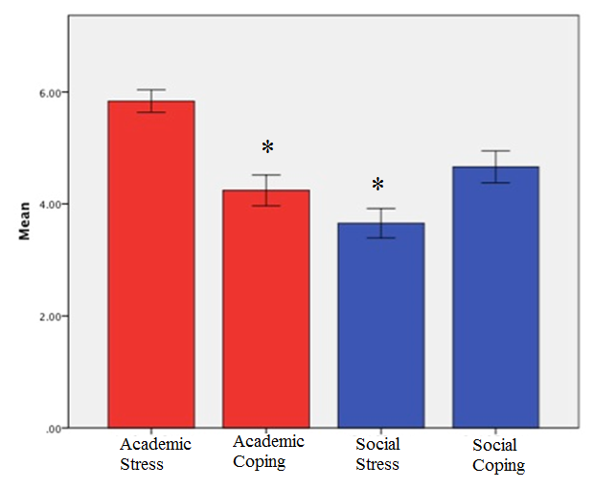

*Figure 1.* Mean ratings on scales of academic and social stress and coping. Variable names are located on the x-axis, and mean scores appear on the y-axis. Error bars represent 95% confidence intervals.

* Significant difference between variables in a given domain, *p* < .001.

as between-subjects factors and academic coping and stress measures as within-subjects factors. This revealed a significant main effect for measure, *F*(1, 95) = 45.62, *p* < .001. Figure 1 indicates that stress ratings were significantly higher than coping ratings in the academic domain. There was also a significant main effect for academic self-efficacy: students with high academic self-efficacy produced higher overall ratings on the stress and coping measures than those with low academic self-efficacy, *F*(1, 95) = 13.30, *p* < .001. The results revealed no significant 3-way interaction (*F*(1, 95) = .05, *p* = .82), but there was a significant interaction between measure and academic self-efficacy, *F*(1, 95) = 21.69, *p* < .001. As suggested by Figure 2 and revealed by independent-samples *t*-tests, students with low self-efficacy trended toward scoring higher than those with high self-efficacy on the stress measure (*t*(97) = 1.89, *p* < .10), but the reverse was true for the coping measure, *t*(97) = -5.93, *p* < .001.

*Figure 2.* Mean academic stress and coping ratings by self-efficacy level. The x-axis displays self-efficacy level categorization, and the y-axis shows mean values of the other two variables. The blue line indicates academic stress scores, and the green line shows academic coping scores. Error bars represent standard errors.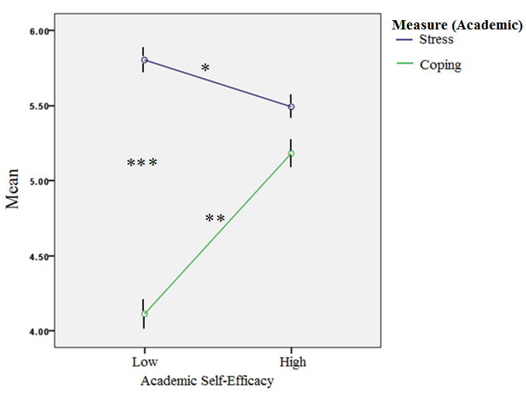

* Trending toward significance, between-groups comparison, *p* < .10

** Significant, between-groups comparison, (*p* < .001)

*** Significant, within-group comparison, *p* < .001

We next investigated relationships among the social domain variables. A 2 (measure: stress, coping) x 2 (self-efficacy level: low, high) x 2 (frequency: low, high) repeated measures ANOVA was conducted, with social self-efficacy level and frequency as between-subjects factors and social stress and coping ratings as within-subjects factors. The results revealed a significant main effect for measure, *F*(1, 86) = 53.30, *p* < .001. Figure 1 indicates that social

coping ratings were higher than social stress ratings. There was also a main effect for social self-efficacy level, with the high self-efficacy group reporting higher scores on the two appraisal measures than students in the low self-efficacy group. There was a main effect for frequency, with students encountering fewer social situations scoring higher on the two appraisal measures than those reporting high situation frequency, (*F*(1, 86) = 6.47, *p* < .05). The analysis also revealed a 3-way interaction that trended toward significance, *F*(1, 86) = 5.21 , *p* < .10. As displayed in Figure 3 and revealed by post hoc *t*-tests, there were no significant differences in either the stress or coping ratings within the low social self-efficacy group 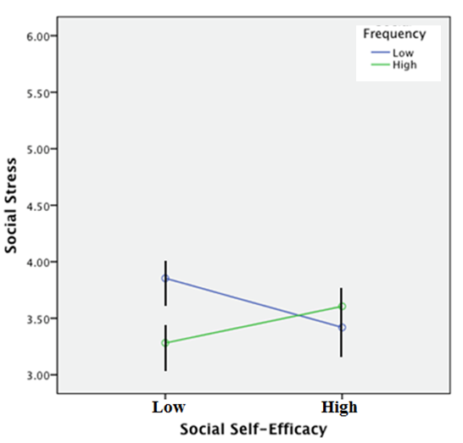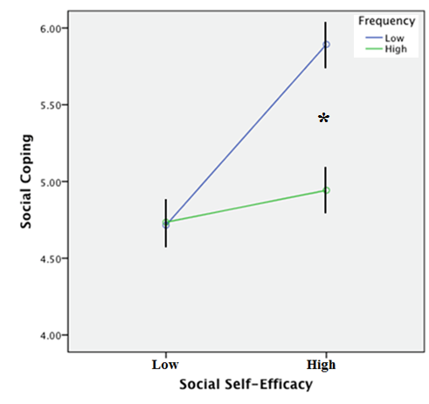

*Figure 3.* Mean social stress and coping scores by social self-efficacy level and social situation frequency. The x-axes display levels of self-efficacy. The y-axes display mean social stress scores (left panel) and mean social coping scores (right panel). Blue lines represent low frequency groups, and green lines represent high frequency groups. Error bars reflect standard errors.

* Significant within-group comparison, *p* < .05.

group based on situation frequency. Within the high self-efficacy group, students with different frequency scores did not differ in stress ratings, but coping ratings (*t*(44) = 2.67, *p* < . 05) were significantly higher for those with low frequencies. Embedded in this 3-way interaction was a significant 2-way interaction between measure and self-efficacy, indicating higher coping scores for the high self-efficacy group compared to those with low self-efficacy, but similar stress scores between the two groups.

**Secondary Analyses**

The results of the primary analyses suggested unpredicted differences between variables in the academic and social domains. To further illuminate these contrasts, a 2 (domain: academic, social) x 2 (measure: stress, coping) repeated measures ANOVA was conducted, with both domain and measure as within-subjects factors. This test revealed a significant main effect for domain, indicating that the academic and social variables yielded different ratings, *F*(1, 98) = 359.81, *p* < .001. There was a significant interaction between domain and measure, *F*(1, 98) = 208.83, *p* < .001. Figure 1 indicates that average academic stress exceeded average academic coping, but average social coping exceeded average social stress.

**Discussion**

This study investigated the relations between perceived self-efficacy, stress and coping appraisals, and prior experiences with stressful situations in both the academic and social domains in a single sample of college students. The results revealed very different patterns in each area. Participants who reported low academic self-efficacy had higher average stress ratings than coping expectations in academic situations. This trend supports the first hypothesis that students with low self-efficacy beliefs would exhibit higher stress than coping scores regardless of levels of priorsituation frequency. The result is consistent with Chemers et al.’s (2001) finding that highly efficacious students tend to perceive academic stressors as challenges rather than threats, with their expected coping ability outweighing perceived stress.Furthermore, Table 3 displays a significantnegative correlation between academic self-efficacy and academic stress, but a significant positive correlation between the former and academic coping. Thus, low levels of perceived self**-**efficacy should predict both high levels of stress and low coping expectancies in academic situations. These results are consistent with Zajacova et al.’s (2005) finding that there is a negative relationship between self-efficacy and stress, as well as with the aforementioned work of Chemers et al. (2001).In summary, our first set of findings lend support to the complex links between self-efficacy perceptions, coping expectations, and levels of stress.

Chemers et al. (2001) found evidence supporting a model in which students’ perceived self-efficacy had a direct effect on their appraisals of academic stressors as challenges or threats, which directly influenced their levels of stress. According to this account, self-efficacy has only an indirect effect on stress, mediated by its direct effect on situation appraisal. Zajacova et al. (2005) argue that perceived self-efficacy and stress together influence performance in the academic domain, which can potentially create a feedback loop in which performance outcomes alter or strengthen perceived self-efficacy or stress levels. Our study cannot decipher the relative viability of either of these explanations, but our results nonetheless support the notion of an important relationship between perceptions of academic ability, coping, and stress in the lives of college students.

Our first analysis also revealed an interesting contrast between groups of students reporting different levels of efficacy beliefs in the academic domain. Students with high self-efficacy perceived lower levels of stress in the demanding academic situations and reported higher coping expectancies than their low self-efficacy counterparts. These differences illuminate the previous finding that self-efficacy predicts domain-specific performance (Multon et al., 1991). The significant positive correlation between academic self-efficacy and academic coping ratings (Table 3) indicates that efficacy beliefs might facilitate effective coping strategies and the subsequent academic performance of these students. Alternatively, behavioral outcomes may drive both perceived self-efficacy and coping expectations.

Our analyses of measures within the social domain illustrated a very different set of findings. Students reporting high social self-efficacy had higher coping expectancies than did those reporting low self-efficacy (Figure 3, right panel), but the two groups did not differ in perceived stress (Figure 3, left panel). A comparison of the two panels of Figure 3 indicates that students reporting high social self-efficacy but low situation frequency had higher coping than stress scores. This difference speaks to our alternative *a priori* prediction that students with high perceived self-efficacy but few encounters with stressful situations would report exaggerated coping expectancies that exceed their ratings of perceived stress*.* Perhaps students with prior experience with the social stressors examined in this study developed specific strategies for coping with them, which would explain the difference in coping scores among students with different frequency ratings. One might consider perceived self-efficacy to be a broader concept than coping strategies, since the latter are specific reactions to particular stressors whereas the former encompasses one’s ability to perform effectively within the context of a given domain. This interpretation might help explain our finding that students differing in social coping and frequency scores could nonetheless exhibit similarly high levels of perceived self-efficacy.

The finding that students with different levels of perceived self-efficacy did not differ in stress ratings contrasts with previous research indicating a consistent, negative correlation between the efficacy beliefs and perceived stress in a given domain (Zajacova et al., 2005). It is possible that this discrepancy occurred because the social situations described in this study may not have been truly “stressful” in nature. Low average frequency ratings (Table 1) indicate that students did not commonly encounter these situations and, therefore, could have had trouble concretely relating to them. Thus, the nature of the social scenarios presented in this study may have obscured any existing relationship between self-efficacy and perceived stress. A similar interpretation extends to the finding that participants with low social self-efficacy but different frequency ratings did not differ from one another in measures of either stress or coping. This trend is consistent with our first hypothesis, but it is possible that such is the case because of the nature of the items included in this study rather than a systematic effect.

The present study addresses a gap in the literature regarding the relation of experienced situation frequency to perceived self-efficacy and situational appraisals. Students reporting high social self-efficacy did not differ by frequency levels in perceived social stress, but those with lower frequency scores did have higher coping expectancies than those with high frequency scores. These results are inconsistent with the prediction that accumulated experience facilitates greater coping ability and provides a basis for accurately high self-efficacy. There are several possible explanations for this unexpected finding. The absence of frequency effects on perceived stress may reflect the fact that most students produced low frequency ratings overall, implying that they had little experience managing feelings of pressurein these scenarios. For those students with relatively higher frequency ratings within this low distribution, there was an unexpected relationship between experience and perceived coping ability, withlower frequency ratings predicting higher coping scores. These results suggest that students who reported greater experience with the hypothetical situations presented in the survey found them somewhat difficult to cope with. Students who seldom, if ever, encountered the situations, however, did not have experience on which to base their expected coping ratings. Thus, this group may have overestimated their actual ability to cope with these situations. This interpretation speaks to Bandura’s caution about the questionable validity of hypothetical scenarios in measurement scales (Bandura, 2006), since respondents have to estimate how they might feel in scenarios they have never encountered.

The results of our primary analyses uncovered an unexpected juxtaposition between the effects of academic and social self-efficacy. We thus conducted a secondary investigation, revealing that students tended to experience levels of stress that exceeded their expected coping abilities in academic situations, whereas the opposite was true in social situations. In the view of Chemers et al. (2001), these results imply that students tended to appraise academic situations as threats but social ones as challenges. It is possible that differences in the academic and social realms of the Brown University environment contributed to this stark contrast. This Ivy League institution is known for its rigorous coursework and its diverse student body. Thus, Brown students may tend to feel less insecure or intimidated socially but are often overwhelmed by academic pressures. Indeed, students accepted to Brown are generally those who were academically successful in high school, but the courses they encounter at this university are often more advanced, more work-intensive, and require more independent time-management than the courses they excelled in during high school. This transition requires adjustment even for top high school students. Furthermore, one’s performance in college academics is indicative of one’s prospects as a graduate school applicant or a job candidate. These long-term implications seem to outweigh those of social competence in situations such as joining student clubs or getting along with college roommates, thus leading to greater pressure and stress with respect to academics. These concerns about the future indeed apply to students at most colleges and universities, so one might argue that students at institutions with less-rigorous course loads might also be more likely to appraise academic stressors as threats rather than challenges. However, at schools with less diverse student bodies and a greater prevalence of often-exclusive organizations such as Greek life, student are likely to experience greater pressure to “fit in” with particular social crowds than at Brown and other universities with similarly liberal social cultures. Although for many students this might still pale in comparison to the pressure of achieving academic, and ultimately career, success, others might greatly internalize this social stress and perceive it as quite threatening. Thus, while most college students are likely to perceive academic stressors as more threatening than challenging, appraisal of social situations may vary as a function of a school’s extracurricular atmosphere and culture.

An alternative explanation for domain-dependent results is that the hypothetical social situations presented in the survey may have been generally less stressful than the academic scenarios posed. The academic situations used in this study may have been so inherently stress-inducing that individuals expected difficulties in coping with them regardless of any amount of previous exposure. Still, the distinct results regarding the function of psychological variables within the academic and social realms reiterates the domain-specificity of perceived self-efficacy and suggests that this property extends to the appraisal of different types of stressful situations in both areas of life.

Several limitations may have influenced the results of this study. Average frequency ratings for both academic and social situations displayed floor effects, especially in relation to average self-efficacy scores, which fell above the middle of 7-point scale (i.e. closer to “always or almost always” than “never or almost never”). Furthermore, the scales employed each contained few questions, to keep the survey a reasonable length. This limitation may have contributed to the modest internal consistencies of the stress rating scales. Whereas items measuring self-efficacy were compiled from previous work, these appraisal scales were created for the purposes of this project, which questions their psychometric properties. Also in the interest of manageable survey length, participants were asked to consecutively assess the levels of stress and coping expectancies they associated with each situation, creating the possibility of a reporting bias.

This study sought to shed further light on previous research by assessing the relationships among perceived self-efficacy and its situational correlates in two of the most pervasive aspects of college life. We investigated the role of the frequency with which students previously encountered stressful academic and social situations. This variable exhibited complicated implications for perceived self-efficacy and the appraisal of stressors. Its impact, as well as the relationship between perceived stress and coping abilities, differed greatly by domain. These contrasting results not only underscore the notion of domain-specificity in efficacy expectations, but also suggest that improving one’s confidence in academic or social situations likely involves very different approaches. Future research should further investigate these relationships and their implications for actual behavioral outcomes. Given the limited personal relatability of hypothetical situations, it would be telling to ask participants to submit lists of difficult situations they have actually encountered and to assess their stress and coping expectancies with respect to these real-life scenarios. Furthermore, it is important to investigate the role of real-time, state-level feelings of stress on perceptions of personal ability. Some studies have assessed the affective states and stress levels of students before taking an exam (Skinner & Brewer, 2002). Since state-level stress responses directly influence behavioral outcomes, additional research should use this approach to assess the relation of these variables to perceived ability in other real-life academic as well as social settings. Investigations focusing on links between one’s appraisal of or reaction to common stressors and the success of their resulting behavior may aid in discovering points of clinical intervention for individuals with anxiety and other forms of compromised functioning. Perceived competency, stress levels, and coping strategies have important implications for students’ effective adjustment to the academic and social realms of college life. The field is in need of research efforts aimed at better understanding the relationship between these variables and translating this knowledge into behavioral interventions.

**References**

Bandura, A. (2006). Guide for constructing self-efficacy scales. *Self-efficacy Beliefs of Adolescents*, *5*, 307-337.

Barry, C. L., & Finney, S. J. (2009). Can We Feel Confident in How We Measure College Confidence?: A Psychometric Investigation of the College Self-Efficacy Inventory. *Measurement and Evaluation in Counseling and Development*, *42*, 197-222.

Chemers, M. M., Hu, L. T., & Garcia, B. F. (2001). Academic self-efficacy and first year college student performance and adjustment. *Journal of Educational Psychology*, *93*(1), 55.

Multon, K. D., Brown, S. D., & Lent, R. W. (1991). Relation of self-efficacy beliefs to academic outcomes: A meta-analytic investigation. *Journal of Counseling Psychology*, *38*(1), 30.

Owen, S. V., & Froman, R. D. (1988). *Development of a college academic self-efficacy scale.* Retrieved from <http://eric.ed.gov/?id=ED298158>.

Skinner, N., & Brewer, N. (2002). The dynamics of threat and challenge appraisals prior to stressful achievement events. *Journal of Personality and Social Psychology*, *83*(3), 678.

Smith, H. M., & Betz, N. E. (2000). Development and validation of a scale of perceived social self-efficacy. *Journal of Career Assessment*, *8*(3), 283-301.

Zajacova, A., Lynch, S. M., & Espenshade, T. J. (2005). Self-efficacy, stress, and academic success in college. *Research in Higher Education*, *46*(6), 677-706.

**Appendix: Measurement Scales**

***Academic Self-Efficacy Scale***

Please rate how certain you are that you can do the things described below by selecting the appropriate number on a scale from 1 to 7.

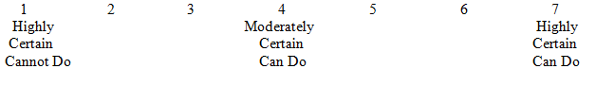

1. Finish my homework assignments by deadlines.

2. Manage time effectively.

3. Participate in class discussions.

4. Do well on my exams.

5. Keep up to date and plan my schoolwork.

6. Take multiple tests in the same week.

7. Get the grades I want.

8. Do well in my toughest class.

9. Understand most ideas presented in class.

10. Relate course content to material in other courses.

***Social Self-Efficacy Scale***

Please rate how certain you are that you can do the things described below by selecting the appropriate number on a scale from 1 to 7.



1. Start a conversation with someone I don’t know very well.

2. Ask a group of people, who are planning to go to a movie, if I can join them.

3. Keep up my side of the conversation.

4. Join a lunch or dinner table where people are already sitting and talking.

5. Make friends in a group where everyone else knows each other.

6. Ask a potential friend out for coffee.

7. Carry on a group conversation with peers.

8. Make close friends at college.

9. Join a student organization.

10. Get along with others I live with.

***Situation Frequency***

Please think of yourself as you have been in general since starting college. Now rate how often you have encountered situations described below during that time. In some cases you may not have encountered the situation exactly as described, but did encounter a situation that was very similar to it. You can include these “similar” situations as you make your ratings. 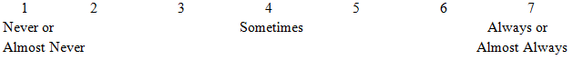

Academic Situations

1. You have to give a presentation to your entire department, and your classmates will be critiquing or discussing your work.

2. You have to take a final exam, which accounts for at least 50% of your grade, in a class that is required for concentration credit.

3. It is the night before an exam, which you realize will cover several chapters that you had forgotten about.

4. In a class required for your concentration, your professor changed the deadline for a paper to today, but you forgot and have not started it.

5. You are completing a semester of independent research but you lost a large amount of data. If you fail this independent research course then you cannot fulfill your concentration requirements

6. You are working on a project, and you are having difficulty completing it. There is no way you will be able to meet with a TA or professor before the deadline.

Social Situations

1. Your close friends exclude you from their housing plans for the next academic year, and you have no one to live with.

2. You are excited about joining a particular club, but realize that you don’t know any of its existing members, who all seem like close friends.

3. You invite a group of friends to a party, but no one shows up.

4. You find out people have been talking about you behind your back and you have already made plans with them for the weekend.

5. You join a table of new acquaintances at the dining hall and they completely exclude you from the conversation.

6. You ask that your roommates to respect certain parts of your living area as your own personal space, but they continue to violate it.

***Stress and Coping***

Please think of yourself as you have been in general since starting college as you consider the following situations.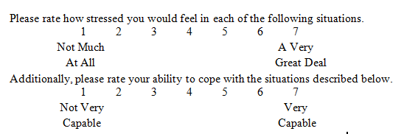

*NOTE: Each of the following items was presented with each of the two rating scales and prompts above, so that participants made two consecutive responses to each item.*

Academic Situations

1. You have to give a presentation to your entire department, and your classmates will be critiquing or discussing your work.

2. You have to take final exam, which accounts for at least 50% of your grade, in a class that is required for concentration credit.

3. It is the night before an exam, which you realize will cover several chapters that you had forgotten about.

4. In a class required for your concentration, your professor changed the deadline for a paper to today, but you forgot and have not started it.

5. You are completing a semester of independent research but you lost a large amount of data. If you fail this independent research course then you cannot fulfill your concentration requirements

6. You are working on a project, and you are having difficulty completing it. There is no way you will be able to meet with a TA or professor before the deadline.

Social Situations

1. Your close friends exclude you from their housing plans for the next academic year, and you have no one to live with.

2. You are excited about joining a particular club, but realize that you don’t know any of its existing members, who all seem like close friends.

3. You invite a group of friends to a party, but no one shows up.

4. You find out people have been talking about you behind your back and you have already made plans with them for the weekend.

5. You join a table of new acquaintances at the dining hall and they completely exclude you from the conversation.

6. You ask that your roommates respect certain parts of your living area as your own personal space, but they continue to violate it.