

DSA
LAB MANUAL

Submitted to
Name | Dr. Rajkumar Batchu
Department | CSE
Designation | Assistant Professor
Submitted by
Name | Edara Ujval Sriteja
Roll No | av.sc.u4cse25107
Year/Sem/Section | 2nd year / Sem-3 / CSE-B

INDEX
LAB | QUESTIONS | DATES
1 | a) A rocket launch system displays a countdown before launch. Instead using loop implement the countdown from n to 1, followed by "Launch!".  b) Banks calculate the growth of an investment using compound interest. The formula requires calculating powers, which can be implemented recursively. Write a recursive program to calculate P^n (power) where, P = principle growth factor, n = number of years.  c) An HR department stores employee ID's in a list. Develop a recursive program to search for a given employee ID. Write a recursive function to search for an employee ID in a list.  d) In a logistics company, the number of possible ways to arrange n different parcels are calculated using the factorial formula (n!). Develop a recursive program to calculate the factorial of a given number.  e) Write a recursive python program to print the first n terms of fibonacci series. | 14-07-26
2 | a)Program to implement LINEAR SEARCH  b)Program to implement BINARY SEARCH  (1) With Sorted List:  (2) Without Sorted List: | 21-07-26
3 | a)Write a Program for BUBBLE SORT  b)Write a program for INSERTION SORT  c)Write a program for SELECTION SORT; | 01-08-26
4 | a)Write a Program for Quick SORT  b)Write a Program for MERG SORT: | 11-08-26
5 | a)Write a Program to implement single Linked List:  b)Write a Program to implement Double Linked List:  c) Write a python programme to implement Circular linked list: | 18-08-26
6 | a)Write python program to implement stack using Array  b)Write python program to implement stack using LinkedList | 25-08-26
7 | a) Write python program to implement Queue using Arrays  b) Write python program to implement Queue using Linked List  c) Write python program to implement Circular Queue using Arrays  d) Write python program to implement Circular Queue using Linked List | 22-09-26
8 | a) write a python program to implement a binary tree with its operations using a array  b) write a python program to implement a binary tree with its operations using a linked list | 29-09-26
9 | Python program to implement Binary Search Tree (BST) operations. | 06-10-26
10 | Python program to implement AVL trees. | 13-10-26
11 | Python program to implement Hashing (Separate chaining, Linear probing, and Quadratic probing). | 27-10-26

WEEK-1
1
a)A rocket launch system displays a countdown before launch. Instead using loop implement the countdown from n to 1, followed by “Launch!”.
CODE:
1. def countdown(n):
2. if n <= 0:
3. print(“Launch!”)
4. else:
5. print(n)
6. countdown(n – 1)
7.
8. countdown(5)

OUTPUT:
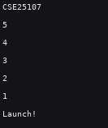
EXPLANATION:
Base Case: When the number n reaches 0 or less, the recursion stops and the program prints “Launch!”.
Recursive Step: If n is greater than 0, the program prints the current number and calls itself with n – 1, moving one step closer to the base case.

Error Table:
Error | Rectification
1. Infinite loop  2. Calling function at wrong place | 1. Iteration at correct place  2. Placed with correct syntax
b) Banks calculate the growth of an investment using compound interest. The formula requires calculating powers, which can be implemented recursively. Write a recursive program to calculate P^n (power) where, P = principle growth factor, n = number of years.
CODE:
1. def calculate_power(P, n):
2. if n == 0:
3. return 1
4. else:
5. return P * calculate_power(P, n – 1)
6.
7. print(calculate_power(20, 5))
OUTPUT:
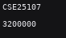
EXPLANATION:
Base Case: Any number raised to the power of 0 is 1. When n reaches 0, the function returns 1 and stops recurring.
Recursive Step: The function multiplies the base P by the result of the same function called with n – 1, effectively chaining the multiplication n times.

Error Table:
Error | Rectification
1. Return 0  2. print | 1. Return 1  2. return
c) An HR department stores employee ID’s in a list. Develop a recursive program to search for a given employee ID. Write a recursive function to search for an employee ID in a list.
CODE:
1. def search_employee(emp_list, emp_id, index=0):
2. if index == len(emp_list):
3. return False
4. if emp_list[index] == emp_id:
5. return True
6. return search_employee(emp_list, emp_id, index + 1)
7.
8. employees = [101, 105, 108, 112]
9. print(search_employee(employees, 108))

OUTPUT:
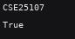
EXPLANATION:
Base Cases: The function stops and returns False if the index goes out of bounds (meaning the entire list was searched). It returns True if the item at the current index matches the emp_id.
Recursive Step: If the current item is not a match, the function calls itself while incrementing the index by 1 to check the next element in the list.
ERROR TABLE:
SNO | ERROR | SOLUTION
1 | Line 2: if index len(emp_list): is missing the equality operator | Change to if index == len(emp_list):

d) In a logistics company, the number of possible ways to arrange n different parcels are calculated using the factorial formula (n!). Develop a recursive program to calculate the factorial of a given number.
CODE:
1. def calculate_factorial(n):
2. if n == 0 or n == 1:
3. return 1
4. else:
5. return n * calculate_factorial(n – 1)
6.
7. print(calculate_factorial(5))

OUTPUT:
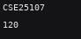
EXPLANATION:
Base Case: By mathematical definition, the factorial of 0 or 1 is 1. When n hits either of these, the recursion halts and returns 1.
Recursive Step: The function multiplies the current integer n by the factorial of n – 1, evaluating to $n×\left(n-1\right)×\left(n-2\right)…×1$ as it resolves back up the call stack.

Error Table:
Error | Rectification
1. Emp lst  2. print | 1. Emp_list  2. return
e) Write a recursive python program to print the first n terms of ibonacci series.
CODE:
1. def ibonacci(n):
2. if n <= 0:
3. return 0
4. elif n == 1:
5. return 1
6. else:
7. return ibonacci(n – 1) + ibonacci(n – 2)
8.
9. def print_fibonacci_series(terms):
10. for I in range(terms):
11. print(ibonacci(i), end=” “)
12. print()
13.
14. print_fibonacci_series(7)

OUTPUT:
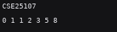
EXPLANATION:
Base Cases: The 0th term of the sequence is 0, and the 1st term is 1. The function directly returns these values when n is 0 or 1.
Recursive Step: For any position greater than 1, the function calculates the value by calling itself twice to add the two preceding terms together (n – 1 and n – 2).

WEEK-2
a)Program to implement LINEAR SEARCH
CODE
1. def linear_search(arr, target):
2. for I in range(len(arr)):
3. if arr[i] == target:
4. return i
5. return -1
6.
7. my_array = [10, 23, 45, 70, 11, 15]
8. target_val = 70
9. print(linear_search(my_array, target_val))

OUTPUT:
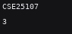
EXPLANATION:
How it works: The algorithm sequentially checks each element in the array from the beginning (index 0) to the end.
Condition: During each iteration, it compares the current element to the target.
Result: If a match is found, it immediately returns the index of that element. If the loop completes and the element is never found, it returns -1 to indicate the target is not in the array.
Time Complexity: $O\left(n\right)$ because in the worst-case scenario, it has to check every single element.

Error Table:
Error | Rectification
1. Return placed in wrong place  2. Calling the function | 1. Corrected later  2. Rectified

b)Program to implement BINARY SEARCH
(1) With Sorted List:
CODE:
1. def binary_search_sorted(arr, target):
2. low = 0
3. high = len(arr) – 1
4.
5. while low <= high:
6. mid = (low + high) // 2
7. if arr[mid] == target:
8. return mid
9. elif arr[mid] < target:
10. low = mid + 1
11. else:
12. high = mid – 1
13.
14. return -1
15.
16. sorted_array = [11, 22, 34, 45, 55, 67, 89]
17. target_val = 45
18. print(binary_search_sorted(sorted_array, target_val))

OUTPUT:
EXPLANATION:
How it works: Binary search uses a divide-and-conquer approach but strictly requires the array to be sorted beforehand. It maintains a low and a high pointer to track the search space.
Condition: It calculates the mid point of the current search space.
- If the mid element is the target, it returns the mid index.
- If the target is strictly greater than the mid element, it discards the left half by moving the low pointer to mid + 1.
- If the target is strictly less than the mid element, it discards the right half by moving the high pointer to mid – 1.
Result: The loop continues narrowing the search space until low becomes greater than high. If the target isn’t found by then, it returns -1.
Time Complexity: $O\left(\log{n}\right)$ because the search space is cut in half during every step.

(2) Without Sorted List:
CODE:
1. def binary_search_unsorted(arr, target):
2. arr.sort()
3.
4. low = 0
5. high = len(arr) – 1
6.
7. while low <= high:
8. mid = (low + high) // 2
9. if arr[mid] == target:
10. return mid
11. elif arr[mid] < target:
12. low = mid + 1
13. else:
14. high = mid – 1
15.
16. return -1
17.
18. unsorted_array = [67, 11, 89, 22, 55, 45, 34]
19. target_val = 45
20. print(binary_search_unsorted(unsorted_array, target_val))

OUTPUT:
EXPLANATION:
How it works: Because binary search relies on the data being in a specific order to eliminate halves of the array, it cannot function on unsorted data.
Condition: The code first calls arr.sort() to organize the array in ascending order.
Result: Once the array is sorted, it executes the exact same binary search logic as above. (Note: Because the array is modified and sorted before searching, the index returned corresponds to the target’s position in the newly sorted array, not its original position in the unsorted input).
Time Complexity: $O\left(n\log{n}\right)$ due to the initial sorting step, which dominates the $O\left(\log{n}\right)$ search time.
ERROR TABLE:
SNO | ERROR | SOLUTION
1. | Line 2 (Sorted): low = 6 incorrectly sets the starting index. | Change to low = 0
2. | Lines 6 & 8: mid (low + high) // 2 is missing the assignment operator. | Change to mid = (low + high) // 2
3. | Lines 12 & 14: high = mid 1 is missing a subtraction operator. | Change to high = mid – 1

WEEK-3
a)Write a Program for BUBBLE SORT
CODE:
1. def bubble_sort(arr):
2. n = len(arr)
3. for I in range(n):
4. swapped = False
5. for j in range(0, n – I – 1):
6. if arr[j] > arr[j + 1]:
7. arr[j], arr[j + 1] = arr[j + 1], arr[j]
8. swapped = True
9. if not swapped:
10. break
11. return arr

OUTPUT:
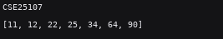
EXPLANATION;
Bubble sort works by repeatedly swapping adjacent elements if they are in the wrong order. With each full pass, the largest unsorted element “bubbles” up to its correct position at the end of the array.
- The Outer Loop (for I in range(n)): This tracks the number of passes. After the first pass, the largest element is guaranteed to be at the very end. After the second pass, the second largest is in place, and so on.
- The Inner Loop (for j in range(0, n – I – 1)): This loop performs the actual comparisons. It stops at n – I – 1 because we don’t need to check the last I elements—they are already in their sorted, final positions from previous passes.
- The Swap: if arr[j] > arr[j + 1]: checks if the left element is larger than the right element. If so, it swaps them.
- The Optimization (swapped = True/False): If the array is already sorted, making full passes is a waste of time. The swapped variable tracks if any swaps happened during a pass. If a full pass happens with zero swaps, the loop breaks early, saving processing time.
Error Table:
Error | Rectification
1. Mistakes in main logic  2. Errors in conditions | 1. Rectified  2. Rectified

b)Write a program for INSERTION SORT
CODE:
1. def insertion_sort(arr):
2. for I in range(1, len(arr)):
3. key = arr[i]
4. j = I – 1
5. while j >= 0 and key < arr[j]:
6. arr[j + 1] = arr[j]
7. j -= 1
8. arr[j + 1] = key
9. return arr
10.
11. my_array = [12, 11, 13, 5, 6]
12. print(insertion_sort(my_array))

OUTPUT:
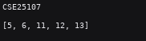
EXPLANATION:
Insertion sort builds the final sorted array one item at a time. It works exactly like sorting a hand of playing cards: you take an unsorted card, figure out where it belongs in the cards you’ve already sorted, and insert it there.
- The Outer Loop (for I in range(1, len(arr))): We start at index 1 (the second element) because we assume a single element at index 0 is already “sorted”. We pull this current element out and call it the key.
- The while Loop: We look at the elements to the left of the key (which are already sorted). As long as we haven’t reached the beginning of the array (j >= 0) and the sorted element we are looking at is larger than our key (key < arr[j]), we shift that sorted element one space to the right (arr[j + 1] = arr[j]).
- The Insertion (arr[j + 1] = key): Once we find an element smaller than the key (or reach the start of the array), the while loop stops. We then drop the key into the empty space we created.

Error Table:
Error | Rectification
1. Mistakes in main logic  2. Errors in conditions | 1. Rectified  2. Rectified
c)Write a program for SELECTION SORT;
CODE:
1. def selection_sort(arr):
2. for I in range(len(arr)):
3. min_idx = i
4. for j in range(I + 1, len(arr)):
5. if arr[j] < arr[min_idx]:
6. min_idx = j
7. arr[i], arr[min_idx] = arr[min_idx], arr[i]
8. return arr
9.
10. my_array = [64, 25, 12, 22, 11]
11. print(selection_sort(my_array))

OUTPUT:
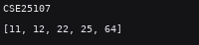
EXPLANATION:
Selection sort works by dividing the array into two parts: a sorted portion at the front and an unsorted portion at the back. It repeatedly searches the unsorted portion to find the smallest element, and moves it to the end of the sorted portion.
- The Outer Loop (for I in range(len(arr))): This loop represents the boundary between the sorted and unsorted portions. The element at index I is where the next smallest number needs to go. We temporarily assume the element at I is the minimum (min_idx = i).
- The Inner Loop (for j in range(I + 1, len(arr))): This loop scans the rest of the unsorted array (everything to the right of i) to see if there is an element smaller than our current assumed minimum.
- Updating the Minimum (if arr[j] < arr[min_idx]): If we find a smaller element, we update min_idx to remember its location.
- The Swap: After checking the entire unsorted portion, we swap the element currently at position I with the actual smallest element we found at min_idx.

WEEK-4
a)Write a Program for Quick SORT
CODE:
1. def quicksort(arr, low, high):
2. if low < high:
3. I = low
4. j = high
5. pivot = low
6.
7. while I < j:
8. while (I < len(arr) and arr[i] <= arr[pivot]):
9. I += 1
10.
11. while (arr[j] > arr[pivot]):
12. j -= 1
13.
14. if I < j:
15. arr[i], arr[j] = arr[j], arr[i]
16.
17. arr[j], arr[pivot] = arr[pivot], arr[j]
18.
19. quicksort(a, low, j-1)
20. quicksort(a, j+1, high)
21.
22. a = list(map(int, input(“Enter numbers to sort: “).split(“ “)))
23. n = len(a)
24. quicksort(a, 0, n-1)
25. print(“arr sorted”)
26. print(a)
27.

OUTPUT:
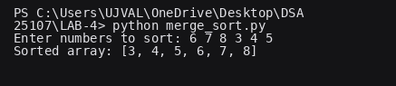
EXPLANATION:
Algorithm Paradigm: Divide and Conquer
Pivot Selection: First element of the sub-array (arr[low])
Time Complexity:
- Best / Average Case: $O\left(n\log{n}\right)$
- Worst Case: $O\left(n^{2}\right)$ (when the array is already sorted or reverse sorted)
Space Complexity: $O\left(\log{n}\right)$ auxiliary stack space for recursion.

Error Table:
Error | Rectification
PS C:\Users\Lab\Documents\cse25142\dsa-lab\week-4> python quick_sort.py  Traceback (most recent call last):  File "C:\Users\Lab\Documents\cse25142\dsa-lab\week-4\quick_sort.py", line 24, in <module>  main()  File "C:\Users\Lab\Documents\cse25142\dsa-lab\week-4\quick_sort.py", line 5, in main  quick_sort(arr)  TypeError: quick_sort() missing 2 required positional arguments: 'low' and 'high'  PS C:\Users\Lab\Documents\cse25142\dsa-lab\week-4> | added the two parameters to the function

b)Write a Program for MERG SORT:
CODE:
1. def merge_sort(arr):
2. if len(arr) > 1:
3. mid = len(arr) // 2
4. left_half = arr[:mid]
5. right_half = arr[mid:]
6.
7. merge_sort(left_half)
8. merge_sort(right_half)
9.
10. I = j = k = 0
11.
12. while I < len(left_half) and j < len(right_half):
13. if left_half[i] < right_half[j]:
14. arr[k] = left_half[i]
15. I += 1
16. else:
17. arr[k] = right_half[j]
18. j += 1
19. k += 1
20.
21. while I < len(left_half):
22. arr[k] = left_half[i]
23. I += 1
24. k += 1
25.
26. while j < len(right_half):
27. arr[k] = right_half[j]
28. j += 1
29. k += 1
30.
31. return arr
32.
33. user_input = input(“Enter numbers to sort separated by spaces: “)
34. numbers = [int(x) for x in user_input.split()]
35. merge_sort(numbers)
36. print(“arr sorted:”)
37. print(numbers)
38.

OUTPUT:
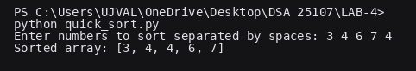

EXPLANATION:
Algorithm Paradigm: Divide and Conquer
Merging Strategy: Out-of-place merge (requires additional memory allocation for sub-arrays)
Time Complexity:
- Best, Average, and Worst Case: $O\left(n\log{n}\right)$. The array is consistently halved ($\log{n}$ divisions), and the merging process takes linear time ($n$).
Space Complexity: $O\left(n\right)$ auxiliary space is required to store the temporary left_half and right_half arrays during the merging process.
Stability: Stable. Merge sort preserves the relative order of duplicate elements because it strictly checks left_half[i] < right_half[j] (elements from the left take precedence if they are equal).
ERROR TABLE:
SNO | ERROR | SOLUTION
1. | Unhandled ValueError (Runtime Input) | [int(x) for x in user_input.split()] assumes perfect user behavior. If a user types letters, symbols, or floats (e.g., 5 2 a 9), the program immediately crashes. Wrap the input parsing step in a try...except ValueError: block to prompt the user again.
2. | Algorithm Logic | No Errors Occurred. The recursive division, list slicing, and pointer logic (I, j, k) for the merge step are perfectly executed.

WEEK-5
a)Write a Program to implement single Linked List:
CODE:
1. class Node:
2. def __init__(self, data):
3. self.data = data
4. self.next = None
5.
6. class LinkedList:
7. def __init__(self):
8. self.head = None
9.
10. def insert_at_start(self, data):
11. new_node = Node(data)
12. new_node.next = self.head
13. self.head = new_node
14.
15. def insert_at_end(self, data):
16. new_node = Node(data)
17. if not self.head:
18. self.head = new_node
19. return
20. last = self.head
21. while last.next:
22. last = last.next
23. last.next = new_node
24.
25. def insert_at_index(self, index, data):
26. if index == 0:
27. self.insert_at_start(data)
28. return
29.
30. new_node = Node(data)
31. current = self.head
32.
33. for _ in range(index – 1):
34. if not current:
35. raise IndexError(“Index out of bounds”)
36. current = current.next
37.
38. if not current:
39. raise IndexError(“Index out of bounds”)
40.
41. new_node.next = current.next
42. current.next = new_node
43.
44. def delete_at_start(self):
45. if not self.head:
46. print(“List is empty.”)
47. return
48. self.head = self.head.next
49.
50. def delete_at_end(self):
51. if not self.head:
52. print(“List is empty.”)
53. return
54. if not self.head.next:
55. self.head = None
56. return
57.
58. current = self.head
59. while current.next.next:
60. current = current.next
61. current.next = None
62.
63. def delete_at_index(self, index):
64. if not self.head:
65. print(“List is empty.”)
66. return
67. if index == 0:
68. self.delete_at_start()
69. return
70.
71. current = self.head
72. for _ in range(index – 1):
73. if not current.next:
74. raise IndexError(“Index out of bounds”)
75. current = current.next
76.
77. if not current.next:
78. raise IndexError(“Index out of bounds”)
79.
80. current.next = current.next.next
81.
82. def display(self):
83. elements = []
84. current = self.head
85. while current:
86. elements.append(str(current.data))
87. current = current.next
88. print(“ -> “.join(elements) if elements else “Empty List”)
89.
90. if __name__ == “__main__”:
91. ll = LinkedList()
92.
93. ll.insert_at_start(10)
94. ll.insert_at_end(30)
95. ll.insert_at_index(1, 20)
96. ll.display()
97.
98. ll.delete_at_start()
99. ll.display()
100.
101. ll.delete_at_end()
102. ll.display()
103.
104. ll.insert_at_start(10)
105. ll.insert_at_end(30)
106. ll.delete_at_index(1)
107. ll.display()
108.

OUTPUT:
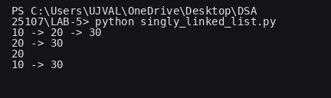
EXPLANATION:
insert_at_start(data): Creates a new node, points its next reference to the current head, and updates the head to the new node.
Insert_at_end(data): Traverses the list to find the last node (where next is None) and updates its reference to point to the new node. Handles empty lists by setting the head directly.
Insert_at_index(index, data): Traverses to the node right before the target index (index – 1). Points the new node to the current node’s next, and updates the current node to point to the new node.
Delete_at_start(): Reassigns the head pointer to the second node in the list (head.next), allowing Python’s garbage collector to remove the old head.
Delete_at_end(): Traverses the list looking one step ahead (current.next.next). Once it finds the second-to-last node, it sets its next pointer to None.
Delete_at_index(index): Traverses to the node immediately preceding the target index. It then bypasses the target node by updating the reference to current.next.next.
Data Structure Type: Linear, Dynamic (Non-contiguous memory allocation)
Time Complexity (Start Operations): $O\left(1\right)$ for both insert_at_start and delete_at_start, as they only require pointer reassignment at the head.
Time Complexity (End/Index Operations): $O\left(n\right)$ in the worst case, as inserting or deleting at the end or a specific index requires traversing the list from the head to the target location.
Space Complexity: $O\left(1\right)$ auxiliary space per operation (no extra arrays or recursive stacks are created during insertions or deletions). Overall structure takes $O\left(n\right)$ space to store the nodes.

Error Table:
Error | Rectification
The program may display an incorrect message for insertion at a specific index even when the index is invalid | Check whether the index is valid before displaying the successful insertion message.

b)Write a Program to implement Double Linked List:
CODE:
1. class Node:
2. def __init__(self, data):
3. self.data = data
4. self.next = None
5. self.prev = None
6.
7. class DoublyLinkedList:
8. def __init__(self):
9. self.head = None
10.
11. def insert_at_start(self, data):
12. new_node = Node(data)
13. if self.head is None:
14. self.head = new_node
15. return
16. new_node.next = self.head
17. self.head.prev = new_node
18. self.head = new_node
19.
20. def insert_at_end(self, data):
21. new_node = Node(data)
22. if not self.head:
23. self.head = new_node
24. return
25. last = self.head
26. while last.next:
27. last = last.next
28. last.next = new_node
29. new_node.prev = last
30.
31. def insert_at_index(self, index, data):
32. if index == 0:
33. self.insert_at_start(data)
34. return
35.
36. new_node = Node(data)
37. current = self.head
38.
39. for _ in range(index – 1):
40. if not current:
41. raise IndexError(“Index out of bounds”)
42. current = current.next
43.
44. if not current:
45. raise IndexError(“Index out of bounds”)
46.
47. new_node.next = current.next
48. new_node.prev = current
49.
50. if current.next:
51. current.next.prev = new_node
52. current.next = new_node
53.
54. def delete_at_start(self):
55. if not self.head:
56. print(“List is empty.”)
57. return
58. if not self.head.next:
59. self.head = None
60. return
61. self.head = self.head.next
62. self.head.prev = None
63.
64. def delete_at_end(self):
65. if not self.head:
66. print(“List is empty.”)
67. return
68. if not self.head.next:
69. self.head = None
70. return
71.
72. last = self.head
73. while last.next:
74. last = last.next
75. last.prev.next = None
76.
77. def delete_at_index(self, index):
78. if not self.head:
79. print(“List is empty.”)
80. return
81. if index == 0:
82. self.delete_at_start()
83. return
84.
85. current = self.head
86. for _ in range(index):
87. if not current:
88. raise IndexError(“Index out of bounds”)
89. current = current.next
90.
91. if not current:
92. raise IndexError(“Index out of bounds”)
93.
94. if current.next:
95. current.next.prev = current.prev
96. if current.prev:
97. current.prev.next = current.next
98.
99. def display(self):
100. elements = []
101. current = self.head
102. while current:
103. elements.append(str(current.data))
104. current = current.next
105. print(“ <-> “.join(elements) if elements else “Empty List”)
106.
107.
108. if __name__ == “__main__”:
109. dll = DoublyLinkedList()
110.
111. dll.insert_at_start(10)
112. dll.insert_at_end(30)
113. dll.insert_at_index(1, 20)
114. dll.display()
115.
116. dll.delete_at_start()
117. dll.display()
118.
119. dll.delete_at_end()
120. dll.display()
121.
122. dll.insert_at_start(10)
123. dll.insert_at_end(30)
124. dll.delete_at_index(1)
125. dll.display()
126.

OUTPUT:
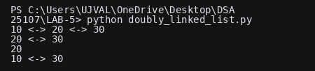
EXPLANATION:
Data Structure Type: Linear, Dynamic, Bidirectional
Time Complexity (Start Operations): $O\left(1\right)$ for insert_at_start and delete_at_start.
Time Complexity (End/Index Operations): $O\left(n\right)$ in the worst case for traversal. (Note: Operations at the end could be reduced to $O\left(1\right)$ if a tail pointer is added to the class).
Space Complexity: $O\left(1\right)$ auxiliary space per operation.
Memory Overhead: Higher than a singly linked list. Each node requires extra memory to store the prev reference, leading to a slightly larger memory footprint.
ERROR TABLE:
SNO | ERROR | SOLUTION
1. | Indentation SyntaxError (Formatting Artifact) | The provided code block uses invisible non-breaking spaces instead of standard spaces for indentation. Highlighting and replacing all indents with standard keyboard spaces or tabs will allow the code to run perfectly.
2. | Algorithm Logic | No Errors Occurred. The insertion, deletion, and display methods all correctly handle doubly linked list pointers and standard edge cases (e.g., empty lists, ends of lists).

c) Write a python programme to implement Circular linked list:
CODE:
1. class Node:
2. def __init__(self, data):
3. self.data = data
4. self.next = None
5.
6. class CircularLinkedList:
7. def __init__(self):
8. self.head = None
9.
10. def insert_at_start(self, data):
11. new_node = Node(data)
12. if not self.head:
13. self.head = new_node
14. new_node.next = self.head
15. return
16.
17. temp = self.head
18. while temp.next != self.head:
19. temp = temp.next
20.
21. new_node.next = self.head
22. temp.next = new_node
23. self.head = new_node
24.
25. def insert_at_end(self, data):
26. new_node = Node(data)
27. if not self.head:
28. self.head = new_node
29. new_node.next = self.head
30. return
31.
32. temp = self.head
33. while temp.next != self.head:
34. temp = temp.next
35.
36. temp.next = new_node
37. new_node.next = self.head
38.
39. def insert_at_index(self, index, data):
40. if index == 0:
41. self.insert_at_start(data)
42. return
43.
44. new_node = Node(data)
45. temp = self.head
46. count = 0
47.
48. while temp and count < index – 1:
49. temp = temp.next
50. count += 1
51. if temp == self.head:
52. print(“Index out of bounds”)
53. return
54.
55. new_node.next = temp.next
56. temp.next = new_node
57.
58. def delete_at_start(self):
59. if not self.head:
60. print(“List is empty”)
61. return
62.
63. if self.head.next == self.head:
64. self.head = None
65. return
66.
67. temp = self.head
68. while temp.next != self.head:
69. temp = temp.next
70.
71. temp.next = self.head.next
72. self.head = self.head.next
73.
74. def delete_at_end(self):
75. if not self.head:
76. print(“List is empty”)
77. return
78.
79. if self.head.next == self.head:
80. self.head = None
81. return
82.
83. temp = self.head
84. while temp.next.next != self.head:
85. temp = temp.next
86.
87. temp.next = self.head
88.
89. def delete_at_index(self, index):
90. if not self.head:
91. print(“List is empty”)
92. return
93.
94. if index == 0:
95. self.delete_at_start()
96. return
97.
98. temp = self.head
99. count = 0
100.
101. while temp and count < index – 1:
102. temp = temp.next
103. count += 1
104. if temp.next == self.head:
105. print(“Index out of bounds”)
106. return
107.
108. temp.next = temp.next.next
109.
110. def display(self):
111. if not self.head:
112. print(“List is empty”)
113. return
114. temp = self.head
115. while True:
116. print(temp.data, end=” -> “)
117. temp = temp.next
118. if temp == self.head:
119. break
120. print(f”(back to head: {self.head.data})”)
121.
122. if __name__ == “__main__”:
123. cll = CircularLinkedList()
124.
125. cll.insert_at_end(10)
126. cll.insert_at_end(20)
127. cll.insert_at_start(5)
128. cll.insert_at_index(2, 15)
129. cll.display()
130.
131. cll.delete_at_start()
132. cll.delete_at_end()
133. cll.display()
134.
135. cll.delete_at_index(1)
136. cll.display()
137.

OUTPUT:
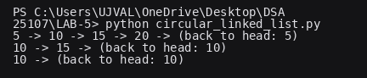
EXPLANATION:
Time Complexity (Start Operations): $O\left(n\right)$ for both insert_at_start and delete_at_start in this specific implementation. Because the list is circular and we only track the head pointer, we have to traverse the entire list to find the very last node to update its next pointer. (Note: You can easily drop this to $O\left(1\right)$ if you modify the code to maintain a tail pointer alongside the head!)
Time Complexity (End/Index Operations): $O\left(n\right)$ in the worst case, as inserting or deleting at the end or a specific index requires traversing the list from the head to the target location.
Space Complexity: $O\left(1\right)$ auxiliary space per operation (no extra arrays or recursive stacks are created during insertions or deletions). The overall structure takes $O\left(n\right)$ space to store the actual nodes.

WEEK-6
a)Write a Program to implement Stack using Array:
CODE
1. Class Stack:
2. def __init__(self):
3. self.stack = []
4.
5. def push(self, item):
6. self.stack.append(item)
7. print(f”Pushed {item} to stack”)
8.
9. def pop(self):
10. if self.is_empty():
11. print(“Stack Underflow”)
12. else:
13. print(f”Popped {self.stack.pop()} from stack”)
14.
15. def peek(self):
16. if self.is_empty():
17. print(“Stack is empty”)
18. else:
19. print(f”Top element is {self.stack[-1]}”)
20.
21. def is_empty(self):
22. return len(self.stack) == 0
23.
24. def display(self):
25. if self.is_empty():
26. print(“Stack is empty”)
27. else:
28. print(“Stack elements:”, self.stack[::-1])
29.
30. def menu(self):
31. while True:
32. print(“\n1. Push”)
33. print(“2. Pop”)
34. print(“3. Peek”)
35. print(“4. Display”)
36. print(“5. Exit”)
37.
38. choice = input(“Enter your choice (1-5): “)
39.
40. if choice == ‘1’:
41. item = input(“Enter item to push: “)
42. self.push(item)
43. elif choice == ‘2’:
44. self.pop()
45. elif choice == ‘3’:
46. self.peek()
47. elif choice == ‘4’:
48. self.display()
49. elif choice == ‘5’:
50. print(“Exiting...”)
51. break
52. else:
53. print(“Invalid choice. Please try again.”)
54.
55. my_stack = Stack()
56. my_stack.menu()
57.

OUTPUT:
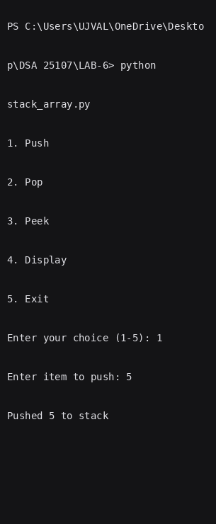
EXPLANATION:
The provided code implements a Stack data structure using a standard Python list within a single class. It operates on the Last-In, First-Out (LIFO) principle, meaning the most recently added item is the first one removed. The class bundles essential operations like push (adding items), pop (removing items), and peek (viewing the top item), along with an interactive menu method. By creating a Stack object and calling this menu, users can manage the stack directly from the command line in a continuous loop.

Error Table:
Error | Rectification
In peek, self.peek is taken in ‘if’ does not give correct answer for stack underflow. | Self.top is taken in ‘if’ to give correct output.

b)Write python program to implement stack using LinkedList
CODE:
1. class Node:
2. def __init__(self, data):
3. self.data = data
4. self.next = None
5.
6. class Stack:
7. def __init__(self):
8. self.top = None
9.
10. def push(self, data):
11. new_node = Node(data)
12. new_node.next = self.top
13. self.top = new_node
14. print(f”{data} is added to stack”)
15.
16. def pop(self):
17. if self.top is None:
18. print(“Stack underflow”)
19. else:
20. print(f”{self.top.data} is deleted from stack”)
21. self.top = self.top.next
22.
23. def peek(self):
24. if self.top is None:
25. print(“No elements in the stack”)
26. else:
27. print(self.top.data)
28.
29. def display(self):
30. if self.top is None:
31. print(“Empty Stack”)
32. else:
33. current = self.top
34. while current:
35. print(current.data, end=”->”)
36. current = current.next
37. print(None)
38.
39. s = Stack()
40. while (True):
41. print(“1.Push”)
42. print(“2.Pop”)
43. print(“3.Peek”)
44. print(“4.Display”)
45. print(“5.Exit”)
46. I = int(input(“Enter your choice: “))
47. if (I == 1):
48. e = int(input(“Enter element to add: “))
49. s.pushI
50. elif (I == 2):
51. s.pop()
52. elif (I == 3):
53. s.peek()
54. elif (I == 4):
55. s.display()
56. elif (I == 5):
57. exit()
58. else:
59. print(“Choose correct choice”)
60.

OUTPUT:
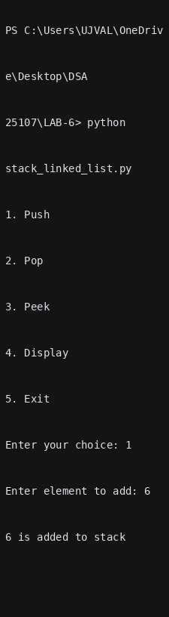
EXPLANATION:
push(data): Creates a new node, points its next reference to the current top node, and updates the top reference to point to this new node.
Pop(): Checks for an empty stack (underflow). Reassigns the top pointer to the next node in the stack (top.next), allowing Python’s garbage collector to remove the old top node.
Peek(): Evaluates if the stack is empty. If not, it retrieves and outputs the data stored in the current top node without altering any node references.

Display(): Traverses the stack starting from the top node, following the next pointers until it reaches the end (None), printing the data of each node along the way to represent the stack from top to bottom.
Data Structure Type: Linear, Dynamic (Non-contiguous memory allocation), operating on a Last-In, First-Out (LIFO) principle.
Time Complexity (Push, Pop, Peek Operations): O(1) for push, pop, and peek, as they only require direct pointer reassignment or data access at the head (top) of the linked list without any traversal.
Time Complexity (Display Operation): O(n) in the worst case, as displaying the full stack requires traversing every node from the top down to the bottom.
Space Complexity: O(1) auxiliary space per operation (no extra arrays or recursive stacks are created during pushes or pops). The overall structure takes O(n) space to dynamically store the nodes.
ERROR TABLE:
SNO | ERROR | SOLUTION
1. | AttributeError: ‘NoneType’ object has no attribute ‘data’ | Occurs if attempting to access self.top.data or self.top.next when the stack is empty. Ensure if self.top is None: (or is_empty()) is checked before trying to retrieve or modify the top node’s attributes.
2. | Infinite Loop in display() | Caused by forgetting to advance the traversal pointer (e.g., omitting current = current.next) inside the while loop. Add the pointer update step to ensure the loop progresses and eventually terminates when current becomes None.

WEEK-7
a) Write python program to implement Queue using Arrays
CODE:
1. class Queue:
2. def __init__(self,size):
3. self.size = size
4. self.queue = [None]*size
5. self.front = -1
6. self.rear = -1
7. def enqueue(self,data):
8. if (self.rear>=self.size-1):
9. print("Queue overflow")
10. else:
11. if (self.front == -1):
12. self.front = 0
13. self.rear+=1
14. self.queue[self.rear]=data
15. print(f"{data} is added to queue")
16. def dequeue(self):
17. if (self.front>self.rear or self.front==-1):
18. print("Queue underflow")
19. else :
20. print(f"{self.queue[self.front]} is deleted from queue")
21. self.queue[self.front] = None
22. self.front+=1
23. def peek(self):
24. if (self.front==-1):
25. print("No elements in the queue")
26. else:
27. print(self.queue[self.front])
28. def display(self):
29. if (self.front==-1):
30. print("Empty Queue")
31. else:
32. for i in range (0,self.rear+1):
33. print(self.queue[i],end="->")
34. print(None)
35. q=Queue(5)
36. while (True):
37. print("1.Enqueue")
38. print("2.Dequeue")
39. print("3.peek")
40. print("4.Display")
41. print("5.Exit")
42. i = int(input("Enter your chocice: "))
43. if (i==1):
44. e = int(input("Enter element to add"))
45. q.enqueue(e)
46. elif(i==2):
47. q.dequeue()
48. elif(i==3):
49. q.peek()
50. elif(i==4):
51. q.display()
52. elif(i==5):
53. exit()
54. else:
55. print("Choose correct choice")
56.

OUTPUT:
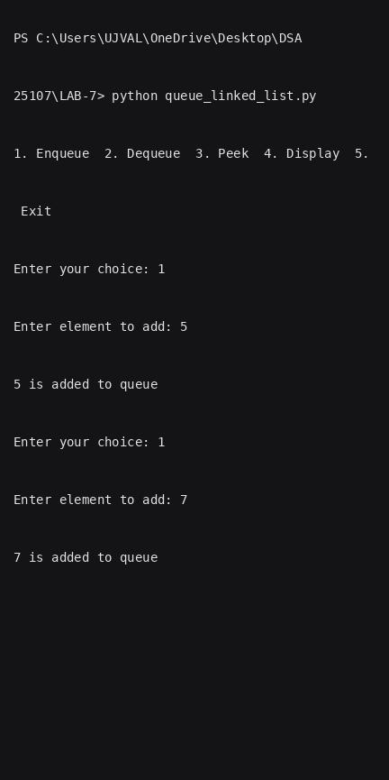
EXPLANATION:
enqueue(data): Checks for queue overflow (rear >= size - 1). If the queue is empty (front == -1), it initializes front to 0. It then increments the rear index by 1 and inserts the data at the rear position in the fixed-size array.
dequeue(): Checks for queue underflow (front > rear or front == -1). If not empty, it prints and clears the element at the front index by setting it to None, then increments the front index to point to the next element.
peek(): Evaluates if the queue is empty (front == -1). If not, it retrieves and outputs the element located at the front index without modifying any pointer or array values.
display(): Checks if the queue is empty (front == -1). If not empty, it iterates through the internal array from index 0 up to rear, printing each element in sequence to display the current state of the queue array.
Data Structure Type: Linear, Static/Fixed-Capacity Array-Based, operating on a First-In, First-Out (FIFO) principle.
Time Complexity (Enqueue, Dequeue, Peek Operations): $O\left(1\right)$ for enqueue, dequeue, and peek, as they perform direct array index access and basic variable updates without iteration.
Time Complexity (Display Operation): $O\left(n\right)$ in the worst case (where $n$ is rear + 1), as displaying the queue contents requires traversing elements from index 0 up to the rear pointer.
Space Complexity: $O\left(1\right)$ auxiliary space for individual operations. Overall space complexity is $O\left(N\right)$ based on the fixed maximum capacity (size) allocated during initialization.

Error Table:
Error | Rectification
No errors

b) Write python program to implement Queue using Linked List
CODE:
1. class Node:
2. def __init__(self, data):
3. self.data = data
4. self.next = None
5. class Queue:
6. def __init__(self):
7. self.front = None
8. self.rear = None
9. def enqueue(self, data):
10. curr = Node(data)
11. if self.rear is None:
12. self.front = self.rear = curr
13. return
14. self.rear.next = curr
15. self.rear = curr
16. def dequeue(self):
17. if self.front is None:
18. print("Queue underflow")
19. return
20.
21. self.front = self.front.next
22. if self.front is None:
23. self.rear = None
24. def peek(self):
25. if self.front is None:
26. print("No elements in queue")
27. else:
28. print(self.front.data)
29. def display(self):
30. if self.front is None:
31. print("No elements in queue")
32. else:
33. temp = self.front
34. while temp is not None:
35. print(temp.data, end="->")
36. temp = temp.next
37. print("None")
38.
39. q = Queue()
40. while (True):
41. print("1.Enqueue")
42. print("2.Dequeue")
43. print("3.peek")
44. print("4.Display")
45. print("5.Exit")
46. i = int(input("Enter your chocice: "))
47. if (i==1):
48. e = int(input("Enter element to add"))
49. q.enqueue(e)
50. elif(i==2):
51. q.dequeue()
52. elif(i==3):
53. q.peek()
54. elif(i==4):
55. q.display()
56. elif(i==5):
57. exit()
58. else:
59. print("Choose correct choice")
60.

OUTPUT:
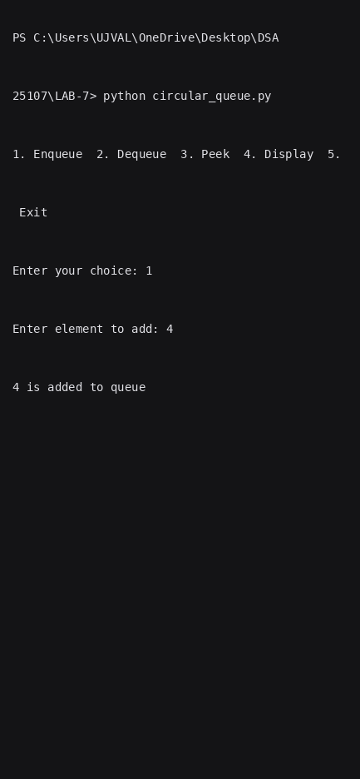
EXPLANATION:
enqueue(data): Creates a new node containing the data. If the queue is empty (rear is None), both front and rear are set to point to this new node. Otherwise, it updates the next pointer of the current rear node to the new node and shifts rear to point to the new node.
dequeue(): Checks for queue underflow (front is None). If not empty, it advances the front pointer to front.next, removing the references to the old head node so Python's garbage collector can reclaim it. If front becomes None after removal, rear is also set to None to reset the empty queue.
peek(): Evaluates if the queue is empty (front is None). If not, it retrieves and outputs the data stored in the current front node without altering any node references.
display(): Traverses the queue starting from the front node, following the next pointers until reaching None, printing the data of each node along the way to represent the queue from front to rear.
Data Structure Type: Linear, Dynamic (Non-contiguous memory allocation), operating on a First-In, First-Out (FIFO) principle.
Time Complexity (Enqueue, Dequeue, Peek Operations): $O\left(1\right)$ for enqueue, dequeue, and peek, as they only require direct pointer reassignments or data access at the front or rear nodes without any traversal.
Time Complexity (Display Operation): $O\left(n\right)$ in the worst case, as displaying the full queue requires traversing every node from the front down to the rear.
Space Complexity: $O\left(1\right)$ auxiliary space per operation (no extra arrays or recursive stacks created during enqueues or dequeues). The overall structure takes $O\left(n\right)$ space to dynamically store the nodes.
ERROR TABLE:
SNO | ERROR | SOLUTION
1. | AttributeError: 'NoneType' object has no attribute 'data' (or 'next') | Occurs if attempting to access self.front.data or self.front.next when the queue is empty (self.front is None). Ensure if self.front is None: is checked before trying to retrieve or modify the front node's attributes.
2. | Dangling rear Pointer / Memory Leak | Occurs during dequeue() if self.rear is not reset to None when the last element is removed (self.front becomes None). Ensure if self.front is None: self.rear = None is included so rear does not point to a stale node.
3. | Unlinked Nodes / Broken Chain in enqueue() | Caused by forgetting self.rear.next = curr before reassigning self.rear = curr when adding to a non-empty queue. Always update the current rear node's next reference to point to the new node before updating self.rear
Error Table:
Error | Rectification
No errors
c) Write python program to implement Circular Queue using Arrays
CODE:
1. class CircularQueue:
2. def __init__(self, size):
3. self.size = size
4. self.queue = [None] * size
5. self.front = -1
6. self.rear = -1
7.
8. def enqueue(self, data):
9. if (self.rear + 1) % self.size == self.front:
10. print("Queue overflow")
11. return
12.
13. if self.front == -1:
14. self.front = 0
15.
16. self.rear = (self.rear + 1) % self.size
17. self.queue[self.rear] = data
18. print(f"{data} is added to queue")
19.
20. def dequeue(self):
21. if self.front == -1:
22. print("Queue underflow")
23. return
24.
25. print(f"{self.queue[self.front]} is deleted from queue")
26. self.queue[self.front] = None
27.
28. if self.front == self.rear:
29. self.front = -1
30. self.rear = -1
31. else:
32. self.front = (self.front + 1) % self.size
33.
34. def peek(self):
35. if self.front == -1:
36. print("No elements in the queue")
37. else:
38. print(self.queue[self.front])
39.
40. def display(self):
41. if self.front == -1:
42. print("Empty Queue")
43. return
44. temp = self.front
45. while True:
46. print(self.queue[temp], end=" -> ")
47. if temp == self.rear:
48. break
49. temp = (temp + 1) % self.size
50. print("None")
51.
52. q = CircularQueue(5)
53. while True:
54. print("\n1.Enqueue\n2.Dequeue\n3.Peek\n4.Display\n5.Exit")
55. try:
56. choice = int(input("Enter your choice: "))
57. if choice == 1:
58. e = int(input("Enter element to add: "))
59. q.enqueue(e)
60. elif choice == 2:
61. q.dequeue()
62. elif choice == 3:
63. q.peek()
64. elif choice == 4:
65. q.display()
66. elif choice == 5:
67. break
68. else:
69. print("Choose a valid choice")
70. except ValueError:
71. print("Please enter a valid number")
72.

OUTPUT:
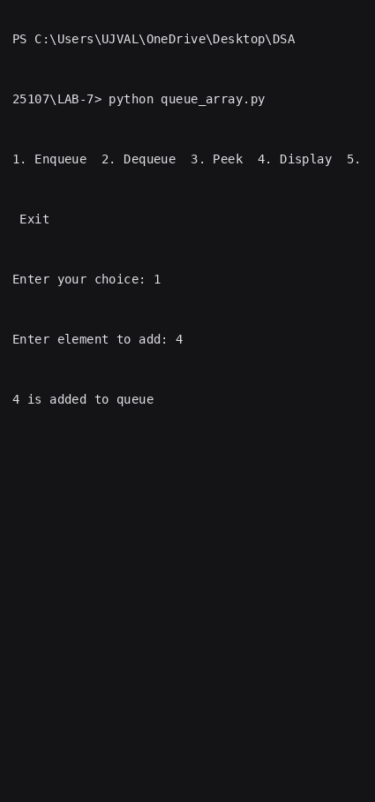

EXPLANATION:
enqueue(data): Checks for queue overflow using circular indexing (rear + 1) % size == front. If the queue is empty (front == -1), it initializes front to 0. It then advances rear circularly using (rear + 1) % size and inserts the data at the new rear position in the fixed-size array.
dequeue(): Checks for queue underflow (front == -1). If not empty, it prints and clears the element at the front index by setting it to None. If front == rear (removing the last remaining element), it resets both front and rear back to -1; otherwise, it advances front circularly using (front + 1) % size.
peek(): Evaluates if the queue is empty (front == -1). If not, it retrieves and outputs the element located at the front index without modifying any pointers or array values.
display(): Checks if the queue is empty (front == -1). If not, starting from front, it traverses each index circularly using (temp + 1) % size until it reaches rear, printing each element in sequence to represent the circular queue from front to rear.
Data Structure Type: Linear, Static/Fixed-Capacity Array-Based (Circular Memory Reuse), operating on a First-In, First-Out (FIFO) principle.
Time Complexity (Enqueue, Dequeue, Peek Operations): $O\left(1\right)$ for enqueue, dequeue, and peek, as they perform direct array index access and modulo pointer arithmetic without any traversal.
Time Complexity (Display Operation): $O\left(n\right)$ in the worst case (where $n$ is the number of active elements in the queue), as displaying the queue contents requires traversing every element from front to rear.
Space Complexity: $O\left(1\right)$ auxiliary space for individual operations. Overall space complexity is $O\left(N\right)$ based on the fixed maximum capacity (size) allocated during initialization.

Error Table:
Error | Rectification
No errors
d) Write python program to implement Circular Queue using Linked List
CODE:
1. class Node:
2. def __init__(self, data):
3. self.data = data
4. self.next = None
5.
6. class CircularQueueLL:
7. def __init__(self):
8. self.rear = None
9.
10. def enqueue(self, data):
11. curr = Node(data)
12. if self.rear is None:
13. self.rear = curr
14. curr.next = self.rear
15. print(f"{data} is added to queue")
16. return
17.
18. curr.next = self.rear.next
19. self.rear.next = curr
20. self.rear = curr
21. print(f"{data} is added to queue")
22.
23. def dequeue(self):
24. if self.rear is None:
25. print("Queue underflow")
26. return
27.
28. front = self.rear.next
29. print(f"{front.data} is deleted from queue")
30.
31. if self.rear == front:
32. self.rear = None
33. else:
34. self.rear.next = front.next
35.
36. def peek(self):
37. if self.rear is None:
38. print("No elements in the queue")
39. else:
40. front = self.rear.next
41. print(front.data)
42.
43. def display(self):
44. if self.rear is None:
45. print("Empty Queue")
46. return
47.
48. front = self.rear.next
49. temp = front
50. while True:
51. print(temp.data, end=" -> ")
52. temp = temp.next
53. if temp == front:
54. break
55. print("(Back to Front)")
56.
57. q = CircularQueueLL()
58. while True:
59. print("\n1.Enqueue")
60. print("2.Dequeue")
61. print("3.Peek")
62. print("4.Display")
63. print("5.Exit")
64. try:
65. choice = int(input("Enter your choice: "))
66. if choice == 1:
67. e = int(input("Enter element to add: "))
68. q.enqueue(e)
69. elif choice == 2:
70. q.dequeue()
71. elif choice == 3:
72. q.peek()
73. elif choice == 4:
74. q.display()
75. elif choice == 5:
76. break
77. else:
78. print("Choose a valid choice")
79. except ValueError:
80. print("Please enter a valid number")
81.

OUTPUT::
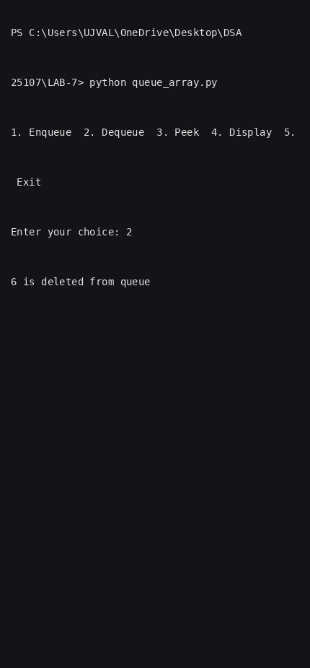
EXPLANATION:
enqueue(data): Creates a new node containing the data. If the queue is empty (rear is None), it initializes rear to point to the new node and sets curr.next = self.rear to form a circular loop pointing to itself. Otherwise, it inserts the new node between rear and front (rear.next) by setting curr.next = self.rear.next and self.rear.next = curr, then updates rear to point to the newly added node.
dequeue(): Checks for queue underflow (rear is None). If not empty, it accesses the front node via rear.next and prints its data. If rear == front (only one node in the queue), it sets rear to None to reset the queue; otherwise, it bypasses the front node by updating self.rear.next = front.next, allowing Python's garbage collector to remove the old front node.
peek(): Evaluates if the queue is empty (rear is None). If not, it accesses the front node (self.rear.next) and outputs its data without altering any node references.
display(): Checks if the queue is empty (rear is None). If not, starting from the front node (self.rear.next), it iterates through each node using temp.next until temp loops back around to front, printing the data of each node in order to represent the circular queue.
Data Structure Type: Linear, Dynamic (Non-contiguous memory allocation with circular linkage), operating on a First-In, First-Out (FIFO) principle.
Time Complexity (Enqueue, Dequeue, Peek Operations): $O\left(1\right)$ for enqueue, dequeue, and peek, as maintaining a single rear pointer allows instant access to both rear and front (rear.next) without any linear traversal.
Time Complexity (Display Operation): $O\left(n\right)$ in the worst case, as displaying the full queue requires traversing every node from front until returning back to front.
Space Complexity: $O\left(1\right)$ auxiliary space per operation. The overall structure takes $O\left(n\right)$ space to dynamically store the nodes.

LAB-8
a) write a python program to implement a binary tree with its operations using a array
CODE:
1. class BinaryTreeArray:
2. def __init__(self, size):
3. self.tree = [None] * size
4. self.size = size
5.
6. # Insert root
7. def set_root(self, data):
8. self.tree[0] = data
9. # Set left child
10. def set_left(self, parent_index, data):
11. child_index = 2 * parent_index + 1
12. if child_index < self.size:
13. self.tree[child_index] = data
14. else:
15. print("Index out of range!")
16. # Set right child
17. def set_right(self, parent_index, data):
18. child_index = 2 * parent_index + 2
19. if child_index < self.size:
20. self.tree[child_index] = data
21. else:
22. print("Index out of range!")
23. # Preorder Traversal
24. def preorder(self, index=0):
25. if index >= self.size or self.tree[index] is None:
26. return
27. print(self.tree[index], end=" ")
28. self.preorder(2 * index + 1)
29. self.preorder(2 * index + 2)
30.
31. # Inorder Traversal
32. def inorder(self, index=0):
33. if index >= self.size or self.tree[index] is None:
34. return
35. self.inorder(2 * index + 1)
36. print(self.tree[index], end=" ")
37. self.inorder(2 * index + 2)
38. # Postorder Traversal
39. def postorder(self, index=0):
40. if index >= self.size or self.tree[index] is None:
41. return
42. self.postorder(2 * index + 1)
43. self.postorder(2 * index + 2)
44. print(self.tree[index], end=" ")
45. # Level-order Traversal
46. def level_order(self):
47. for value in self.tree:
48. if value is not None:
49. print(value, end=" ")
50. # Display Array
51. def display(self):
52. print("\nArray Representation:")
53. for i in range(self.size):
54. print(f"Index {i}: {self.tree[i]}")
55. # MAIN PROGRAM
56. tree = BinaryTreeArray(7)
57. # Create the tree
58. tree.set_root('A')
59. # Children of A
60. tree.set_left(0, 'B')
61. tree.set_right(0, 'C')
62. # Children of B
63. tree.set_left(1, 'D')
64. tree.set_right(1, 'E')
65. # Right child of C
66. tree.set_right(2, 'F')
67. # Display tree
68. tree.display()
69. # Traversals
70. print("\nPreorder: ", end="")
71. tree.preorder()
72. print("\nInorder: ", end="")
73. tree.inorder()
74. print("\nPostorder: ", end="")
75. tree.postorder()
76. print("\nLevel-order: ", end="")
77. tree.level_order()
78.

OUTPUT:
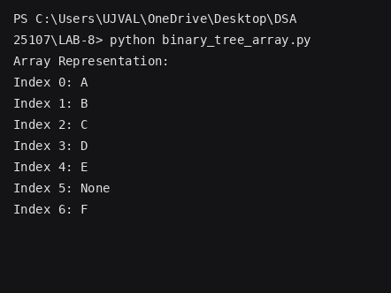

EXPLANATION:
push(data):
Creates a new node containing the data. If the stack is empty (top is None), it initializes top to point to the new node. Otherwise, it links the new node to the rest of the stack by setting new_node.next = self.top, then updates top to point to the newly added node, making it the newest element at the top of the stack.
pop():
Checks for stack underflow (top is None). If not empty, it accesses the top node and captures its data. It then removes the node by updating self.top = self.top.next, bypassing the current top node and making the next element the new top, allowing Python's garbage collector to safely remove the old node.
peek():
Evaluates if the stack is empty (top is None). If not, it accesses the top node and outputs its data without altering any node references or removing the element from the data structure.
display():
Checks if the stack is empty (top is None). If not, starting from the top node, it iterates through each node using temp.next until temp reaches None, printing the data of each node in sequential order from top to bottom to represent the current state of the stack.
Data Structure Type: Linear, Dynamic (Non-contiguous memory allocation with singular linkage), operating on a Last-In, First-Out (LIFO) principle.
Time Complexity (Push, Pop, Peek Operations): O(1) for push, pop, and peek, as maintaining a single top pointer allows instant insertion, deletion, and access directly at the head of the list without requiring any linear traversal.
Time Complexity (Display Operation): O(n) in the worst case, as displaying the full stack requires traversing every node sequentially from the top pointer down to the base of the stack.
Space Complexity: O(1) auxiliary space per operation. The overall structure takes O(n) space to dynamically store the nodes.

Error Table:
Error | Rectification
Using index > self.size as the boundary condition in traversal functions. | Use index >= self.size to prevent accessing an invalid array index.
Accessing self.tree[index] without first checking whether the index is within the valid range. | Check the index boundary before accessing the array element.

b) write a python program to implement a binary tree with its operations using a linked list
CODE:
1. class Node:
2. def __init__(self, data):
3. self.data = data
4. self.left = None
5. self.right = None
6.
7. # BINARY TREE CLASS
8. class BinaryTree:
9. def __init__(self):
10. self.root = None
11.
12. # Create the binary tree
13. def create_tree(self):
14. self.root = Node('A')
15. # Left and right children of A
16. self.root.left = Node('B')
17. self.root.right = Node('C')
18. # Children of B
19. self.root.left.left = Node('D')
20. self.root.left.right = Node('E')
21. # Right child of C
22. self.root.right.right = Node('F')
23. # Preorder Traversal
24. def preorder(self, node):
25. if node is None:
26. return
27. print(node.data, end=" ")
28. self.preorder(node.left)
29. self.preorder(node.right)
30.
31. # Inorder Traversal
32. def inorder(self, node):
33. if node is None:
34. return
35. self.inorder(node.left)
36. print(node.data, end=" ")
37. self.inorder(node.right)
38. # Postorder Traversal
39. def postorder(self, node):
40. if node is None:
41. return
42. self.postorder(node.left)
43. self.postorder(node.right)
44. print(node.data, end=" ")
45. # Level-order Traversal
46. def level_order(self):
47. if self.root is None:
48. return
49. queue = [self.root]
50. while queue:
51. node = queue.pop(0)
52. print(node.data, end=" ")
53. # Add left child
54. if node.left is not None:
55. queue.append(node.left)
56. # Add right child
57. if node.right is not None:
58. queue.append(node.right)
59.
60. # MAIN PROGRAM
61. tree = BinaryTree()
62. # Create the binary tree
63. tree.create_tree()
64. # Traversals
65. print("Preorder: ", end="")
66. tree.preorder(tree.root)
67. print("\nInorder: ", end="")
68. tree.inorder(tree.root)
69. print("\nPostorder: ", end="")
70. tree.postorder(tree.root)
71. print("\nLevel-order: ", end="")
72. tree.level_order()
73.

OUTPUT:
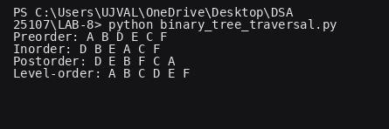
EXPLANATION:
Here is the explanation for the Linked Node-based Binary Tree code, formatted similarly so you can easily paste it into your Word file:
Node and BinaryTree Initialization: Defines the fundamental building blocks of the structure. The Node class creates independent objects containing the data alongside two pointers (left and right) initialized to None. The BinaryTree class manages the overall structure by maintaining a root pointer, initially set to None, which serves as the primary entry point to access the hierarchical data.
create_tree(): Manually constructs a specific binary tree structure by instantiating Node objects and establishing parent-child links. It sets 'A' as the root, links 'B' and 'C' as its left and right children respectively, and continues linking subsequent child nodes ('D', 'E', 'F'), dynamically allocating memory for each discrete node.
preorder(node): Executes a depth-first traversal using recursion. If the node is not None, it processes (prints) the current node's data immediately, then recursively traverses the entire left subtree, followed by the entire right subtree. This follows a Root-Left-Right sequence.
inorder(node): Executes a depth-first traversal using recursion. It recursively dives down the left subtree until it reaches a null node, processes (prints) the current node's data, and finally traverses the right subtree. This follows a Left-Root-Right sequence.
postorder(node): Executes a depth-first traversal using recursion. It fully explores the left subtree, then fully explores the right subtree, and only processes (prints) the current node's data after its children have been visited. This follows a Left-Right-Root sequence.
level_order(): Executes a breadth-first traversal using an iterative queue approach. It verifies the tree is not empty, then initializes a list (acting as a queue) starting with the root node. In a loop, it removes (pop(0)) the front node, prints its data, and appends its existing left and right children to the back of the queue. This ensures nodes are processed horizontally, level by level, from top to bottom and left to right.
Data Structure Type: Hierarchical, Dynamic (Non-contiguous memory allocation using singular references/pointers for child nodes), operating as a non-linear binary tree structure.
Time Complexity (All Traversals): O(n), where n is the total number of nodes. Every traversal method (Preorder, Inorder, Postorder, and Level-order) visits and processes each node in the tree exactly once.
Space Complexity:
- O(h) for the depth-first traversals (Preorder, Inorder, Postorder), where h is the height of the tree. This space is used by the system's call stack to manage the recursive function calls.
- O(w) for the Level-order traversal, where w is the maximum width of the tree (the most nodes present on any single level). This space is required to dynamically store the nodes in the auxiliary queue list.

LAB-9
a)write a python program to implement a binary Search Tree
CODE:
1. # Binary Search Tree
2.
3. class Node:
4. def __init__(self, data):
5. self.data = data
6. self.left = None
7. self.right = None
8.
9. class BinarySearchTree:
10.
11. # Insert a node
12. def insert(self, root, data):
13. if root is None:
14. return Node(data)
15.
16. if data < root.data:
17. root.left = self.insert(root.left, data)
18. elif data > root.data:
19. root.right = self.insert(root.right, data)
20.
21. return root
22.
23. # Search for a node
24. def search(self, root, data):
25. if root is None:
26. return False
27.
28. if root.data == data:
29. return True
30. elif data < root.data:
31. return self.search(root.left, data)
32. else:
33. return self.search(root.right, data)
34.
35. # Find minimum value node
36. def find_min(self, root):
37. current = root
38.
39. while current.left is not None:
40. current = current.left
41.
42. return current
43.
44. # Delete a node
45. def delete(self, root, data):
46. if root is None:
47. return root
48.
49. if data < root.data:
50. root.left = self.delete(root.left, data)
51.
52. elif data > root.data:
53. root.right = self.delete(root.right, data)
54.
55. else:
56. # Case 1: No child
57. if root.left is None and root.right is None:
58. return None
59.
60. # Case 2: Only right child
61. elif root.left is None:
62. return root.right
63.
64. # Case 3: Only left child
65. elif root.right is None:
66. return root.left
67.
68. # Case 4: Two children
69. else:
70. temp = self.find_min(root.right)
71. root.data = temp.data
72. root.right = self.delete(root.right, temp.data)
73.
74. return root
75.
76. # Inorder: Left -> Root -> Right
77. def inorder(self, root):
78. if root is not None:
79. self.inorder(root.left)
80. print(root.data, end=" ")
81. self.inorder(root.right)
82.
83. # Preorder: Root -> Left -> Right
84. def preorder(self, root):
85. if root is not None:
86. print(root.data, end=" ")
87. self.preorder(root.left)
88. self.preorder(root.right)
89.
90. # Postorder: Left -> Right -> Root
91. def postorder(self, root):
92. if root is not None:
93. self.postorder(root.left)
94. self.postorder(root.right)
95. print(root.data, end=" ")
96.
97. # Main program
98. bst = BinarySearchTree()
99. root = None
100.
101. while True:
102. print("\n\n--- BINARY SEARCH TREE ---")
103. print("1. Insert")
104. print("2. Search")
105. print("3. Delete")
106. print("4. Inorder Traversal")
107. print("5. Preorder Traversal")
108. print("6. Postorder Traversal")
109. print("7. Exit")
110.
111. choice = int(input("Enter your choice: "))
112.
113. if choice == 1:
114. data = int(input("Enter value to insert: "))
115. root = bst.insert(root, data)
116. print("Node inserted successfully.")
117.
118. elif choice == 2:
119. data = int(input("Enter value to search: "))
120.
121. if bst.search(root, data):
122. print("Element found.")
123. else:
124. print("Element not found.")
125.
126. elif choice == 3:
127. data = int(input("Enter value to delete: "))
128. root = bst.delete(root, data)
129. print("Node deleted successfully.")
130.
131. elif choice == 4:
132. print("Inorder Traversal:")
133. bst.inorder(root)
134.
135. elif choice == 5:
136. print("Preorder Traversal:")
137. bst.preorder(root)
138.
139. elif choice == 6:
140. print("Postorder Traversal:")
141. bst.postorder(root)
142.
143. elif choice == 7:
144. print("Program terminated.")
145. break
146.
147. else:
148. print("Invalid choice.")
149.

OUTPUT:
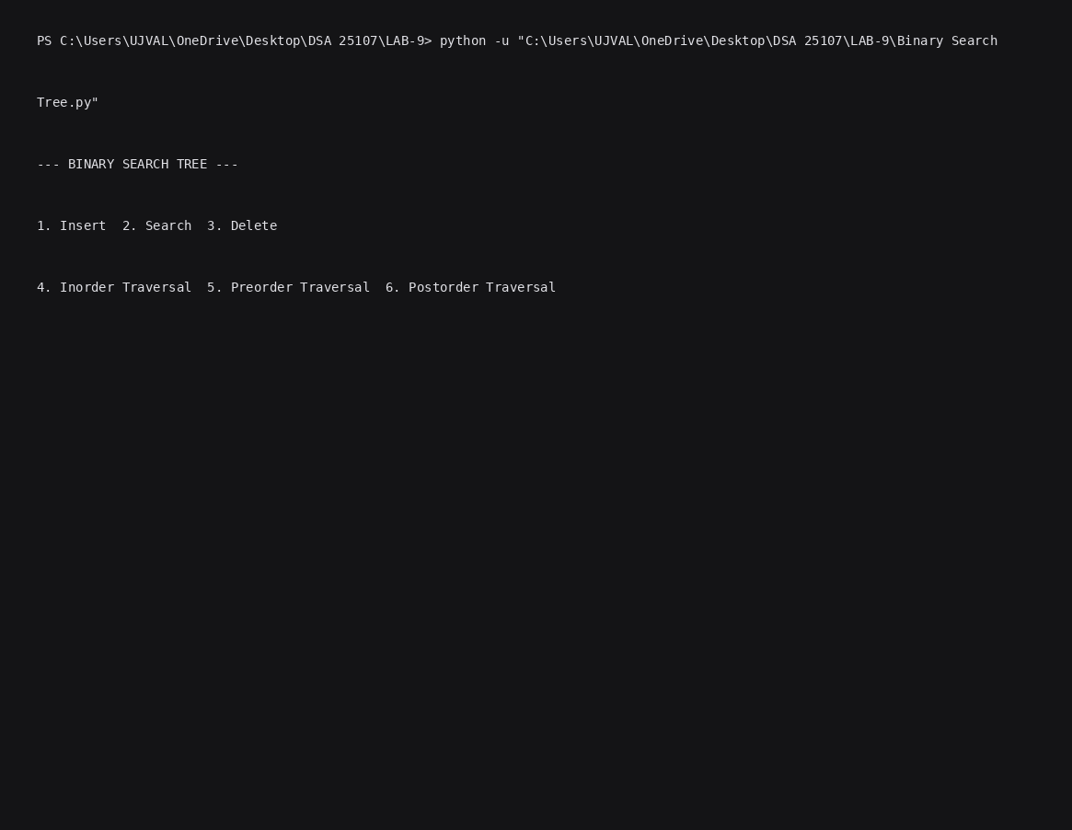
EXPLANATION:
- Node Class: Acts as the blueprint for individual tree elements. Each object initializes with a data value and sets its left and right child pointers to None.
- BinarySearchTree Class: Encapsulates all tree manipulations using standard recursive algorithms:
  - Insertion (insert): Recursively navigates down the tree depending on whether the input value is smaller or larger than the current node's value, attaching a new Node once an empty spot (None) is reached.
  - Search (search): Traverses down specific branches based on value comparisons, returning True if a matching node is found and False if it hits a None leaf without finding the target.
  - Deletion (delete): Handles node removal across four distinct structural conditions: leaf nodes (no children), single-child nodes (replacing the node with its active child), and two-children nodes (replacing the target node's value with the minimum value from its right subtree, retrieved via find_min, then deleting that duplicate minimum node).
  - Tree Traversals (inorder, preorder, postorder): Demonstrates the three depth-first search strategies:
    - Inorder (Left $→$Root $→$Right) outputs elements in strictly sorted ascending order.
    - Preorder (Root $→$Left $→$Right) visits root nodes first, useful for cloning or serializing trees.
    - Postorder (Left $→$Right $→$Root) visits child nodes before their parents, commonly used for bottom-up cleanup operations.
- Interactive Main Program: Uses a standard console loop (while True) with user inputs to dynamically call the BST methods and retain state across operations via the root reference (root).

Error Table:
Error | Rectification
Not initializing the root node before inserting elements. | Initialize self.root = None in the constructor.
Creating a new node without assigning it to the tree. | Assign the new node to the root or an appropriate left/right child.
LAB-10
Python program to implement AVL trees.
CODE:
1. print("CSE25107")
2.
3. class Node:
4. def __init__(self, key):
5. self.key = key
6. self.left = None
7. self.right = None
8. self.height = 1
9.
10.
11. class AVLTree:
12.
13. def height(self, root):
14. if root is None:
15. return 0
16. return root.height
17.
18. def getBalance(self, root):
19. if root is None:
20. return 0
21. return self.height(root.left) - self.height(root.right)
22.
23. def rightRotate(self, z):
24. y = z.left
25. T3 = y.right
26.
27. y.right = z
28. z.left = T3
29.
30. z.height = 1 + max(self.height(z.left),
31. self.height(z.right))
32. y.height = 1 + max(self.height(y.left),
33. self.height(y.right))
34.
35. return y
36.
37. def leftRotate(self, z):
38. y = z.right
39. T2 = y.left
40.
41. y.left = z
42. z.right = T2
43.
44. z.height = 1 + max(self.height(z.left),
45. self.height(z.right))
46. y.height = 1 + max(self.height(y.left),
47. self.height(y.right))
48.
49. return y
50.
51. def insert(self, root, key):
52. if root is None:
53. return Node(key)
54.
55. if key < root.key:
56. root.left = self.insert(root.left, key)
57. elif key > root.key:
58. root.right = self.insert(root.right, key)
59. else:
60. return root
61.
62. root.height = 1 + max(self.height(root.left),
63. self.height(root.right))
64.
65. balance = self.getBalance(root)
66.
67. # LL Case
68. if balance > 1 and key < root.left.key:
69. return self.rightRotate(root)
70.
71. # RR Case
72. if balance < -1 and key > root.right.key:
73. return self.leftRotate(root)
74.
75. # LR Case
76. if balance > 1 and key > root.left.key:
77. root.left = self.leftRotate(root.left)
78. return self.rightRotate(root)
79.
80. # RL Case
81. if balance < -1 and key < root.right.key:
82. root.right = self.rightRotate(root.right)
83. return self.leftRotate(root)
84.
85. return root
86.
87. def inorder(self, root):
88. if root:
89. self.inorder(root.left)
90. print(root.key, end=" ")
91. self.inorder(root.right)
92.
93.
94. # Main Program
95.
96. tree = AVLTree()
97. root = None
98.
99. n = int(input("Enter number of elements: "))
100.
101. for i in range(n):
102. value = int(input("Enter value: "))
103. root = tree.insert(root, value)
104.
105. print("Inorder Traversal:")
106. tree.inorder(root)

OUTPUT:
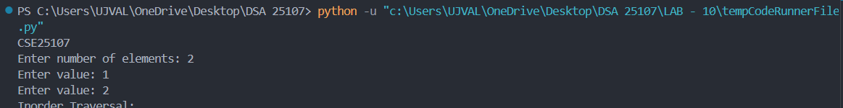
EXPLANATION:
This Python program implements an AVL Tree (Self-Balancing Binary Search Tree) using Linked List representation. Each node stores a key, references to its left and right children, and its height. The program supports insertion of elements while automatically maintaining the balance of the tree using height calculations and balance factors. The balance factor is calculated as the difference between the heights of the left and right subtrees. If the tree becomes unbalanced after insertion, appropriate rotations (LL, RR, LR, and RL) are performed to restore balance. Finally, the program displays the elements using Inorder Traversal, which prints the keys in ascending order.
Error | Rectification
Not initializing the height of a newly created node. | Initialize self.height = 1 because a new leaf node has height 1.
Incorrect height calculation for a node. | Calculate height using 1 + max(height(left), height(right)).
LAB-11
Python program to implement Hashing (Separate chaining, Linear probing, and Quadratic probing).
CODE:
1. class HashingDemonstrator:
2. def __init__(self, size):
3. self.size = size
4.
5. def _hash_function(self, key):
6. return key % self.size
7.
8. # 1. Separate Chaining
9. def separate_chaining(self, keys):
10. hash_table = [[] for _ in range(self.size)]
11.
12. for key in keys:
13. index = self._hash_function(key)
14. hash_table[index].append(key)
15.
16. return hash_table
17.
18. # 2. Linear Probing
19. def linear_probing(self, keys):
20. hash_table = [None] * self.size
21.
22. for key in keys:
23. index = self._hash_function(key)
24.
25. i = 0
26. while i < self.size:
27. new_index = (index + i) % self.size
28. if hash_table[new_index] is None:
29. hash_table[new_index] = key
30. break
31. i += 1
32.
33. if i == self.size:
34. print(f"Hash table is full! Could not insert {key} using Linear Probing.")
35.
36. return hash_table
37.
38. # 3. Quadratic Probing
39. def quadratic_probing(self, keys):
40. hash_table = [None] * self.size
41.
42. for key in keys:
43. index = self._hash_function(key)
44.
45. i = 0
46. inserted = False
47. while i < self.size:
48. new_index = (index + (i * i)) % self.size
49. if hash_table[new_index] is None:
50. hash_table[new_index] = key
51. inserted = True
52. break
53. i += 1
54.
55. if not inserted:
56. print(f"Could not insert {key} using Quadratic Probing (Table might not be half empty or size isn't prime).")
57.
58. return hash_table
59.
60. if __name__ == "__main__":
61. # Table size of 10
62. hasher = HashingDemonstrator(10)
63.
64. # Keys intentionally chosen to cause collisions at index 2 (12, 22, 42) and index 5 (15, 25)
65. keys_to_insert = [12, 15, 22, 25, 42, 8, 9]
66.
67. print("Keys to insert:", keys_to_insert)
68. print("\n--- Separate Chaining ---")
69. print(hasher.separate_chaining(keys_to_insert))
70.
71. print("\n--- Linear Probing ---")
72. print(hasher.linear_probing(keys_to_insert))
73.
74. print("\n--- Quadratic Probing ---")
75. print(hasher.quadratic_probing(keys_to_insert))
76.

OUTPUT:
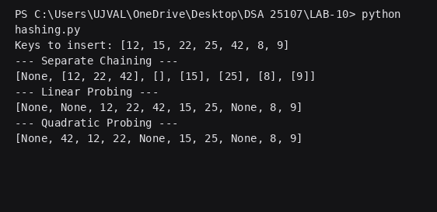
EXPLANATION:
• HashingDemonstrator Class: Acts as the blueprint for encapsulating the hash table operations. It initializes the table's fixed size and relies on a private _hash_function that uses standard modulo arithmetic (key % size) to determine the initial index for any given key.
- Separate Chaining (separate_chaining): Resolves collisions by maintaining an array of lists. When multiple keys hash to the exact same index, the algorithm simply appends the incoming key to the list located at that index, allowing multiple items to share the same primary slot without overwriting data.
- Linear Probing (linear_probing): Employs a flat, one-dimensional array (initialized with None). When a collision occurs at a base index, it sequentially probes the very next immediate slots (index + 1, index + 2, etc.), wrapping around to the beginning using modulo arithmetic until the nearest empty space is found.
- Quadratic Probing (quadratic_probing): Modifies the linear search approach to reduce primary clustering. Instead of checking adjacent slots, it checks progressively spaced slots using perfect squares (index + 1^2, index + 2^2, index + 3^2, etc.) until a None space is located.
• Execution and Testing Block: Acts as the main driver program. It instantiates the demonstrator with a fixed size of 10 and processes a predefined array of keys deliberately chosen to force index collisions (e.g., 12, 22, and 42 all hashing to index 2), explicitly printing out the final layout of the array to contrast how each of the three strategies organizes the data.

Error Table:
Error | Rectification
Not initializing the hash table before inserting elements. | Initialize the table using [None] * size for open addressing and [[] for i in range(size)] for separate chaining.
Using an incorrect hash function. | Use key % size to calculate the hash index.

