

User Interface Design (23CSE113)
LAB MANUAL

Submitted by
Name | E. Ujval Sriteja
Roll No | AV.SC.U4CSE25107
Year/Sem/Section | 1st YEAR/SEM-2/CSE-B
Submitted to
Name | Dr. Rajkumar Batchu
Department | CSE

INDEX

S. No | Title | Page No. | REMARKS
1. | Week-1  1A. To understand the installation process of a VS code and get familiar with its environment for web development.  1B. To learn the basic structure of an HTML document and create a simple webpage using headings and paragraphs.  1C. To understand and implement basic HTML tags such as image, hyperlink, text formatting, and inline styling to design a simple webpage. | 5-14
2. | Week 2  2AvTo design a simple web page using HTML that demonstrates the use of  background colour, background image, heading styling, and preformatted text. | 15-18
3. | Week-3  3A. TIMETABLE USING TABLE TAGS | 19-29
4. | Week-4  4a. a collage wants to collect student details through an online admission form. Design a registration form using only html tags (no css) with papers labels, table alignments, background colour and border.  4b. a company wants to design a webpage that displays two different forms side by side using I frames. One I frame should display a login page form and other should display a registration form. | 30-35

5. | Week-5  5a. To create a responsive card layout using HTML and CSS with three cards, each containing an image, title, and button.  5b. To design a mini website using iframe with navigation links (Home, About, Contact), where clicking on each link displays the respective content within the same page using internal or external CSS.  5c. To design an Amrita login page using HTML and CSS that displays different campuses, where clicking on each campus shows its details on the same page. | 36-48
6. | Week-6  6. Design a responsive e-commerce application using the grid layout. This application should contain different categories of products such as electronics, clothing, home-appliances, books. Based on the category we select corresponding products should be displayed on the sidebar | 49-52
7. | WEEK-7  7. Create a Git hub account and create a repository named UIDLAB upload every week experiments, lab reports in that repository and make the repository | 53-56

Week 1:

1A .To understand the installation process of a VS code and get familiar with its environment for web development.
AIM: Downloading and installation of vs code:
INSTALLATION:

STEP-1:
- Turn on your computer.
- Open any web browser such as Google Chrome or Firefox.

STEP-2:

- Visit the Official Website https://code.visualstudio.com
- On the homepage, click the Download for Windows button.
- The website automatically detects your operating system.
- A setup file with .exe extension will start downloading.’

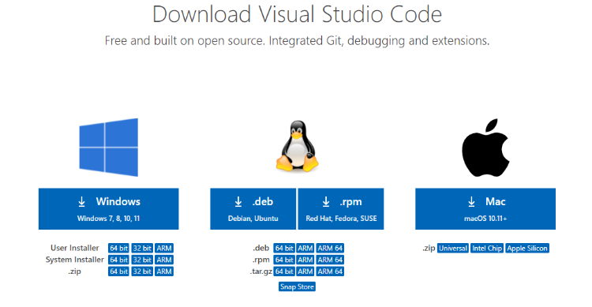

STEP-3:
- Open File Explorer.
- Go to the Downloads folder.
- Find the file named similar to VSCodeUserSetup-x64.exe.

STEP-4:
- Double-click on the downloaded setup file.
- If a security prompt appears, click Yes to allow installation.
- The VS Code setup wizard will open.

STEP-5:
- Read the license terms shown on the screen.
- Select I accept the agreement.
- Click Next to continue.
- 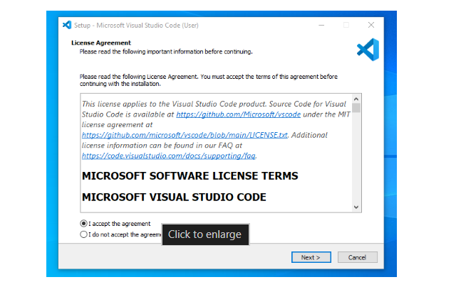
STEP-6:
- Choose the default installation folder.
- Click NEXT without changing the path.

STEP-7:
- Tick the following options for better usage:
Add to PATH
Create desktop icon
Register Code as an editor for supported file types
- Click Next.
- 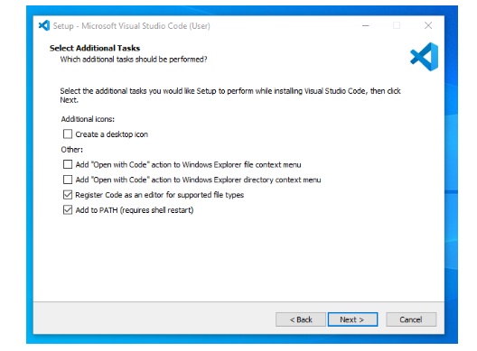

STEP-8:
- Click the Install button.
- Wait for the installation process to complete.
- This may take a few seconds.
- 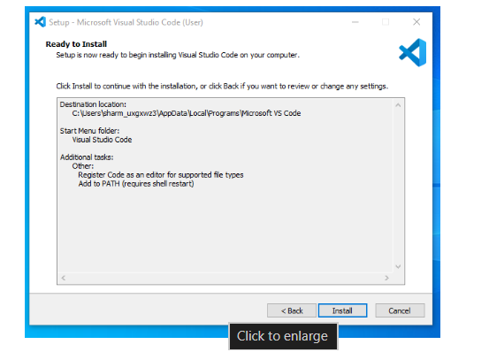

STEP-9:
- After installation, tick Launch Visual Studio Code.
- Click Finish.
- VS Code will open successfully.

1b. To learn the basic structure of an HTML document and create a simple webpage using headings and paragraphs.
AIM: STRUCTURE OF HTML
CODE:

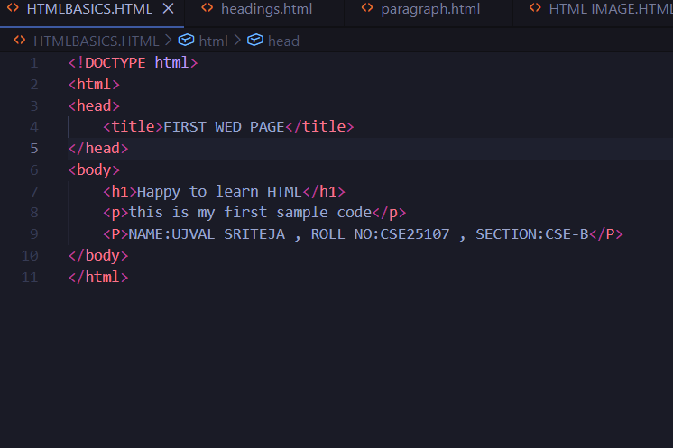
  - Above picture refers the basic structure of html
EXPLANATION:
- DOCTYPE HTML:

- DOCTYPE HTML in above code tells that document is written in HTML.
- This line is always written at the top.
2.<HTML>:
- This is the root element of the HTML page.
- The code for preparing a webpage is written in between the opening and closing tags of HTML.
3.<HEAD>:
- IT is used to title the webpage which appears at the place of new tab instead of new tab.

4.<BODY>:
- ALL code of the main body of WEBPAGE is written in between body tags.
- <h1> and <p> tags are used for HEADING AND PARAGRAPH and many other tags are used in between body tags

OUTPUT:

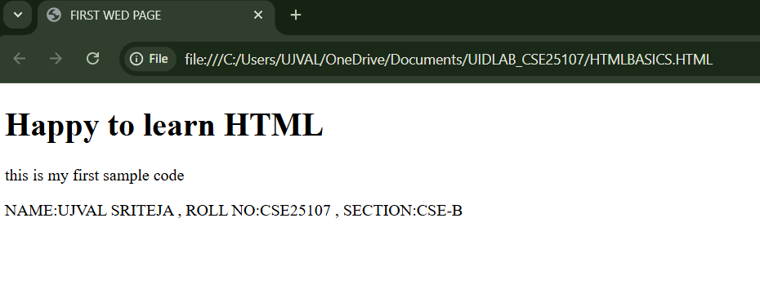

1c. BASIC TAGS OF HTML:
AIM: USING THE BASIC HTML TAGS
CODE:
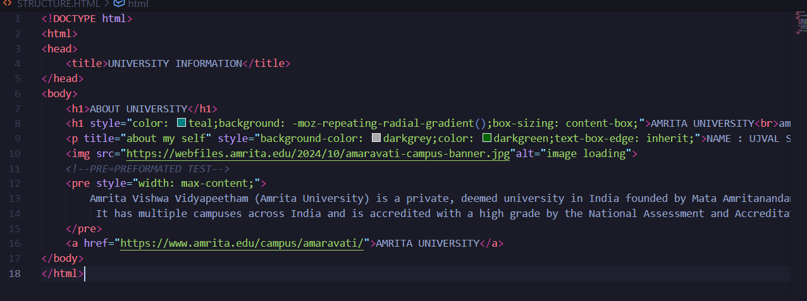
EXPLANATION:

THE TAGS USED ABOVE ARE:
- <title> </title>
- <h1></h1>
- <p></p>
- <img>
- <a></a>
- <pre></pre>
- <br>

<title>:
- It is a tag used in between the tags of head.
- It is used to customize the name of the web page in place of new tab.
- It has closing tag </title>

<h1>:
- H in the tag refers to heading.
- There are six levels oh headings which we can use in creating the web pages.
- They are <h1> , <h2> , <h3> , <h4> , <h5> , <h6>
- They used to change the level of heading in web pages]
- It has closing tag </h1>.

<p>:
- p- in the tag refers to the paragraph.
- <p> tag is used to create a paragraph in website.
- It has a closing tag</p>.
- It doesn’t care about the gaps and give the direct paragraphs without any break.

<image>:
- Image tag is used to add a image to our creating website.
- In this tag we have alt and it is used for alternate text if any problem in loading the image.
- This tag doesn’t have closing tag.

<a>:
- a tag is used to add a links in this our website.
- It contains href which is a part to add link and we can give a name that refers link as shown in above code.
- It has closing tag</a>.

<pre>:
- Pre tag is used to add the lines of paragraph separately as shown in above code.
- Pre refers to PREFORMATED TEXT.
- It has closing tag </pre>.

<br>:
- Br tag is used to break the continuous flow of sentence while using <p> tag.
- It will break the paragraph.
- It doesn’t have closing tag.

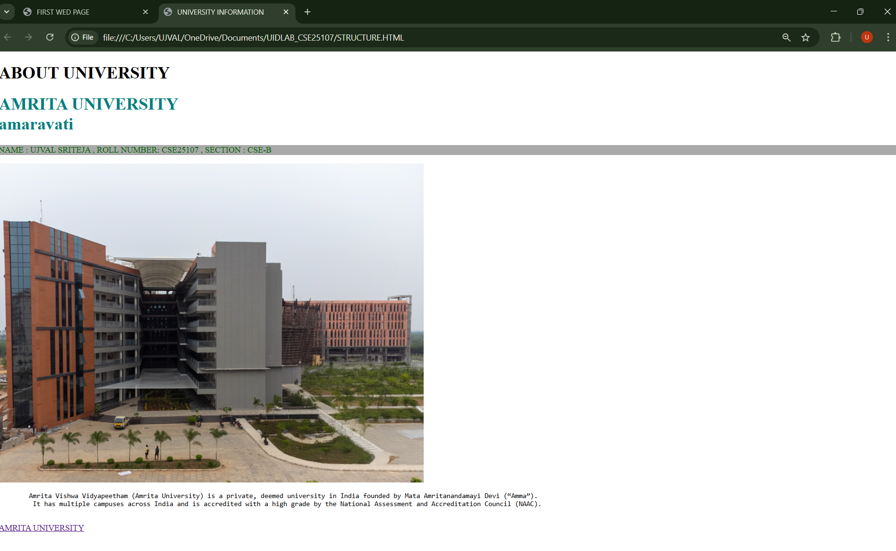
OUTPUT:

WEEK 2:

2A. To design a simple web page using HTML that demonstrates the use of
background colour background image, heading styling, and preformatted text.

Aim: To design a simple web page using HTML that demonstrates the use of
background colour background image, heading styling, and preformatted text.

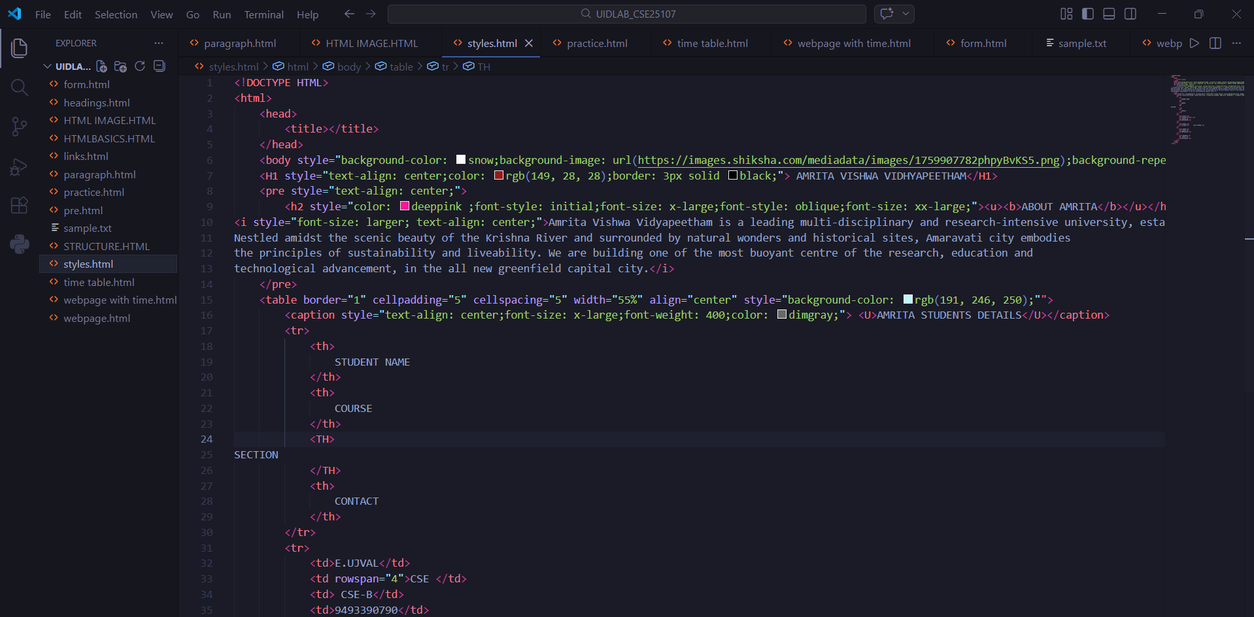
PROGRAM:

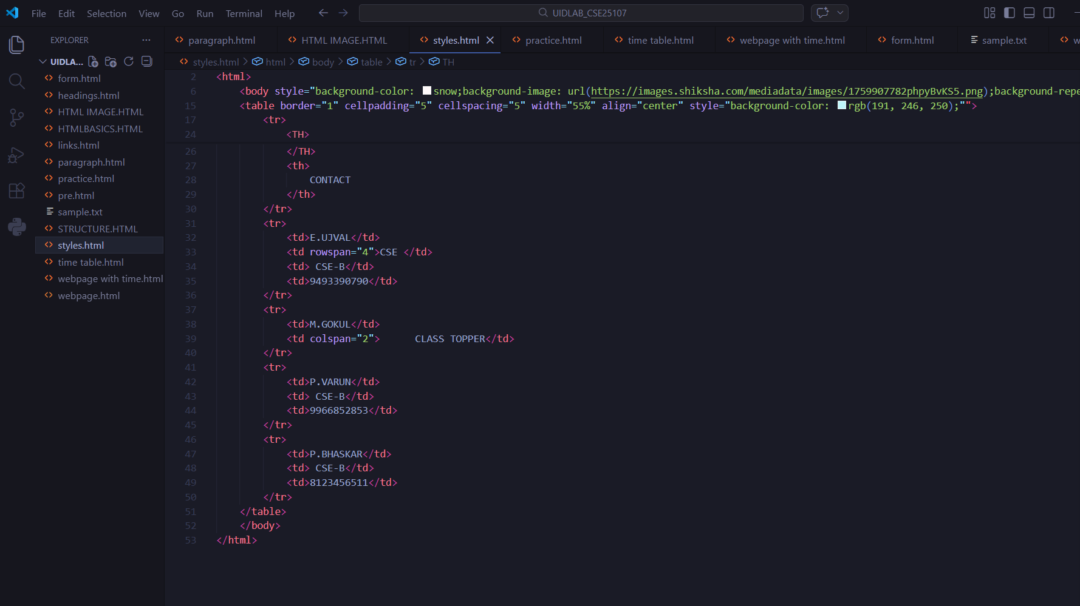

- style attribute – Used to apply CSS styles directly to an element to control colour, alignment, background, font size, spacing, borders, and layout.
- Style tag is to design the created web page
- There are many attributes in style tag which is used to design the web page

OUTPUT:

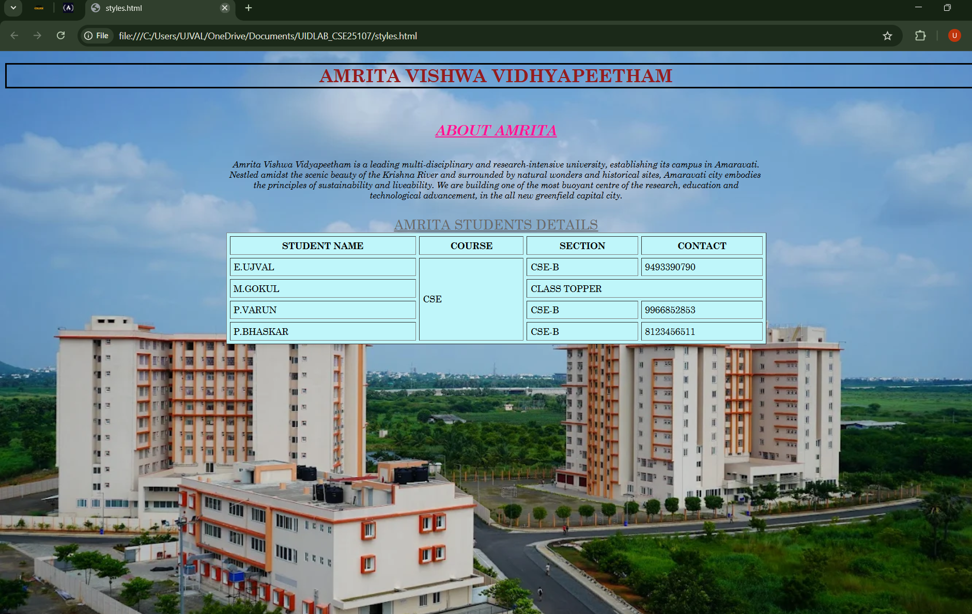

TAGS USED:
- <u> – Underlines the enclosed text to give it visual emphasis.
- <b> – Displays text in bold without indicating extra importance.
- table – Creates a table to arrange data in rows and columns.
- tr – Defines a table row inside the table.
- td – Defines a normal table data cell used to store text, images, or other content.
- Th – Defines a table header cell. It 3
- is bold and centred by default and is used for headings.
- style attribute – Used to apply CSS styles directly to an element to control colour, alignment, background, font size, spacing, borders, and layout.
- Colour: Colour attribute in style used to decide the colour of text.
- Colspan: colspan is an attribute used to combine the colomns.
- Rowspan: rowspan is an attribute used to combine the rows.
- Background colour: background colour is an attribute is used to set the background colour of the webpage.
- Background image: background image is an attribute is used to set the background image of the webpage.
- Font style: font style is an attribute used to change the font of the text in webpage.
- Text align: text align is an attribute used to set the text at centre of the webpage.
- Cellpadding and cell spacing is used to set the borders to the table.
- Font size: font size is an attribute used to change the size of the text in webpage.

WEEK-3

3A. To design and develop an academic timetable using HTML tables
Applying row span, column span, and styling for proper structure and
presentation.
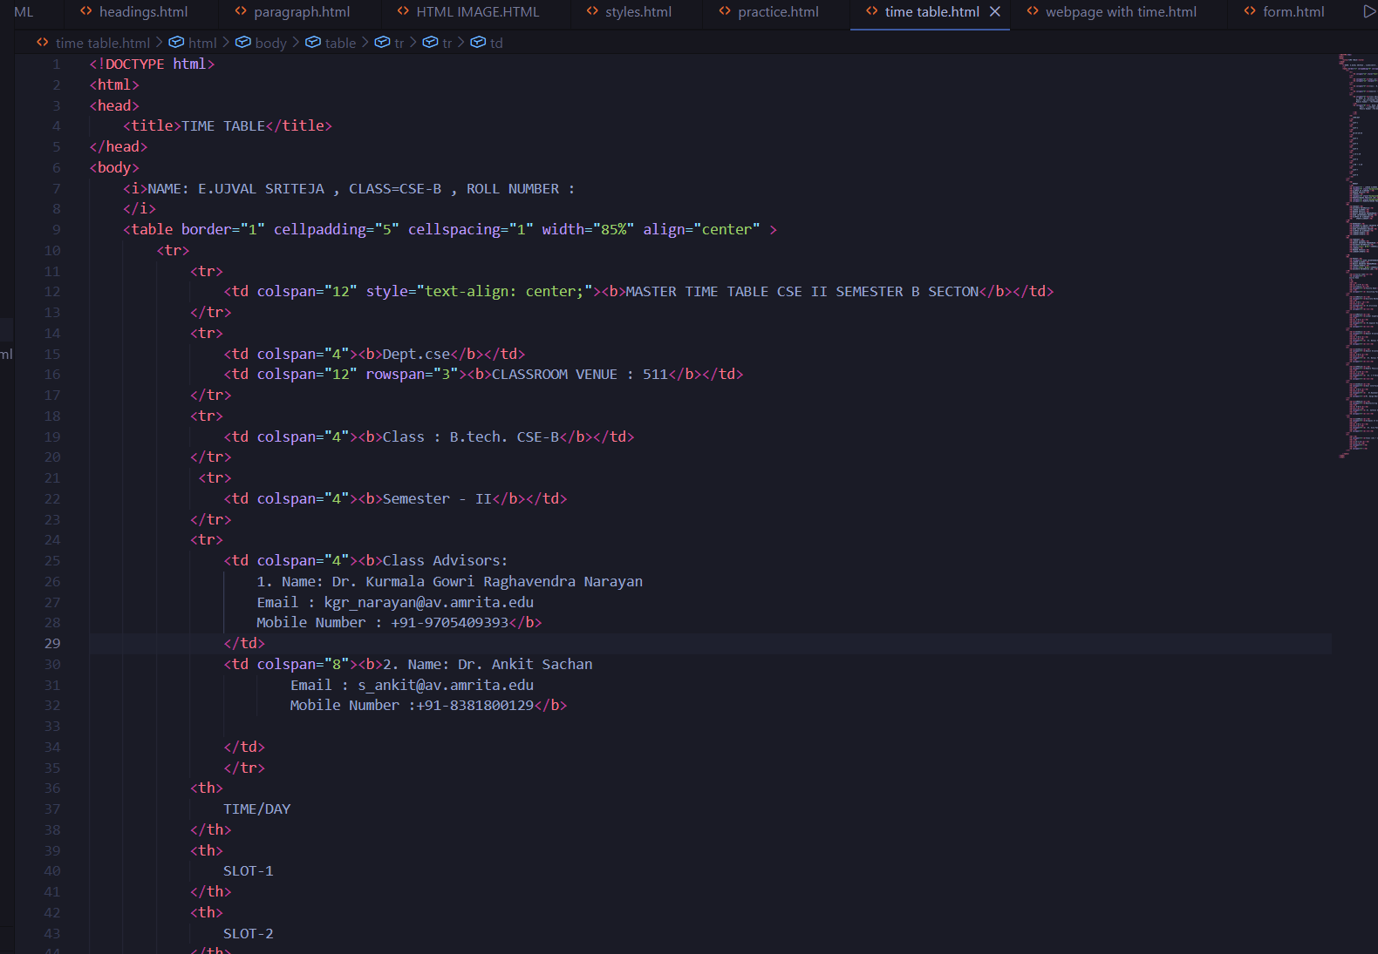
program:
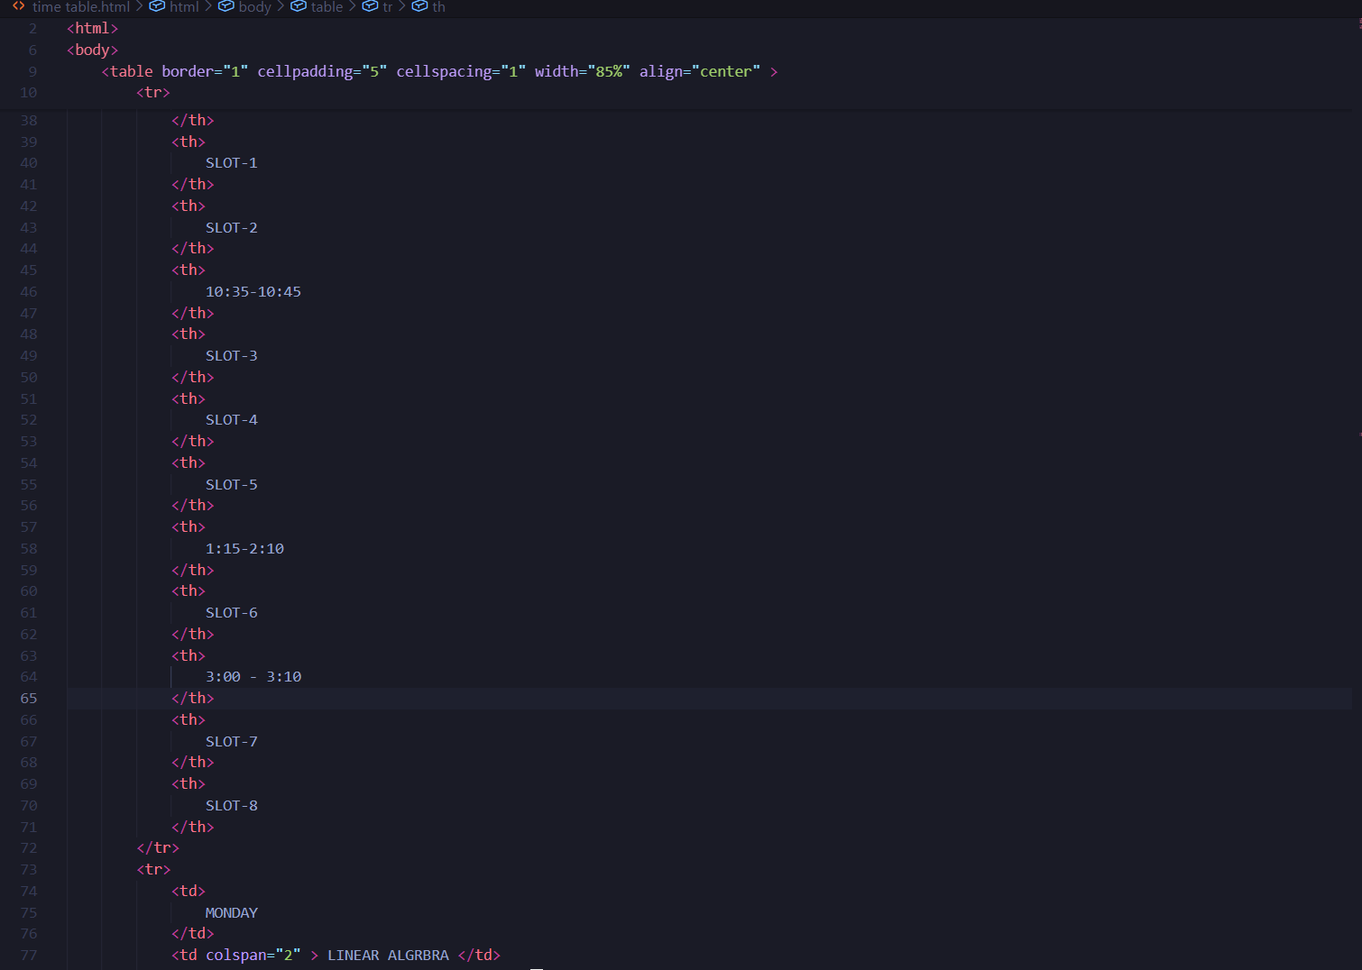
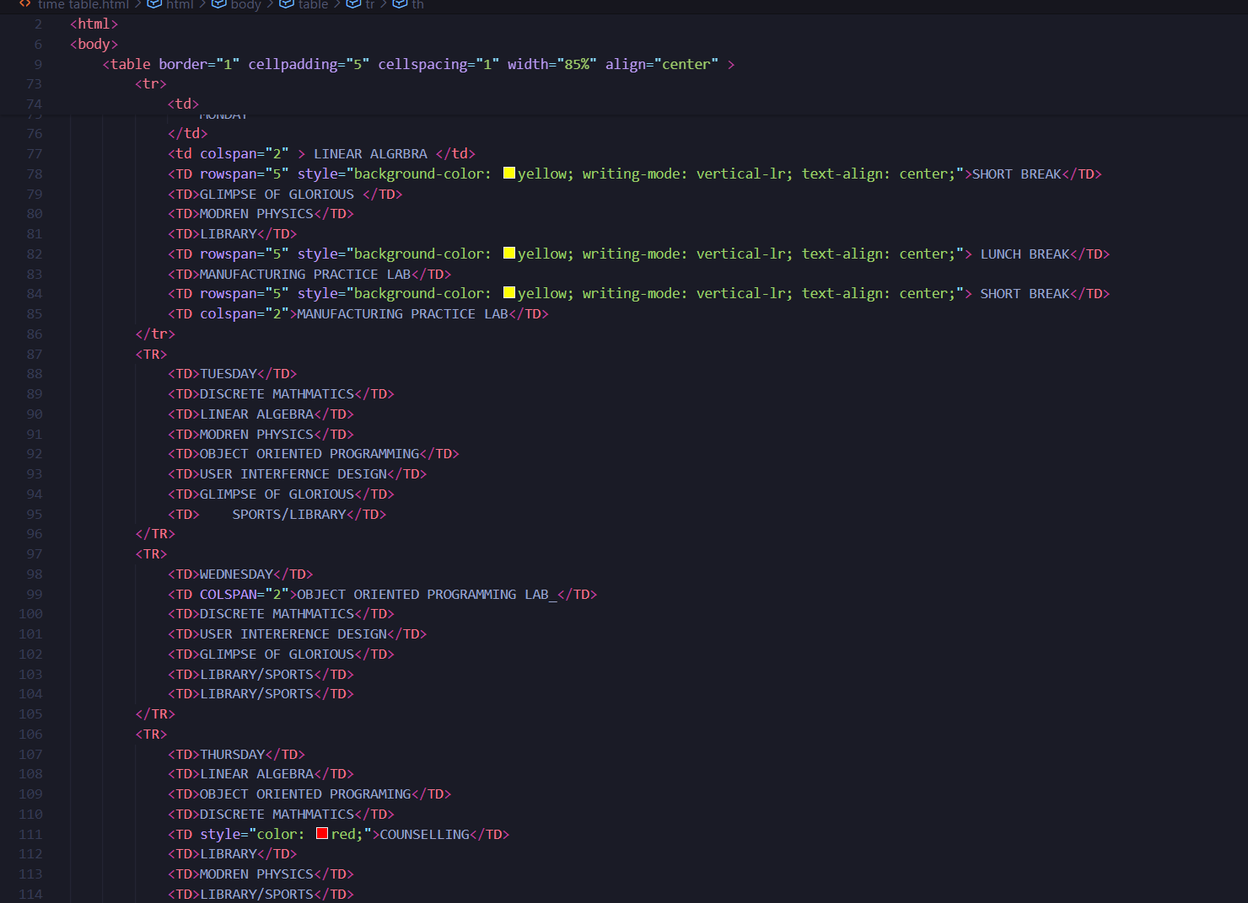
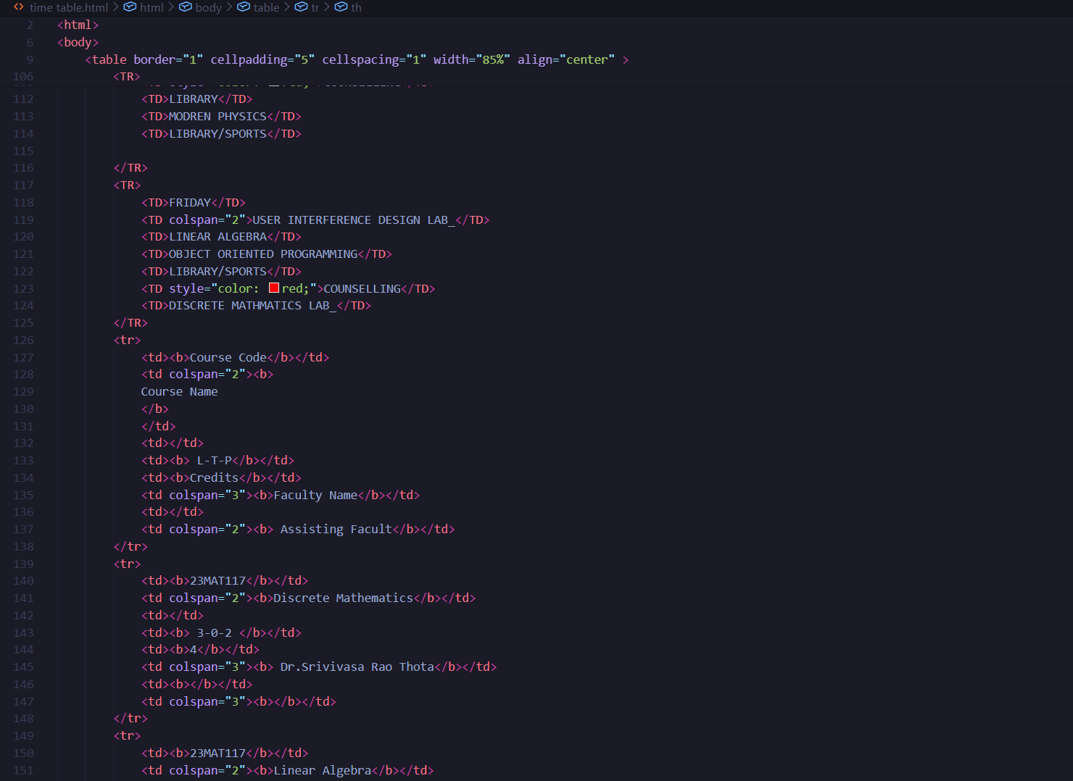

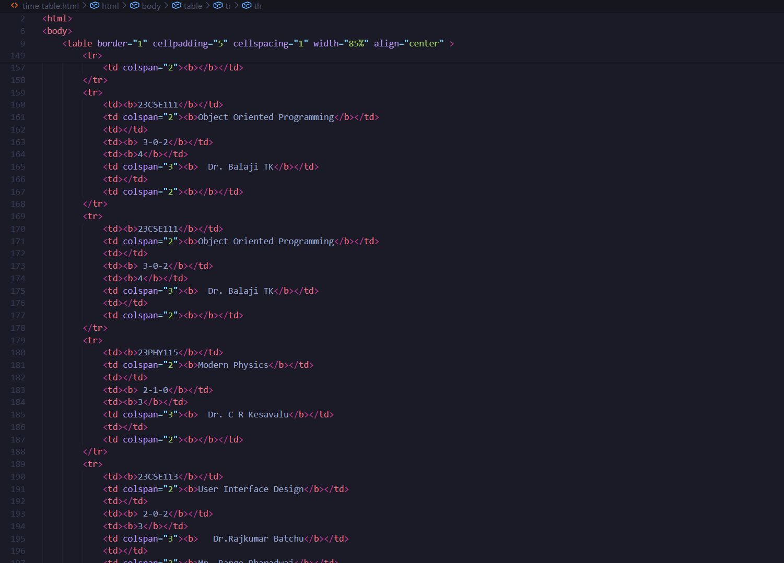
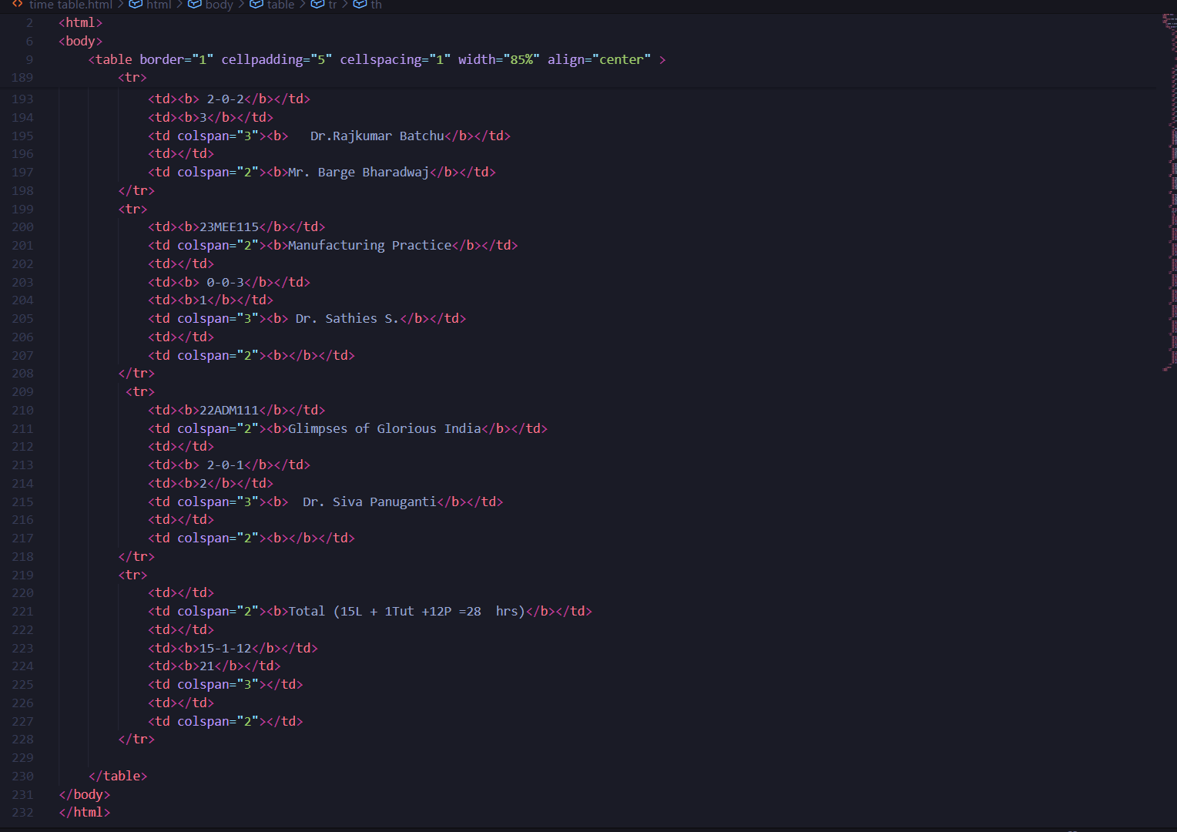

OUTPUT:

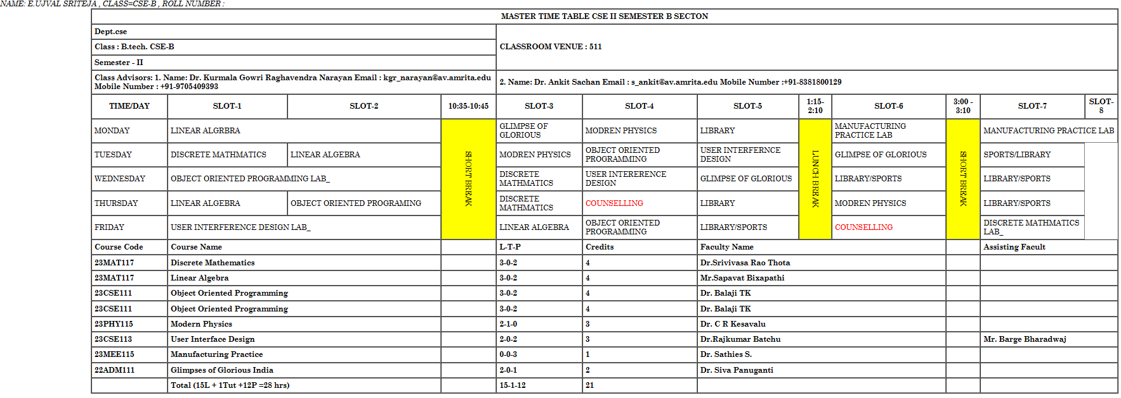

TAGS USED:
- <u> – Underlines the enclosed text to give it visual emphasis.
- <b> – Displays text in bold without indicating extra importance.
- table – Creates a table to arrange data in rows and columns.
- tr – Defines a table row inside the table.
- td – Defines a normal table data cell used to store text, images, or other content.
- Th – Defines a table header cell. It is bold and centred by default and is used for headings.
- style attribute – Used to apply CSS styles directly to an element to control colour, alignment, background, font size, spacing, borders, and layout.
- Colour: Colour attribute in style used to decide the colour of text.
- Colspan: colspan is an attribute used to combine the colomns.
- Rowspan: rowspan is an attribute used to combine the rows.
- Font style: font style is an attribute used to change the font of the text in webpage.
- Text align: text align is an attribute used to set the text at centre of the webpage.
- Cellpadding and cell spacing is used to set the borders to the table.
- Font size: font size is an attribute used to change the size of the text in webpage.

3b. To create a comprehensive webpage that includes an academic timetable along with syllabus representation using images and structured HTML elements.
Aim: To create a comprehensive webpage that includes an academic timetable along with syllabus representation using images and structured HTML elements.

Program

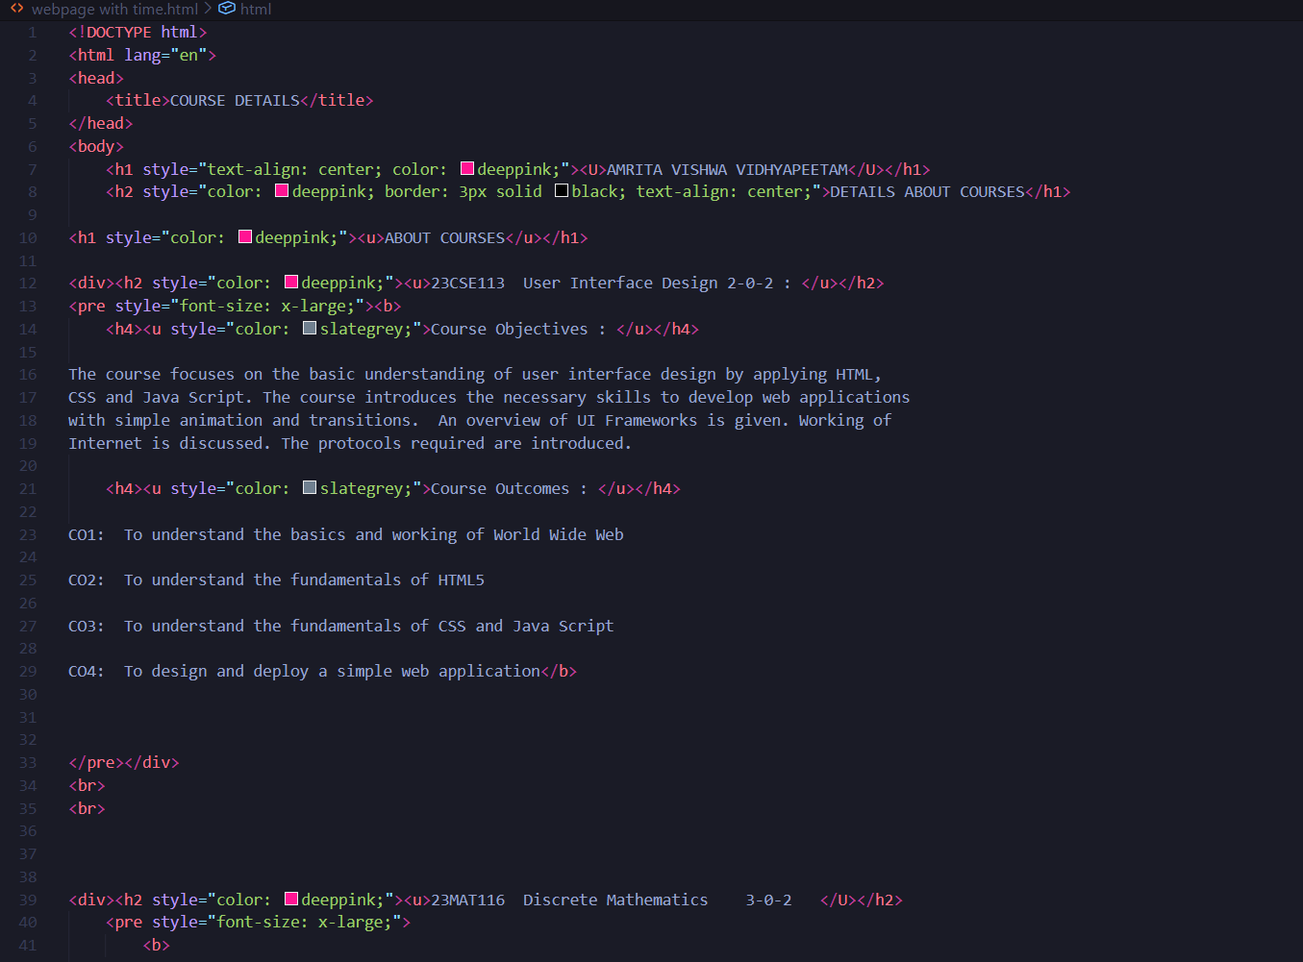

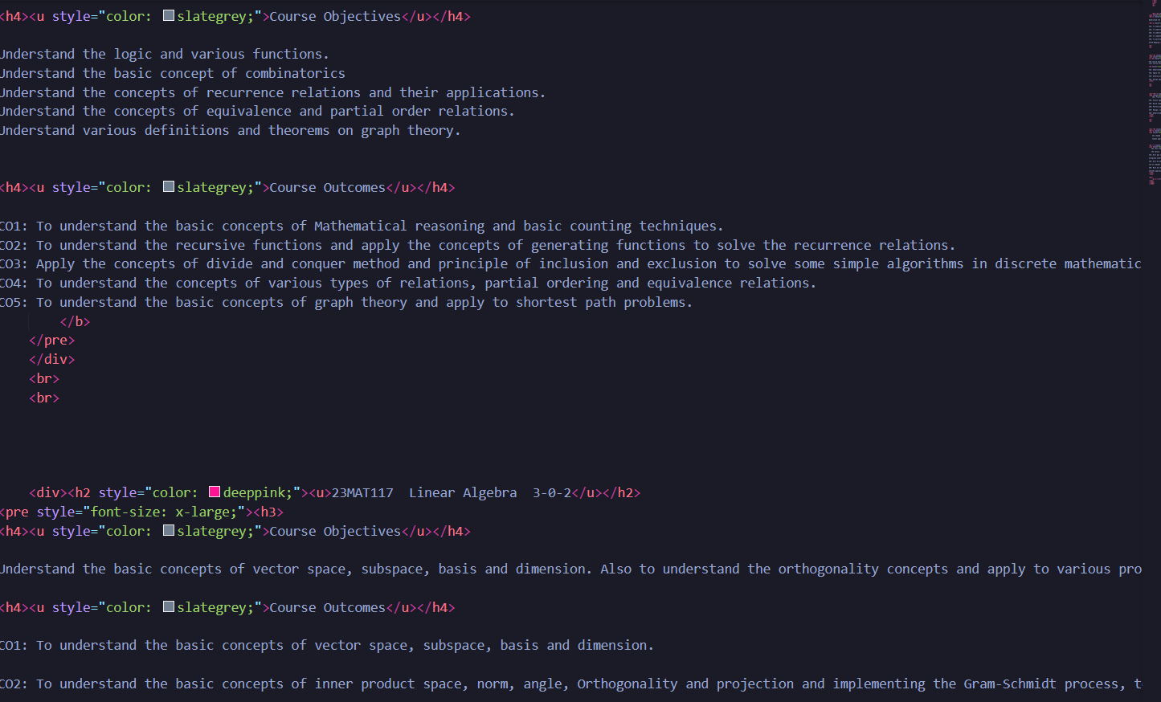

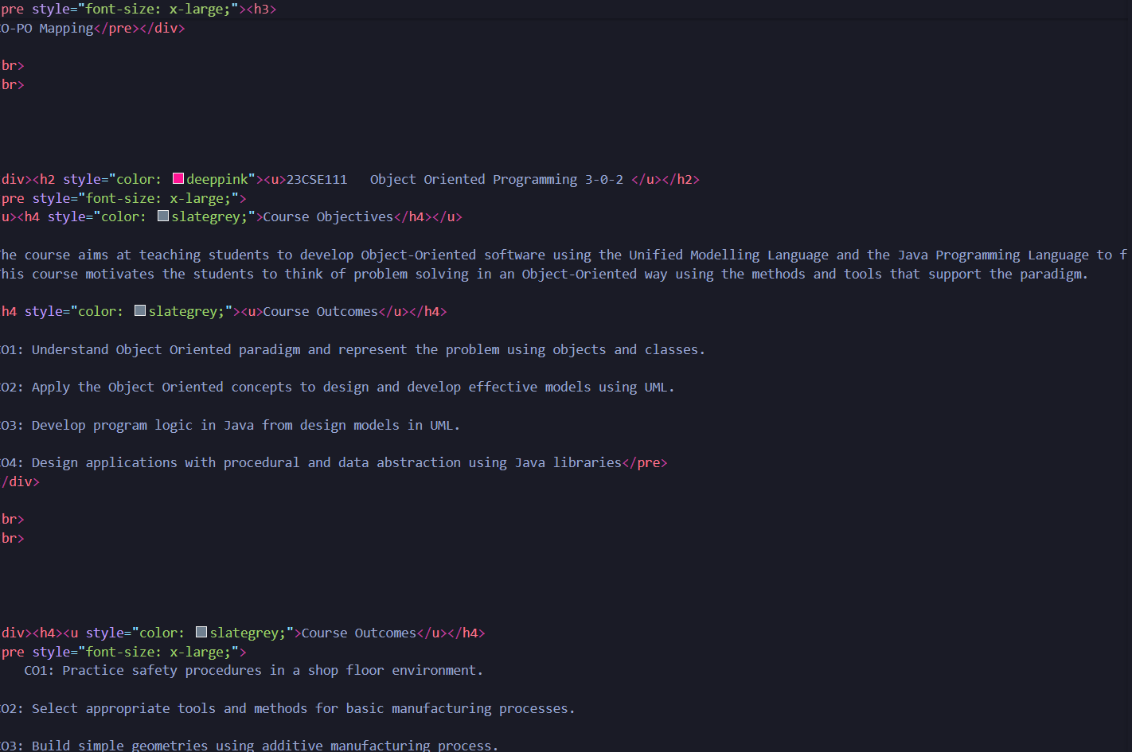

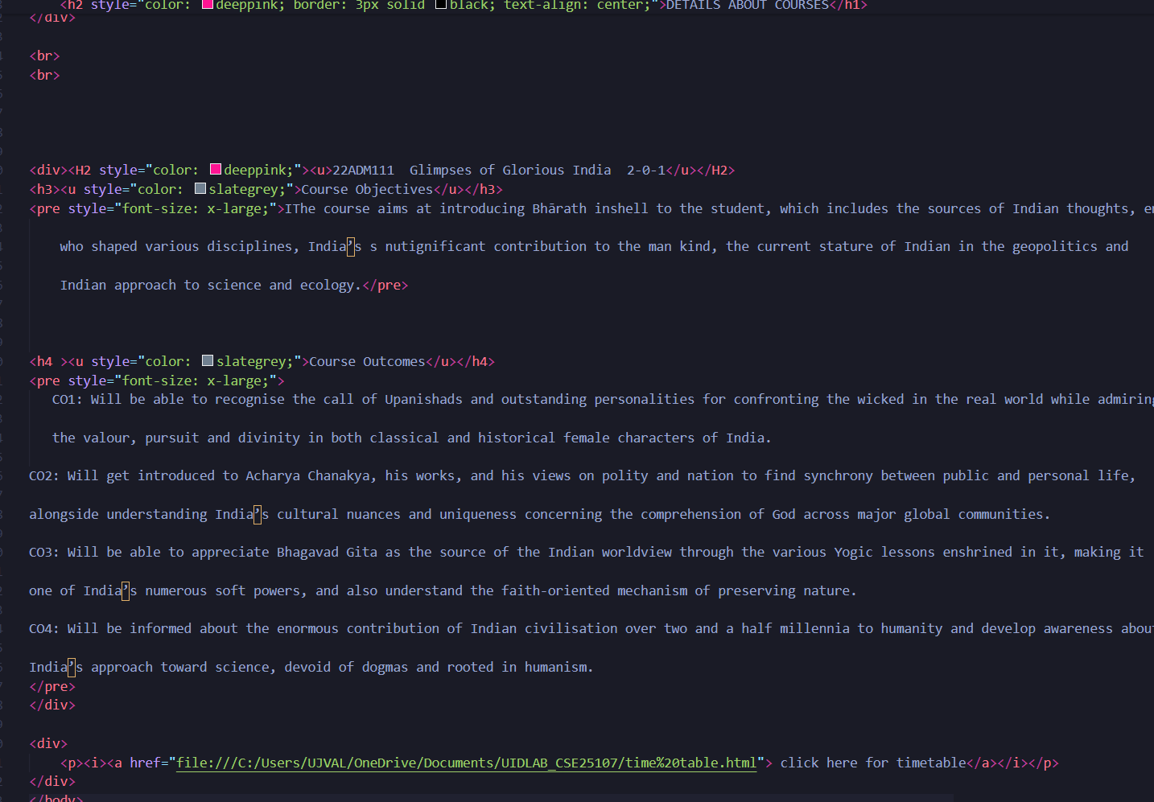

Output

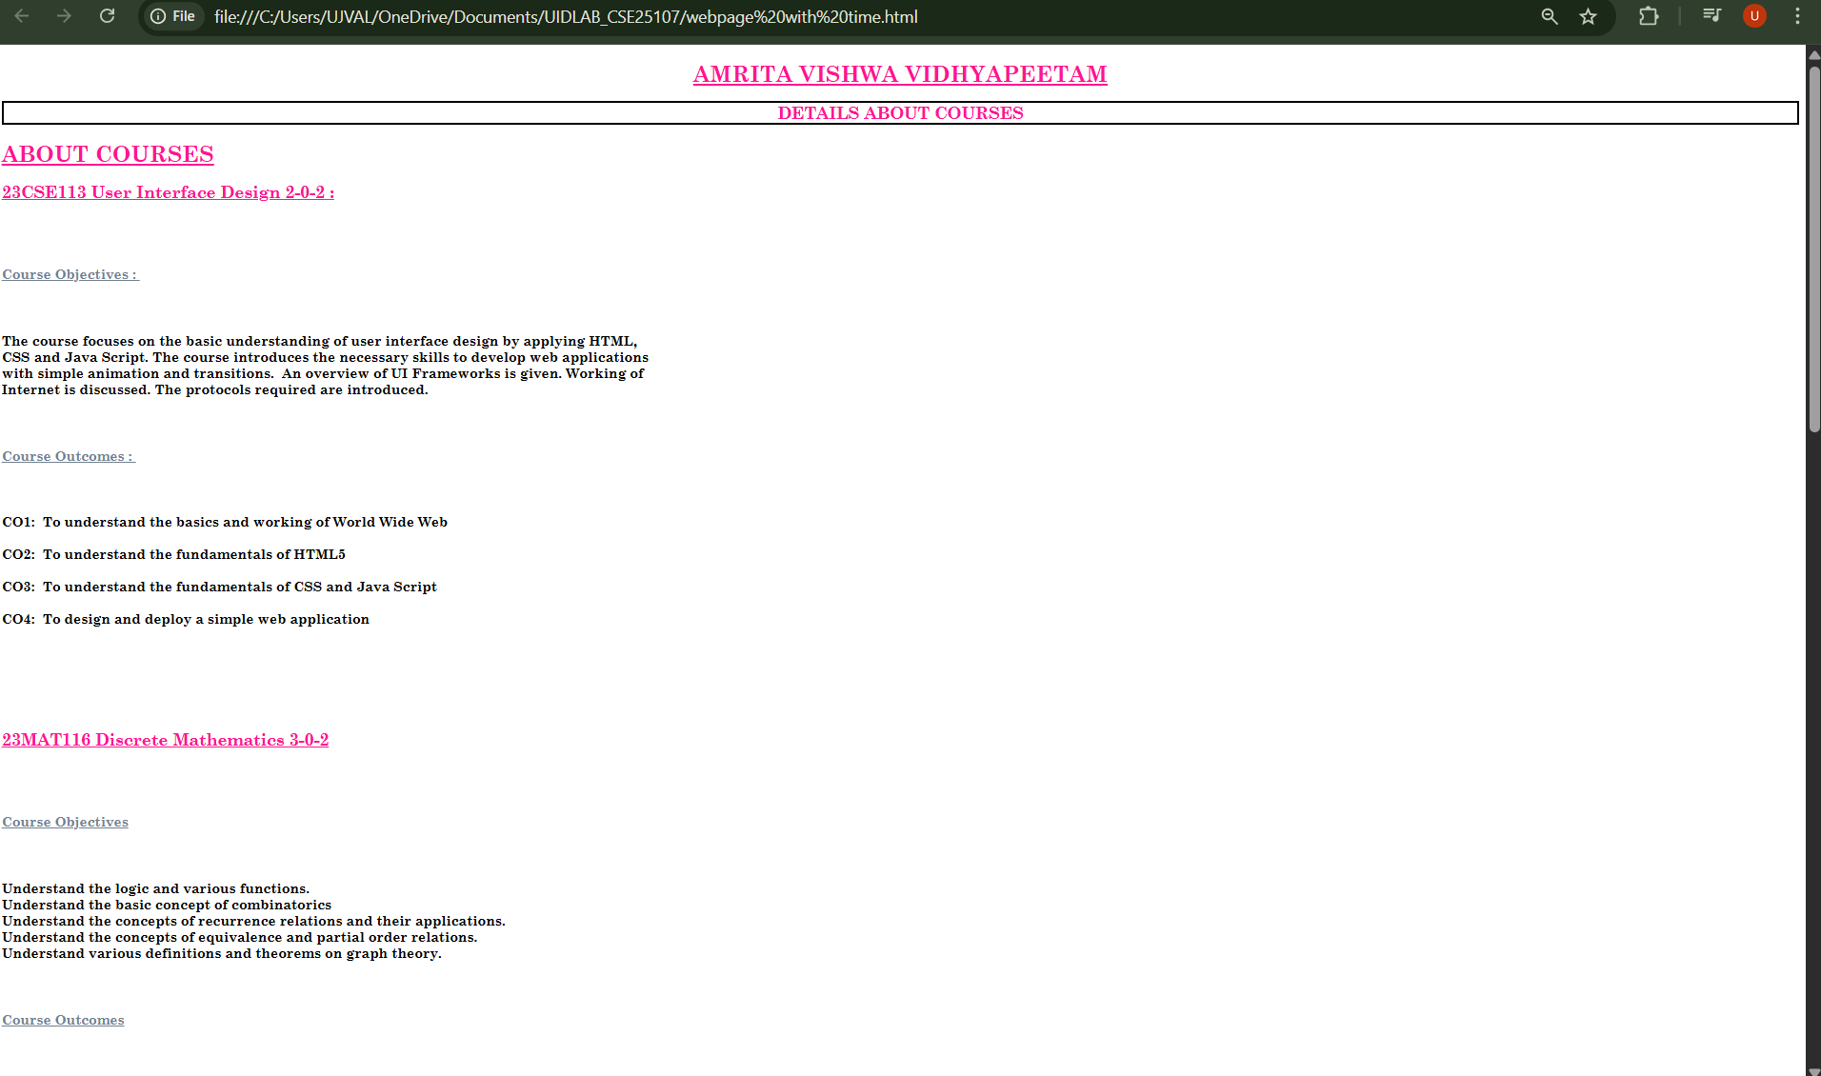
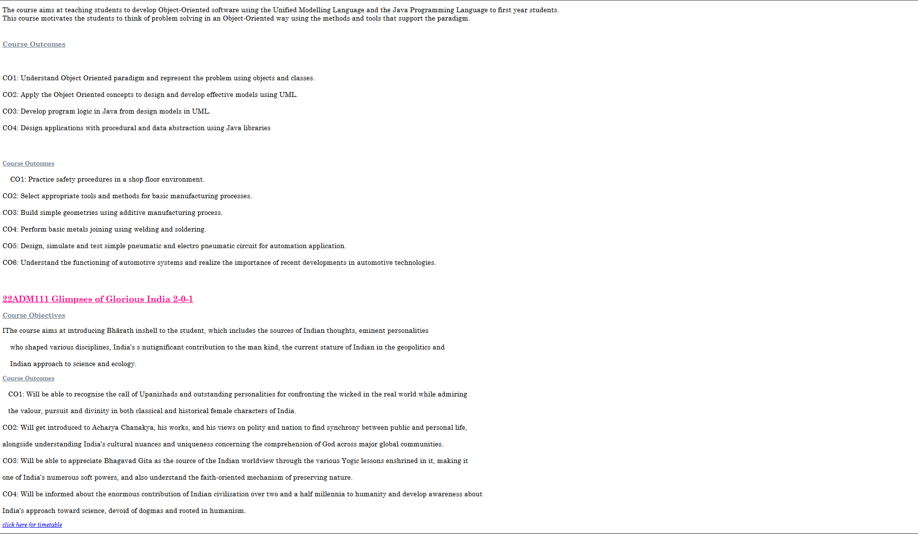

Tags used:
- <h1> to <h6>: this tag is used for headings.
- <u>: this tag is used for underline the text in webpages.
- <b>: this tag is used for bold the sentence.
- <i>: this tag is used for change the font into italic format.
- <div>: creates a section or division in webpage.
- <pre>: display the text in preformatted form.
- <br>: to break the sentence.
- <p>: for creating paragraph.
- <a>: create a link to access another webpage or site.
- style: used to decorate the webpage.

WEEK-4
4a. a collage wants to collect student details through an online admission form. Design a registration form using only html tags (no css) with papers labels, table alignments, background colour and border.

Aim: a collage wants to collect student details through an online admission form. Design a registration form using only html tags (no css) with papers labels, table alignments, background colour and border.

Program:
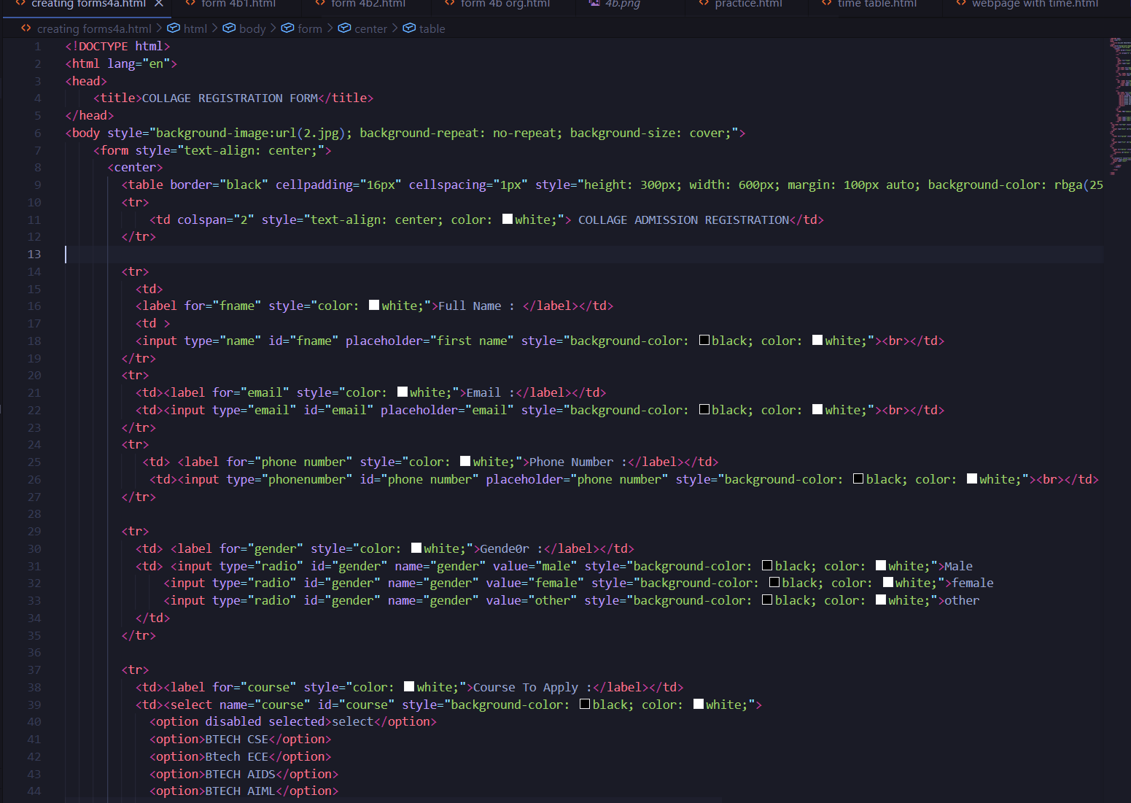

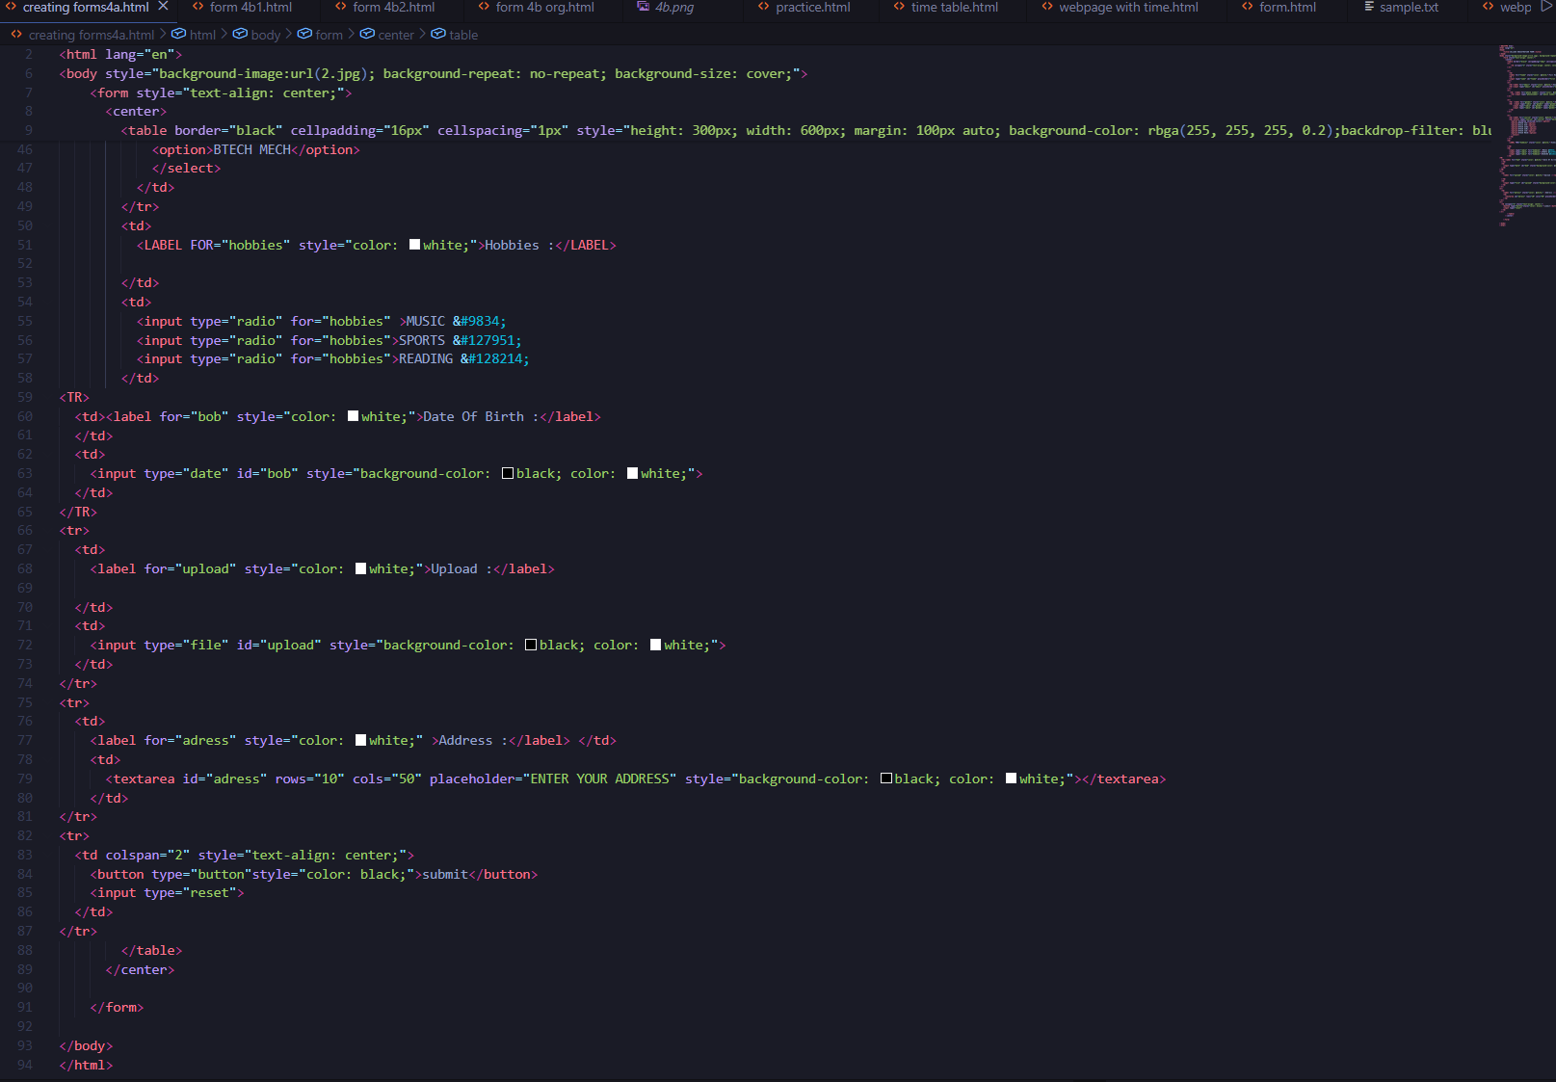

Output:
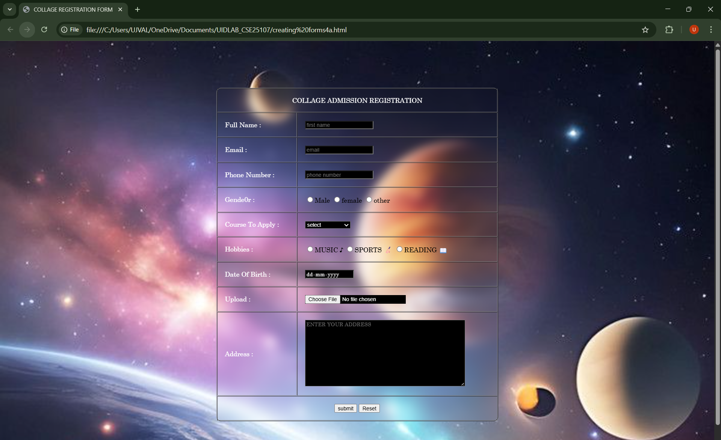

Tags used:
- <form>: this tag is used to create a form using different attributes in this form tag.
- <center>: this tag is used to shift the content or form into centre of the web page.
- <table>: this tag is used to create a table with rows and columns in our own webpages.
- <tr>: for rows in table
- <td>: for columns in table.
- <label>: provides connection with label and input field and provides the label for the input field.
- <input>: creates a field for collect the user details in webpage.
- <select>: this tag is used to create a dropdown list for user preferences.
- <option>: this tag is used to display options to user and to collect the information from the user.
- <text area>: creates a multiline field for user input.
- <button>: creates button in webpages.
- Type=”name”: attribute used for collect name from user.
- Type = “email”: attribute used for collect mail from user.
- Type= radio: attribute used for provide options for user.
- Type= date: attribute used for collect date from user.
- Type = file: attribute used for collect file from user.
- Type= reset: attribute used to create reset button in webpage.

4b. a company wants to design a webpage that displays two different forms side by side using I frames. One I frame should display a login page form and other should display a registration form.
Aim: a company wants to design a webpage that displays two different forms side by side using I frames. One I frame should display a login page form and other should display a registration form.

Program:
Login page:
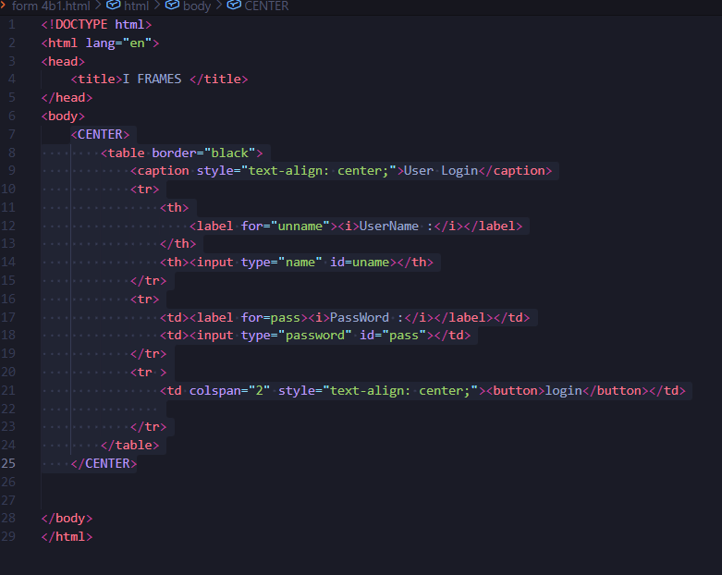

Registration page:
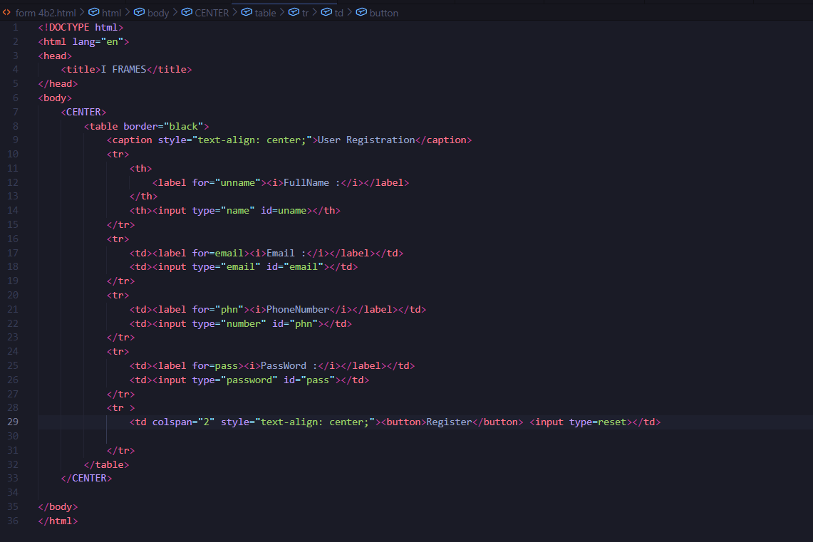

Final page:
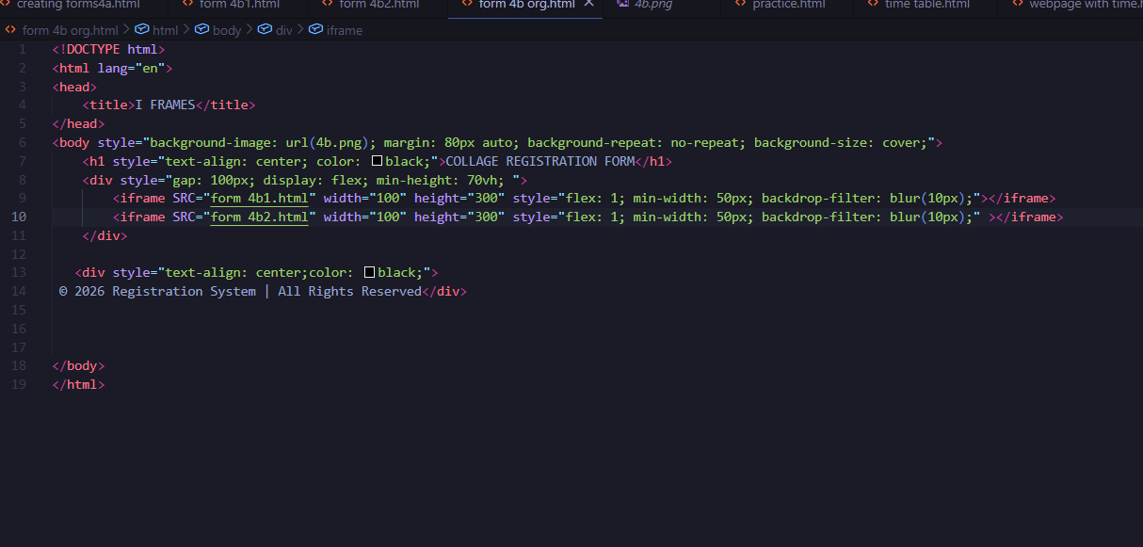

Output:
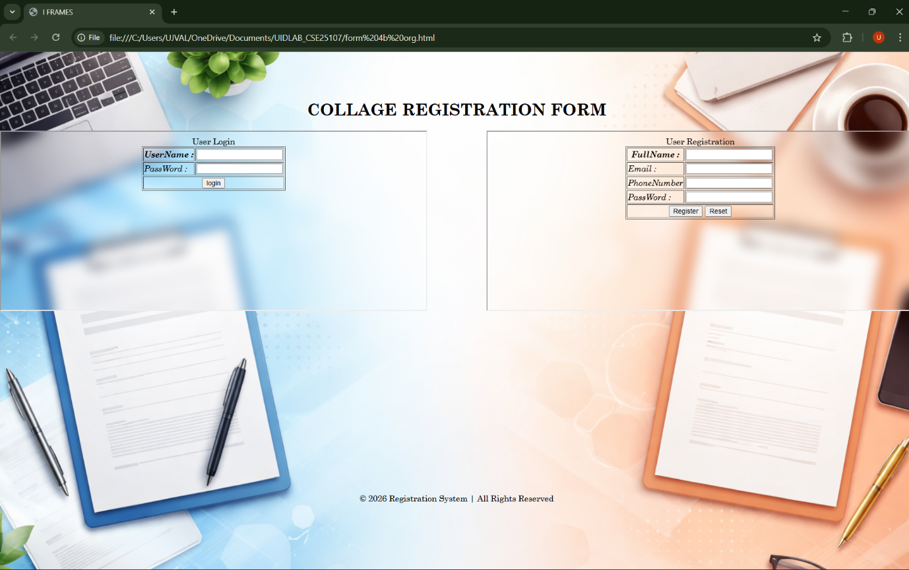

Tags used:
- <div>: this tag is used to create a section or divides specific part in webpage.
- <iframe>: this tag is used to provide separate webpages in same webpage.
- Width: this is attribute used to set the width of the iframe.
- Height: attribute used to set the height of the iframe.
- Display flex: attribute used for displaying webpages side by side.
- Back-drop filter: blur(): applies blur effect to the background.

WEEK-5
5a. To create a responsive card layout using HTML and CSS with three cards, each containing an image, title, and button.
Aim: To create a responsive card layout using HTML and CSS with three cards, each containing an image, title, and button

Program:

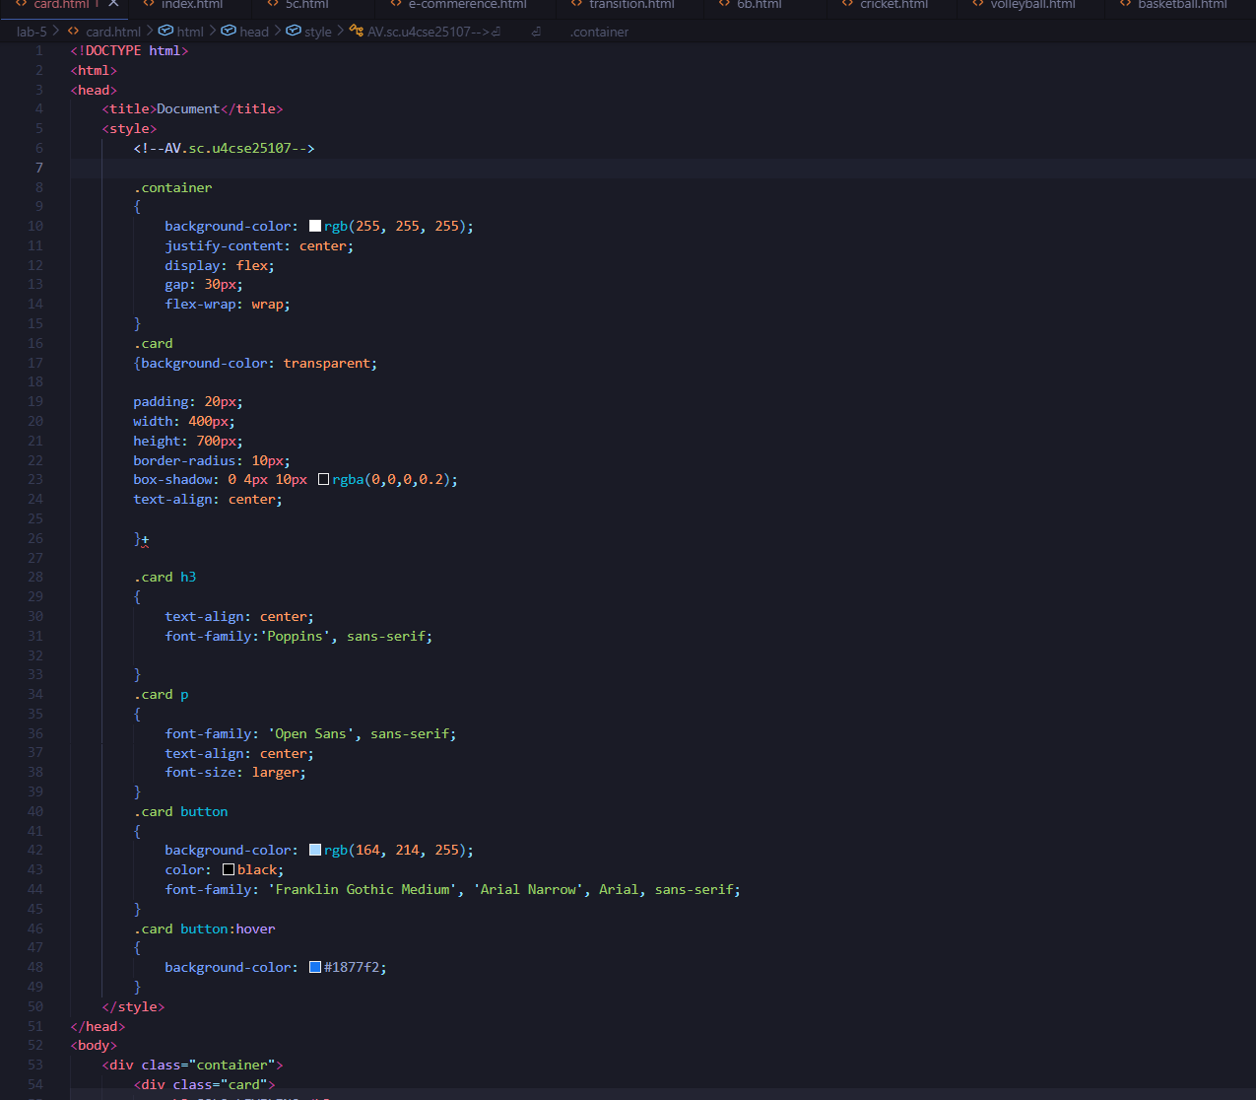

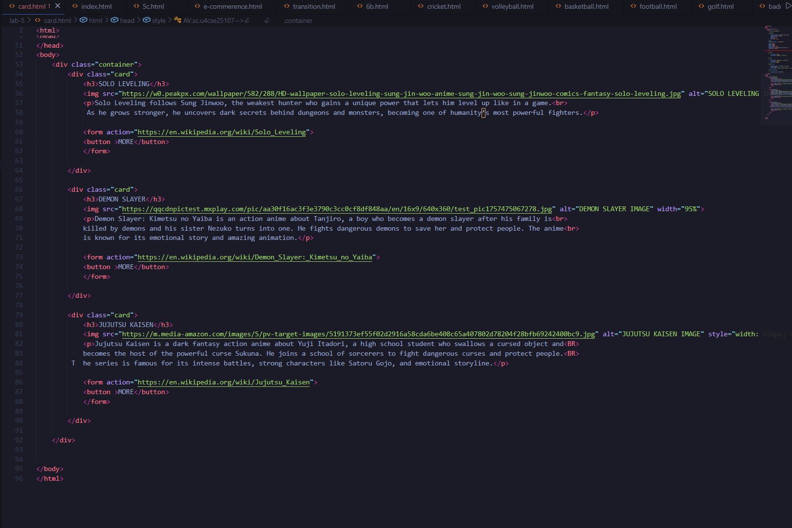

OUTPUT:

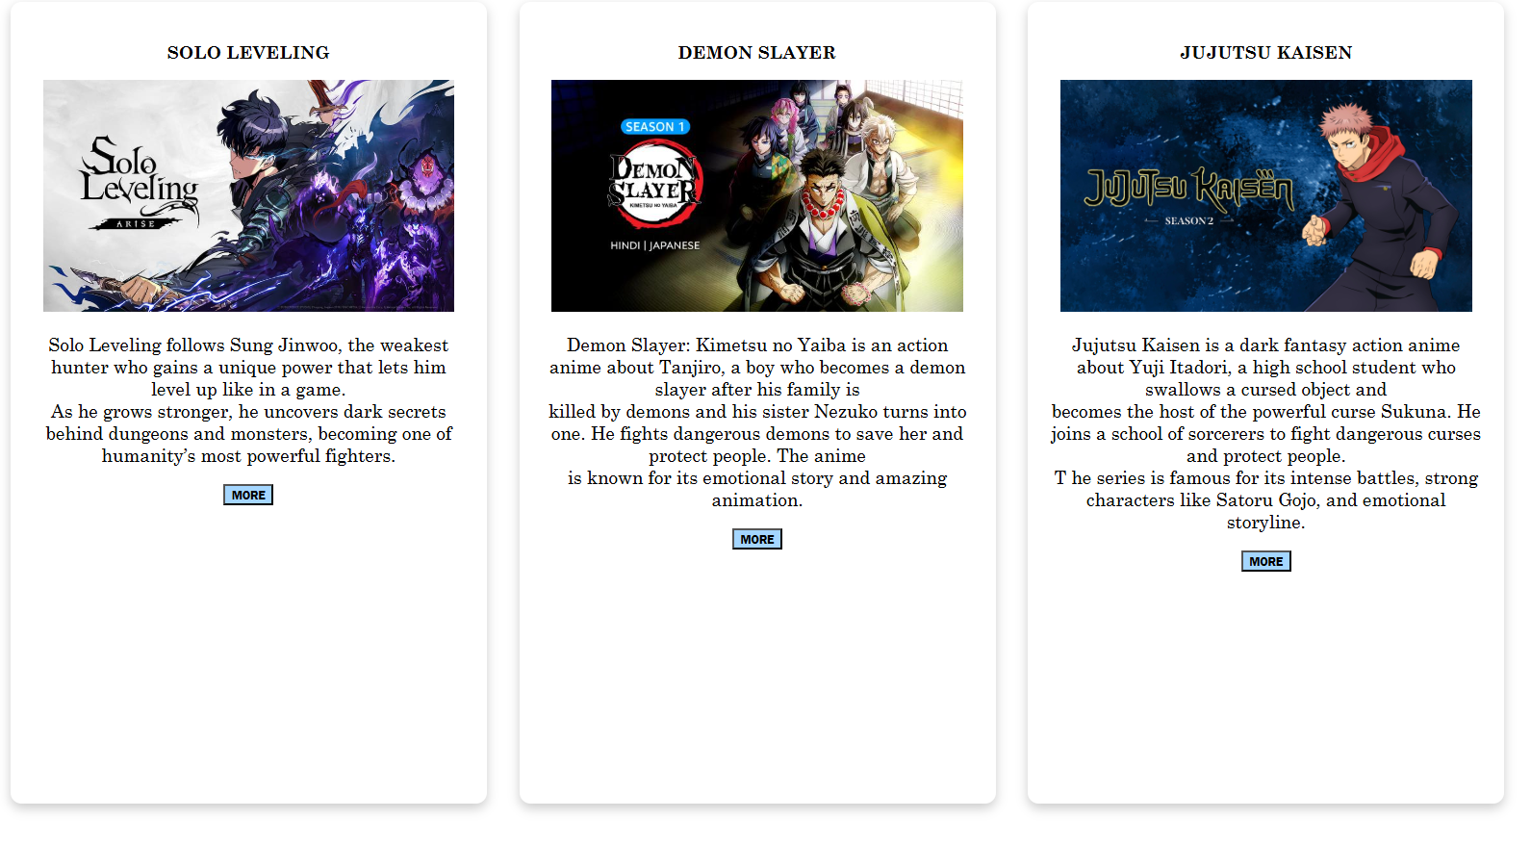

Tags Used:
- <style> – Used to add internal CSS styles to design the webpage.
- <div> – A container used to group and organize HTML elements.
- <img> – Displays an image on the webpage using the source URL.
- <br> – Inserts a line break within text.
- <form> – Creates a form used to send data or redirect to another page.
- <button> – Creates a clickable button for user interaction.
- Hover: is used to add the effect of glow to the button.

5b. To design a mini website using iframe with navigation links (Home, About, Contact), where clicking on each link displays the respective content within the same page using internal or external CSS.
Aim:
To design a mini website using iframe with navigation links (Home, About, Contact), where clicking on each link displays the respective content within the same page using internal or external CSS.
Program:
Main:
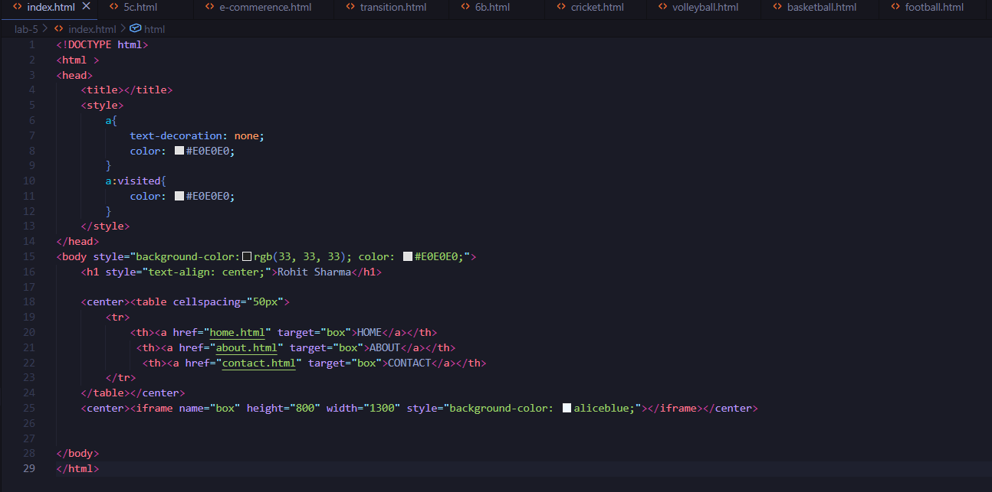
Sub webpages:
Contact:
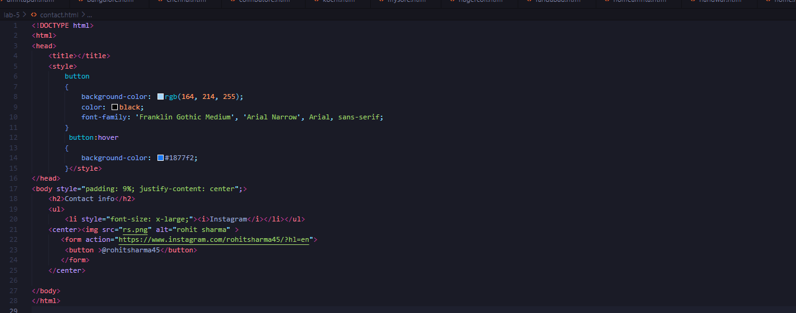
About
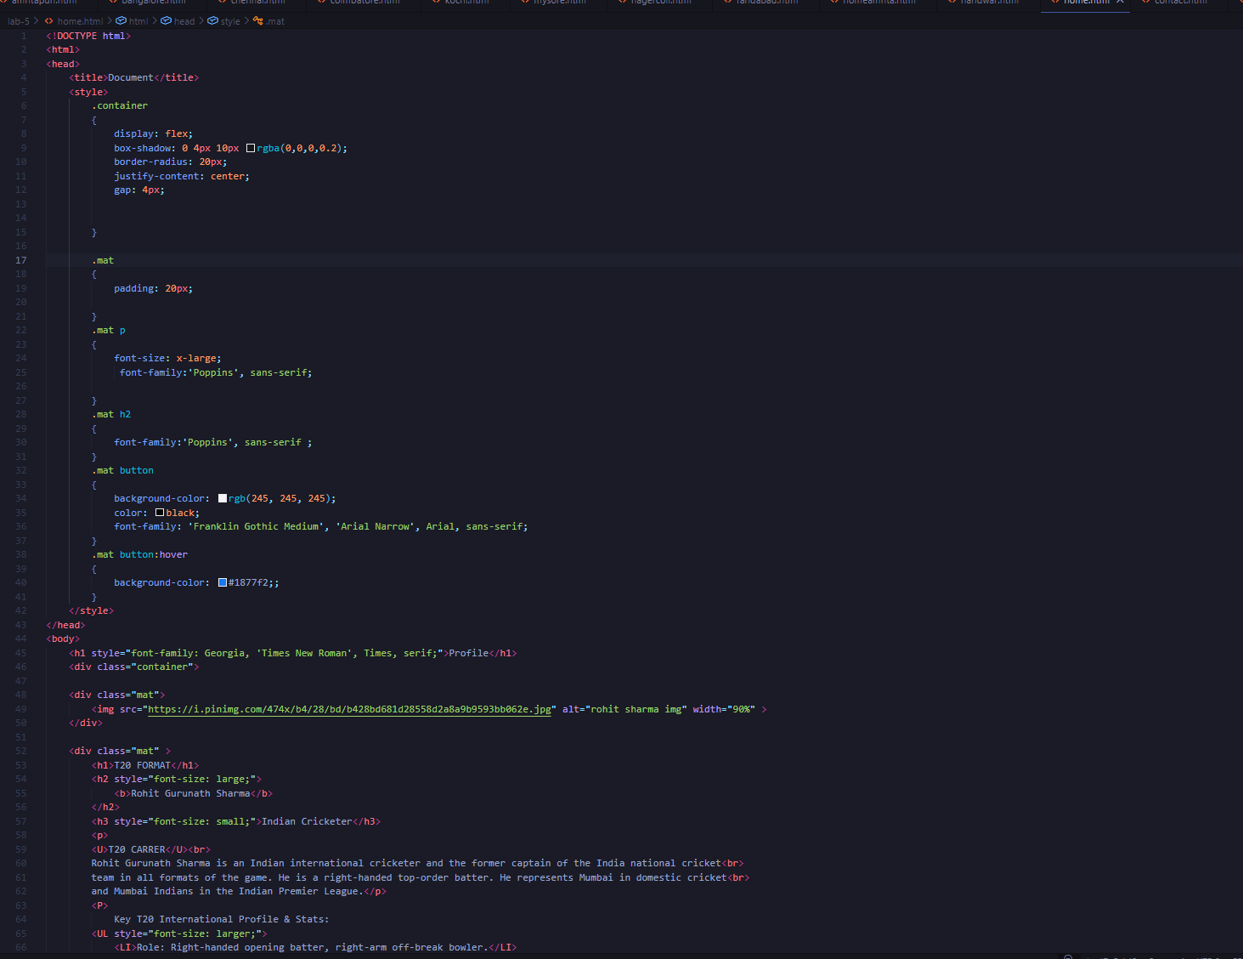Profile:
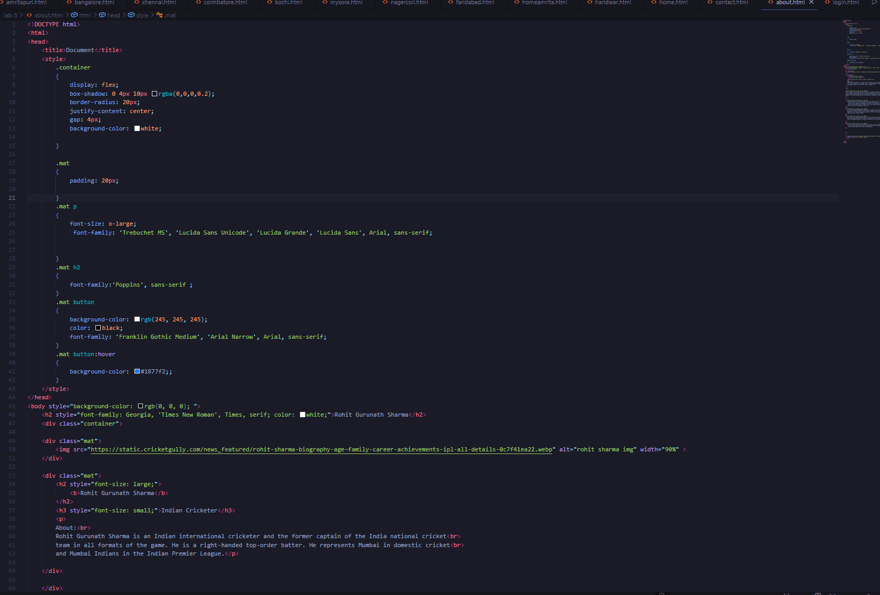
Output:
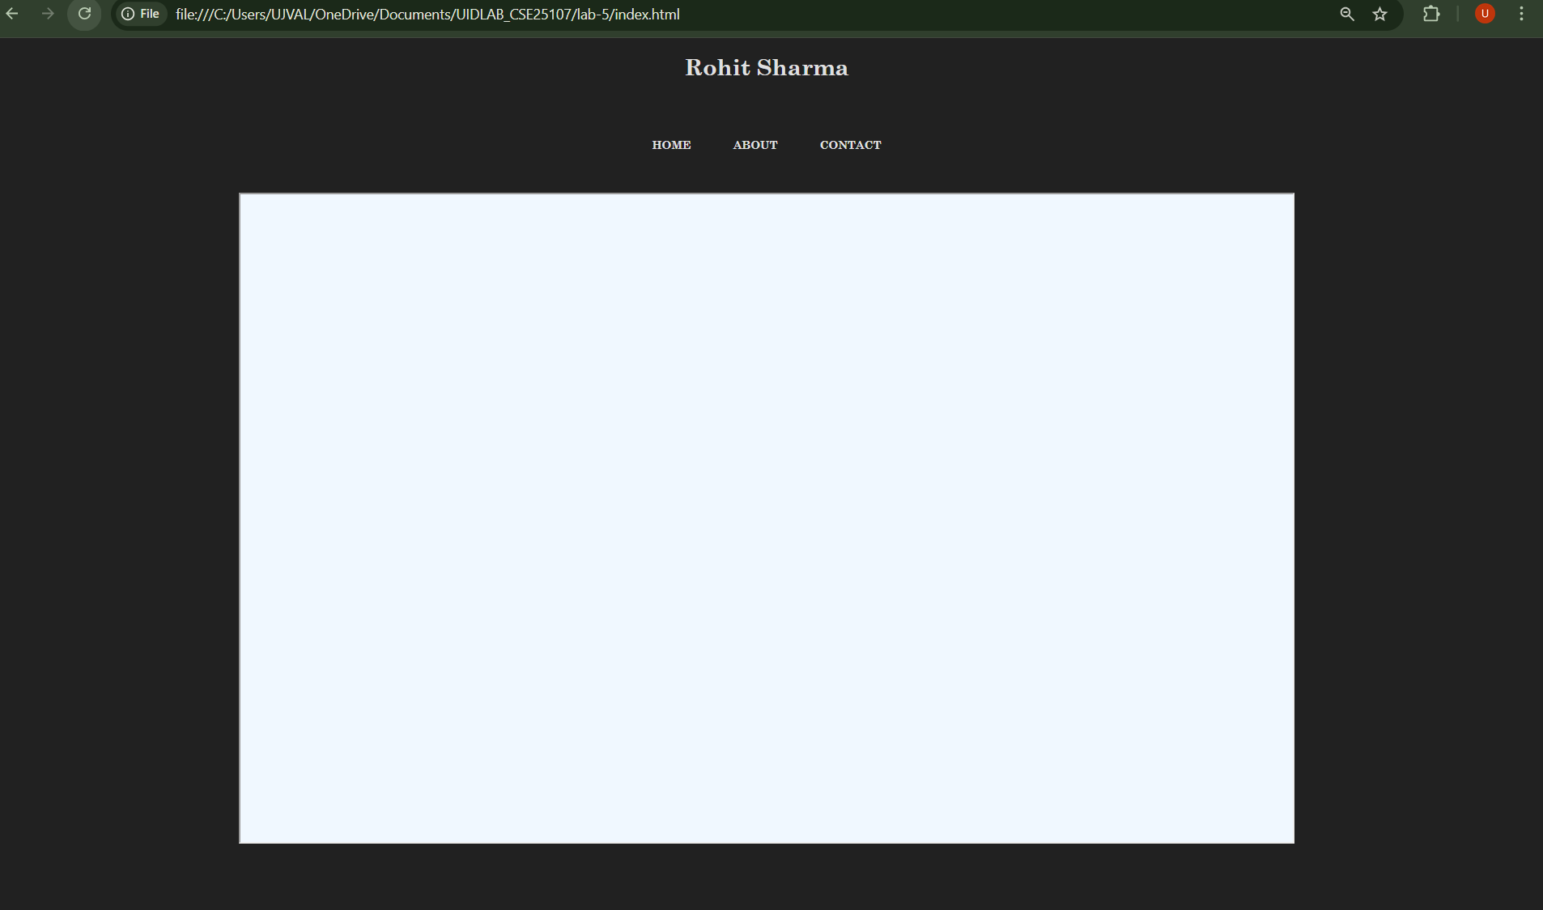

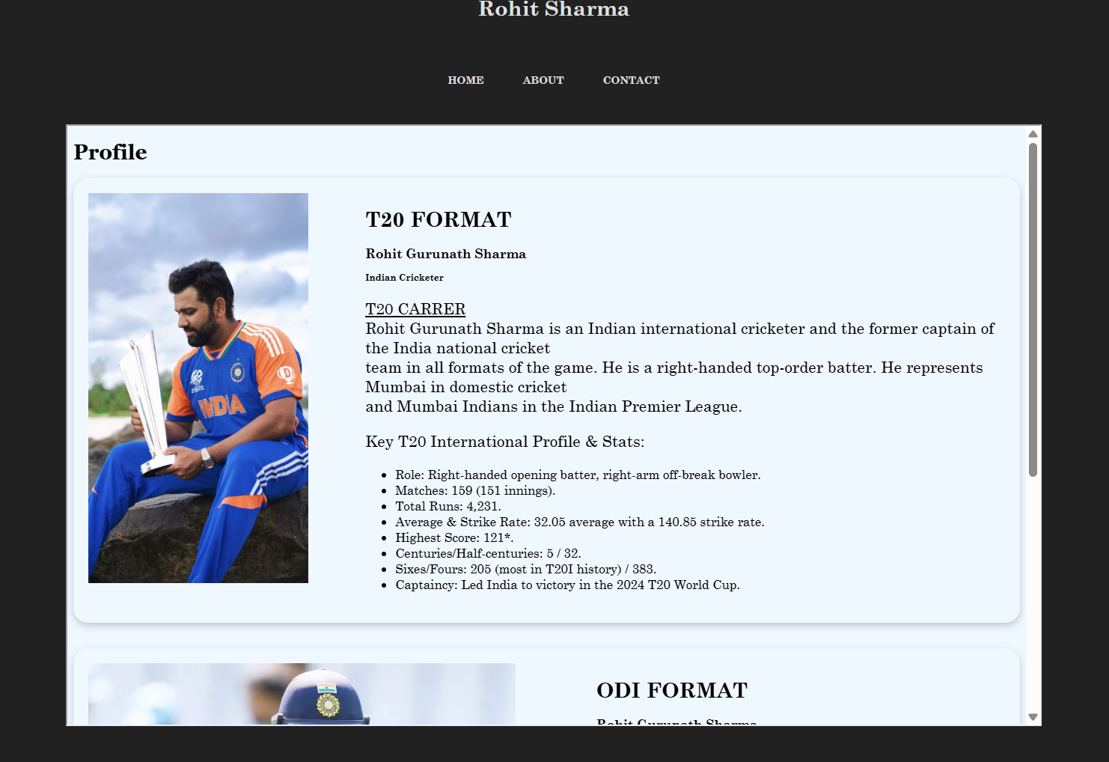

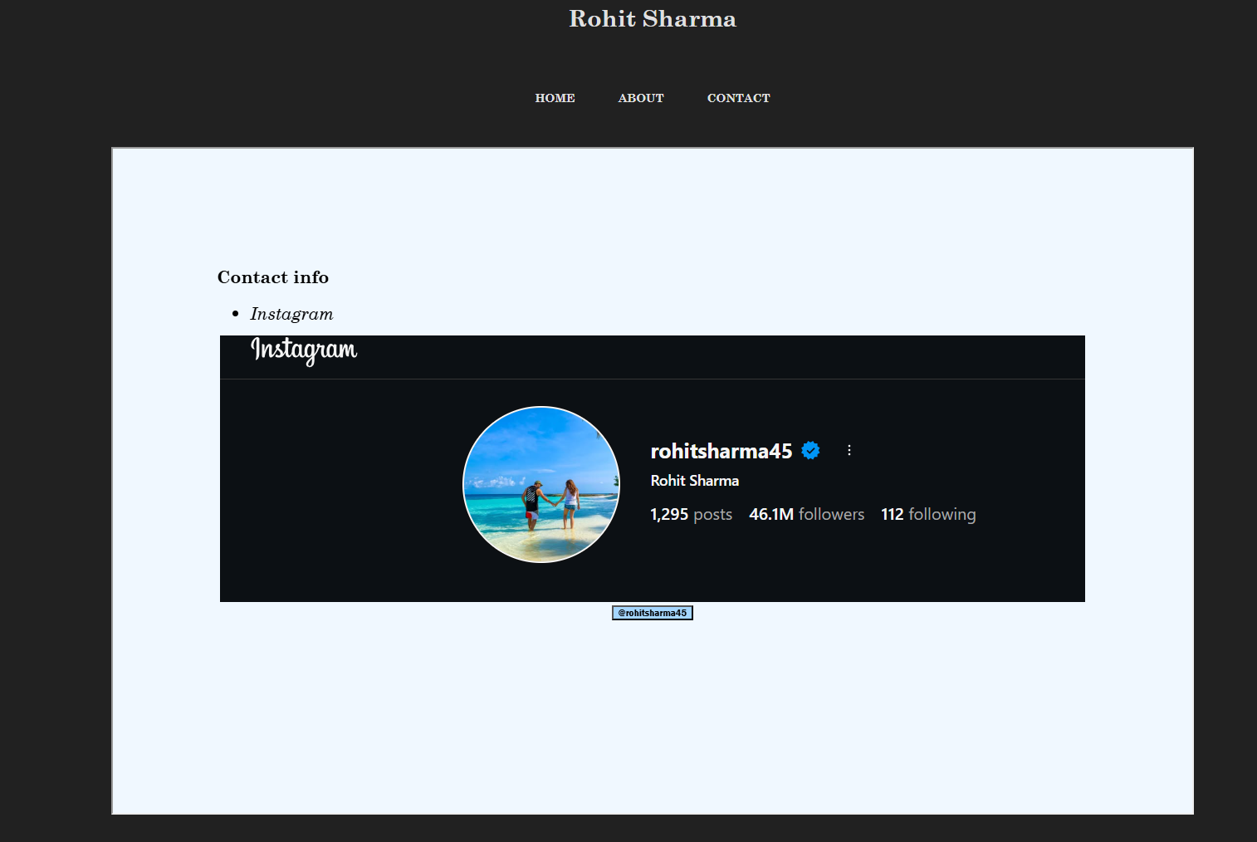

Tags used:
- <div> – A container used to group and structure HTML elements.
- <img> – Displays an image on the webpage using a source URL.
- <br> – Inserts a line break in the text.
- <ul> – Creates an unordered list of items.
- <li> – Represents an item inside a list.
- <center> – Centers the content horizontally on the webpage.
- <table> – Creates a table structure to organize data in rows and columns.
- <iframe> – Embeds another webpage inside the current page.
- <form> – Creates a form used for submitting data or redirecting to another page.
- <button> – Creates a clickable button for user interaction.
- Hover: is used to add the effect of glow to the button.

5c. To design an Amrita login page using HTML and CSS that displays different campuses, where clicking on each campus shows its details on the same page.
Aim:
To design an Amrita login page using HTML and CSS that displays different campuses, where clicking on each campus shows its details on the same page.

Program:
Main:
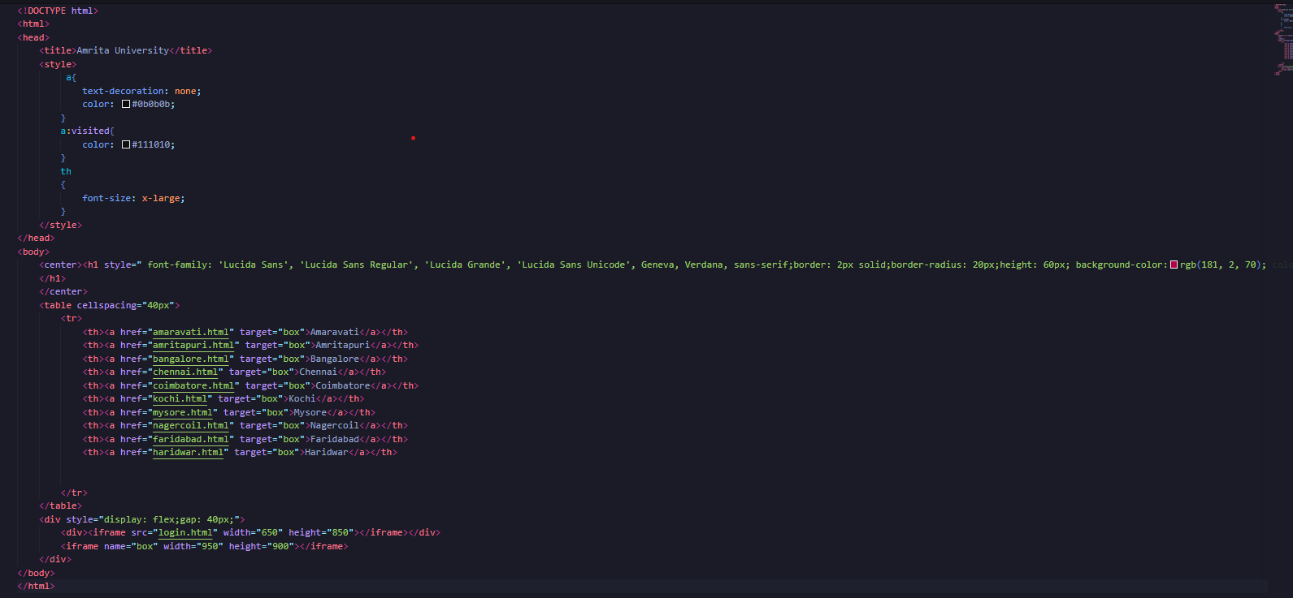

Sub webpages:
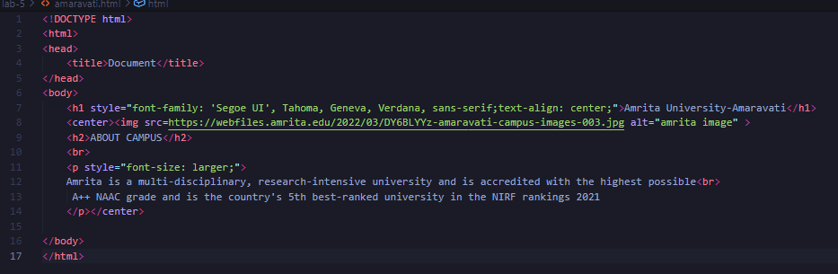

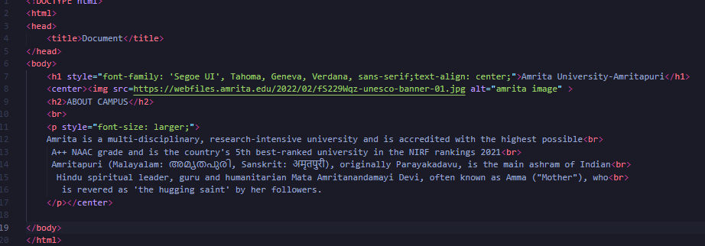
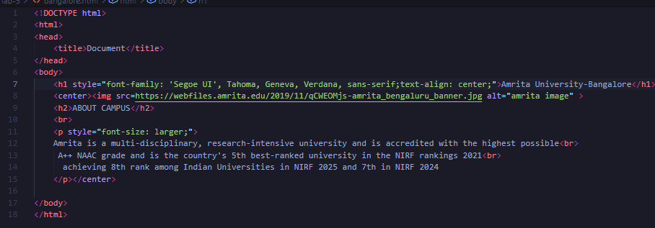
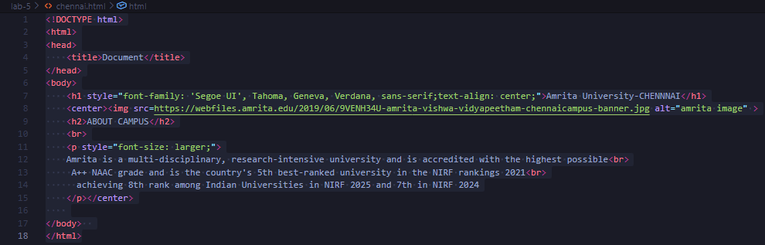
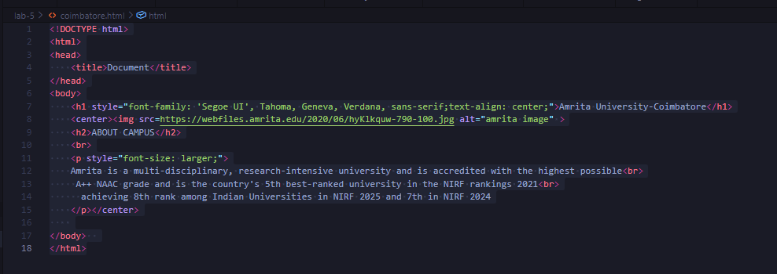
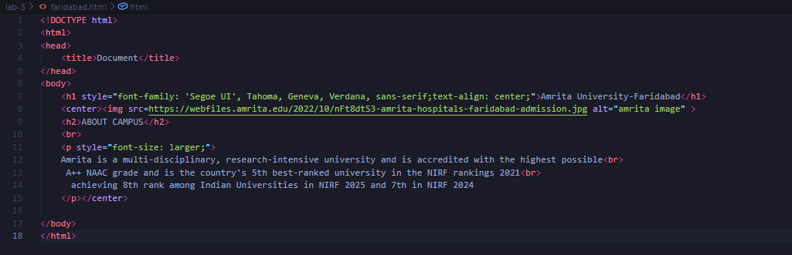
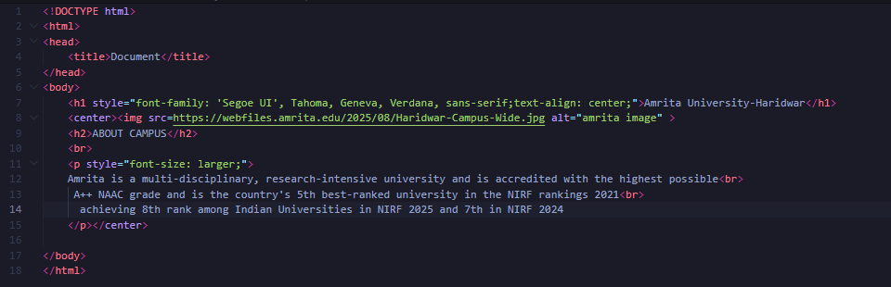
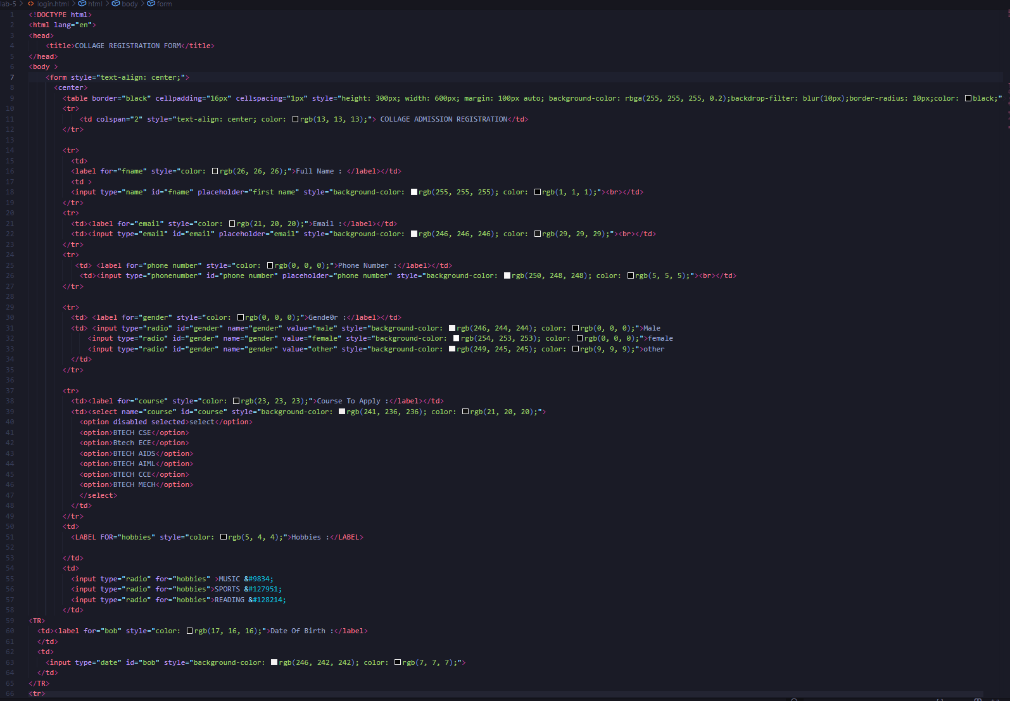

Output:
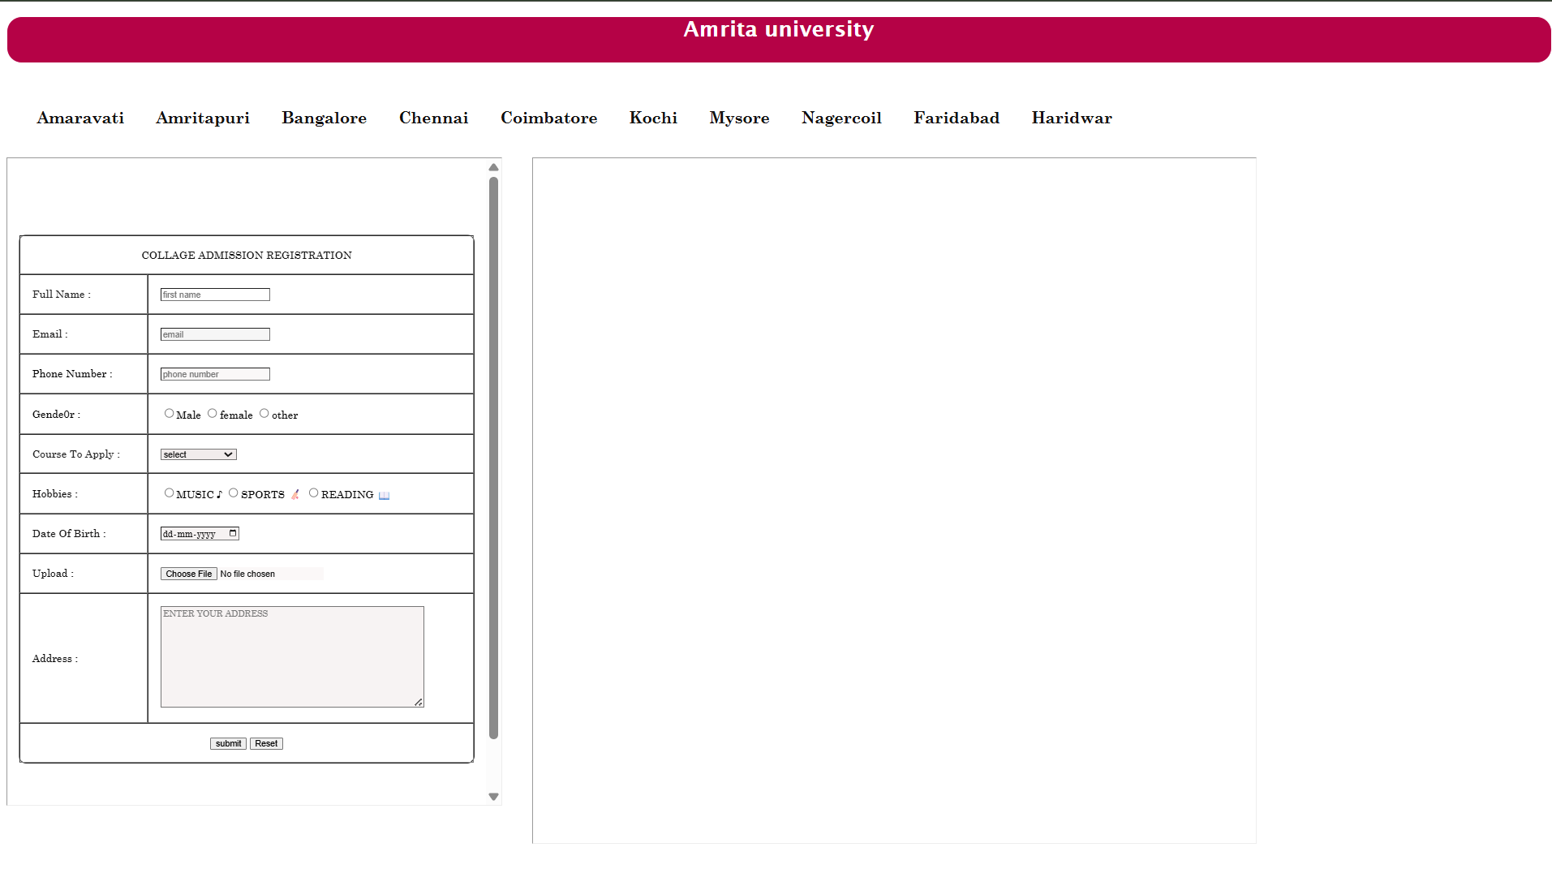

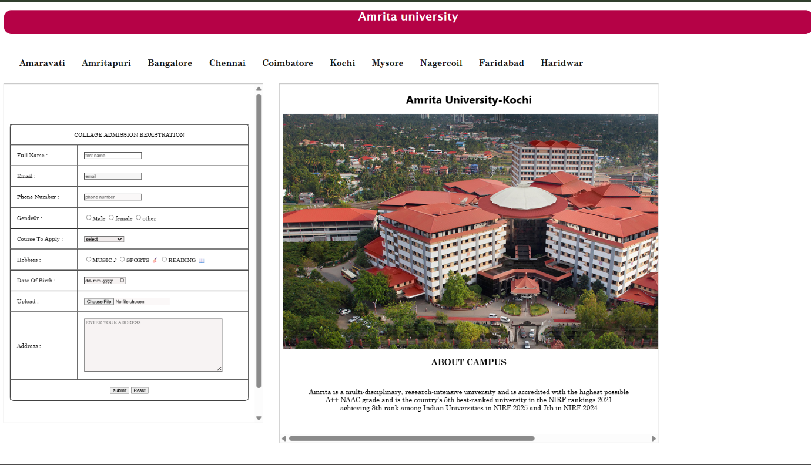

Tags-used:
- <div> – A container used to group and structure HTML elements.
- <img> – Displays an image on the webpage using a source URL.
- <br> – Inserts a line break in the text.
- <ul> – Creates an unordered list of items.
- <li> – Represents an item inside a list.
- <center> – Centers the content horizontally on the webpage.
- <table> – Creates a table structure to organize data in rows and columns.
- <iframe> – Embeds another webpage inside the current page.
- <form> – Creates a form used for submitting data or redirecting to another page.
- <button> – Creates a clickable button for user interaction.
- Hover: is used to add the effect of glow to the button.

Week-6:
6. Design a responsive e-commerce application using the grid layout. This application should contain different categories of products such as electronics, clothing, home-appliances, books. Based on the category we select corresponding products should be displayed on the sidebar.
Aim:
Design a responsive e-commerce application using the grid layout. This application should contain different categories of products such as electronics, clothing, home-appliances, books. Based on the category we select corresponding products should be displayed on the sidebar.

Program:
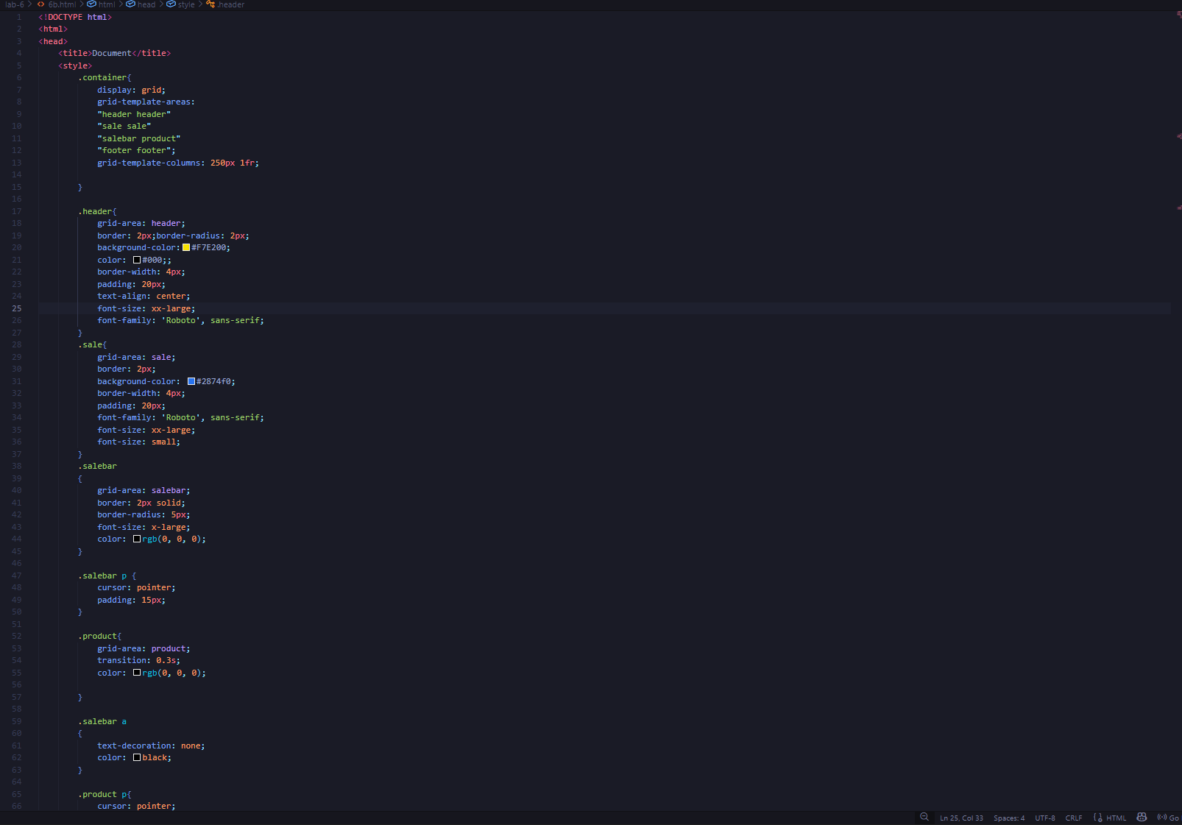

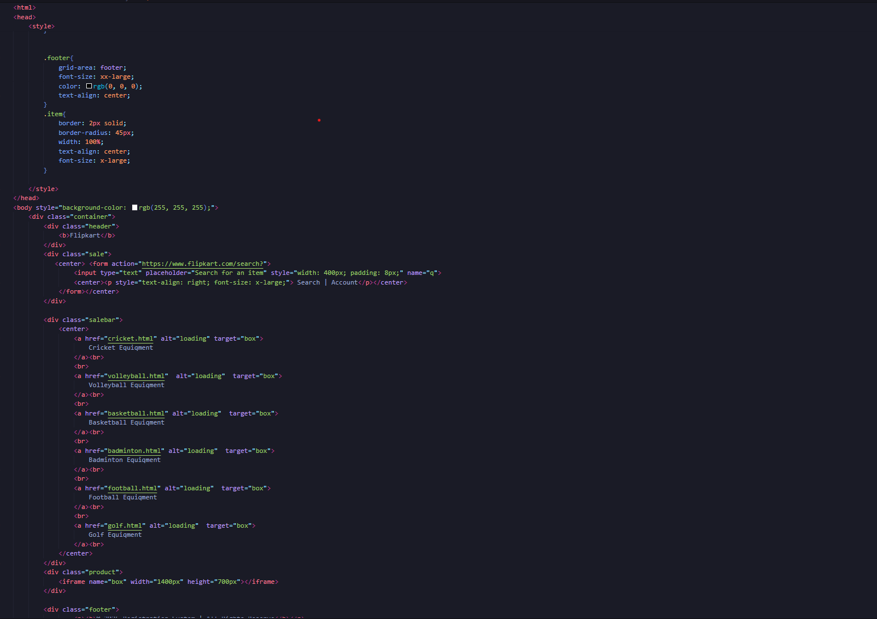

Output:
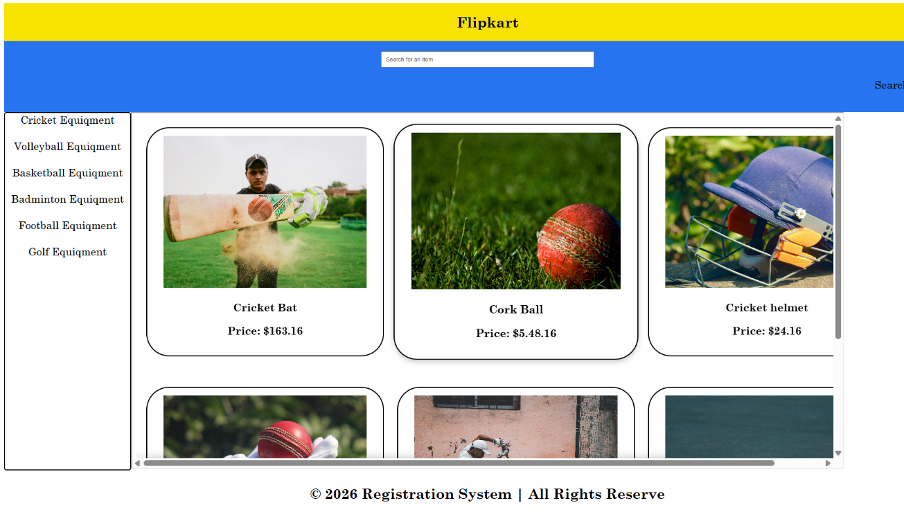

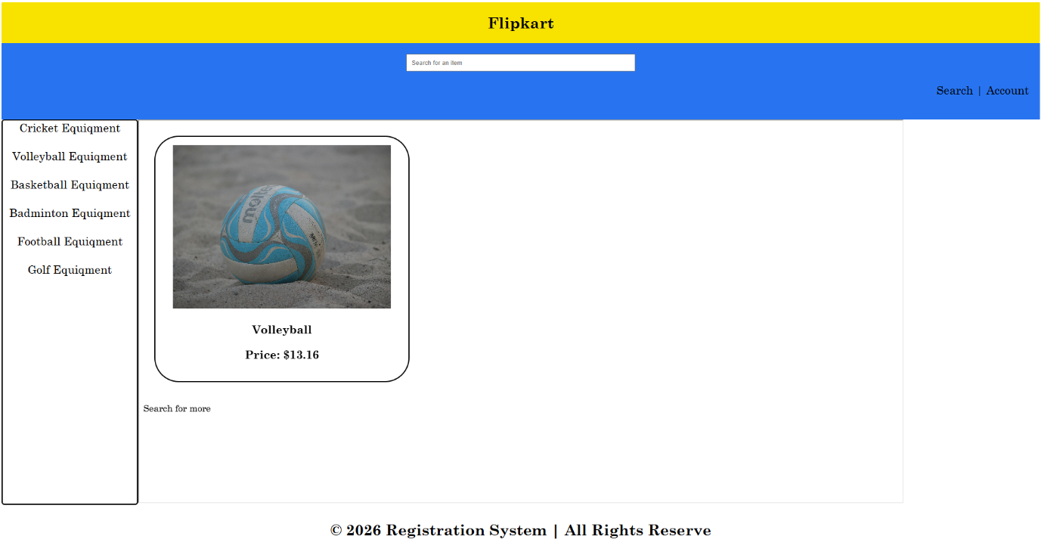

Tags-used:
- <style> – Used to define internal CSS styles for the webpage layout and design.
- <div> – A container element used to group and structure sections of the webpage.
- <b> – Displays text in bold format to emphasize important text.
- <form> – Creates a form used to collect input or send data to a server or URL.
- <input> – Creates an input field where users can enter data (like search text).
- <center> – Aligns the content horizontally at the center of the page.
- <iframe> – Embeds another webpage or document inside the current webpage

WEEK-7
7. Create a Git hub account and create a repository named UIDLAB upload every week experiments , lab reports in that repository and make the repository
Aim: Saving codes in GitHub

Step-1:
Visit the GITHUB website https://github.com/ .

Step-2:
Create a account or login a GIT HUB account.

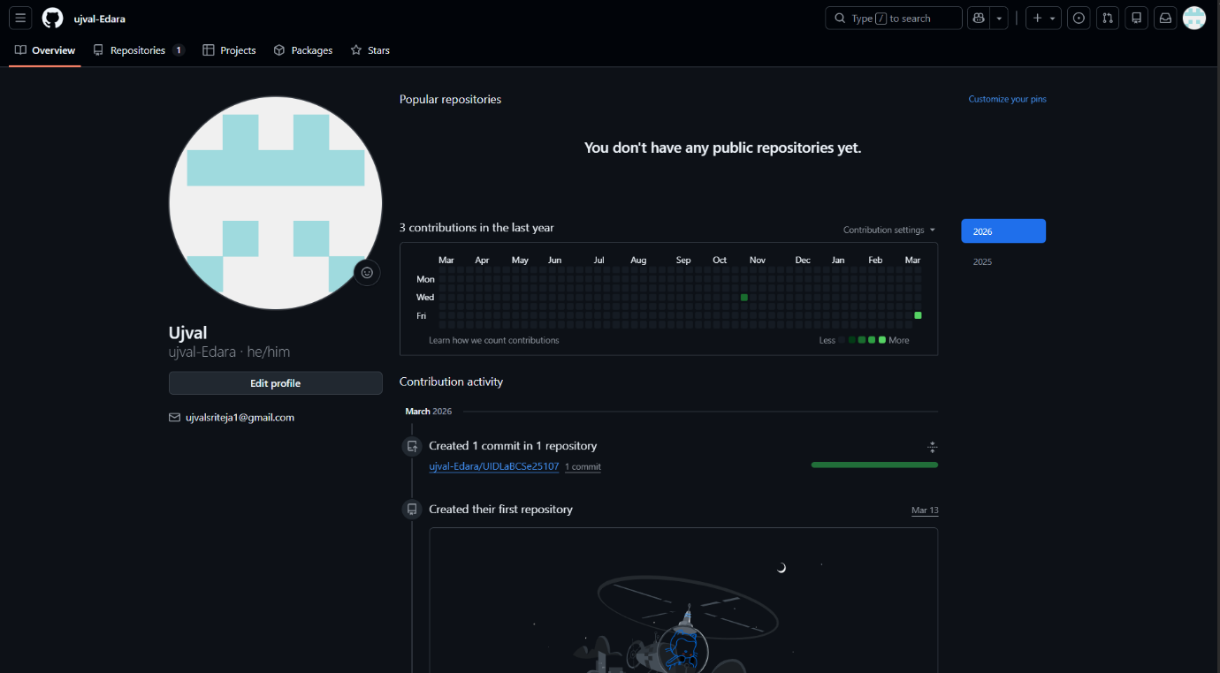

Step-3:
Add repository with name which consist of UID lab and roll number.
Keep the repository to private.

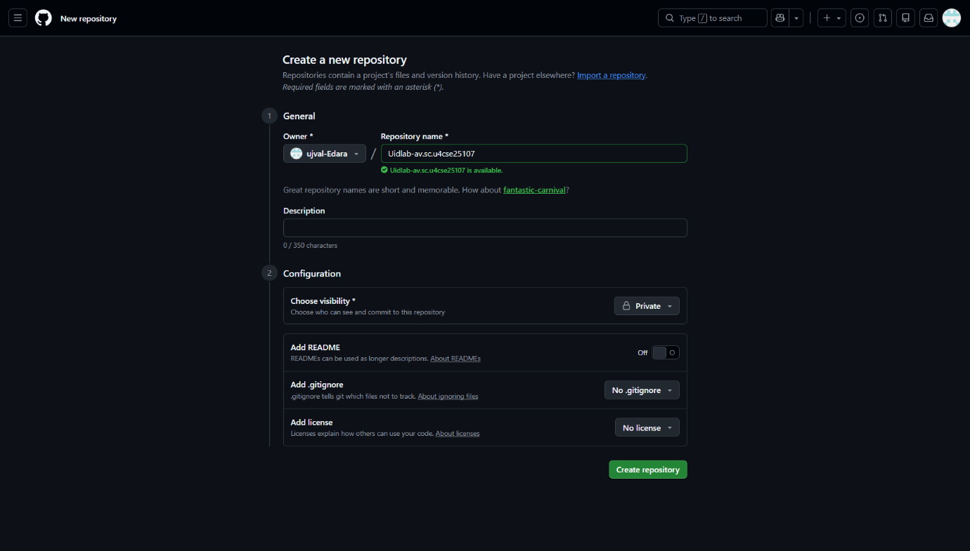

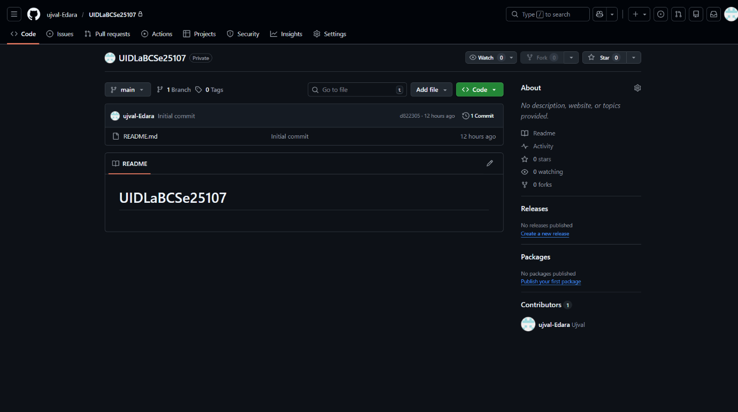

STEP-4:
Download Git Application from https://git-scm.com/install/windows
Restart the system after installation.
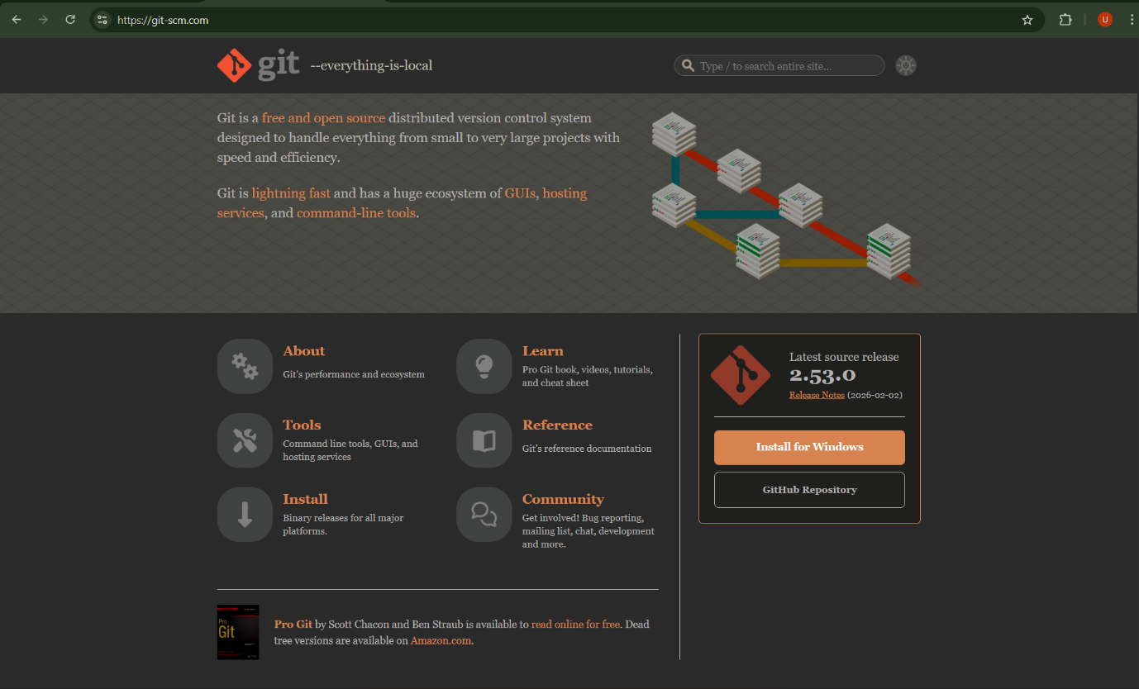
STEP-5:
Open in VS code the UID lab folder required to push to GitHub.
Open new Terminal In VS code.
STEP-7:
Pass these codes in the terminal to push the files to GitHub.
git init
git add .
git commit -m "First commit"
git branch -M main
git remote add origin <PASTE_YOUR_URL_HERE>
git push -u origin main

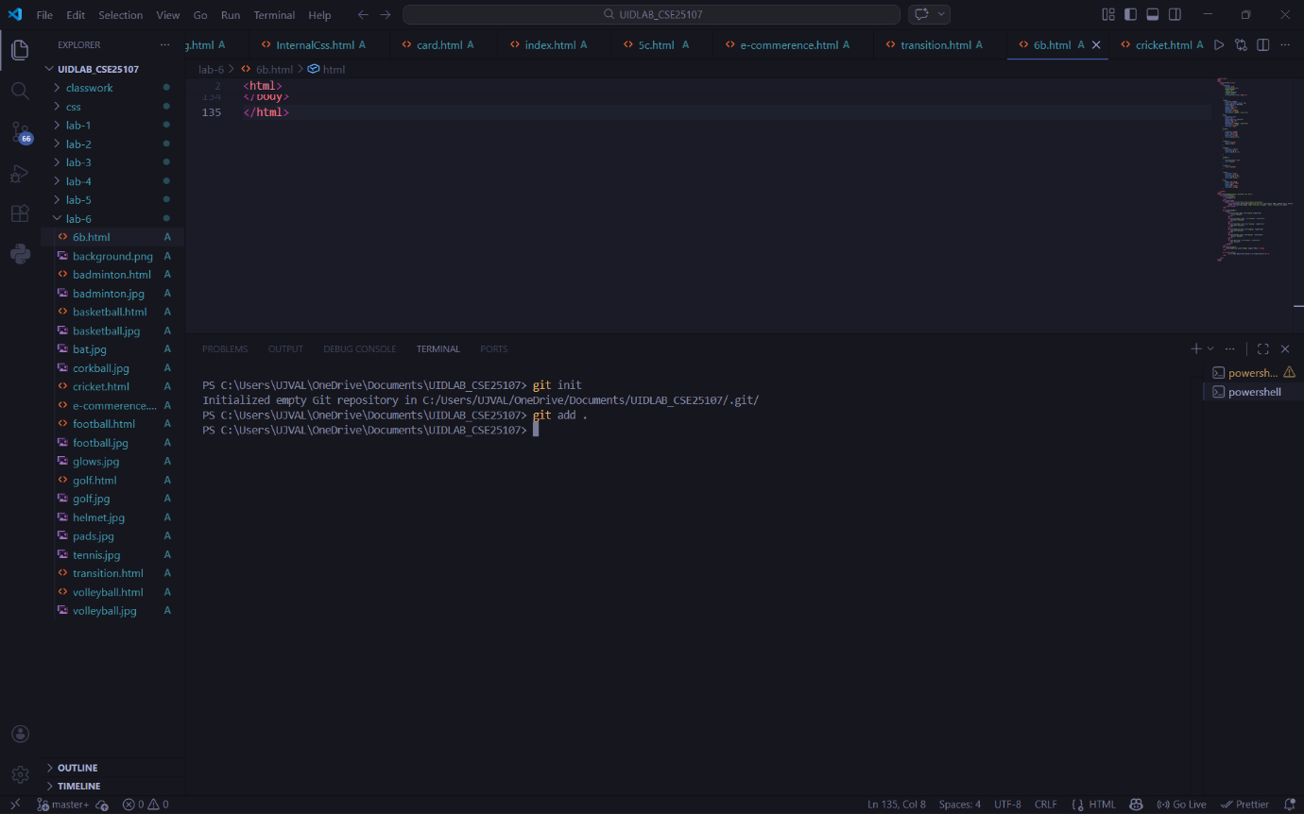
STEP-8:
All your files will be uploaded to github.
