Plan

The plan is to create a film browser application to the android mobile phone. The phone can control a server where the films stored.

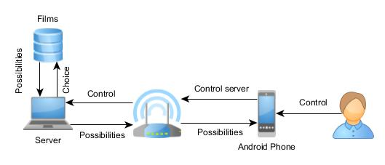

# Server side

1. Create python application which can handle video files
2. Create webserver which can be handle by the android phone

# Phone side

1. Create android app which can connect to the server
2. Create fancy GUI for the users