Live Whiteboard
Real-Time Collaborative Drawing Application
Peer-to-Peer • WebRTC • No Backend Required

━━━━━━━━━━━━━━━━━━━━━━━━━━━━━━

Developer: Ujwal
Date: April 2026
Tech Stack: React 18 • PeerJS • WebRTC • Canvas API • Tailwind CSS • Vite
Live Demo: https://live-whiteboard-ujwal.vercel.app

1. Introduction
Live Whiteboard is a real-time collaborative drawing application that lets two users draw together on a shared canvas. It uses WebRTC DataChannels for direct peer-to-peer communication — after the initial connection handshake, all drawing data flows directly between browsers without touching any server.

Key Highlights:
- No sign-up required — share a link and start drawing instantly
- Zero backend — 100% client-side architecture
- Sub-50ms latency — direct P2P connection, not server-relayed
- Privacy by design — no data stored anywhere

2. Project Objectives
# | Objective | Status
1 | Implement WebRTC peer-to-peer communication | ✅
2 | Build real-time collaborative canvas drawing | ✅
3 | Support multiple tools (pen, eraser, shapes) | ✅
4 | Implement undo system with canvas snapshots | ✅
5 | Show remote cursor with name tag | ✅
6 | Responsive design (desktop + mobile) | ✅
7 | Deploy to production on Vercel | ✅

3. Technology Stack
Technology | Version | Purpose
React | 18.2 | UI framework with hooks for state management
Vite | 5.0 | Build tool — fast dev server + optimized production builds
PeerJS | 1.5 | WebRTC abstraction — handles signaling and ICE negotiation
HTML5 Canvas | Native | Drawing surface — zero dependencies
Tailwind CSS | 3.4 | Utility-first CSS framework
React Router | 6.x | Client-side routing for room URLs
nanoid | 5.x | Unique room ID generation
Vercel | — | Hosting with global CDN

4. System Architecture

4.1 How It Works
The application has two phases:

Signaling Phase (one-time): Both browsers connect to the PeerJS Cloud signaling server via WebSocket. The server brokers the WebRTC handshake by exchanging SDP offers/answers and ICE candidates. STUN servers help discover public IP addresses for NAT traversal.

Data Phase (persistent): Once the WebRTC DataChannel opens, all communication flows directly between browsers. Drawing messages (JSON) are sent at ~60fps. No server is involved in this phase.

4.2 Component Structure
App.jsx (Router)
├── Home.jsx — Landing page (Create / Join room)
└── Room.jsx — Whiteboard page
├── usePeer() — PeerJS lifecycle management
├── useRoom() — Host/guest connection logic
├── useCanvas() — Drawing engine + undo + remote sync
├── Toolbar.jsx — Tools, colors, brush size, actions
├── ConnectionStatus.jsx — Live connection indicator
└── Toast.jsx — Join/leave notifications

4.3 Message Protocol
All P2P messages use a typed JSON format:
Message | Payload | When Sent
DRAW_START | x, y, color, size, tool | User begins a stroke
DRAW_MOVE | x, y | Mouse/touch moves (~60fps)
DRAW_END | — | Stroke completed
CLEAR | — | Canvas cleared
UNDO | — | Undo triggered
CURSOR_MOVE | x, y, peerId | Cursor position update
HELLO | name, color | On connection (identity exchange)

5. Features
Feature | Description
Real-time drawing sync | Strokes appear on both peers simultaneously via DataChannel
5 drawing tools | Pen, Eraser, Line, Rectangle, Circle
Color palette | 8 preset colors + custom color picker
Brush size slider | Adjustable from 2px to 40px
Undo system | Canvas snapshot stack (up to 50 levels)
Remote cursor | See peer's cursor position with name badge
One-click room creation | Unique room ID generated via nanoid
Copy link / Web Share | Share room URL instantly
Export PNG | Download canvas as image
Keyboard shortcuts | P, E, L, R, C, U, Ctrl+Shift+Del
Touch support | Works on mobile and tablets
Toast notifications | Peer joined/left alerts
Auto-reconnection | Guest retries on disconnect (5 attempts)

6. Key Implementation Details

6.1 React 18 StrictMode Handling
React 18 double-mounts components in development. When the host registers a fixed peer ID, the second mount fails because the ID is still held by the signaling server. Solution: retry up to 3 times with a 1.5s delay.

6.2 Shape Preview Rendering
Shape tools (rect, circle, line) need live preview while dragging. The canvas is snapshotted before drag starts, then on each mouse move the snapshot is restored and the shape redrawn at the new size — producing flicker-free rubber-band rendering.

6.3 Message Throttling
Mouse events fire at 120-240Hz on modern displays. To prevent flooding the DataChannel, outgoing draw moves are batched using requestAnimationFrame and sent at ~60fps.

6.4 Eraser via Compositing
Instead of tracking individual strokes for erasing, the eraser uses Canvas globalCompositeOperation = "destination-out" — making erase just another draw operation with zero extra complexity.

7. Screenshots

7.1 Home Page
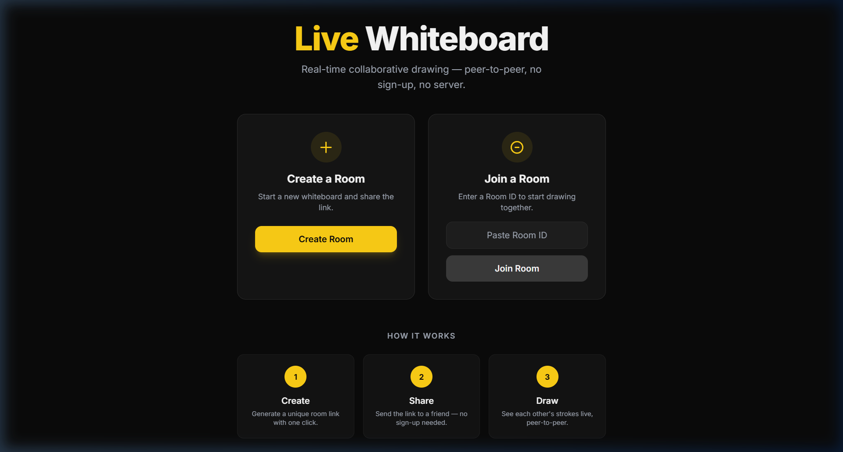
Landing page with Create Room and Join Room options. Dark theme with yellow accent. "How It Works" guide at the bottom.

7.2 Whiteboard Room
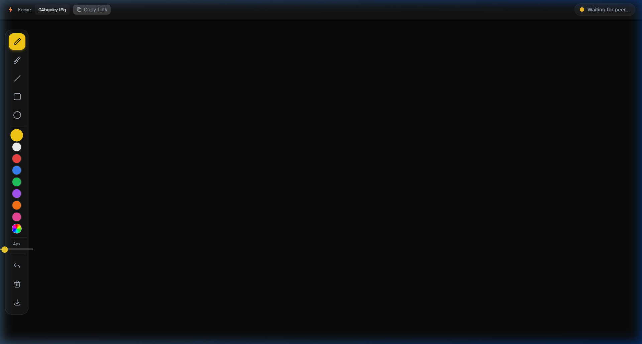
Full drawing interface showing the toolbar (tools, colors, brush size, actions), room header with share button, and connection status indicator.

7.3 Drawing Demo
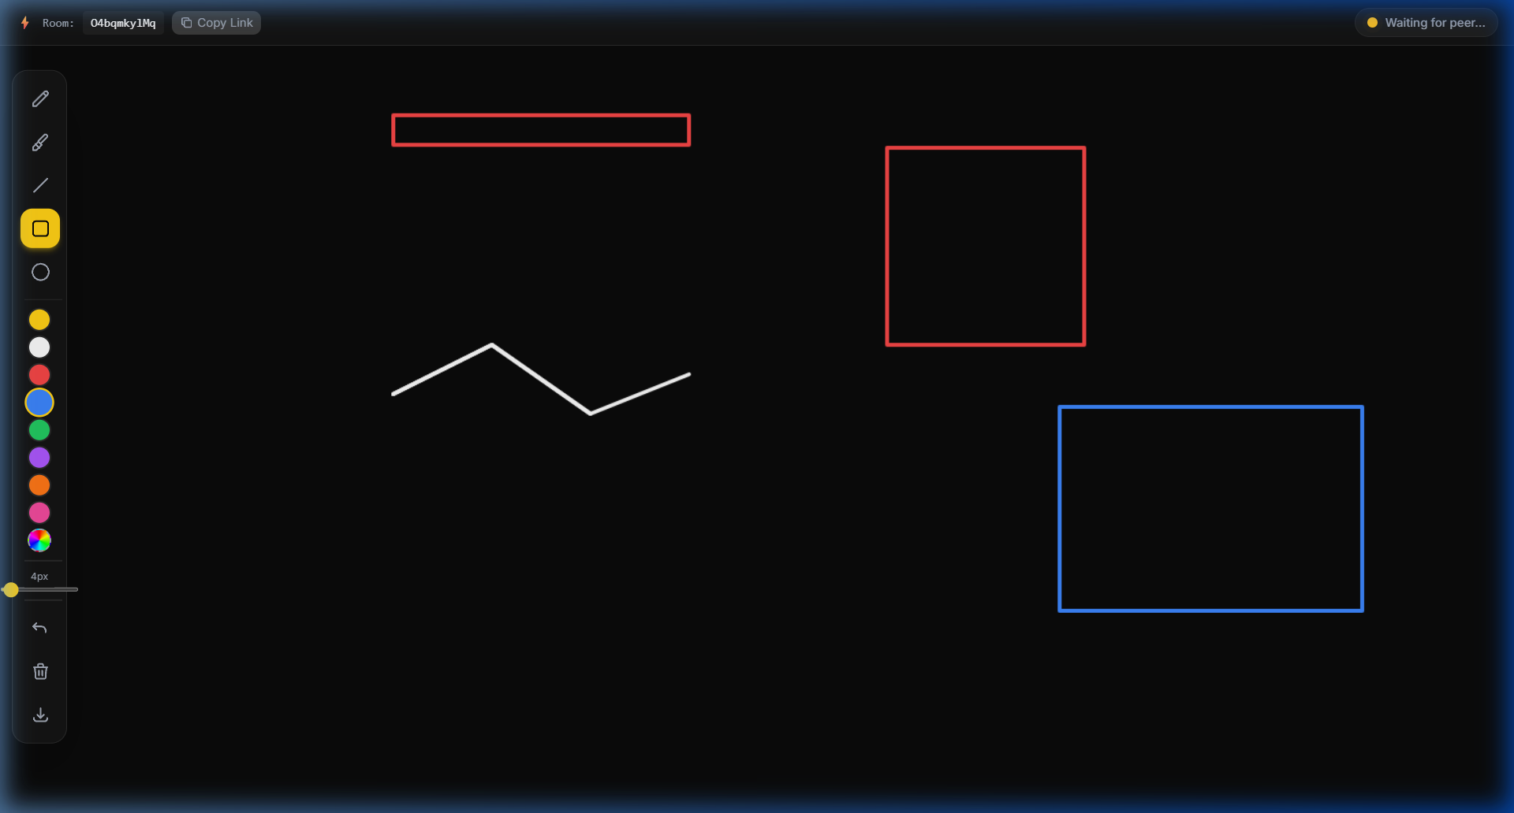
Multi-tool demonstration showing freehand pen strokes (white), rectangles (red, blue), drawn with different colors and tools in a single session.

8. Testing
Test Case | Result
Room creation + unique ID generation | ✅ Pass
Peer connection (two browser tabs) | ✅ Pass
Drawing sync (both directions) | ✅ Pass
Shape tools render correctly | ✅ Pass
Eraser works on all content | ✅ Pass
Undo restores previous state | ✅ Pass
Clear canvas syncs to peer | ✅ Pass
Export PNG downloads correctly | ✅ Pass
Keyboard shortcuts functional | ✅ Pass
Mobile touch drawing works | ✅ Pass
Production build succeeds | ✅ Pass

Browser Compatibility:
Browser | Status
Google Chrome 90+ | ✅ Tested
Mozilla Firefox 85+ | ✅ Compatible
Microsoft Edge 90+ | ✅ Compatible
Safari 15+ | ✅ Compatible

9. Deployment
The application is deployed on Vercel with zero configuration. The build pipeline:
- npm install — install dependencies
- npm run build — Vite production build (outputs to /dist, ~287 KB total)
- vercel --prod — deploy to global CDN

A vercel.json rewrite rule ensures all routes serve index.html for client-side routing.

10. Future Scope
- Multi-user rooms (N-peer mesh or SFU topology)
- Text tool with font selection
- Session persistence via IndexedDB
- Image paste / drag-and-drop
- End-to-end encryption for DataChannel
- Infinite canvas with pan and zoom

11. Conclusion
Live Whiteboard demonstrates that modern browsers can power real-time collaborative applications without any backend infrastructure. Using WebRTC DataChannels, the app achieves direct peer-to-peer communication with sub-50ms latency, comparable to native applications.

The project covers React hooks architecture, WebRTC signaling/ICE, Canvas 2D rendering, responsive design, and production deployment — all in ~886 lines of source code across 12 files.

12. References
- W3C. WebRTC 1.0: Real-Time Communication Between Browsers. W3C Recommendation.
- MDN Web Docs. WebRTC API. Mozilla Developer Network.
- PeerJS Documentation. https://peerjs.com/docs/
- MDN Web Docs. Canvas API. Mozilla Developer Network.
- React Documentation — Hooks. Meta.
- Tailwind CSS Documentation. Tailwind Labs.
- Vite Documentation. https://vitejs.dev/

