**Chapter 1**

**INTRODUCTION**

**1.1 Objective Overview:**

This project is an online portal between students and faculty. This innovative system allows college faculty to share important data as well as notifications with engineering students. It consists of a faculty login along with student login. Since college faculty operate through pc and document uploading is simpler through a pc, the faculty login is to be performed through a computer. Faculty may upload documents of subject syllabus, timetable document, notifications, E-notes etc. through their provided login. The documents are uploaded by faculty to different corresponding departments. We propose to build this system on an online server that allows faculty to upload data and students may view and download required documents through their android device. Here students only see and download data of their particular semester. Rest data is hidden.

**1.2 Features:**

• **User login:** This allows only the registered users to login in order to use this location tracking application.

• **Document details:** This module stores documents in word and pdf format and also allows students to view particular data.

• **Server management:** The server smartly handles data and allows students with web browser to access data as well as faculty to upload document details.

• **Faculty Upload:** The system allows faculty to upload documents to server.

• **Student Download:** The system allows student to download and view data through his login details phone using an active internet connection.

**Chapter 2**

**DESIGN AND IMPLEMENTATION**

**2.1 Use Case Diagram:**



* 1. **Class Diagram:**



# 2.3 Existing system

# No Software present at all.

# Time consumed in distributing notes to everyone individually.

# Manual Paperwork.

# Students are informed by sending mail to them manually about the notes.

# Lack of accessibility.

# 2.4 Proposed system

The proposed System user can share the files with multiple users at a time. Users will have at most security in this project using password hash as a result users’ passsword are hashed and are not accessible by others.

This project has a large scope as it has the following features which help in making it easy to use, understand and modify it:

* Ease of sharing notes
* No Need to do Paper Work.
* To save the environment by using paper free work.
* To increase the efficiency of the notes sharing.
* Management of all notes.
* Easy and secure user log in and registration.
* Department based notes management.
* Simplified Management of all notes.
* Upload of notes.
* Approve and disapprove notes features.
* Admin Panel.
* User profile management.

This Notes Management System can be readily used by non-programming personal avoiding human handled chance of error. This project is used by three types of users

i. Students.

ii. Teachers

iii. Administrators

Students and Teachers can create their accounts and start viewing notes shared by other users as well as upload their own notes. Administrator is must be an authorized user who will keep track of all the uploaded notes and manage users as well through the admin panel.

# Chapter 3

# Hardware and software requirements

### Software Requirements

* Windows 7/8.1/10
* MYSQL
* Notepad++, Sublime Text
* XAMP Server

### Hardware Requirements

* Processor – all
* Hard Disk – 20GB or more
* Memory – 1GB RAM

**Chapter 4**

**RESULT ANALYSIS**

**4.1 Snapshots:** 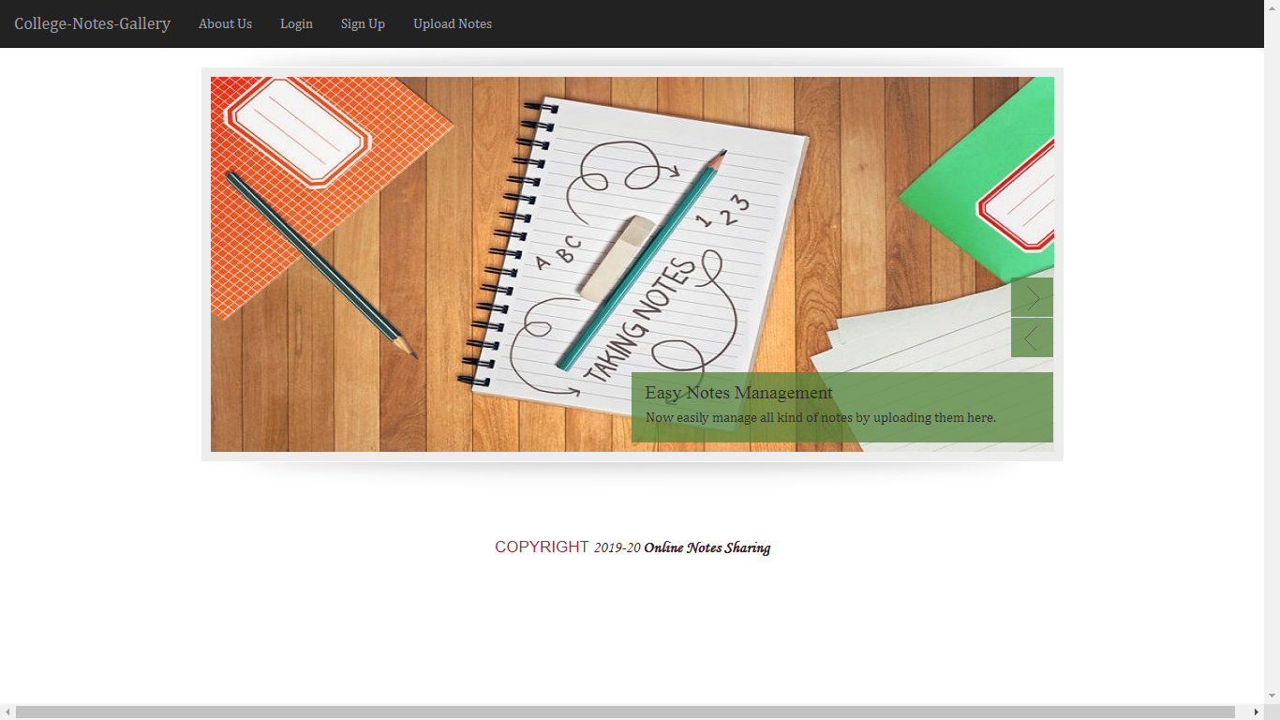

**Fig-1: Index**

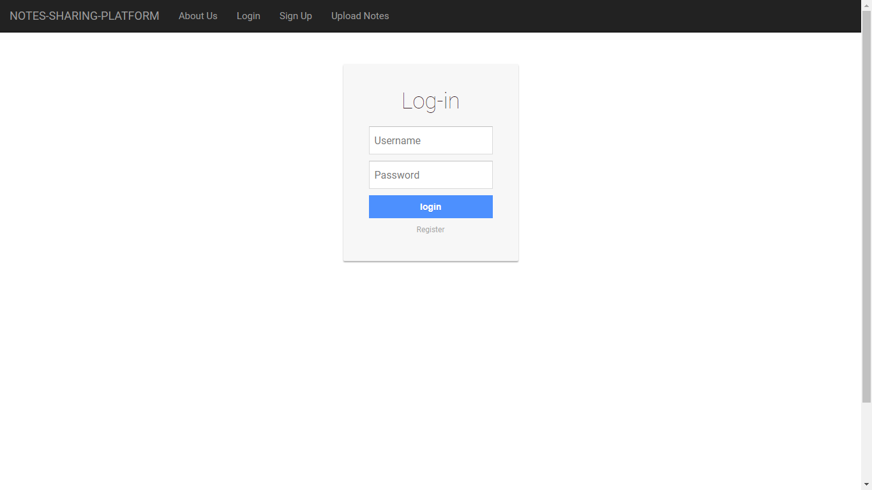

**Fig-2: Login page**

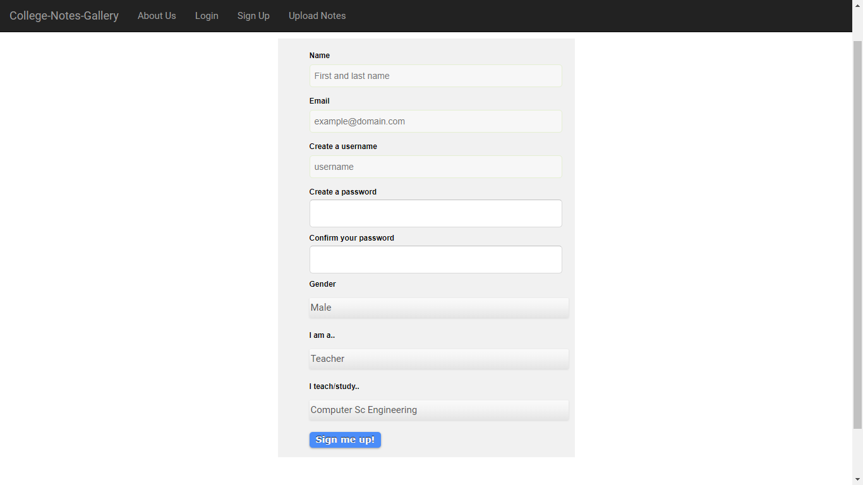

**Fig-3: Sign up form**

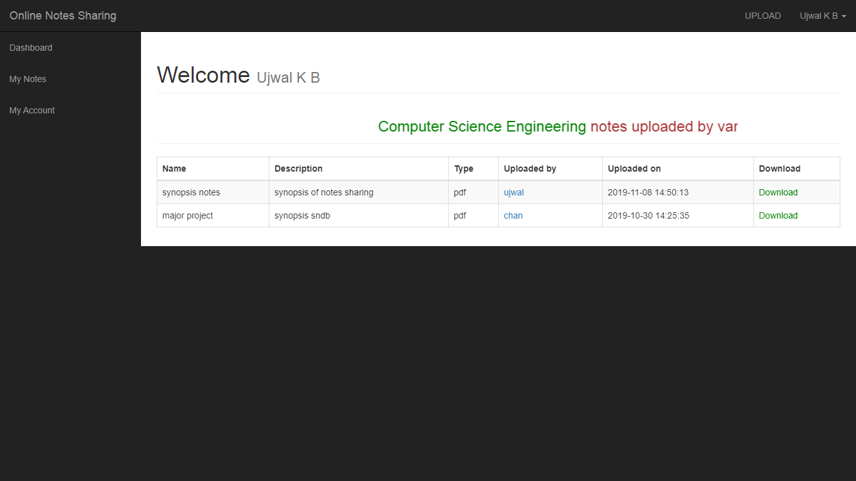

**Fig-4: User dashboard**

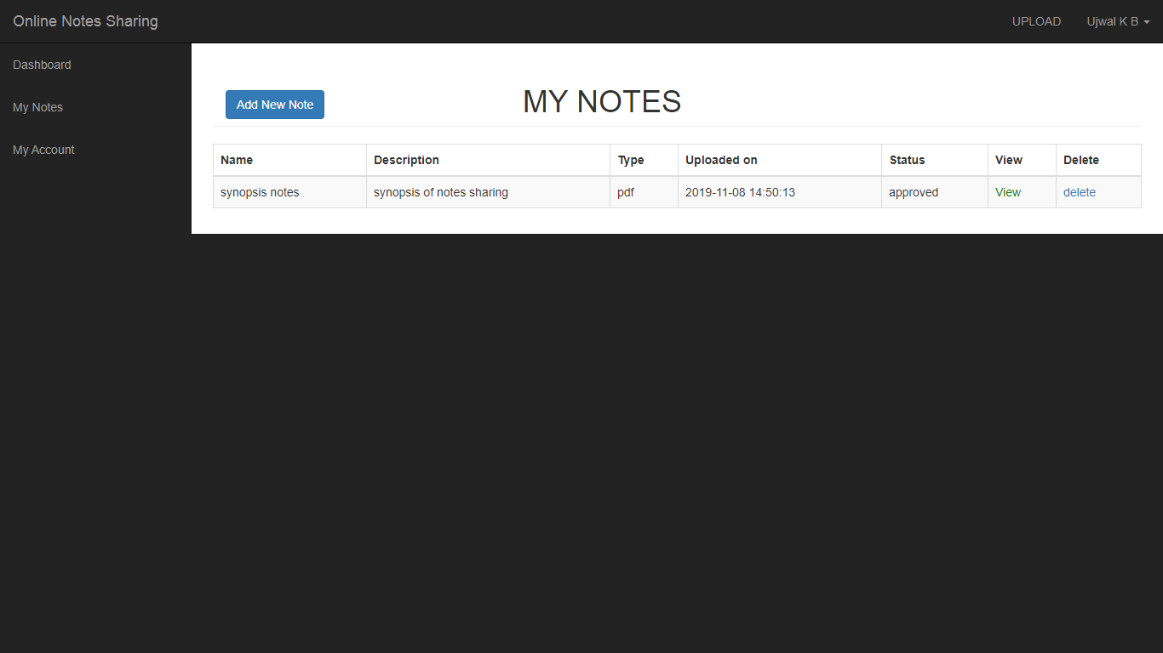

**Fig-5: User’s notes**

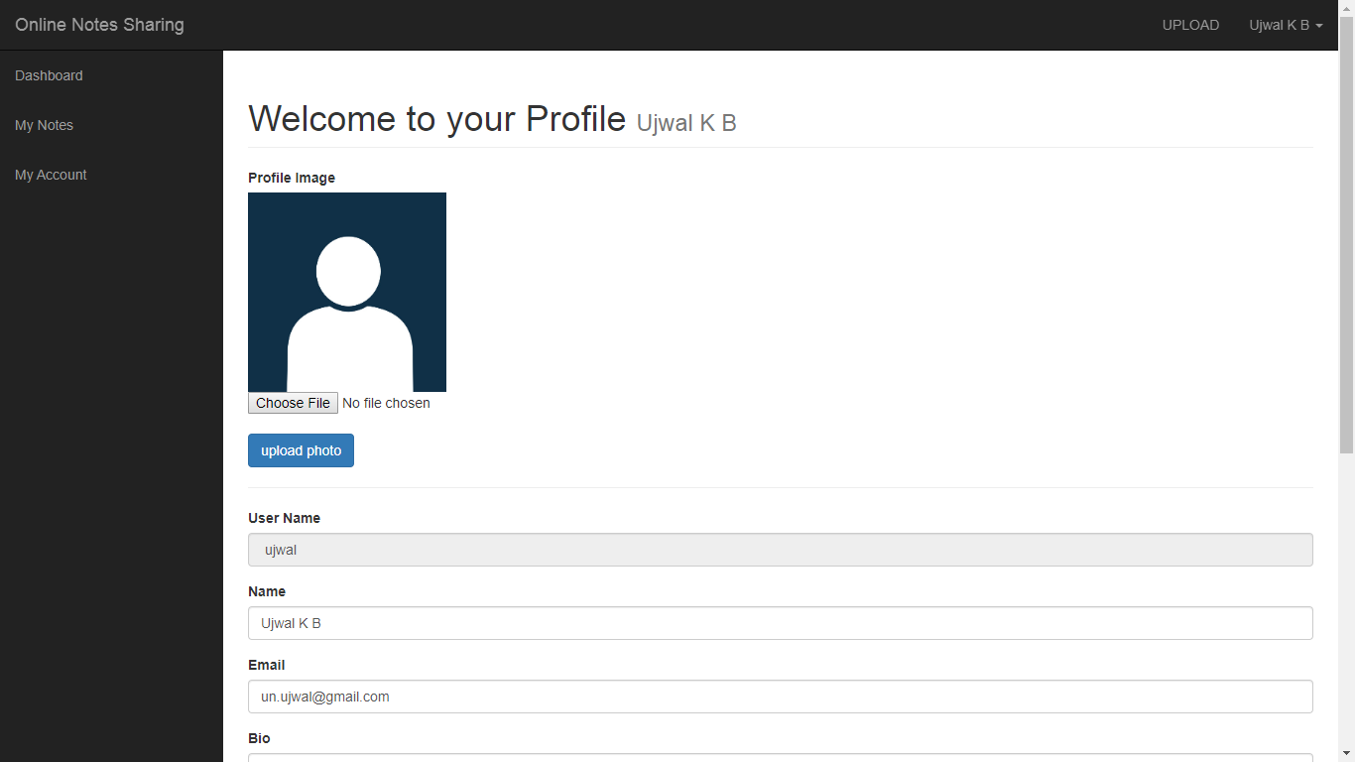

**Fig-6: User’s profile**

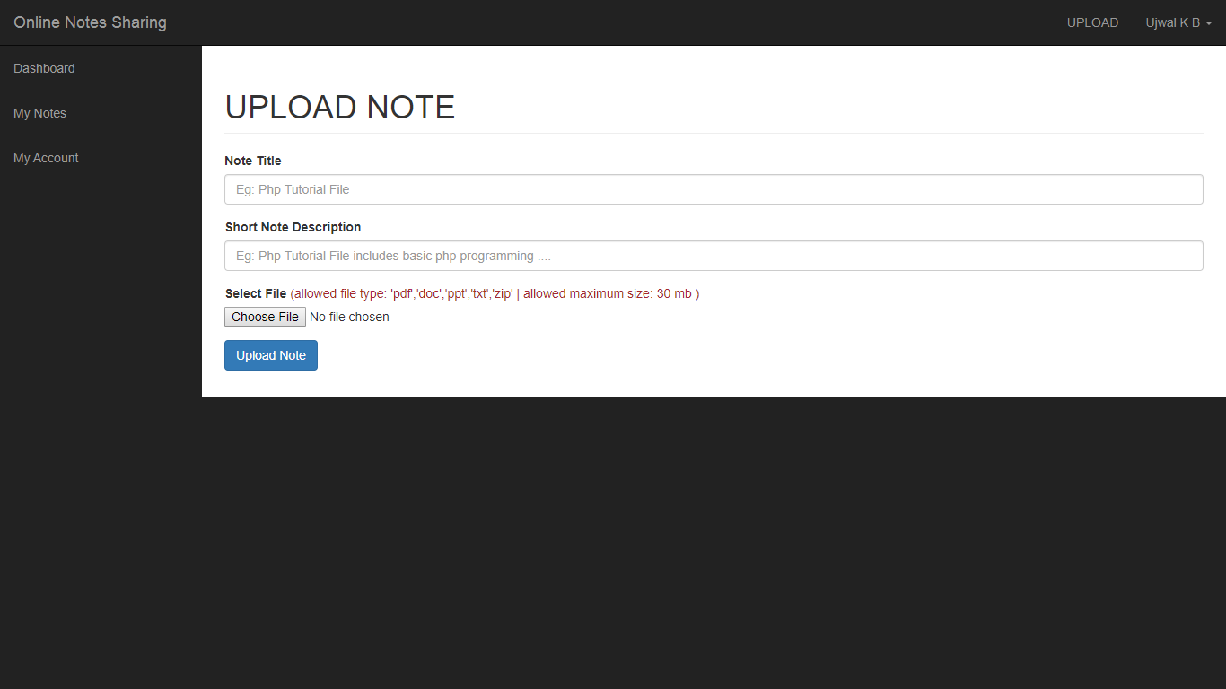

**Fig-7: User notes upload**

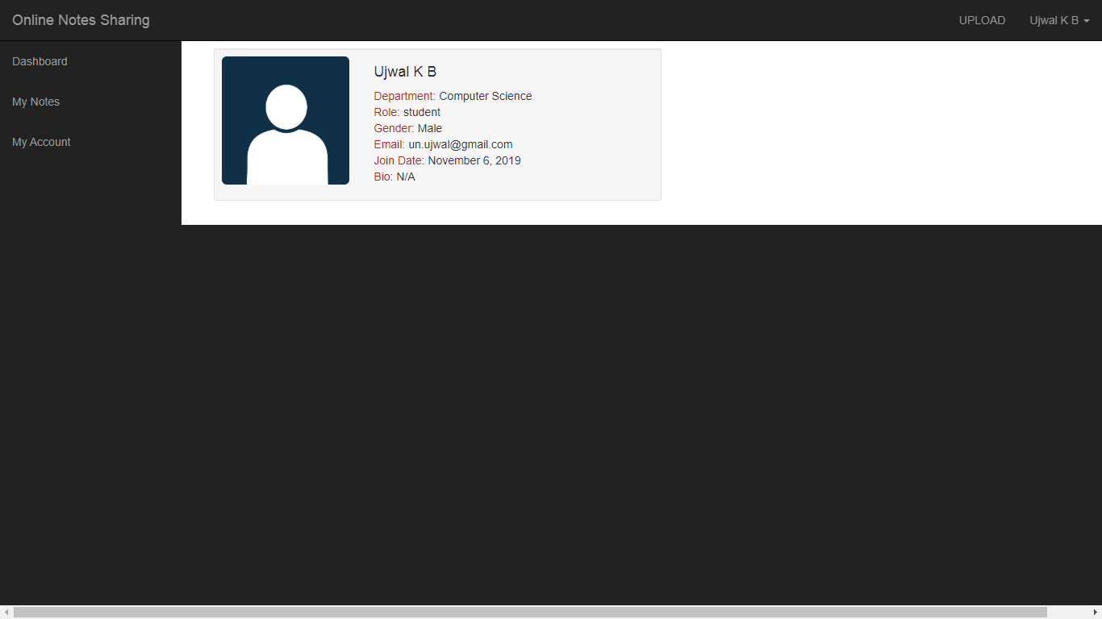

**Fig-8: User’s details**

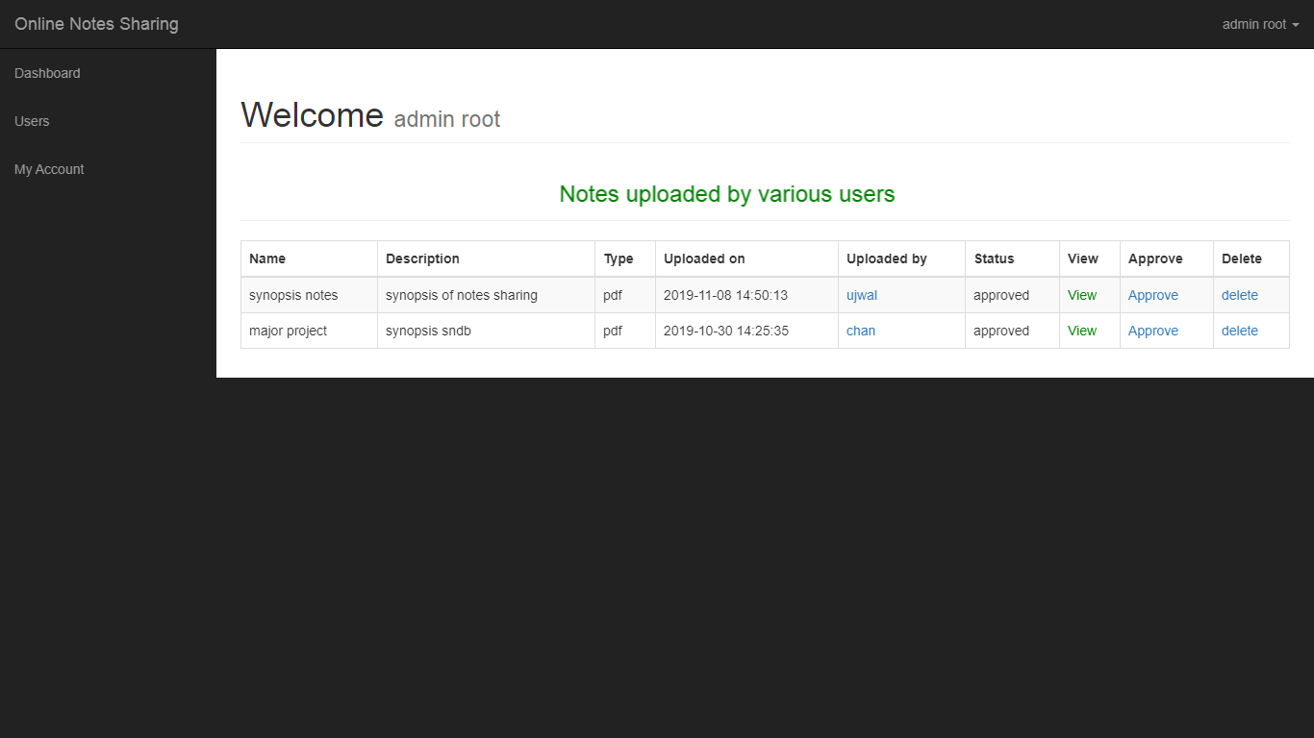

**Fig-9: Admin dashboard**

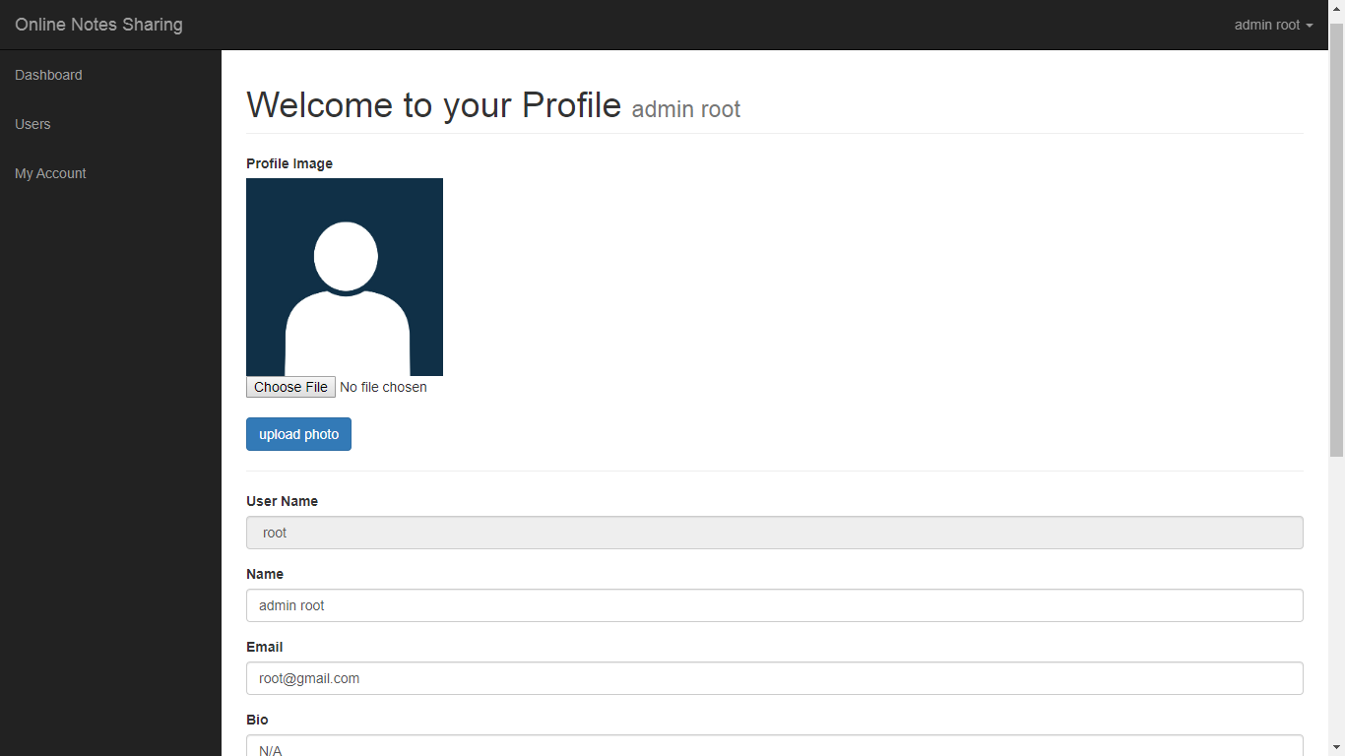

**Fig-10: Admin profile**

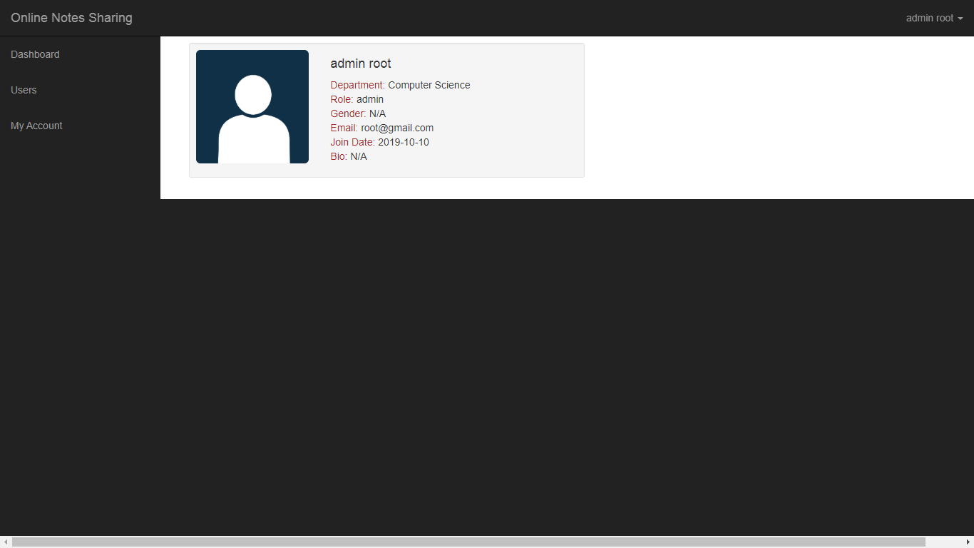

**Fig-11: Admin details**

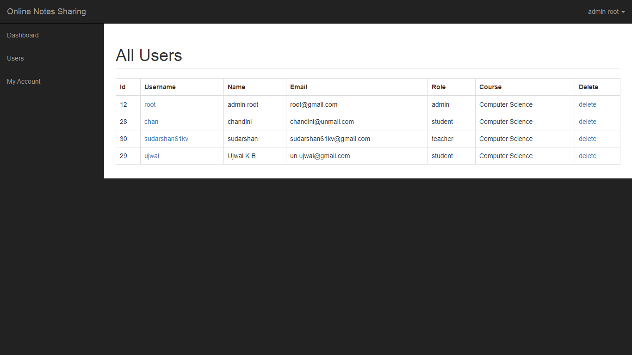

**Fig-12: List of all users for admin**

**Chapter 5**

**CONCLUSION AND FUTURE ENHANCEMENT**

**CONCLUSION:**

This project is more suitable for any institution or faculty and features of this smart sharing system is more easy to use. This project will helpful both for the faculty and students of any institute.

**Future ENHANCEMENT:**

* The files can be stored onto cloud storage.
* The security can be enhanced.