

Music store management system

About me

I'm Ujwala Nagandla, a 2024 B.Tech graduate in Electronics and Communication Engineering (ECE), with a strong passion for data science. I'm actively exploring every possible opportunity to deepen my knowledge and hands-on experience in the field of data science.

Objective of the Project

The objective is to automate processes like inventory management, sales tracking, customer data management, and generating reports. By doing so, the system will streamline operations, enable better decision-making through insightful data analysis, and ultimately contribute to increased efficiency and potential profitability for the music store.

ER Diagram

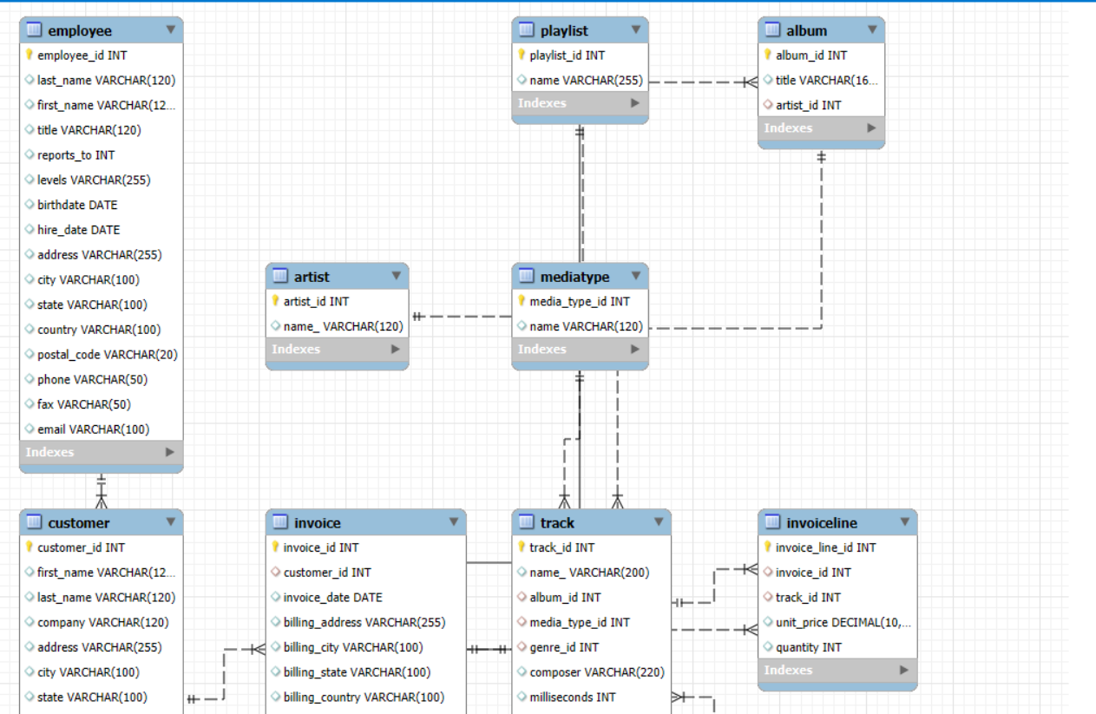

SQL Queries and results

Business Insights

* Understanding Best Sellers: Tracking sales data in the SQL database helps identify the most popular albums, artists, and genres, allowing the store to optimize inventory by stocking more in-demand products and reducing slow-moving items.
* Preventing Stockouts and Overstock: Analysing sales trends and inventory levels ensures the store avoids running out of popular items or having excessive quantities of less popular ones, which directly impacts profitability.
* Informed Purchasing Decisions: Data-driven insights into product performance guide purchasing decisions, allowing the store to invest in products that align with customer preferences and generate higher sales.

Conclusion

In conclusion, implementing a music store management system SQL project delivers significant business advantages. The ability to efficiently manage and analyse data allows music stores to make informed decisions across all aspects of their operations, from inventory and sales to customer relationships and marketing.

# THANK YOU