UrbanNest Realty Pvt. Ltd. – Residential Property Catalogue 2025

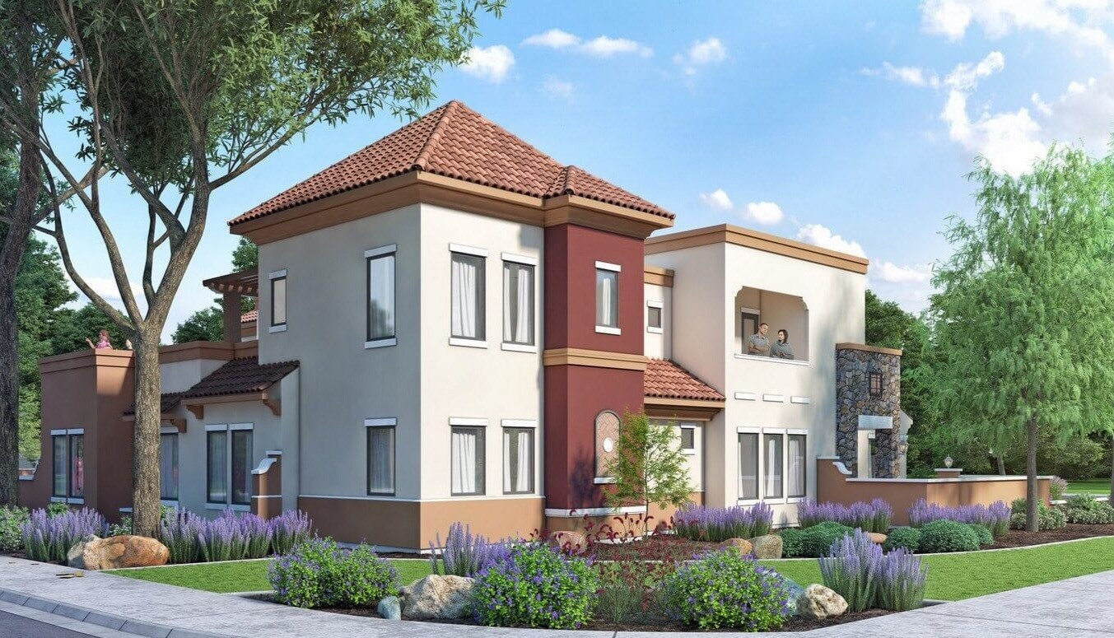 | Property Name: Urban Heights Residency  Location: Gachibowli, Hyderabad  3BHK Luxury Apartment, Smart Security, Gym & Clubhouse  Area: 1500 sq. ft. | ₹ 85 Lakhs – ₹ 1.2 Crore
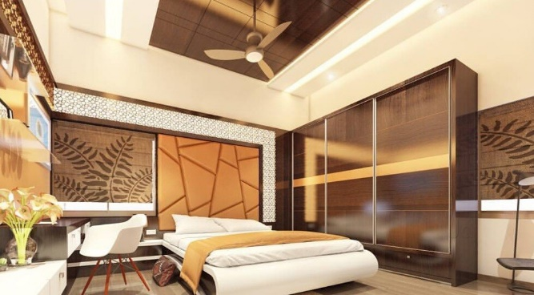 | . Property Name: SkyView Towers  Location: Madhapur, Hyderabad  2BHK Modern Flats, Pool, Children's Play Area  Area: 1200 sq ft. | ₹ 65 Lakhs – ₹ 90 Lakhs
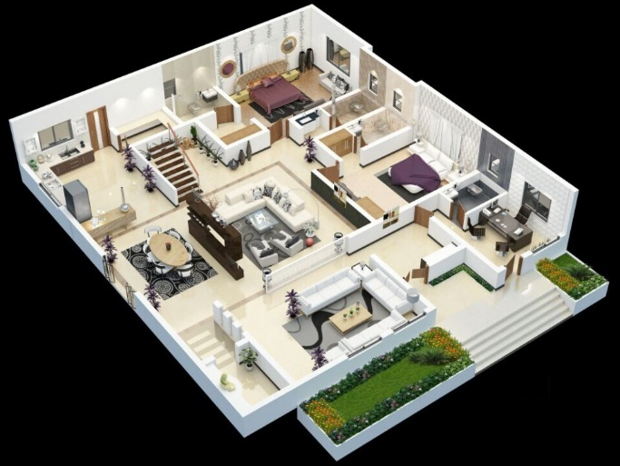 | Property Name: Green Valley Villas  Location: Kondapur, Hyderabad  4BHK Independent Villas, Private Garden, Solar Power  Area: 2800 sq. ft. | ₹ 2.5 – ₹ 3 Crore
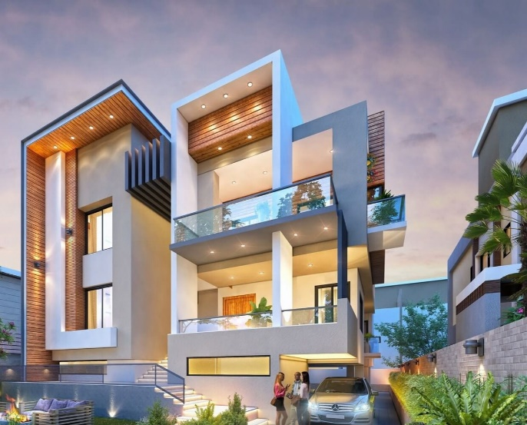 | Property Name: CityNest Apartments  Location: Kukatpally, Hyderabad  1 & 2 BHK Apartments, Near Metro, 24/7 Water Supply  Area: 800 sq. ft. | ₹ 45 – ₹ 70 Lakhs

For site visits and inquiries, contact UrbanNest Realty at info@urbannestrealty.com

