Gayathri
23bd1a050y

Kubernetes Using Minikube:
Step -1:
Start Minikube : Command- minikube start
- First, you need to start your Kubernetes cluster using Minikube.
- When you start it, Minikube sets up a lightweight virtual machine on your system and runs a local Kubernetes node inside it.
Step-2:Then check for the status Minikube status
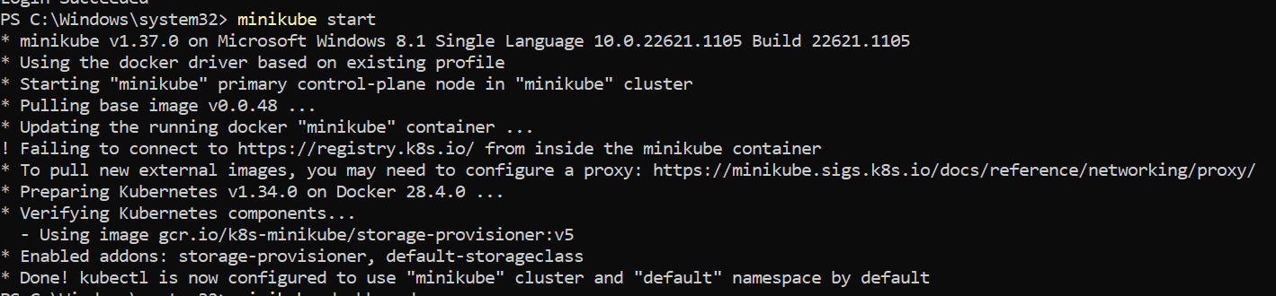
Step-3:Create an image
Step-4:Verify the deployment using kubectl get deployments command Kubernetes responds by showing you a list that includes the names of deployment groups
Step-5:Run the kubectl get pods command
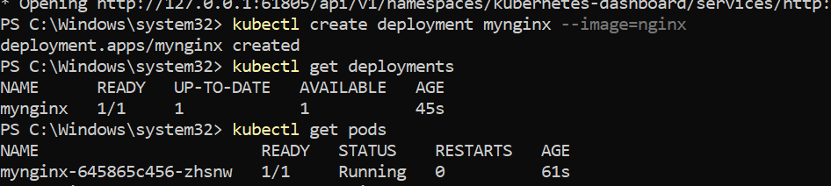

Step -6:Run the kubectl describe pods command
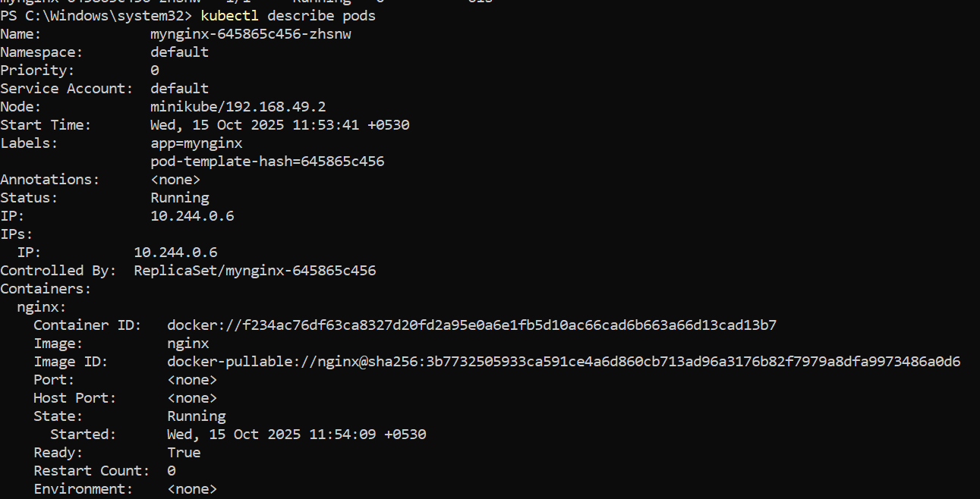
Step-7: Expose the deployment as a service
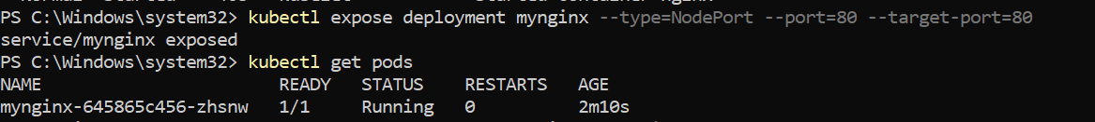
Step-8:Scales the nginx deployment to 4 replicas (pods)
- After creating the service, check its details to see which port Kubernetes assigned to it.
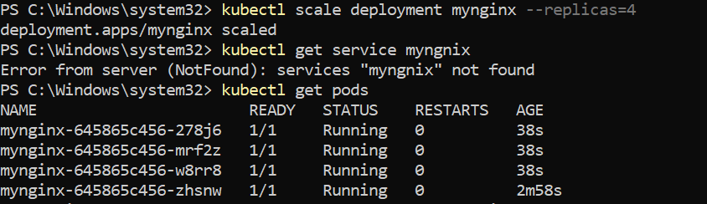
Step-9:Check the NGINX Service Details
- After creating the service, check its details to see which port Kubernetes assigned to it.
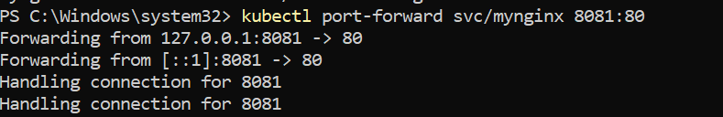
output will be displayed in http://localhost:8082
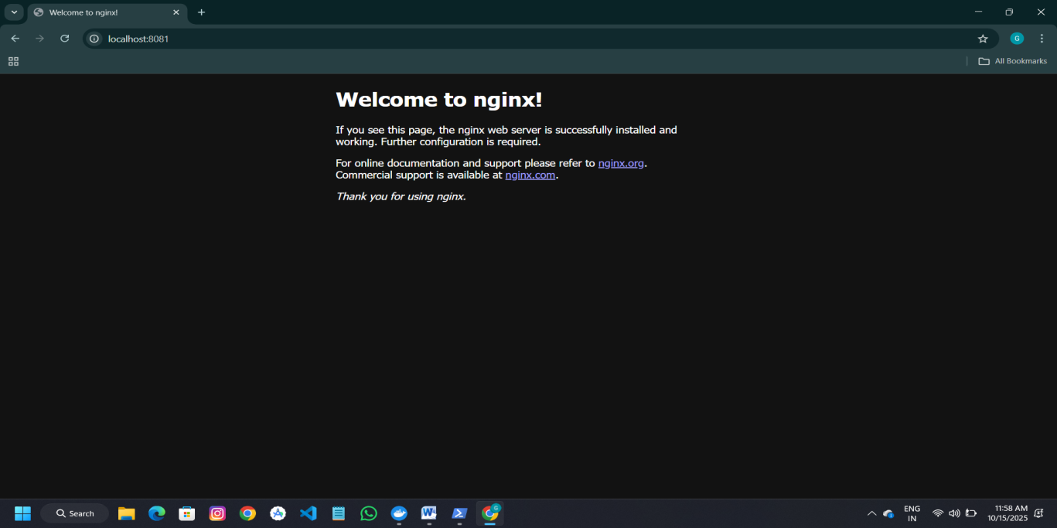

Step-10: Stop and Clean Up
- Stop Nginx Deployment:
- Stop Minikube :
- Delete Minikube :
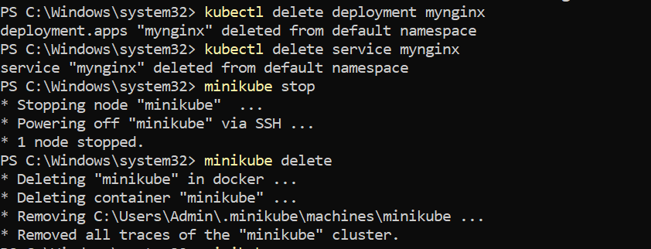

Nagios Automation Steps

Step 1: Pull the Nagios Docker Image

Open a terminal and run:

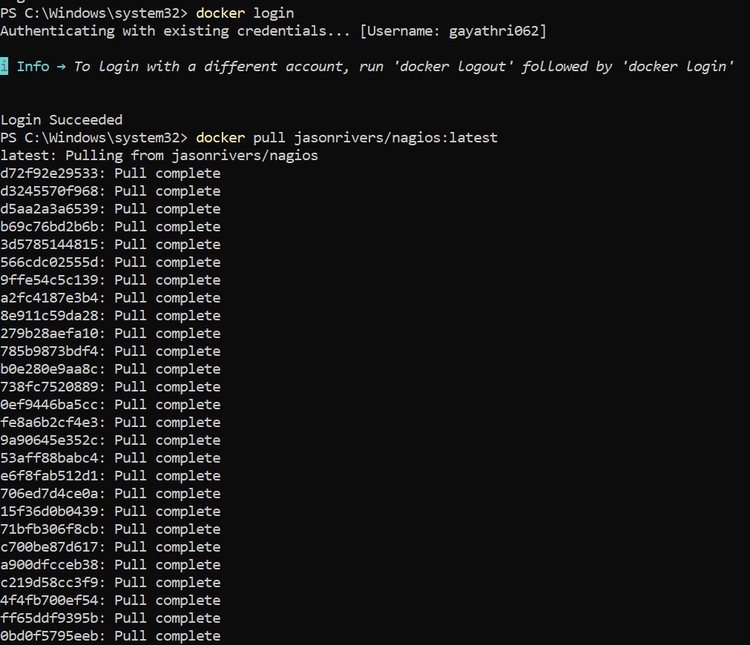

Step 2: Run Nagios:

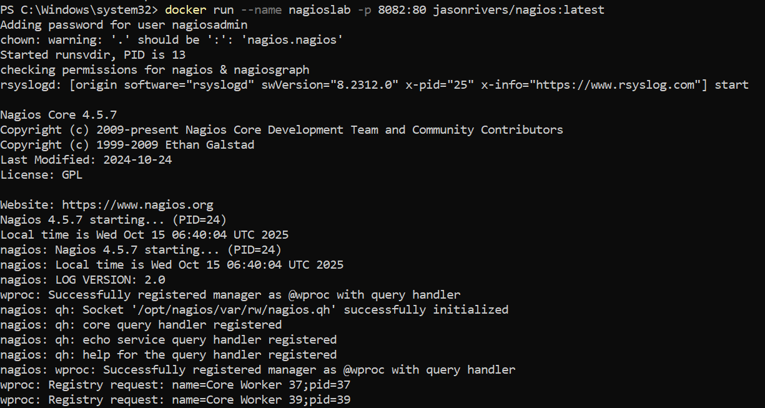

Step 3: Access Nagios Dashboard
- Open your browser and navigate to:
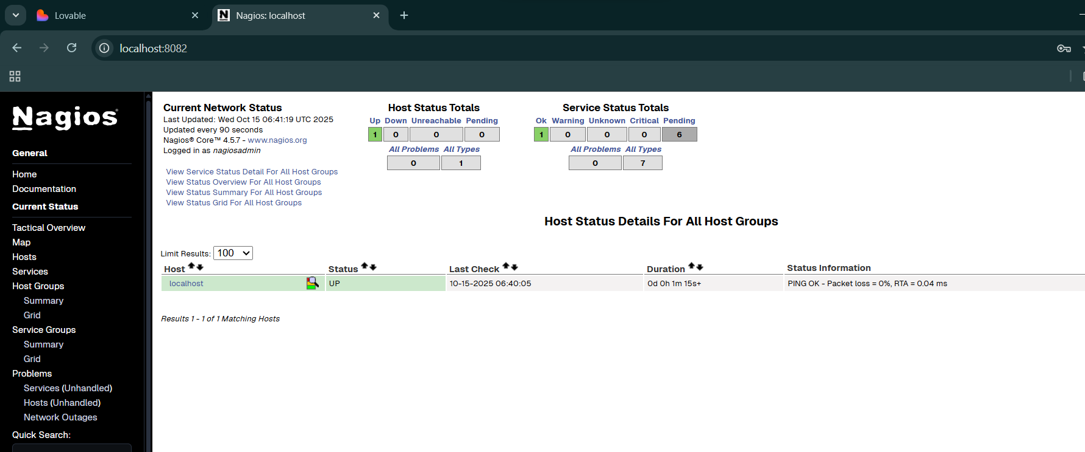
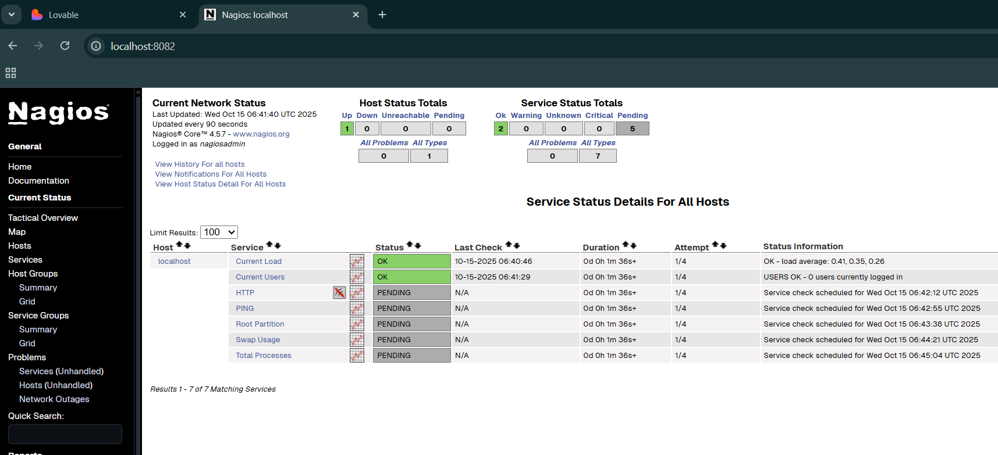
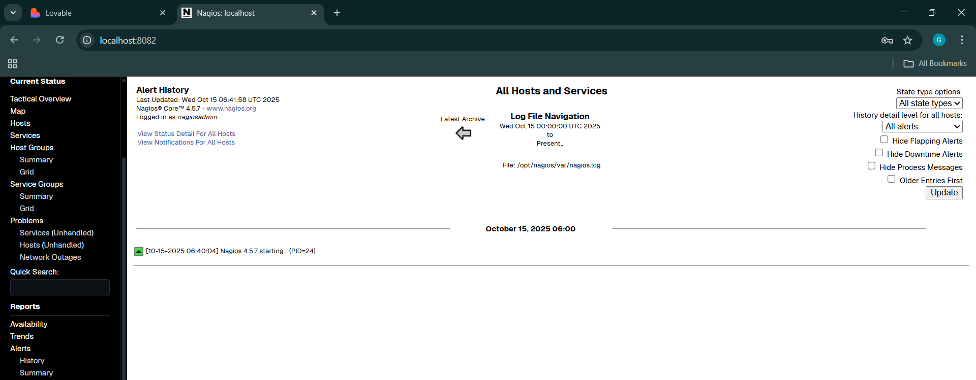

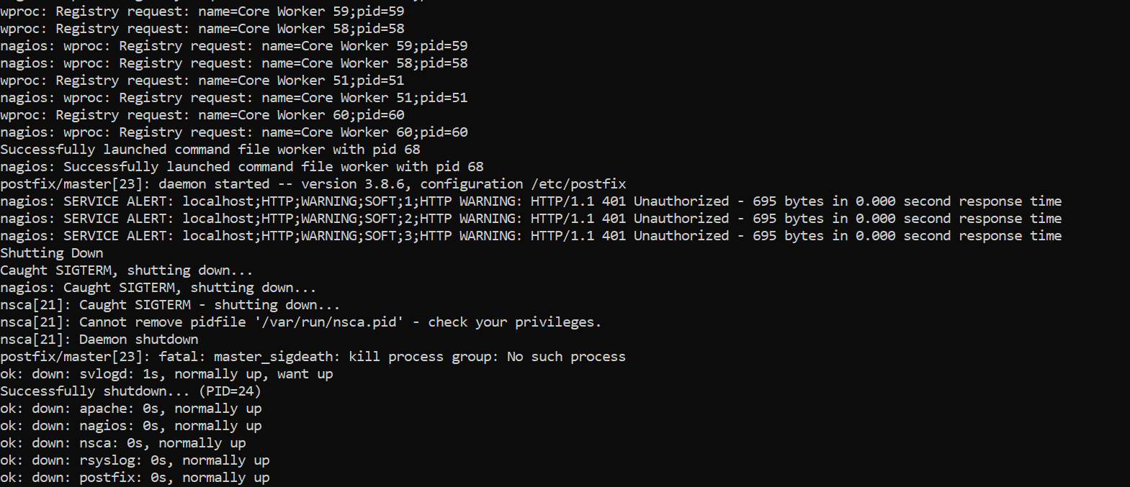

Step 5: Stop and Remove Nagios
- Stop the Container :
- Delete the Container :
- Remove the Image :

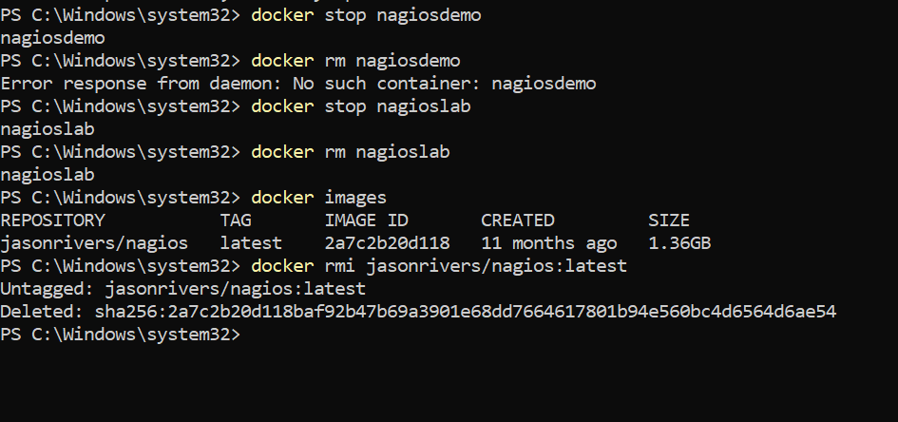

Scenario Based Questions :

1. Pod keeps restarting repeatedly. What will you do?
- Check pod logs:
- kubectl logs <pod-name> --previous
- Describe the pod for events:
- kubectl describe pod <pod-name>

2.Pod stuck in “Pending” state. Possible reasons & troubleshooting:
- Possible reasons:
  - No available nodes or resources (CPU/RAM).
  - Node selectors or taints not matching.
  - PersistentVolume not bound.
- Fix:
  - Check events: kubectl describe pod <pod-name>
  - Check node capacity: kubectl get nodes
  - Check storage claim status: kubectl get pvc

3. Debug a failed deployment in Kubernetes:
- Check deployment status:
- kubectl rollout status deployment/<deployment-name>
- Describe deployment for errors:
- kubectl describe deployment <deployment-name>

4.Some pods failing health checks — what to do?
- Describe one of the failing pods:
- kubectl describe pod <pod-name>
- Check readiness/liveness probe configs in YAML.
- Check app logs for startup or connection errors.
- Fix probe paths or delay timings, then update deployment.

5.Roll back a faulty deployment:
- View rollout history:
- kubectl rollout history deployment/<deployment-name>
- Roll back:
- kubectl rollout undo deployment/<deployment-name>

6.Debug a running pod:
- Get logs:
- kubectl logs <pod-name>
- Execute a shell inside pod:
- kubectl exec -it <pod-name> -- /bin/bash
- Check container processes, environment variables, and network access.

7.Expose a local service externally:
- Use a Service of type LoadBalancer or NodePort:
- kubectl expose deployment <name> --type=NodePort --port=80
- For local cluster (like Minikube):
- minikube service <service-name>

8.Start and Stop Nagios.
- Start:
- sudo systemctl start nagios
- Stop:
- sudo systemctl stop nagios

9. Nagios web shows “Unable to connect to Nagios process”?
- Check if Nagios service is running:
- sudo systemctl status nagios
- Restart service:
- sudo systemctl restart nagios
- Check permissions of /usr/local/nagios/var/rw/nagios.cmd.

10.New host not appearing in Nagios web interface?
- Verify host config:
- nagios -v /usr/local/nagios/etc/nagios.cfg
- Restart Nagios after config validation:
- sudo systemctl restart nagios

11.Check whether Nagios is running properly?
sudo systemctl status nagios

12. View Nagios logs in real-time.
tail -f /usr/local/nagios/var/nagios.log

13.Advantages of using Nagios ?
- Monitors servers, networks, and apps.
- Alerts on failures or downtime.
- Supports plugins for customization.
- Centralized monitoring dashboard.
- Open-source and highly extensible.

