* 1. <https://console.developers.google.com/>
  2. Oauth consent screen- give details: user type external. Add a test user for testing purposes. Can also give same in assignment while testing
  3. Machine generated alternative text:
     RPI 
     APIs & Services 
     Dashboard 
     Library 
     Credentials 
     OAuth consent screen 
     Domain verification 
     Page usage agreements 
     OAuth consent screen 
     ujwaltest 
     EDIT APP 
     Publishing status O 
     Testing 
     PUBLISH APP 
     User type 
     External O 
     MAKE INTERNAL 
     Test users 
     While publishing status is set to "Testing", only test users are able to access 
     the app. Allowed user cap prior to app verification is 1 00, and is counted over 
     the entire lifetime of the app. Learn more 
     + ADD USERS 
  4. Now go to credentials- and create oauth client ID (also see link in case of doubts below: <https://medium.com/@alexanderleon/implement-social-authentication-with-react-restful-api-9b44f4714fa>)
     1. App type: web application
     2. Authorizied Js login url: localhost:3000
     3. 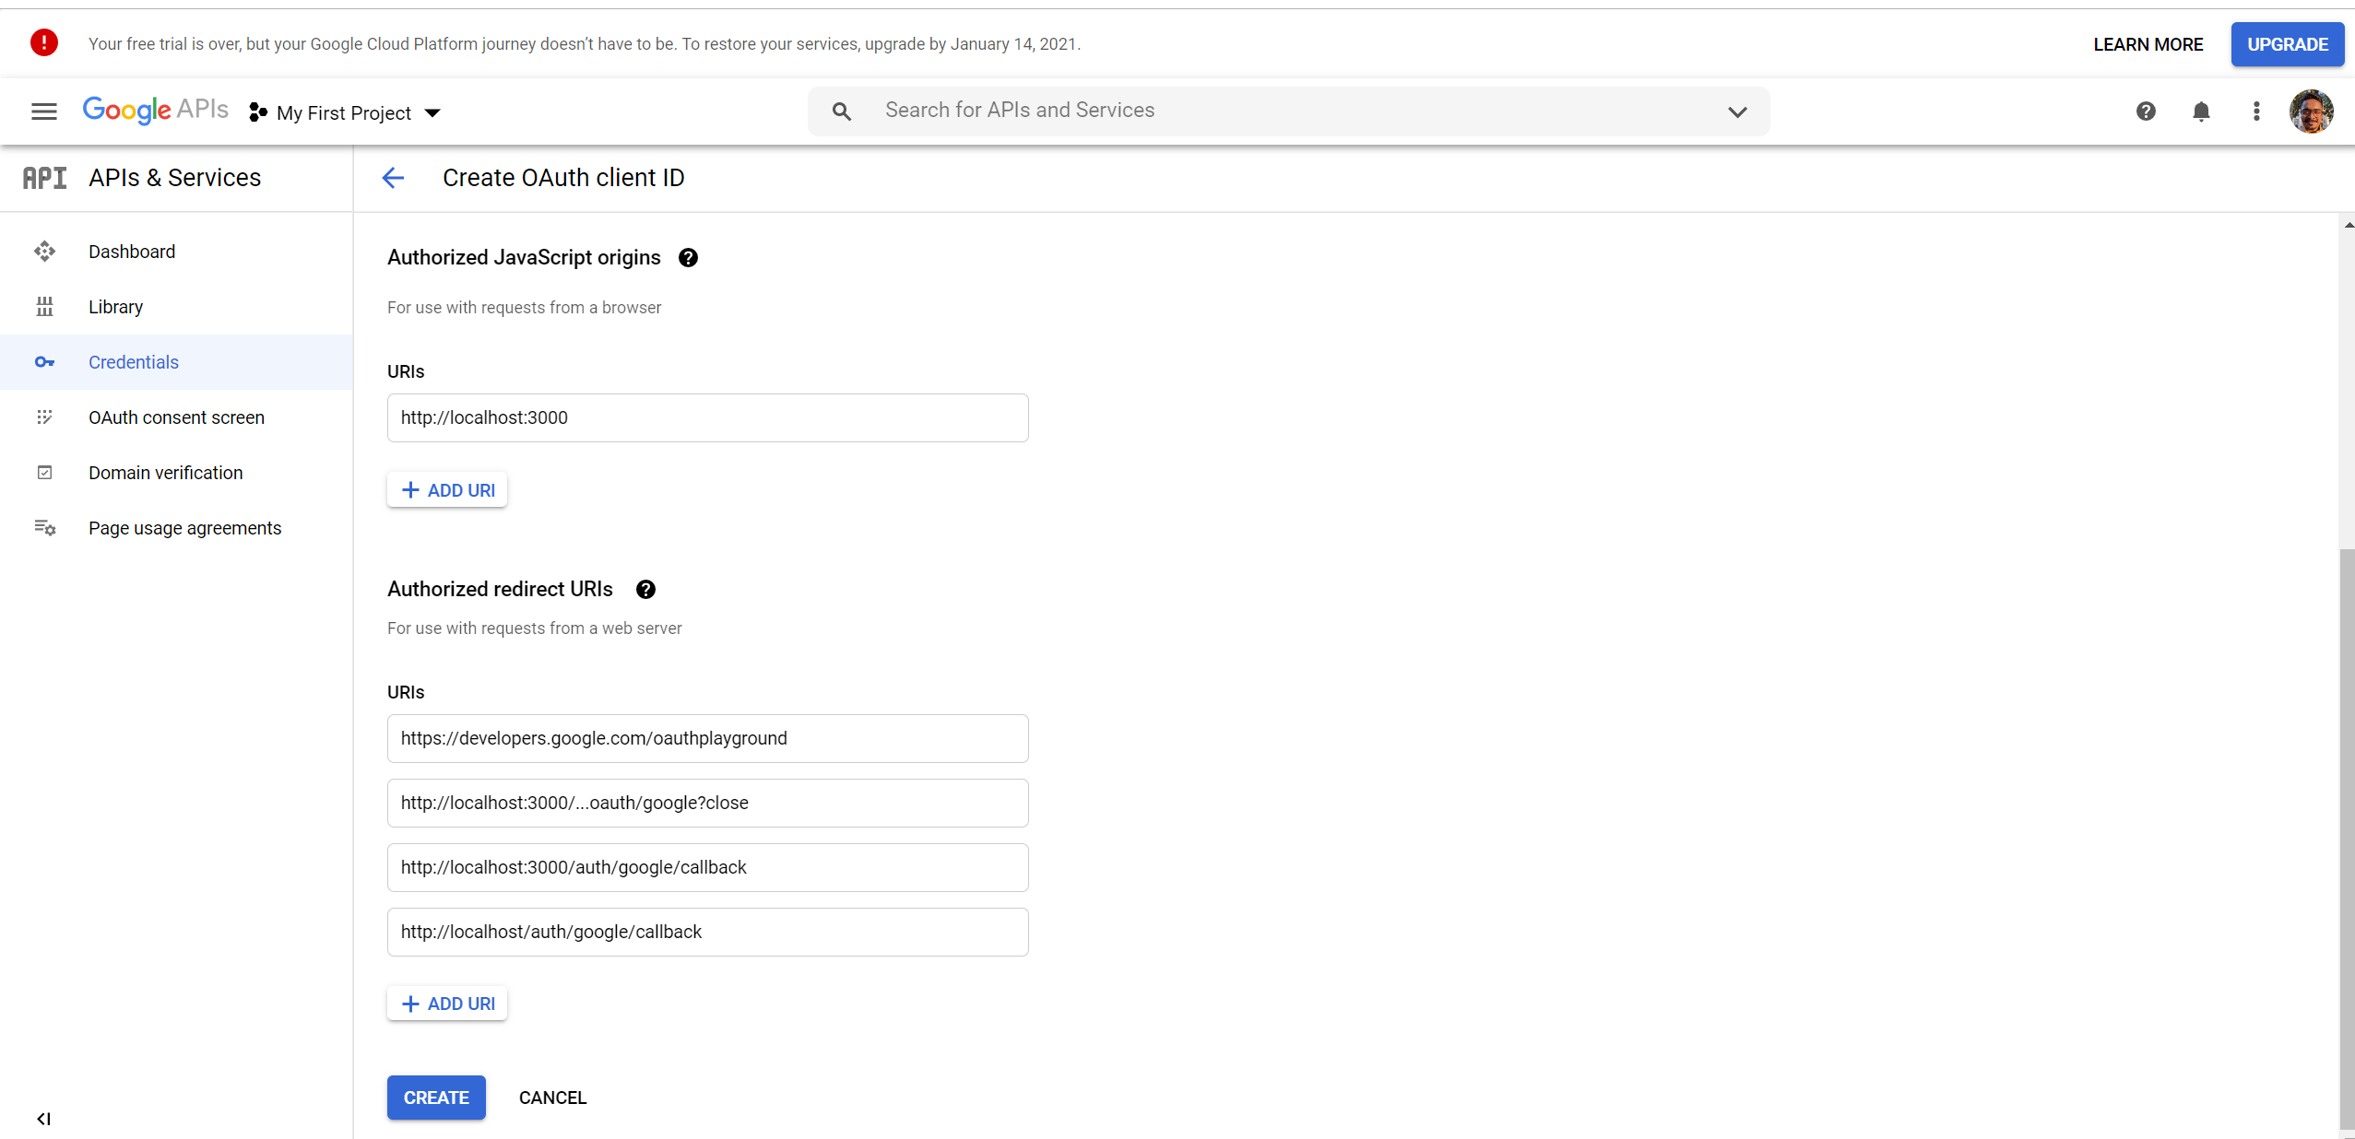
  5. Click create and save the client ID and secret displayed
     1. Client ID: s
     2. Client secret: s
  6. Lets create backend:
     1. Create a new folder called backend in ur system
     2. Open CMD- and navigate inside backend folder
     3. Execute "dotnet new webapi"- this will create the projcet
     4. A folder strucutre like this will be created:
     5. Machine generated alternative text:
        OneDrive 
        - SAP SE 
        Projects 
        Name 
        Coding Projects 
        Gmail OAuth 
        backend 
        Status 
        Date modified 
        1/1/2021 11:35 AM 
        1/1/2021 11:35 AM 
        1/1/2021 11:35 AM 
        1/1/2021 11:35 AM 
        1/1/2021 11:35 AM 
        1/1/2021 11:35 AM 
        1/1/2021 11:35 AM 
        1/1/2021 11:35 AM 
        1/1/2021 11:35 AM 
        Type 
        File folder 
        File folder 
        File folder 
        JSON File 
        JSON File 
        Visual C# Project File 
        Visual C# Source File 
        Visual C# Source File 
        Visual C# Source File 
        Size 
        > 
        > 
        > 
        > 
        > 
        > 
        > 
        > 
        OneDrive - SAP SE 
        Daily Work Update 
        Documents 
        Learning 
        Microsoft Teams Chat Files 
        Microsoft Teams Data 
        Notebooks 
        Personal 
        Projects 
        Controllers 
        Properties 
        appsettings.Development.json 
        appsettings.json 
        backend.csproj 
        Program.cs 
        Startup.cs 
        WeatherForecast.cs 
        1 KB 
        1 KB 
        1 KB 
        1 KB 
        2 KB 
        1 KB 
  7. Now add the below packages into the project (run in same CMD window, in same backend folder):

dotnet add package Google.Apis.Auth

dotnet add package Newtonsoft.Json

dotnet add package Serilog

dotnet add package Serilog.Sinks.Console

* 1. Now open the project is normal Vs or VS code
  2. Program.cs before change:
  3. Machine generated alternative text:
     anamespace backend 
     8, 
     8, 
     8, 
     public class Program 
     public static void Main(string[] args) 
     CreateHostBui1der(args) . Build() . Run() ; 
     public static IHostBui1der CreateHostBui1der(string[] args) 
     Host . CreateDefau1tBui1der (args) 
     . ConfigureWebHostDefau1ts(webBui1der 
     webBui1der . ; 
  4. Startup.cs before change:
  5. 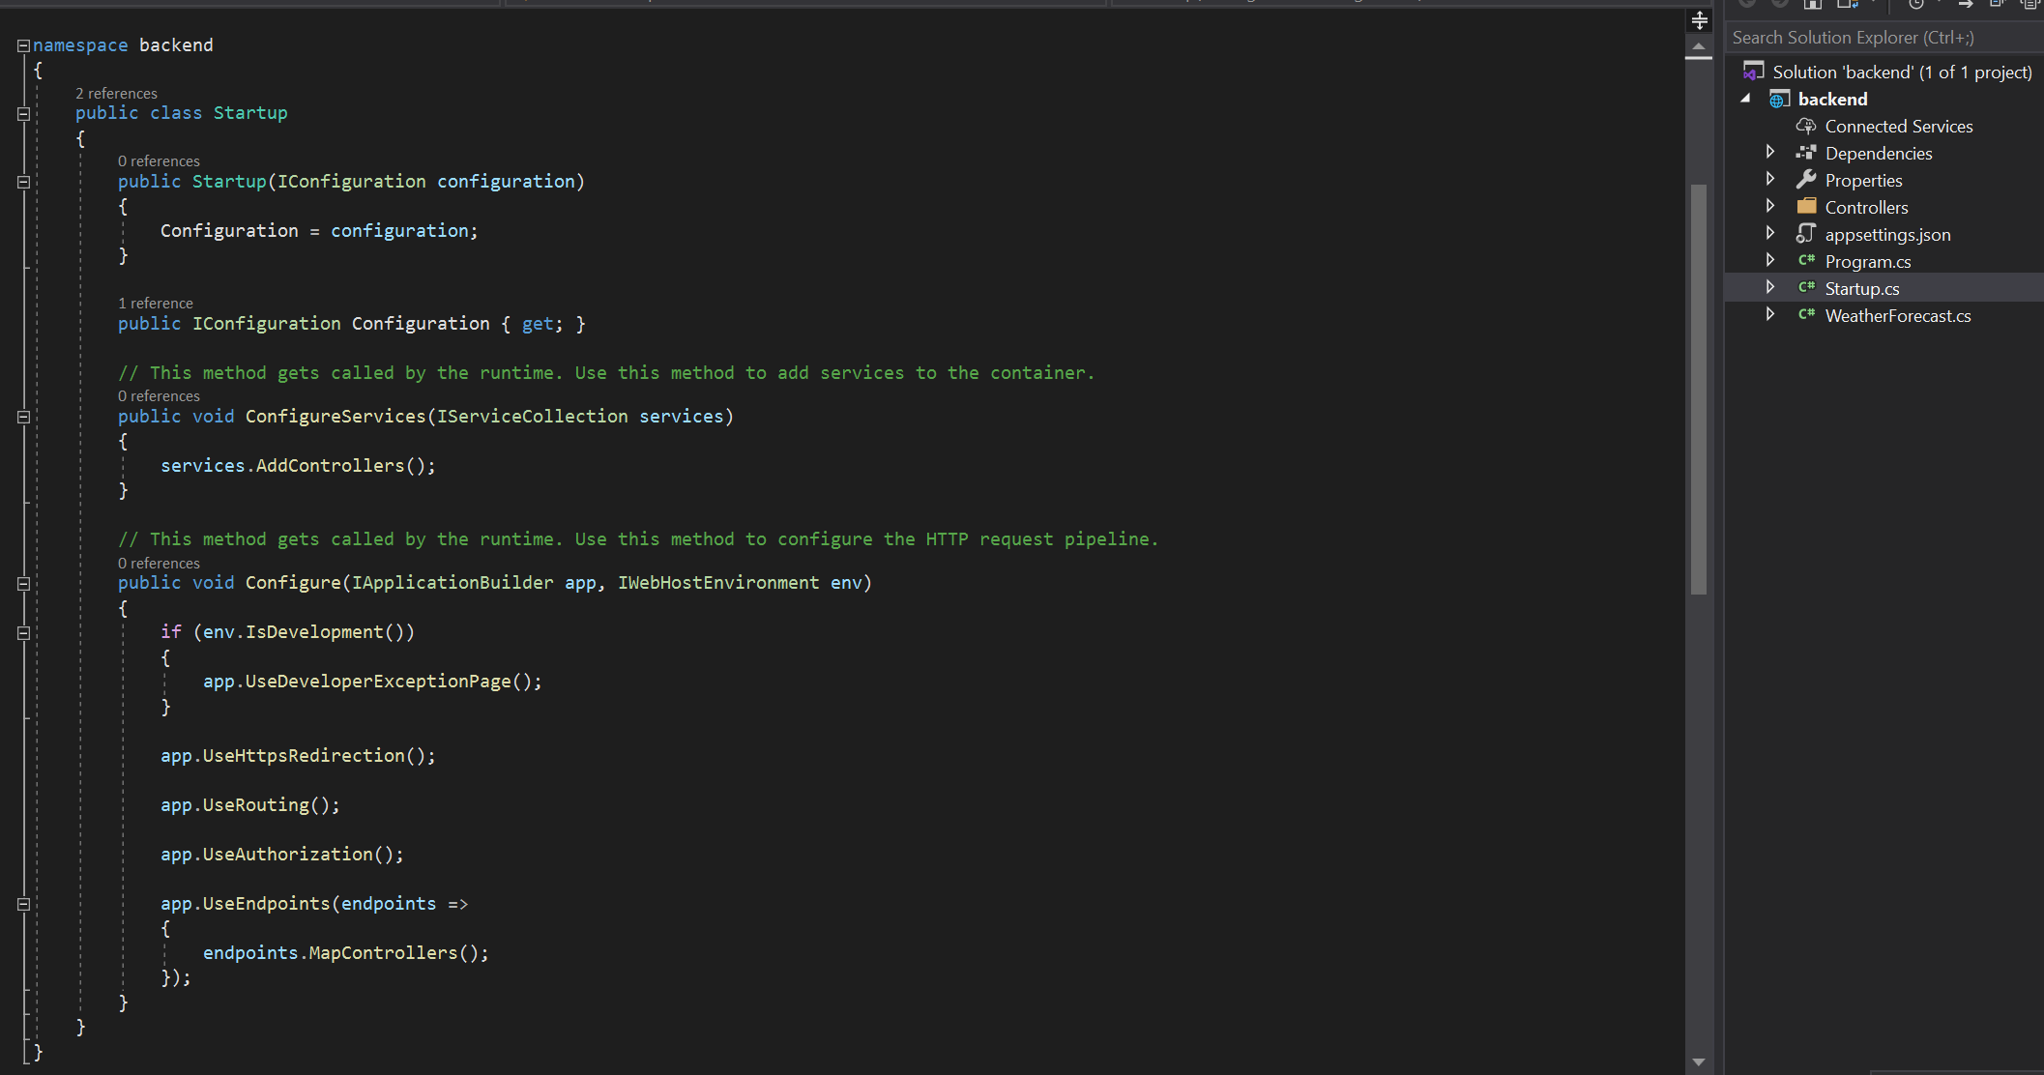
  6. In frontend folder, first run "npm install"
  7. npm run-script build
  8. npm start