TAKEAWAY SYSTEM

UIT2211 – SOFTWARE DEVELOPMENT PROJECT –I

A PROJECT REPORT

Submitted by
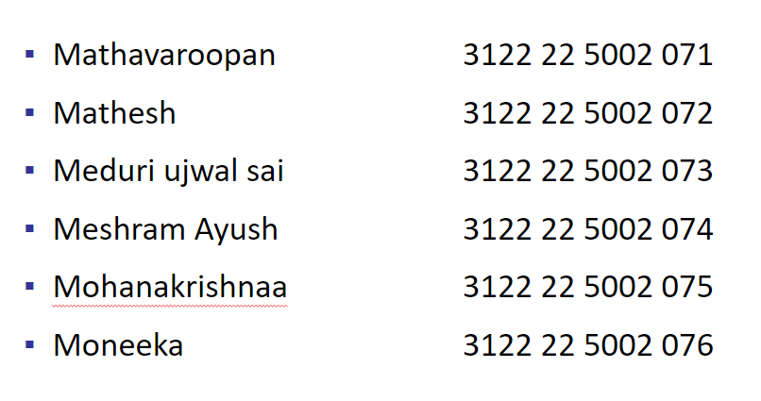
3122 22 5002 076

SSN COLLEGE OF ENGINEERING,
KALAVAKKAM

AUGUST 2022

- Abstract of the project

Problem description:
The hotel needs a take-away management system to handle their menu, assign order tokens, calculate bill amounts, confirm orders upon payment, and send notifications to customers and the manager. The system should allow the manager to view order and item lists, and notify customers when their orders are ready for pickup

Motivation:
1. Simplify and enhance the take-away experience with an efficient system for menu management, order assignment, and bill generation.
2.Errors, and boost customer satisfaction with automated notifications and order tracking for seamless order fulfillment.

Objective:
To provide a user friendly interface to order the food. To reduce the crime happening in the hotel

Client description:

- Requirements Specification of the project
- List all Functional modules.
- Digital food ordering system
- Automatic bill generation
- Displaying recent orders to the manager
- To make the food production department’s job easier
- To reduce the crime happening in the shop

- Use the following format to represent all modules in terms of epic, user stories under each epic

Sprint # | Epic | User Story # | Requirement / User Story | Essential or Desirable | Description of the Requirement | Remarks
1 | Login/signup page | 1 | User-friendly interface for login page | Essential | To get the user details and use them for further process. | The user should be asked to fill his details with a smooth and good-looking interface.
1 | Login/signup page | 2 | Adding features like OTP verification while signing up | Desirable | An OTP should be created for user authorization. | The OTP should expire after some certain time limit.
2 | Menu system | 1 | Create a linked queue data structure where every node is a customer | Essential | Queues are used as it follows First In First Out (FIFO) order which is the required condition here. | Nodes should be properly created and linked as a proper queue.
2 | Menu system | 2 | Create a hashmap datastructure for food production department | Essential | To know the customers details based on the ordered items. | Proper hashing to customer (which is in queue ) should be made.

3.Implementation and Risk Management [Individual contribution]
Name and Register number of the student: Mathavaroopan sivakumar
Role in the project:
- Implementation
Sprint # | Epic | User Story # | Requirement / User Story | Remarks on implementation
1 | Manager’s system | 1 | Shifting data from the data structure to the manager’s page and food production department page | No data loss should occur while transporting data.
1 | Manager’s system | 2 | Creating a clear cut interface for the manager | Display every aspect such as paid status, bill number etc.
2 | Food production department – Order displaying system | 1 | Create a user-friendly interface to display the number of items to be prepared and the customers waiting in the queue | Create a checklist for the food production department to keep track of the orders.
2 | Food production department – Order displaying system | 2 | Build a system to send a notification to the customer once the order is ready | No delay should be there. Lag should be minimal

- Risk Management [Sprint wise]
Risk # | Risk Description | Probability | Impact | Mitigation Plan
1 | Excessively sending emails
2 | Delay in Receiving emails
3

- Test Log report [Mention the test case that covers all user stories under each epic]
TC id | RS # | Test case description/ condition | Test case input | Expected Output | Result (PASS/ FAIL)
 |  | Appending customers and their orders in the linked queue data structure | Customer details – customer_id, verificatioon, order_head and a linkedlist of ordered items | Successfully appending the data on the data structure | PASS

- Project progress [Sprint wise Burn-up and Burn-down chart]
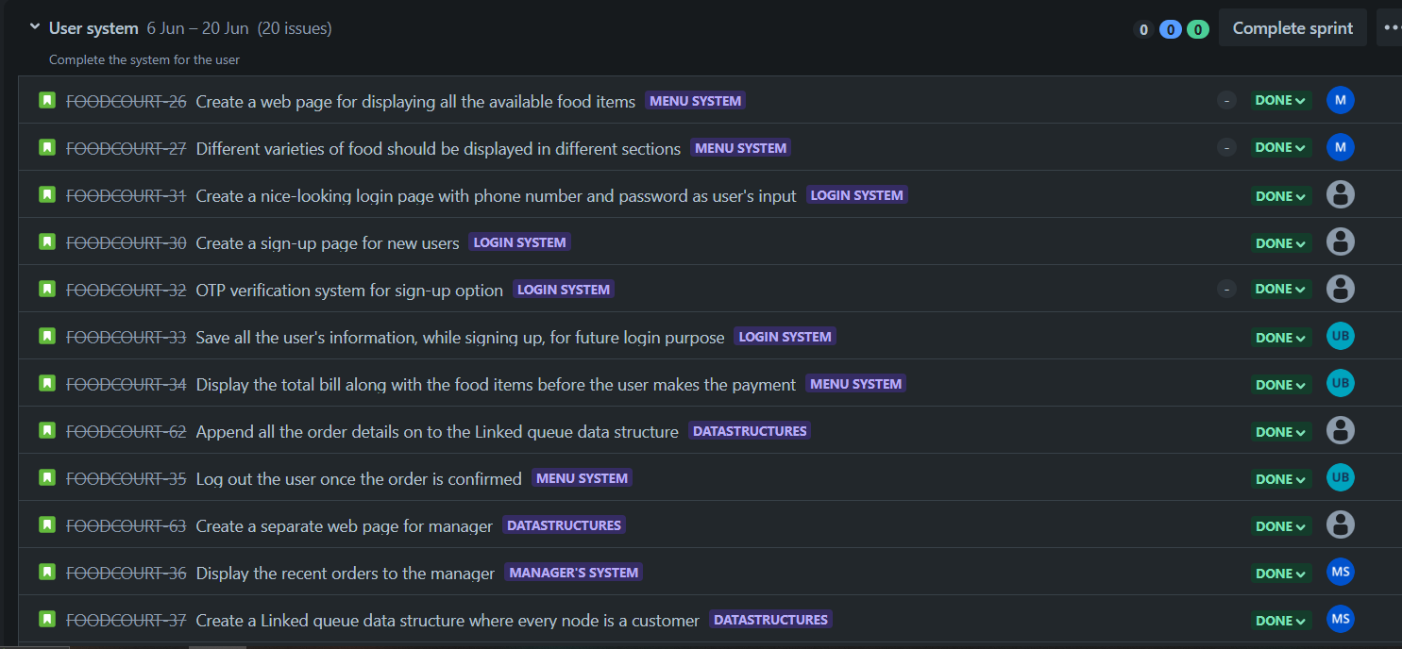
- Reports [Generated from JIRA tool – Product requirement, Decision, Meeting Notes]
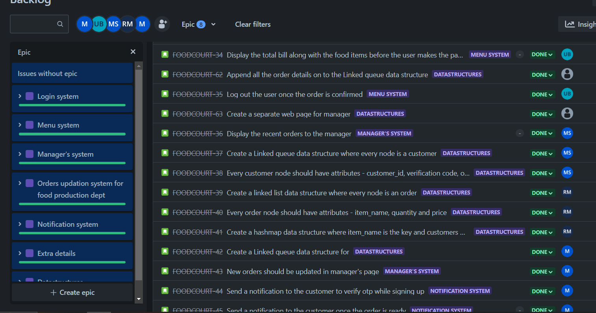

- Results [Screen shots and important code snippets with description]
FRONT END:
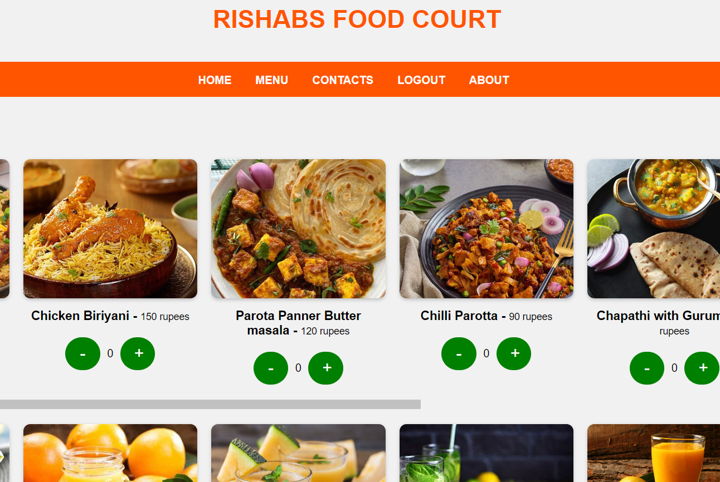

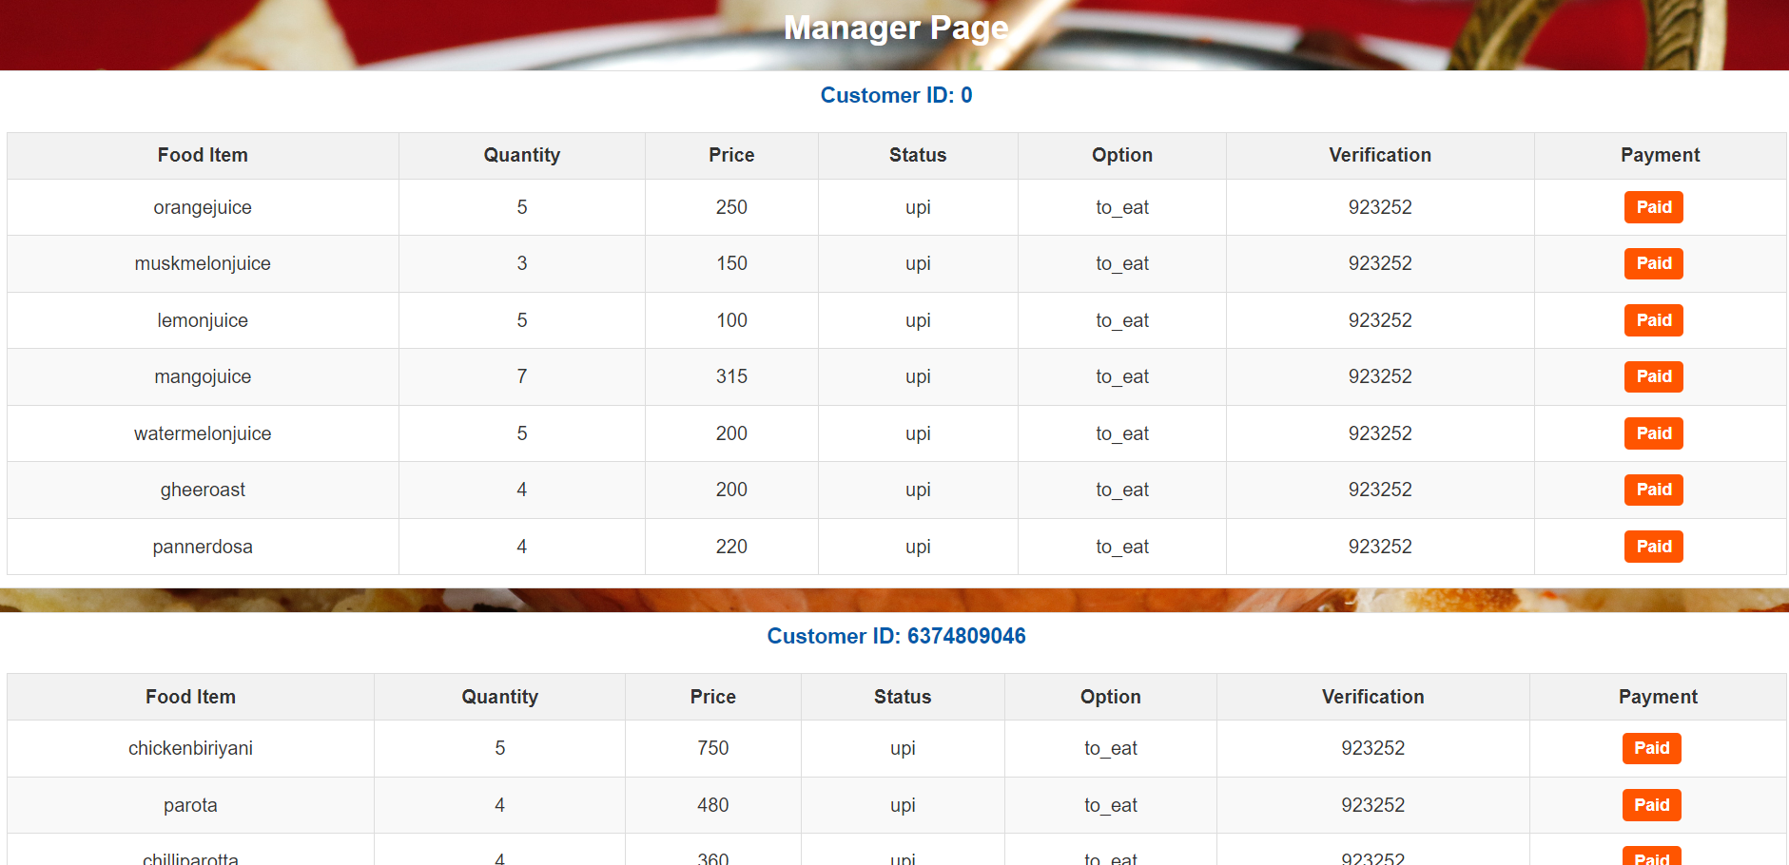

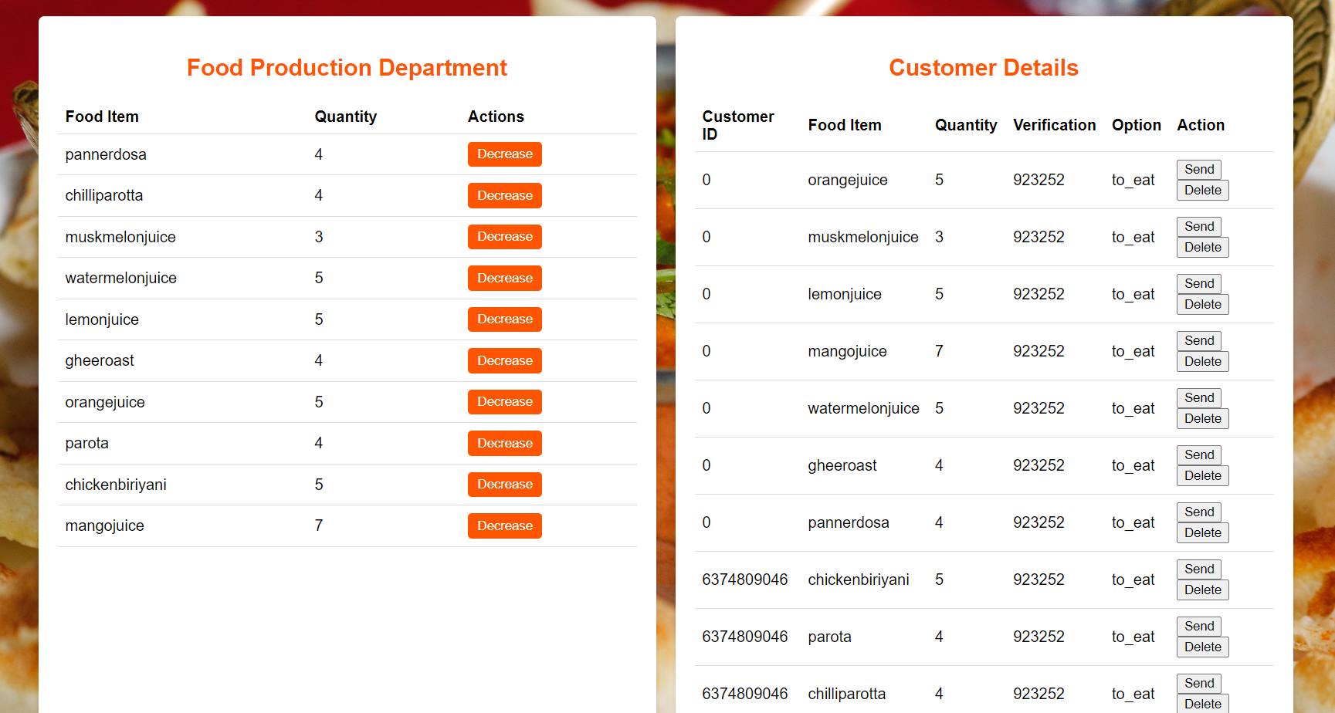

DATA STRUCTURES
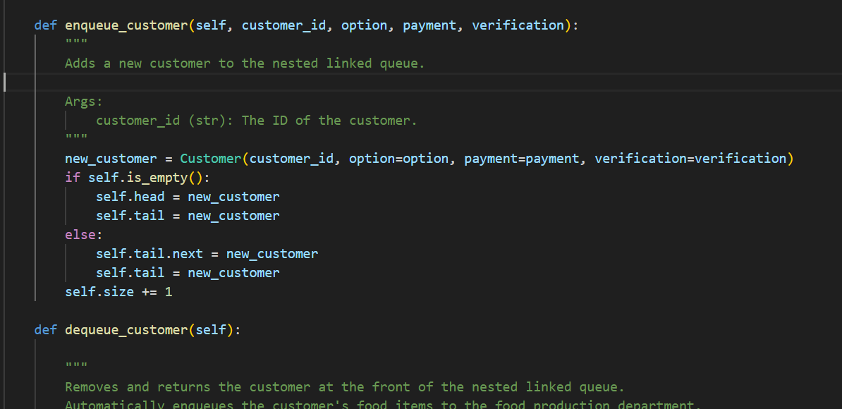

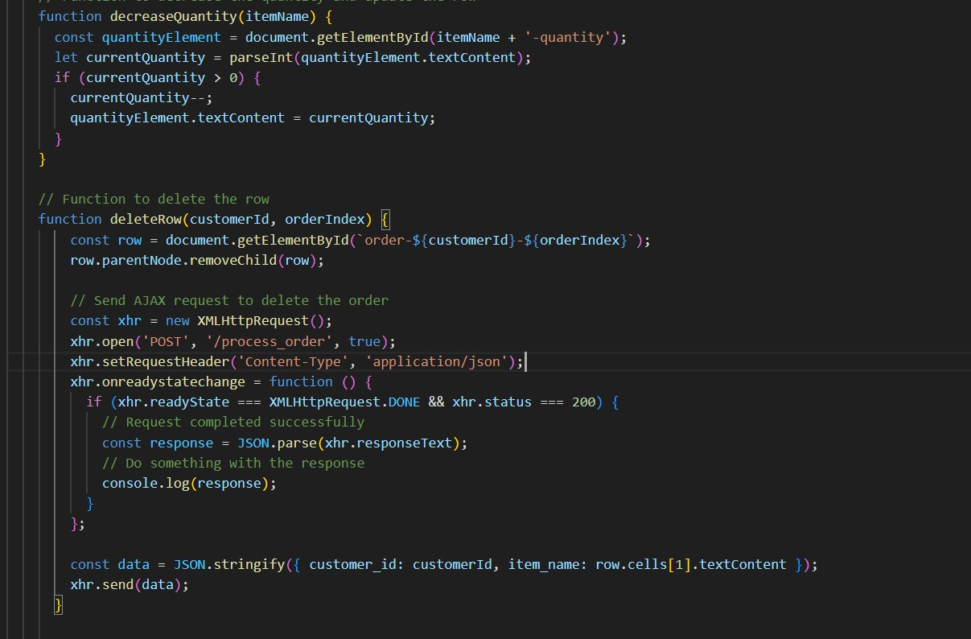
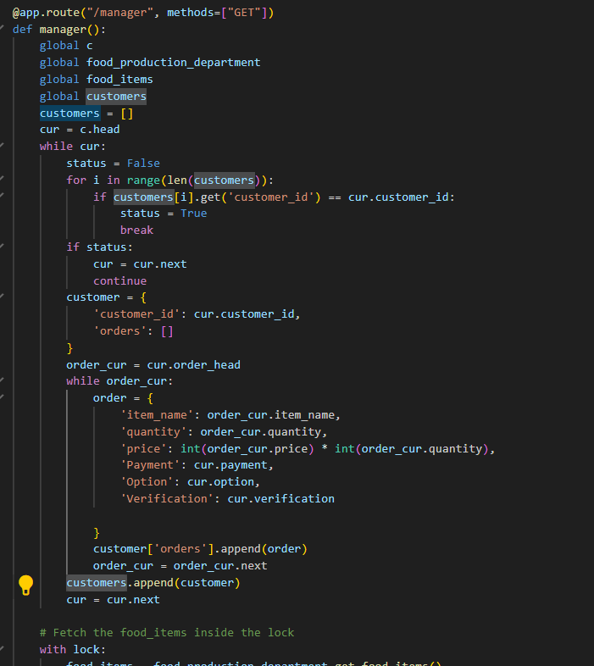

BACK-END (CSV FILES)
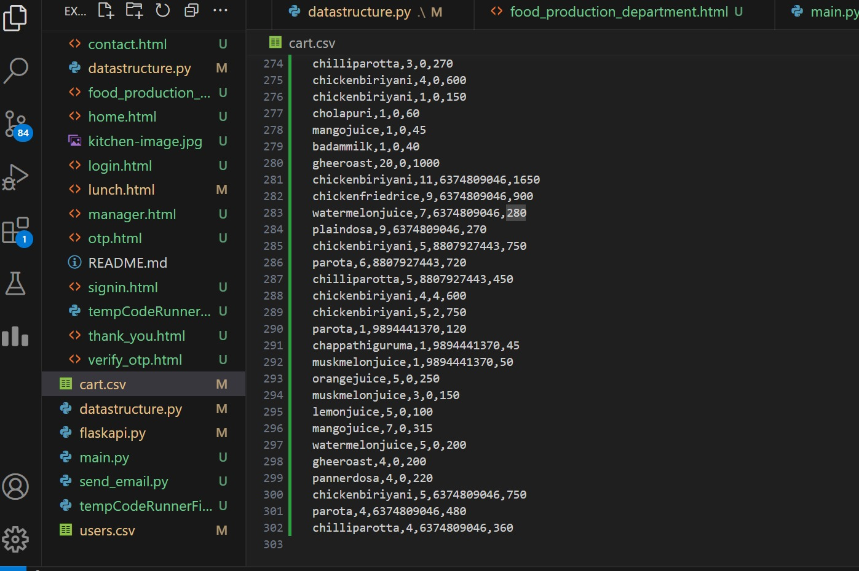

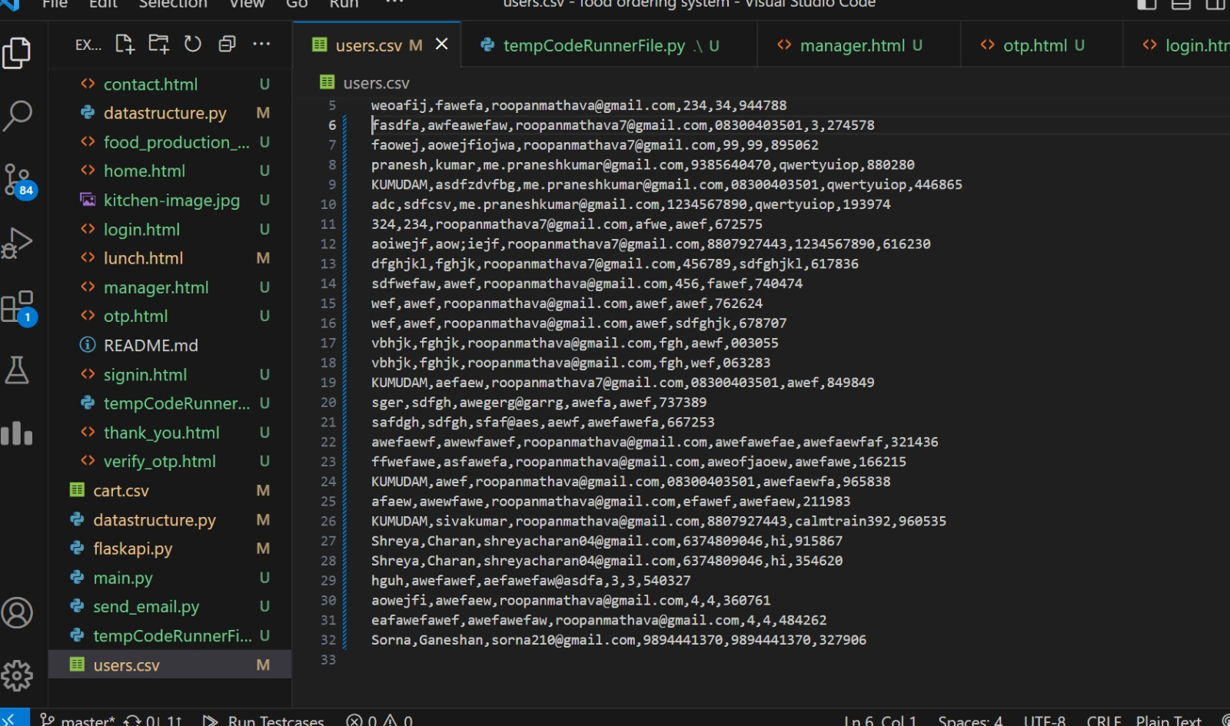

- Client evaluation report

- Conclusion

- The takeaway system has been successfully implemented and it can be used to successfully improve time management and efficiency in Rishabs Food Court.
- Users can easily login or sign up and order their desired items and collect them without unnecessary waiting time.
- This software helps Rishabs in easy management of customers by using the available functionality in them.

- References
https://realpython.com/tutorials/flask/
https://www.youtube.com/watch?v=MwZwr5Tvyxo&list=PL-osiE80TeTs4UjLw5MM6OjgkjFeUxCYH
https://www.youtube.com/watch?v=G3e-cpL7ofc&t=1840s&pp=ygUIaHRtbCBjc3M%3D

CLIENT EVALUATION REPORT

Name of the project:
Team Members:
Client details:
Rating System - 1: Strongly disagree 2: Disagree 3: Neutral 4: Agree 5: Strongly Agree
Questions | 1 | 2 | 3 | 4 | 5
The problem was well discussed and, the requirements and goals were clear.
The project plan was well defined and communicated from the start.
The resources were adequate for achieving the goals.
The original timeline was realistic and was followed.
The teamwork was well demonstrated.
The client was communicated on regular intervals and given updates on the progress of the project.
The expected project requirements have been satisfied.

