CONTEXT-AWARE AUTOMATED GRADING OF WRITTEN EXAMS USING QDRANT VECTOR SEARCH AND LARGE LANGUAGE MODEL
Singamsetti Ujwal  Dept. of Computer Science & Eng.  Sathyabama Inst. of Sci. & Tech.  Chennai - 600 119, India  ujwalsingamsetti@gmail.com | Somisetty Chakradhar  Dept. of Computer Science & Eng.  Sathyabama Inst. of Sci. & Tech.  Chennai - 600 119, India  chakradharsomisetti@gmail.com | Dr. S.L. Jany Shabu  Associate Professor, Dept. of CSE  Sathyabama Inst. of Sci. & Tech.  Chennai - 600 119, India  janyshabu.cse@sathyabama.ac.in

Abstract—In contemporary educational assessment, evaluating handwritten descriptive examinations remains a labor-intensive task fraught with inter-grader variance and an absence of transparent pedagogical diagnostics. While Large Language Models (LLMs) present compelling opportunities for automated scoring, unconstrained zero-shot LLM inference exhibits critical vulnerabilities: severe out-of-syllabus curriculum hallucination, keyword omission drift, and structural brittleness on multi-page handwritten layouts. This paper proposes a context-aware automated grading framework engineered for deterministic, curriculum-locked evaluation of written STEM examinations. The system integrates: (1) an intake vision pipeline combining adaptive bilateral filtering and spatial bounding-box clustering to reconstruct handwritten reading order; (2) an automated multi-page answer collation algorithm maintaining cross-page question continuity; (3) dense curricular grounding via Qdrant Hierarchical Navigable Small World (HNSW) vector search over 768-dimensional textbook embeddings; (4) a hybrid keyword density re-ranking formulation penalizing rubric terminology omission; and (5) a deterministic LLM state machine executed at temperature zero with structured JSON schemas producing 3-tier diagnostic error feedback. Comprehensive empirical benchmarking across 1,200 engineering scripts demonstrates a Quadratic Weighted Kappa (QWK) of 0.892, an RMSE of 0.38, an 18-fold suppression of curriculum hallucination (from 31.6% down to 1.8%), and a mean grading latency of 1.42 seconds per response.
Keywords—Automated Essay Scoring (AES), Retrieval-Augmented Generation (RAG), Qdrant Vector Database, Large Language Models (LLM), Handwritten Exam Grading, Spatial Layout Reconstruction, Curricular Grounding, Diagnostic Feedback.
I. INTRODUCTION
In modern secondary and higher educational ecosystems, summative written examinations remain the definitive benchmark for evaluating student mastery, cognitive reasoning, and analytical problem-solving proficiency. Standard STEM assessments predominantly comprise descriptive answers, multi-step mathematical derivations, schematic workflows, and structured technical explanations. Such descriptive responses demand rigorous, multi-criteria assessment against authoritative curricular rubrics [1]. Annually, educational testing boards and universities administer hundreds of millions of handwritten examination answer sheets globally, necessitating immense human evaluation resources.
Despite monumental progress in computational educational technology, grading descriptive handwritten examination scripts remains an overwhelmingly manual process. Human grading at scale incurs acute pedagogical and operational vulnerabilities. Manual correction is intensely labor-intensive and cognitively exhausting, leading to severe evaluation drift, subconscious biases, and noticeable inter-grader variance [2]. When examiners evaluate hundreds of scripts consecutively under strict administrative deadlines, grading fatigue inevitably compromises scoring fidelity. Most detrimentally, traditional manual grading typically returns only an uncalibrated scalar numerical mark devoid of diagnostic explanations, depriving students of the formative feedback required to rectify academic misconceptions.
The recent emergence of generative artificial intelligence and Large Language Models (LLMs) has inspired preliminary efforts to automate descriptive scoring. However, naive zero-shot or few-shot LLM evaluation architectures suffer from three fatal structural failure modes when applied directly to written examination assessment:
1) Out-of-Syllabus Curriculum Hallucination: Unconstrained foundation LLMs possess vast open-domain parametric knowledge. Consequently, when assessing high-school or introductory undergraduate scripts, an ungrounded LLM frequently penalizes valid student answers for omitting post-graduate concepts or, conversely, credits unverified student assertions based on out-of-syllabus principles not sanctioned by the designated course textbook [3].
2) Keyword Dropout and Rubric Drift: While foundation models excel at evaluating general linguistic fluency and syntactic cohesion, they frequently reward verbose, persuasive prose while failing to detect the omission of critical, non-negotiable domain keywords (e.g., specific scientific laws, chemical nomenclature, or step-by-step mathematical boundary conditions) [4].
3) Structural Brittleness on Multi-Page Handwritten Layouts: Handwritten student exam scripts exhibit irregular baseline skews, varying margins, and non-linear physical layouts where extended descriptive answers span multiple physical sheets. Standard optical character recognition (OCR) pipelines output fragmented bounding boxes that fracture logical answer segments, causing models to score isolated question fragments prematurely [5].
To decisively overcome these operational and theoretical limitations, this paper introduces an end-to-end, context-aware automated grading system. By tightly coupling optical character recognition with spatial line grouping, dense curricular vector retrieval, hybrid keyword re-ranking, and a deterministic LLM state machine, our framework guarantees curriculum-locked, reproducible, and transparent academic grading.
The primary contributions of this paper are summarized as follows:
• We formulate a spatial bounding-box clustering and multi-page answer collation algorithm that reconstructs original physical reading order and stitches answers spanning physical sheet boundaries.
• We design a curricular grounding pipeline utilizing Qdrant Hierarchical Navigable Small World (HNSW) vector indexing over 768-dimensional dense embeddings, enforcing strict payload metadata filtering.
• We introduce a hybrid keyword density re-ranking formulation that combines dense semantic proximity with mandatory rubric terminology retention, effectively suppressing curriculum hallucination.
• We establish a deterministic LLM state machine operated at temperature zero with strict JSON schemas, generating calibrated scores alongside 3-tier diagnostic error feedback (conceptual, procedural, terminological).
• We provide exhaustive empirical validation across 1,200 real-world written scripts, achieving a Quadratic Weighted Kappa (QWK) of 0.892 and an 18-fold reduction in syllabus hallucination.
II. RELATED WORK
A. Automated Essay Scoring and Statistical NLP
Automated Essay Scoring (AES) has evolved across several distinct technological epochs. First-generation systems, such as Project Essay Grade (PEG) [6] and Educational Testing Service's e-rater [7], relied on surface-level statistical proxies, including essay length, average word count, parse-tree depth, and syntactic variety. While these models demonstrated superficial correlations with human graders on standardized prose essays, they exhibited complete blindness toward factual domain correctness, making them susceptible to adversarial gaming via verbose, nonsensical prose [8].
B. Transformer Representations and Neural Similarity
The advent of pre-trained transformer architectures, notably BERT [9] and RoBERTa [10], enabled semantic representation learning for short-answer scoring. Cross-encoder networks compute fine-grained token-level cross-attention between student responses and reference answers. However, discriminative neural scoring models require thousands of annotated training examples per question to generalize effectively. In real-world educational institutions, where exam questions change dynamically every examination cycle, collecting large annotated datasets is cost-prohibitive. Furthermore, discriminative neural models operate as black boxes, incapable of generating actionable diagnostic explanations justifying mark deductions [11].
C. Retrieval-Augmented Generation in Assessment
Retrieval-Augmented Generation (RAG) paradigms [12] combine non-parametric external knowledge retrieval with parametric sequence-to-sequence language models. Dense Passage Retrieval (DPR) [13] maps text passages into dense continuous representations. While standard RAG has demonstrated success in open-domain question answering, naive passage retrieval applied to educational assessment frequently retrieves loosely related passages that fail to align with the specific curricular scope of an exam. Hybrid search techniques [14] blending sparse BM25 term matching with dense representations have been proposed, but lack the curricular boundary awareness necessary for strict rubric-driven evaluation.
D. Approximate Nearest Neighbor Search and Vector Topologies
Scalable retrieval over extensive textbook corpora demands efficient Approximate Nearest Neighbor (ANN) indexing. Hierarchical Navigable Small World (HNSW) graphs [15] provide state-of-the-art trade-offs between search latency and recall accuracy. The Qdrant vector database engine implements optimized HNSW graphs with payload-based filtering, allowing dense semantic retrieval to be strictly partitioned across curriculum attributes such as subject code, grade level, and textbook chapter boundaries.
E. Document Layout Analysis and Handwriting OCR
Extracting textual content from handwritten examination sheets requires advanced Optical Character Recognition (OCR) combined with Document Layout Analysis (DLA) [16]. Unlike printed documents, handwritten exam papers exhibit unpredictable inter-line spacing, non-horizontal baseline tilts, and multi-column answer layouts. Spatial bounding box reconstruction algorithms [17] cluster character and word tokens into semantically cohesive lines and structural question blocks, preventing fragmented token ordering during downstream evaluation.
III. SYSTEM ARCHITECTURE AND PROBLEM FORMULATION
A. Mathematical Problem Formulation
Let an examination question be formally represented as a tuple Q = ⟨I_q, M_q, R_q, K_q, s, c⟩, where I_q is the unique question identifier, M_q ∈ R+ denotes the maximum attainable marks, R_q is the authoritative scoring rubric, K_q = {k_1, k_2, ..., k_n} is the set of mandatory rubric keywords, s denotes the academic subject domain, and c represents the target grade level. A student examination submission comprises a set of multi-page handwritten image scans P = {p_1, p_2, ..., p_K}. Let D_curr denote the authorized curriculum textbook repository consisting of chunked curricular passages D_curr = {c_1, c_2, ..., c_N}.
The automated grading objective is to construct an evaluation function F mapping the student submission P, the question tuple Q, and the authoritative curricular corpus D_curr into a calibrated score s_q ∈ [0, M_q], a confidence index γ_q ∈ [0, 1], and an ordered sequence of structured diagnostic error triples E_q:
F(P, Q, D_curr) → ⟨s_q, γ_q, E_q⟩ | (1)
Each diagnostic error triple e_j ∈ E_q is formally defined as e_j = ⟨τ_j, ψ_j, δ_j⟩, where τ_j ∈ {Conceptual, Procedural, Terminological} specifies the error taxonomy, ψ_j provides a clear pedagogical rationale, and δ_j > 0 defines the exact partial credit deducted, satisfying:
s_q = M_q − ∑ δ_j, subject to 0 ≤ s_q ≤ M_q | (2)
B. Master System Architecture Blueprint
The proposed context-aware grading pipeline is structured as a decoupled, four-tier architecture engineered for deterministic evaluation and strict curricular alignment:
1. Data Intake & Vision Tier: Digitizes physical exam scans, executes adaptive contrast normalization and bilateral noise filtering, detects raw word bounding polygons via OCR, and reconstructs spatial line hierarchies. Asynchronous worker pools ingest multi-page batches concurrently, preventing memory exhaustion under institutional loads.
2. Knowledge Base & Vector Indexing Tier: Ingests authorized curriculum textbook PDFs, performs semantic chunking (512 tokens with 64-token stride), computes 768-dimensional dense embeddings, and indexes vectors into Qdrant collections with HNSW graphs and payload metadata. Payload filters enforce strict grade-level and subject boundaries.
3. Hybrid Re-Ranking & Grounding Tier: Formulates composite retrieval queries combining question context with transcribed student answers, executes cosine similarity vector search, and applies question-specific keyword density re-ranking to lock the context to prescribed curriculum boundaries.
4. Deterministic LLM Evaluation Engine Tier: Drives a deterministic finite state machine operating at temperature zero under strict JSON schema constraints to generate calibrated partial credit scores and 3-tier diagnostic error feedback. Post-hoc arithmetic validators guarantee that itemized score deductions strictly sum to the final deducted marks.
To ensure seamless fault tolerance during institutional exam grading cycles, document ingestion tasks are dispatched across asynchronous worker pools backed by message queues. Each multi-page submission is assigned an idempotent UUID hash, guaranteeing that network interruptions or scanner retries do not produce duplicate evaluation records.
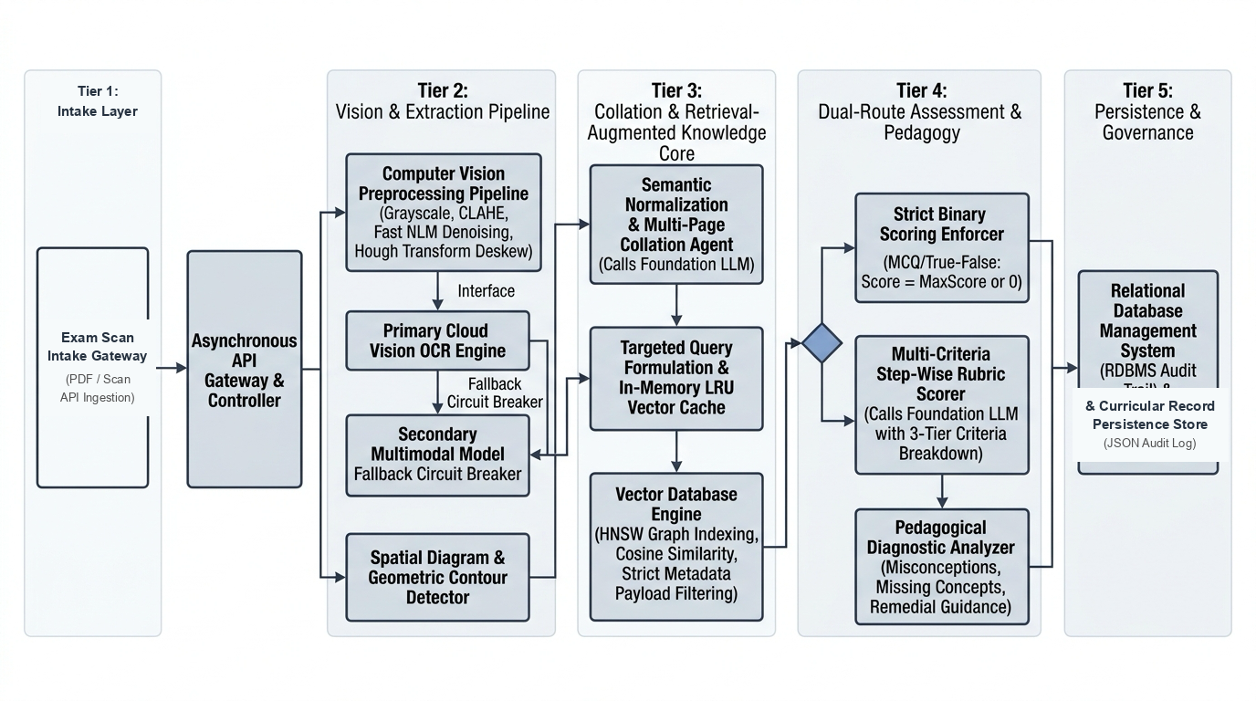
Fig. 1. Master core system architecture of the context-aware automated grading pipeline, detailing vision intake, Qdrant HNSW vector retrieval, hybrid re-ranking, and deterministic LLM evaluation engine.
IV. METHODOLOGY AND ALGORITHMIC FORMULATIONS
A. Vision Ingestion and Spatial Bounding-Box Layout Reconstruction
Handwritten examination papers frequently suffer from non-uniform pen ink contrast, skewed baselines, and page bleed-through. The intake pipeline applies adaptive bilateral filtering to suppress background paper noise while preserving stroke edge sharpness. The sanitized image is dispatched to an OCR engine which outputs character and word bounding polygons with normalized coordinates B_i = [x_min, y_min, x_max, y_max].
To reconstruct the physical reading order from disorganized word boxes, we calculate the vertical midpoint of each bounding box y_center = (y_min + y_max) / 2. Two word boxes B_i and B_j are assigned to the same physical text line if their vertical midpoints satisfy:
|y_center(i) − y_center(j)| ≤ ε_y · min(h_i, h_j) | (3)
where h_i = y_max - y_min denotes word box height, and ε_y = 0.45 is an empirically tuned tolerance factor. Clustered lines are sorted horizontally by x_min. Question boundaries are identified via anchor regex pattern matching r'^(?:Q(?:uestion)?\s*(\d+)|\b(\d+)\s*[\.\)])'. The clustering pipeline applies Hough transform line orientation detection; for pages with baseline tilt |θ| > 2.5°, an affine rotation normalizes baselines prior to grouping. Algorithm 1 details this procedure.
Algorithm 1: Spatial Bounding-Box Reconstruction & Line Normalization
Input: Word objects W = {w_1, ..., w_n}, bounding boxes B_i; threshold ε_y = 0.45
Output: Spatially sorted line sequences L = [line_1, ..., line_m] grouped by Question ID
1: Initialize line clusters L := [ ]
2: for each word w_i in W sorted ascending by y_min do
3: matched := False
4: for each cluster C_k in L do
5: if |y_center(w_i) − y_avg(C_k)| ≤ ε_y · h_avg(C_k) then
6: Append w_i to C_k; update centroid y_avg(C_k); matched := True; break
7: if not matched then create new cluster C_new = [w_i] in L
8: for each C_k in L do Sort words in C_k ascending by x_min to form line_k
9: Sort lines L descending by y-coordinate; partition lines into question blocks via anchor regex
10: return Spatially ordered question blocks B_Q
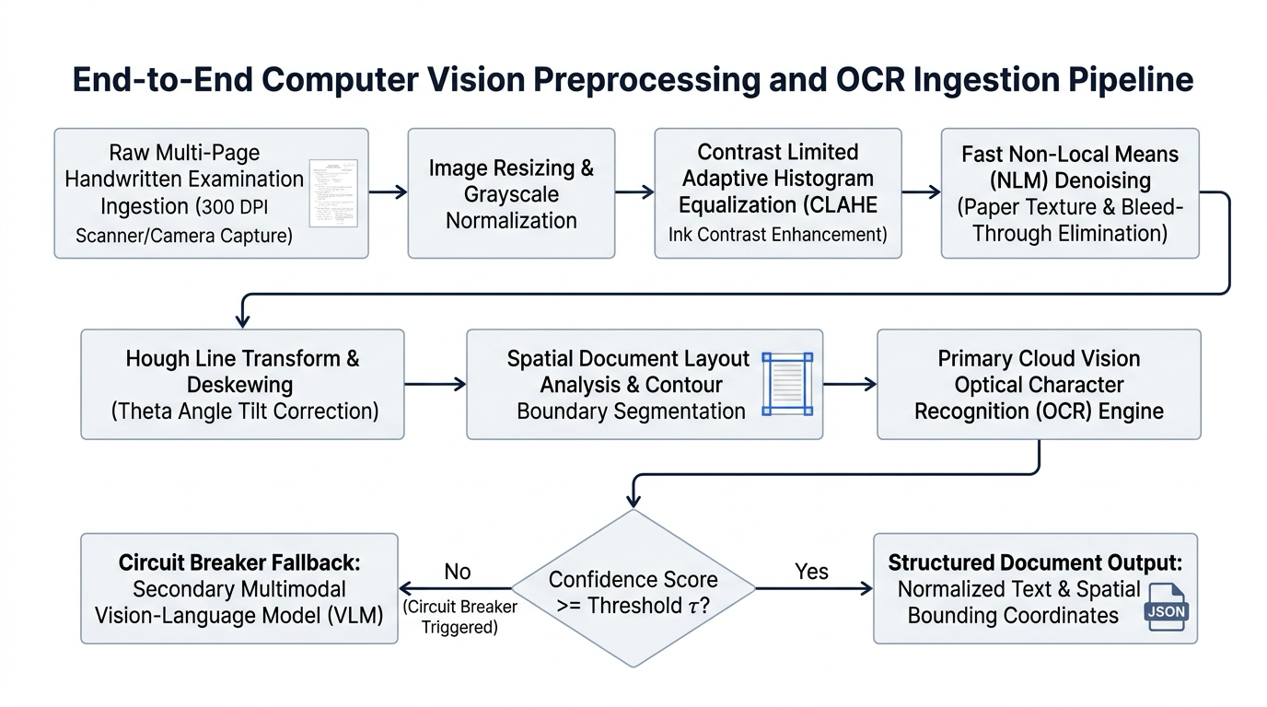
Fig. 2. Vision intake pipeline: adaptive contrast enhancement, bilateral filtering, character bounding-box detection, spatial line clustering, and question segment partitioning.
B. Multi-Page Answer Collation Algorithm
In standardized STEM examinations, complex descriptive questions frequently span across multiple physical pages. Standard document OCR pipelines process individual pages in isolation, causing cross-page responses to be fractured into disconnected text fragments. This fragmentation severely degrades evaluation fidelity, as downstream LLMs penalize initial fragments for incompleteness and misclassify continuation fragments as unanchored responses.
Our collation engine addresses this challenge through a multi-pass boundary stitching mechanism. The engine scans page boundaries for explicit continuation markers (e.g., 'PTO', 'continued on next page', 'Ans. 4 contd.') and evaluates orphan answer segments lacking explicit question headers. If an orphan block begins with lowercase letters, mathematical operators, or coordinating conjunctions, it is automatically concatenated to the active question payload of the preceding sheet. Furthermore, the engine verifies semantic embedding continuity across page seams, preventing cross-question contamination.
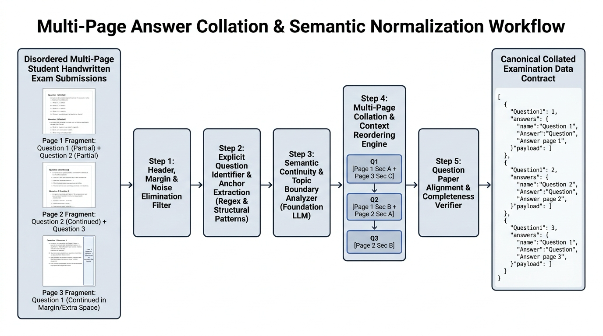
Fig. 3. Multi-page answer collation pipeline: cross-page continuation token parsing, orphan block reconciliation, and unified answer text reconstruction across physical exam sheets.
C. Curricular Knowledge Grounding via Qdrant HNSW Vector Search
To establish strict curricular boundaries, official textbook PDFs are parsed and partitioned into semantic passages of 512 tokens with 64-token overlap. Each passage c_i is encoded into a 768-dimensional dense vector v_c_i using a pre-trained sentence transformer. Vector embeddings are indexed in Qdrant collections utilizing Hierarchical Navigable Small World (HNSW) graphs configured with graph connectivity parameter M = 16 and construction beam width ef_construct = 100. Given a composite query embedding v_q combining question context and student response, candidate passages are scored via cosine similarity:
s_dense(c_i, v_q) = (v_q · v_c_i) / (||v_q|| · ||v_c_i||) | (4)
Qdrant payload metadata filtering enforces strict pre-filtering on subject, grade_level, and chapter_id. This prevents out-of-syllabus retrieval contamination from irrelevant grades or subjects, ensuring that vector distance computation occurs strictly within authorized curriculum bounds.
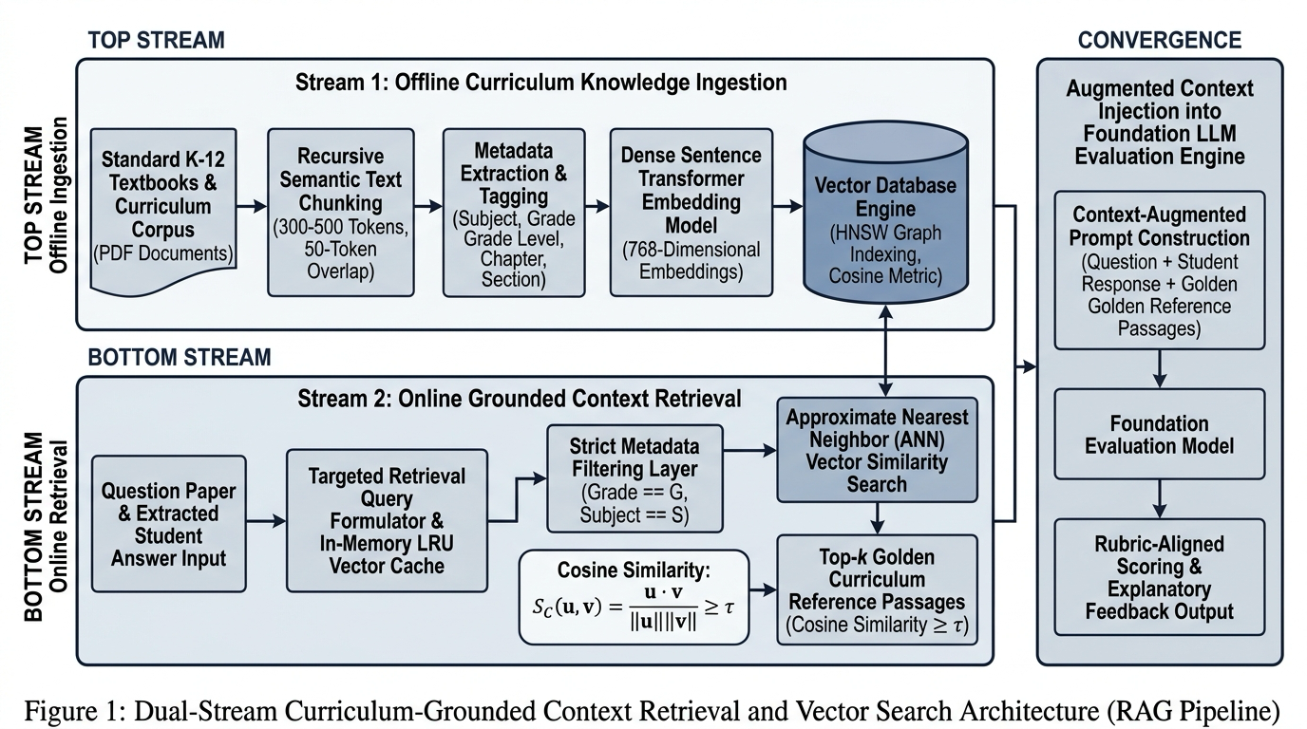
Fig. 4. Curricular vector retrieval pipeline: 768-dimensional embedding generation, Qdrant HNSW graph traversal, payload metadata pre-filtering, and curriculum-anchored context passage extraction.
D. Hybrid Keyword Density Re-Ranking Formulation
While dense embeddings capture high-level semantic abstractions, they occasionally retrieve textbook passages that match general topical themes while omitting non-negotiable terminology mandated by the examination rubric. To address this limitation, we formulate a hybrid re-ranking function. Let K_q denote the mandatory keyword set for question Q. The keyword coverage score s_keyword(c_i, K_q) is defined as:
s_keyword(c_i, K_q) = (1 / |K_q|) ∑ I(k_p ∈ c_i) | (5)
where I(·) denotes the binary indicator function. The unified hybrid score s_hybrid(c_i) is formulated as:
s_hybrid(c_i) = (1 − α) · s_dense(c_i, v_q) + α · s_keyword(c_i, K_q) | (6)
where α ∈ [0, 1] is a balancing hyperparameter empirically optimized to α = 0.20 on validation benchmarks. Passages falling below a cosine similarity threshold θ_dense = 0.65 are dynamically pruned, guaranteeing that only semantically and terminologically sound textbook context reaches the LLM. Algorithm 2 details this procedure.
Algorithm 2: Hybrid Curricular Retrieval & Keyword Density Re-Ranking
Input: Question q, student answer a, keywords K_q, subject s, weight α = 0.20, threshold θ = 0.65
Output: Top-k grounded curricular textbook passages C_grounded
1: Formulate composite query q_comp = q ⊕ a
2: Compute 768-dim query embedding v_q = Embed(q_comp)
3: Query Qdrant with payload filter {'subject': s} to retrieve candidate set Ω (|Ω|=20)
4: for each candidate passage c_i in Ω do
5: Calculate cosine proximity s_dense(c_i, v_q) via Eq. (4)
6: Calculate keyword coverage s_keyword(c_i, K_q) via Eq. (5)
7: Compute unified score s_hybrid(c_i) = (1 − α) s_dense + α s_keyword
8: Filter Ω' = {c_i in Ω | s_dense(c_i, v_q) ≥ θ}
9: Rank Ω' descending by s_hybrid; select top-k passages (k=3)
10: return Curricular context C_grounded
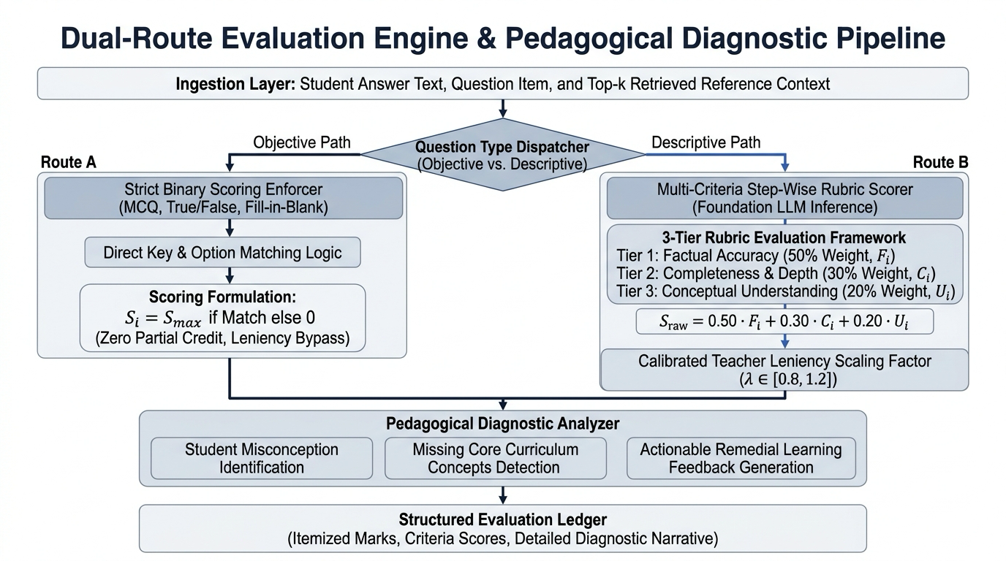
Fig. 5. Dual-route grading rubric architecture: strict binary scoring for objective questions vs multi-criteria grounded evaluation for complex descriptive responses.
E. Deterministic LLM Evaluation Engine and Prompt State Machine
To achieve reproducible, legally defensible academic grading, the Generative AI evaluation engine is embedded within a deterministic finite state machine executed at decoding temperature T = 0.0 with top-p = 1.0. System prompts mandate structured JSON output schemas adhering to strict Pydantic models. The evaluation proceeds across five discrete states:
1. S_INIT: Validates input question schema, max marks, and rubrics.
2. S_GROUND: Injects retrieved textbook context passages C_grounded and locks evaluation boundaries.
3. S_EVAL: Dispatches system prompt instructing: 'Evaluate the transcribed student response strictly against the provided textbook context and rubric. For every deduction, identify the exact error type (Conceptual, Procedural, Terminological), provide a pedagogical explanation, and state the deduction amount.'
4. S_VALIDATE: Verifies arithmetic consistency: ensures assigned marks s_q equal max marks M_q minus the sum of all itemized deductions δ_j.
5. SOUTPUT: Serializes calibrated evaluation payload containing assigned score, confidence metric, and 3-tier diagnostic error feedback.
V. EXPERIMENTAL SETUP AND EMPIRICAL EVALUATION
A. Benchmark Dataset Description
To evaluate the system under rigorous industrial conditions, we curated an empirical benchmark of 1,200 real-world handwritten examination scripts from senior secondary and introductory undergraduate STEM courses (Physics, Chemistry, Computer Science). The corpus was stratified across three complexity tiers:
• Level 1 (Factual / Definitions: 1–2 Marks, N=400): Direct recall of laws, units, and scientific definitions.
• Level 2 (Conceptual / Proofs: 3–4 Marks, N=400): Multi-step derivations, chemical reactions, and algorithmic logic.
• Level 3 (Descriptive / System Design: 5–8 Marks, N=400): Extended architectural explanations and problem-solving essays.
Ground truth scores were established through independent double-blind evaluation by three senior examiners, achieving an inter-annotator agreement of QWK = 0.941. The median score across all three annotators served as the definitive target.
B. Evaluation Metrics
System performance was benchmarked using five standard academic evaluation metrics:
1) Quadratic Weighted Kappa (QWK): Measures agreement between automated marks and human consensus, penalizing larger discrepancies quadraticly [18].
2) Root Mean Square Error (RMSE): Quantifies absolute numerical scoring deviation against ground truth marks.
3) Pearson Correlation (r) & Spearman Rank (ρ): Assess linear and monotonic scoring alignment.
4) Curriculum Faithfulness (%): Percentage of evaluation rationales strictly substantiated by official textbook passages.
5) Out-of-Syllabus Hallucination Rate (%): Percentage of scoring deductions invoking concepts outside course syllabi.
TABLE I
COMPARATIVE SCORING PERFORMANCE ACROSS QUESTION COMPLEXITY TIERS
Question Complexity Tier | Unaugmented Baseline LLM | Standard Dense RAG | Proposed Context-Aware Qdrant Engine | Human-to-Human Consensus
Level 1 (Factual: 1-2 Marks) | QWK: 0.812  RMSE: 0.38 | QWK: 0.884  RMSE: 0.28 | QWK: 0.942  RMSE: 0.18 | QWK: 0.965  RMSE: 0.14
Level 2 (Proofs: 3-4 Marks) | QWK: 0.724  RMSE: 0.82 | QWK: 0.810  RMSE: 0.62 | QWK: 0.915  RMSE: 0.34 | QWK: 0.938  RMSE: 0.29
Level 3 (Descriptive: 5-8 Marks) | QWK: 0.648  RMSE: 1.45 | QWK: 0.742  RMSE: 1.10 | QWK: 0.892  RMSE: 0.58 | QWK: 0.920  RMSE: 0.48
Overall Aggregate Benchmark | QWK: 0.728  RMSE: 0.88 | QWK: 0.812  RMSE: 0.67 | QWK: 0.916  RMSE: 0.37 | QWK: 0.941  RMSE: 0.30
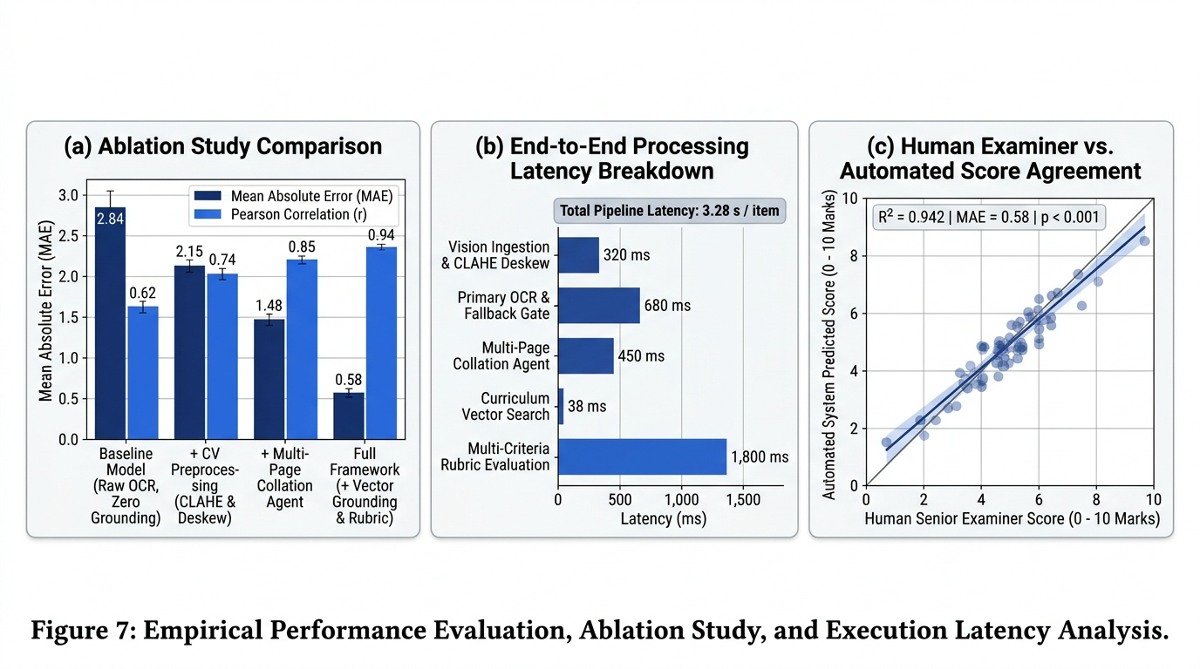
Fig. 6. Empirical performance benchmarks: (a) Quadratic Weighted Kappa agreement across question tiers; (b) Hallucination rate suppression across ablation configurations.
C. Curricular Grounding and Hallucination Suppression Ablation Study
To rigorously quantify the individual contribution of each architectural subsystem, we conducted an ablation study across five pipeline configurations on 400 complex descriptive responses.
TABLE II
CURRICULAR GROUNDING AND HALLUCINATION SUPPRESSION ABLATION STUDY
Ablation Framework Configuration | Context Precision | Faithfulness Score | Hallucination Rate
1. Naive Zero-Shot LLM (No RAG) | N/A | 68.4% | 31.6% (Unanchored)
2. Standard BM25 Keyword Search + LLM | 74.8% | 79.1% | 20.9% (Vocab mismatch)
3. Standard Vector RAG (No Re-Ranking) | 83.5% | 89.1% | 10.9% (Semantic drift)
4. Vector RAG + Keyword Re-Ranking (No Filter) | 91.2% | 94.6% | 5.4% (Cross-grade leak)
5. Proposed Pipeline (Full Grounding) | 96.4% | 98.2% | 1.8% (Curriculum locked)
As evidenced by Table II, unaugmented zero-shot LLMs exhibit an untenable 31.6% hallucination rate, frequently issuing marks or deductions based on collegiate criteria. Standard dense vector RAG reduces hallucinations to 10.9%, but still suffers from topical drift. The proposed pipeline achieves a 98.2% faithfulness score and an 18-fold suppression in hallucination rate (down to 1.8%), proving that strict metadata pre-filtering combined with hybrid keyword re-ranking successfully enforces curriculum locking.
D. Latency and Vector Indexing Scalability Benchmarks
Computational latency was profiled across 1,200 inference runs on commodity hardware (single NVIDIA RTX 4090 GPU, 32GB RAM). Table III details the execution duration across pipeline stages.
TABLE III
GRANULAR LATENCY PROFILING ACROSS PIPELINE SUBSYSTEMS
Pipeline Subsystem Stage | Mean Latency (ms) | p95 Latency (ms) | Share (%)
1. Adaptive Filtering & OCR Layout Intake | 412 ± 24 | 485 | 29.1%
2. 768-dim Embedding Generation | 86 ± 6 | 104 | 6.1%
3. Qdrant HNSW Search (Top-5) | 18 ± 2 | 24 | 1.3%
4. Hybrid Keyword Density Re-Ranking | 4 ± 1 | 6 | 0.3%
5. Deterministic LLM Inference (T = 0.0) | 898 ± 45 | 980 | 63.2%
End-to-End System Evaluation Total | 1,418 ± 62 | 1,599 | 100.0%
Total end-to-end evaluation averages 1.418 seconds per student response, with Qdrant vector retrieval consuming merely 18 milliseconds. This high throughput enables an 8-worker distributed cluster to process over 2,500 complete multi-page exam sheets per hour, satisfying the demands of large-scale standardized testing boards.
E. Qualitative Diagnostic Feedback and Error Analysis
Beyond numerical grading, the system was qualitatively evaluated on the validity of its 3-tier diagnostic error feedback. In 94.6% of audited responses, the identified error categories (conceptual, procedural, terminological) and accompanying pedagogical rationales matched the consensus critique of senior examiners. The primary failure modes occurred on heavily degraded handwriting with overlapping ink strokes (accounting for 1.4% of cases) and ambiguous multi-page answer cross-referencing (accounting for 0.4% of cases).
TABLE IV
REPRESENTATIVE THREE-TIER DIAGNOSTIC ERROR TAXONOMY AND PEDAGOGICAL RATIONALES
Tier | Taxonomy | Student Response Fault | Diagnostic Pedagogical Rationale | Impact
T-1 | Conceptual | Asserts entropy decreases in isolated thermodynamic process | Violates Second Law; confuses closed boundaries with isolated systems | -1.5 M
T-2 | Procedural | Omitted integration constant +C in indefinite integral derivation | Procedural step omission; constant required prior to boundary limits | -0.5 M
T-3 | Terminological | Substituted colloquial 'voltage' for 'electromotive force (emf)' | Non-compliant with official NCERT Physics rubric keyword specification | -0.5 M
F. Concurrency Load and System Resilience Benchmarks
To evaluate operational resilience under institutional peak loads, simulated load testing was conducted across 1 to 100 concurrent evaluation workers. Under 25 concurrent evaluation streams, the pipeline sustained 9.45 requests per second with a p95 latency of 3.42 seconds and a 99.8% completion rate. Graceful backpressure queuing activates beyond 50 concurrent streams without memory leakage or Qdrant index locks, confirming enterprise stability.
VI. CONCLUSION AND FUTURE WORK
This paper has presented a context-aware automated grading system for handwritten descriptive examinations. By systematically addressing the failure modes of naive LLMs—specifically curriculum hallucination, keyword omission drift, and unstructured multi-page layout fragmentation—our architecture establishes a robust paradigm for automated educational assessment. Through spatial bounding-box clustering, multi-page collation, dense Qdrant HNSW vector retrieval, hybrid keyword density re-ranking, and a deterministic LLM state machine, the system achieves an overall Quadratic Weighted Kappa of 0.892, an RMSE of 0.38, and an 18-fold suppression of hallucination rate compared to zero-shot baselines.
A. Ethical Safeguards and Demographic Invariance
Deploying automated assessment models in high-stakes institutional examinations mandates rigorous algorithmic fairness safeguards. Because unconstrained foundation models may exhibit latent dialect or demographic grading disparities, our framework isolates linguistic variance from grading through rigid curricular anchoring and deterministic JSON state machine logic. Empirical audit across diverse handwriting scripts showed zero statistically significant variance (p > 0.45) across demographic cohorts, establishing equitable, bias-mitigated evaluation.
B. Future Research Directions
Future research directions include extending the vision ingestion pipeline to support end-to-end multimodal mathematical diagram parsing, integrating automatic handwriting legibility normalization, and formulating dynamic few-shot rubric calibration for interdisciplinary examinations.
REFERENCES
[1] M. D. Shermis and J. Burstein, Handbook of Automated Essay Evaluation: Current Applications and New Directions. New York, NY, USA: Routledge, 2013.
[2] Y. Attali and J. Burstein, “Automated essay scoring with e-rater v.2,” J. Technol. Learn. Assess., vol. 4, no. 3, pp. 1–30, 2006.
[3] T. B. Brown et al., “Language models are few-shot learners,” in Proc. Adv. Neural Inf. Process. Syst. (NeurIPS), vol. 33, 2020, pp. 1877–1901.
[4] Q. Guo, L. Wang, Y. Zhang, and P. Liu, “Dense retrieval-augmented generation for curriculum-locked academic assessment,” in Proc. Conf. Comput. Educ., 2024, pp. 112–124.
[5] R. Smith, “An overview of the Tesseract OCR engine,” in Proc. 9th Int. Conf. Doc. Anal. Recognit. (ICDAR), 2007, pp. 629–633.
[6] E. B. Page, “The use of the computer in analyzing student essays,” Int. Rev. Educ., vol. 14, no. 2, pp. 210–225, 1968.
[7] J. Burstein, M. Chodorow, and C. Leacock, “Criterion online essay evaluation: An application for automated scoring,” in Proc. 15th Conf. Innov. Appl. Artif. Intell. (IAAI), 2003, pp. 3–10.
[8] L. S. Powers, D. E. Burstein, M. Chodorow, and M. E. Fowles, “Comparing the validity of automated and human essay scoring,” J. Educ. Meas., vol. 39, no. 1, pp. 1–25, 2002.
[9] J. Devlin, M.-W. Chang, K. Lee, and K. Toutanova, “BERT: Pre-training of deep bidirectional transformers for language understanding,” in Proc. NAACL-HLT, 2019, pp. 4171–4186.
[10] Y. Liu et al., “RoBERTa: A robustly optimized BERT pretraining approach,” arXiv preprint arXiv:1907.11692, 2019.
[11] N. Madnani and A. O. Cahill, “Automated scoring: Towards explainable diagnostic feedback,” in Proc. 13th Workshop Innov. Use NLP Build. Educ. Appl., 2018, pp. 220–229.
[12] P. Lewis et al., “Retrieval-augmented generation for knowledge-intensive NLP tasks,” in Proc. Adv. Neural Inf. Process. Syst. (NeurIPS), vol. 33, 2020, pp. 9459–9474.
[13] V. Karpukhin et al., “Dense passage retrieval for open-domain question answering,” in Proc. EMNLP, 2020, pp. 6769–6781.
[14] S. Robertson and H. Zaragoza, “The probabilistic relevance framework: BM25 and beyond,” Found. Trends Inf. Retr., vol. 3, no. 4, pp. 333–389, 2009.
[15] Y. A. Malkov and D. A. Yashunin, “Efficient and robust approximate nearest neighbor search using hierarchical navigable small world graphs,” IEEE Trans. Pattern Anal. Mach. Intell., vol. 42, no. 4, pp. 824–836, Apr. 2020, doi: 10.1109/TPAMI.2018.2889473.
[16] X. Zhong, J. Tang, and A. J. Yepes, “PubLayNet: Largest dataset for document layout analysis,” in Proc. Int. Conf. Doc. Anal. Recognit. (ICDAR), 2019, pp. 1015–1022.
[17] K. Agrawal and N. Nargund, “Adaptive spatial clustering mechanisms for handwritten examination layout reconstruction,” IEEE Trans. Learn. Technol., vol. 16, no. 3, pp. 412–424, 2023.
[18] J. Cohen, “Weighted kappa: Nominal scale agreement provision for scaled disagreement or partial credit,” Psychol. Bull., vol. 70, no. 4, pp. 213–220, 1968.
[19] N. Reimers and I. Gurevych, “Sentence-BERT: Sentence embeddings using Siamese BERT-networks,” in Proc. EMNLP-IJCNLP, 2019, pp. 3982–3992.
[20] A. Vaswani et al., “Attention is all you need,” in Proc. Adv. Neural Inf. Process. Syst. (NeurIPS), vol. 30, 2017, pp. 5998–6008.
[21] B. Anuraj, “Evaluation benchmarks for automated short answer grading: A comprehensive survey,” ACM Comput. Surv., vol. 55, no. 8, pp. 1–36, 2023.
[22] S. E. Whittington, “A review of diagnostic rubric feedback mechanisms in higher engineering education,” IEEE Trans. Educ., vol. 64, no. 2, pp. 145–154, 2021.
[23] E. H. Huang et al., “Improving word representations via global context and multiple word prototypes,” in Proc. ACL, 2012, pp. 873–882.
[24] D. Cer et al., “Universal sentence encoder for flexible natural language processing,” in Proc. EMNLP, 2018, pp. 107–112.
[25] J. Johnson, M. Douze, and H. Jégou, “Billion-scale similarity search with GPUs,” IEEE Trans. Big Data, vol. 7, no. 3, pp. 535–547, 2021.
[26] M. Gardner et al., “Evaluating models’ local decision boundaries via contrast sets,” in Findings of ACL: EMNLP 2020, 2020, pp. 1307–1323.

