AUTOMATED CNC POTTING MACHINE
FOR NURSERY FARMING

Submitted by

UJWAL WAGHRAY (1171310091)

SHIBIN V PHILIP (1171310066)

Under the guidance of

Mr. P. JEKAN
(Assistant Professor, Department of Electronics and Instrumentation Engineering)

in partial fulfillment for the award of the degree

of

BACHELOR OF TECHNOLOGY

in

ELECTRONICS AND INSTRUMENTATION

of

FACULTY OF ENGINEERING AND TECHNOLOGY


S.R.M. Nagar, Kattankulathur, Kancheepuram District

MAY 2017
SRM UNIVERSITY
(under section 3 of UGC Act, 1956)

BONAFIDE CERTIFICATE

Certified that this project report titled “AUTOMATED CNC POTTING MACHINE FOR NURSERY FARMING” is the bonafide work of “UJWAL WAGHRAY (1171310091) & SHIBIN V PHILIP (1171310066)”, who carried out the project work under my supervision. Certified further, that to the best of my knowledge the work reported herein does not form any other project report or dissertation on the basis of which a degree or award was conferred on an earlier occasion on this or any other candidate.

SIGNATURE SIGNATURE

P.JEKAN DR.A.VIMALA JULIET

GUIDE HEAD OF THE DEPARTMENT

Assistant Professor Dept. of Electronics & Instrumen-

Dept. of Electronics & Instrumentation tation Engineering

Engineering

Signature of Internal Examiner Signature of External Examiner
ABSTRACT

Automated CNC Potting Machine is an open source and scalable automated precision farming machine and software. Similar to today’s 3d printers or CNC milling machines, CNC farm hardware employs linear guides in the y, z directions and moves the trays in the x direction on a conveyor belt that allow for tooling such as plows, seed injectors, watering nozzles, and sensors, to be precisely positioned and used on the plants and soil. The entire system is numerically controlled and thus fully automated from ploughing to harvest. The hardware designed uses open source protocol a person can design their farm to their desired specification like number of pots to be manufactured at a time, speed of manufacturing and upload numerical control code to the hardware.
The on board sensors are used in detecting the soil conditions, position of trays and pots and execute the task of ploughing, watering, soil testing and seeding based on the requirements.

iii
ACKNOWLEDGEMENTS

I would like to express my deepest gratitude to my guide, Mr. P.JEKAN his valuable guidance, consistent encouragement, personal caring, timely help and providing me with an excellent atmosphere for doing research. All through the work, in spite of his busy schedule, he has extended cheerful and cordial support to me for completing this research work.

Author(s)

iv

TABLE OF CONTENTS


ABSTRACT

ACKNOWLEDGEMENTS
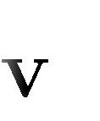
LIST OF TABLES

LIST OF FIGURES

ABBREVIATIONS

- INTRODUCTION

  - Brief review of components
  - About the Project
  - Objectives

- LTERATURE SURVEY
  - Existing technologies
  - Problems with existing technologies

- CNC POTTING MACHINE METHODOLOGY

- BLOCK DIAGRAM

- SYSTEM DESCRIPTION

    - Arduino Mega
    - NEMA 17
    - A4988
    - Servo Motor
    - Soil Moisture sensor
    - IR sensor
    - Relay boards

6 SIMULATION RESULTS

7 CODING

8 CONCLUSION

9 REFERENCES

v
LIST OF FIGURES

ABBREVIATIONS
AC ALTERNATING CURRENT

DC DIRECT CURRENT

GPS GLOBAL POSITIONING SYSTEM

LCD LIQUID CRYSTAL DISPLAY

LED LIGHT EMITTING DIODE

PWM PULSE WIDTH MODULATION

UART UNIVERSAL ASYNCHRONOUS . RECEIVER AND TRANSMITTER

USB UNIVERSAL SERIAL BUS

vii



INTRODUCTION



The world’s population is growing and with that growth we must produce more food. Due to the industrial and petrochemical revolutions, the agriculture industry has kept up in food production, but only by compromising the soil, the environment, our health and the food production system itself. Conventional agriculture methods are unsustainable and a paradigm shift is needed. AUTOMATED CNC POTTING MACHINE can help in solving this problem by totally automating the crop manufacturing and nurturing them in nurseries. Thus, exponentially increasing the quality and quantity of food production.

  - Brief review of various Systems to be used:
1.1.1 CNC Machine

Computer Numerical Control (CNC) is one in which the functions and motions of a machine tool are controlled by means of a prepared program containing coded alphanumeric data. CNC can control the motions of the workpiece or tool, the input parameters such as feed, depth of penetration, speed, and the functions such as turning driller on/off, water pump on/off.

1
Advantages and Limitations: The benefits of CNC are
- High accuracy in manufacturing,
- Short production time,
- Greater manufacturing flexibility,
- Simpler fix Turing,
- Reduced human error

    - Conveyor System

A conveyor system is a common piece of mechanical handling equipment that moves materials from one location to another. Conveyors are especially useful in applications involving the transportation of heavy or bulky materials. Conveyor systems allow quick and efficient transportation for a wide variety of materials, which make them very popular in the material handling and packaging industries. Many kinds of conveying systems are available and are used according to the various needs of different industries.

Advantages of Conveyor System:

Conveyor systems are used widespread across a range of industries due to the numerous benefits they provide.
- Conveyors are able to safely transport materials from one level to another, which when done by human labor would be strenuous and expensive.
- They can be installed almost anywhere, and are much safer than using a forklift or other machine to move materials.
- They can move loads of all shapes, sizes and weights. Also, many have advanced safety features that help prevent accidents.
- There are a variety of options available for running conveying systems, including the hydraulic, mechanical and fully automated systems, which are equipped to fit individual needs.

2
    - Switching Mode Power Supply

The switched mode power supply too converts the available unregulated ac or dc input voltage to a regulated dc output voltage. However in case of SMPS with input supply drawn from the ac mains, the input voltage is first rectified and filtered using a capacitor at the rectifier output. The unregulated dc voltage across the capacitor is then fed to a high frequency dc-to-dc converter. Most of the dc-to-dc converters used in SMPS circuits have
an intermediate high frequency ac conversion stage to facilitate the use of a high frequency transformer for voltage scaling and isolation. In contrast, in linear power supplies with input voltage drawn from ac mains, the mains voltage is first stepped down (and isolated) to the desired magnitude using a mains frequency transformer, followed by rectification and filtering.
The high frequency transformer used in a SMPS circuit is much smaller in size and weight compared to the low frequency transformer of the linear power supply circuit.

  - About this Project :

Agriculture equipment and technology has been steadily becoming more accurate and precise with the advent of GPS and short range radio locating, tractor autopilot, computer vision, data mapping tools, and variable rate tooling. These technologies are incrementally augmenting abilities of freedriving tractors to allow some of the many benefits of precision agriculture to be realized. Rather than making incremental changes to existing equipment, CNC potting Machine takes a new approach at precision agriculture, tearing down everything from the past and starting from the ground up. By simply placing the tooling equipment on a set of tracks, rather than a free driving tractor, the system has the ability to be extremely precise
3
Reposition tooling in exact locations repeatedly overtime. This is done with

Similar technologies that has been around for decades in printers, manufacturing equipment, and more recently 3D printers and CNC milling machines.
This new method of precision agriculture has the potential to be as accurate as human labor with the automation and cost effectiveness of a machine. Precision can increase efficiency in the agriculture system in many ways including the following.

The following is a sample of intrinsic advantages of CNC Machine that make it a superior system to conventional methods and technologies.
● Ability to plant poly crops in a machine efficient manner
● Ability to optimize operations such as watering, spraying, and seed spacing
● Full automation and 24/7 possible operation
●Virtually unlimited farm design possibilities
● Ability to plant in the most space efficient layouts
● Scalable from a backyard system to an industrial operation
● Allows for the democratization and decentralization of food production
The vision of this project is to create an open and accessible technology aiding everyone to grow organic food and to grow food for everyone in nurseries.

  - Objectives:
- To design an automated robotic control system for crop manufacturing
- To reduce resource consumption by reducing water, labour and electricity consumption in manufacturing crops
- To make an open source platform which is flexible for varios crops and pot sizes
- To be able to control the manufacturing remotely without human help
- To introduce cost effective automated solution for small and medium scale nurseries for planting and nurturing poly crops.

4

CHAPTER 2

LITERATURE SURVEY

2.1 Existing Systems:

Robotics in agriculture has been a target for agricultural aspirants for many years. The first report was published from the February 1934 Modern Mechanics journal. This concept tries to establish crisis that a farmer could be separated from a machine’s field operation where initially there was only little progress in the automation of Agrobots or indeed an automotive sector. It was after this gradual development in the field of agriculture began to take place. Also unlike in the present scenario which requires large manpower and investment for fruit picking process we can replace it with few numbers of this device, thus paving way for precision agriculture.
The farming using this kind of device is called precision farming. The main parts of the robot are the tiller, plougher and the wheels section. Three cameras are present for praying pesticides and for fruit picking. The tiller is a horizontal bar with a number of jagged teeth’s fixed on it to aerate or loosen the soil bed. Cong Ming, in Ligang and Fag Bo [4] published a paper titled “Intelligent robot Mowers: A review”, Robot, Vol. 29, no 4.From this we can say that the plougher is similar to a tiller but has sharper and longer blades to turn over the soil. Both the tiller and plougher are crafted of sheet metal for the prototype model. The robot section consists of 7 motors out of which 5 are dc motors and 2 are servo motors. Four dc motors are attached to wheels strung on either side such that each side is driven by two motors each. The plougher is attached with another dc motor which aids polar movement in the plougher. However the tiller is fitted with more sophisticated servo motor for precise angular movement of the tiller. The servo motor serves its optimum purpose in the speed dispensing box where it is placed to slide the opening exactly for few inches in order to let the seeds fall in the soil. The AVR microcontroller and the other interfacing hardware are all mounted on the robot for convenience.

2.2 Problems with existing systems:

The existing system only deals with the on field crops and precision is lacking with the existing technologies whereas the with proposed system poly crops can be manufactured and nurtured with precision.

CHAPTER 3

CNC POTTING MACHINE METHODOLOGY

The integrated block shows the ﬂow of process and connections of various components. The components are programmed to interact with each other in such a way so as to make a working controlled system

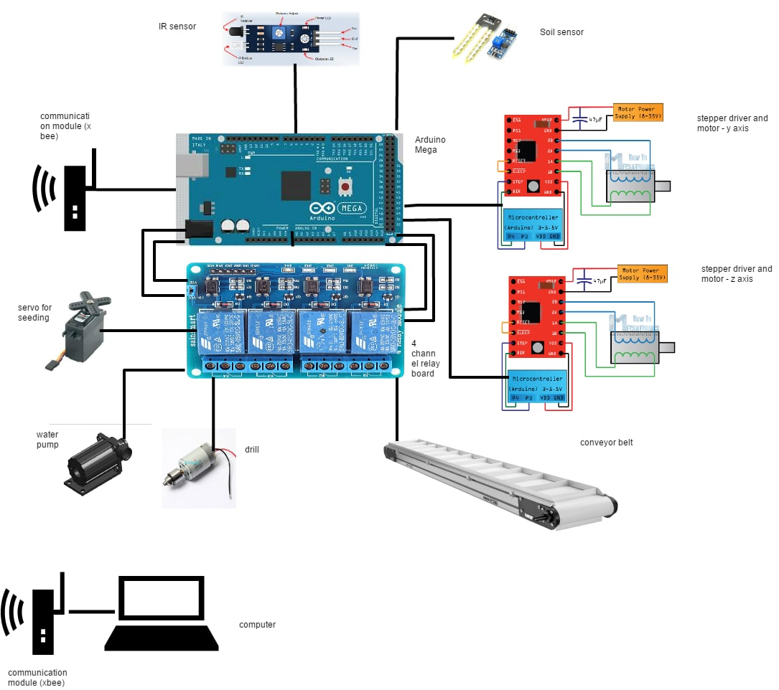

CHAPTER 4

BLOCK DIAGRAM
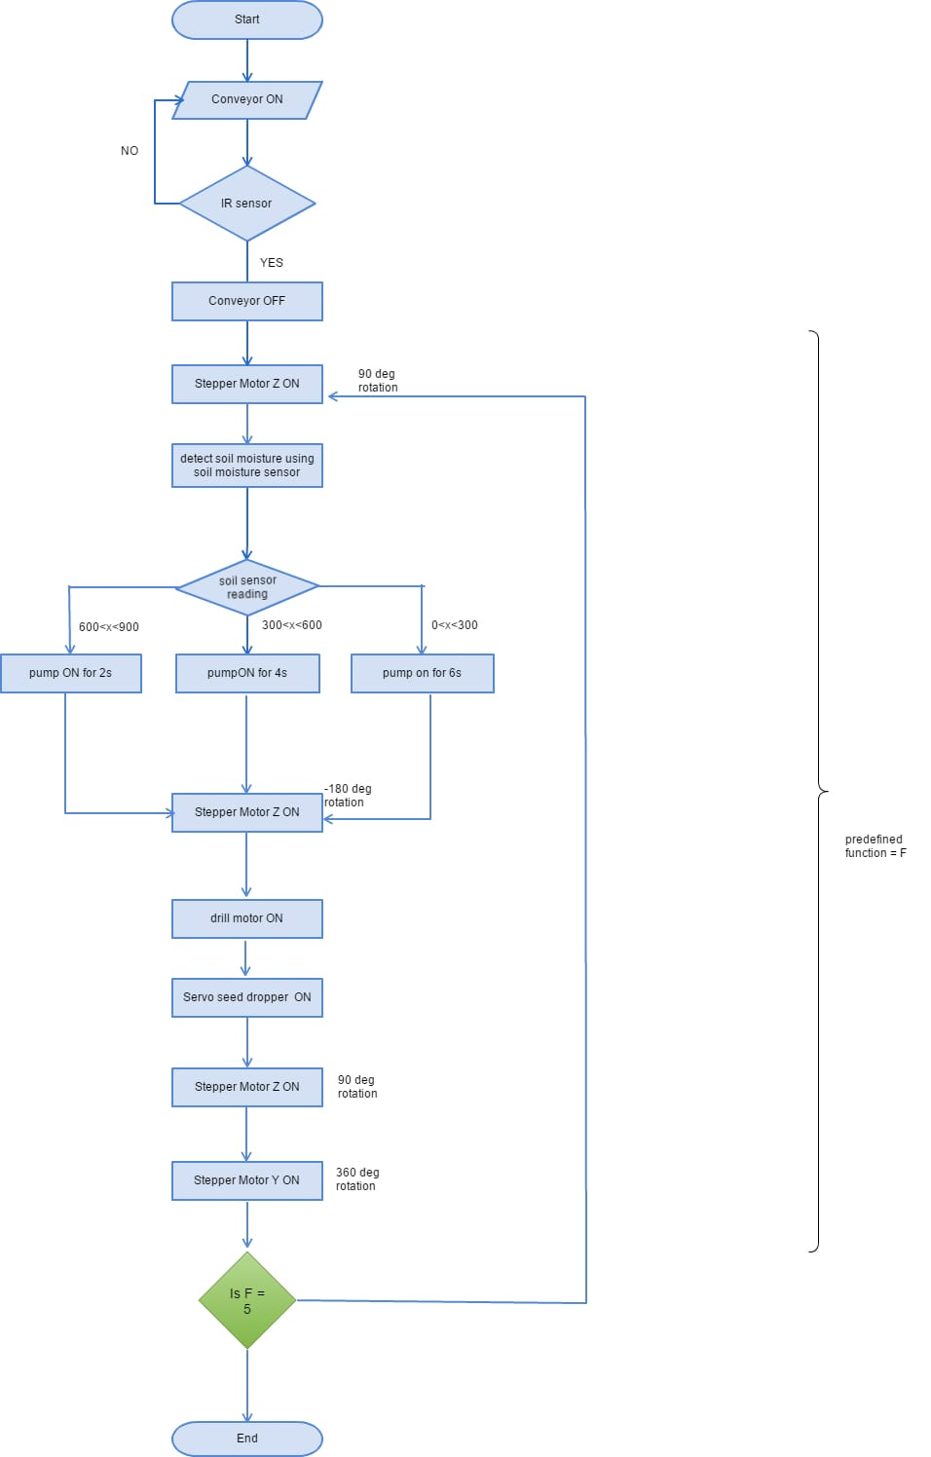

CHAPTER 5

SYSTEM DESCRIPTION

5.1 Arduino Mega 256:

The Arduino Mega 2560 is a microcontroller board based on the ATmega2560 (datasheet). It has 54 digital input/output pins (of which 14 can be used as PWM outputs), 16 analog inputs, 4 UARTs (hardware serial ports), a 16 MHz crystal oscillator, a USB connection, a power jack, an ICSP header, and a reset button. It contains everything needed to support the microcontroller; simply connect it to a computer with a USB cable or power it with a AC-to-DC adapter or battery to get started.

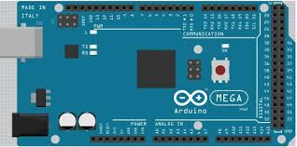

  - NEMA 17:

A NEMA 17 stepper motor is a stepper motor with a 1.7 x 1.7 inch (43.2 x 43.2 mm) faceplate. The NEMA 17 is larger and generally heavier than for example a NEMA 14, but this also means it has more room to put a higher Torque.

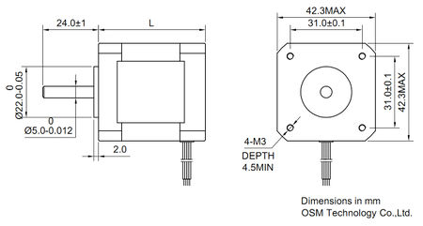

5. 3 Stepper motor driver A4988:

This breakout board for Allegro’s A4988 micro stepping bipolar stepper motor driver features adjustable current limiting, over-current and over-temperature protection, and five different micro step resolutions (down to 1/16-step). It operates from 8 V to 35 V and can deliver up to approximately 1 A per phase without a heat sink or forced air flow (it is rated for 2 A per coil with sufficient additionalcooling).

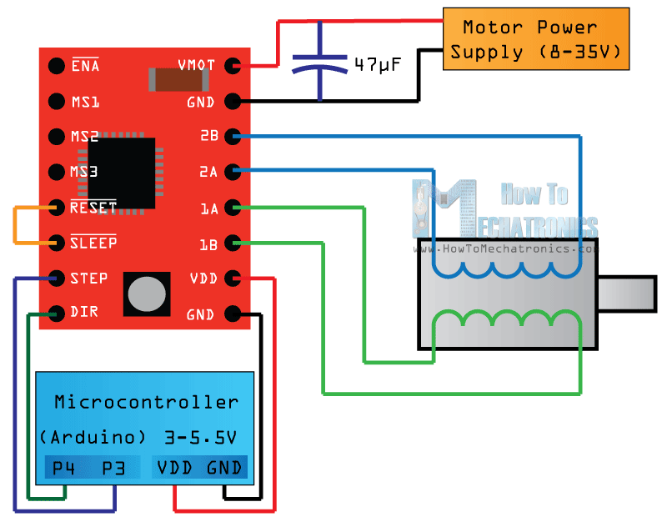

5.4 Servo motor:

A servomotor is a rotary actuator or linear actuator that allows for precise control of angular or linear position, velocity and acceleration.[1] It consists of a suitable motor coupled to a sensor for position feedback. It also requires a relatively sophisticated controller, often a dedicated module designed specifically for use with servomotors.

Servomotors are not a specific class of motor although the term servomotor is often used to refer to a motor suitable for use in a closed-loop control system.

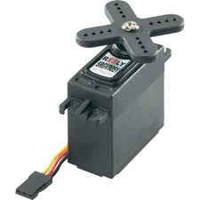

5.5 Soil moisture sensor:

The Soil Moisture Sensor uses capacitance to measure the water content of soil (by measuring the dielectric permittivity of the soil, which is a function of the water content). Simply insert this rugged sensor into the soil to be tested, and the volumetric water content of the soil is reported in percent.

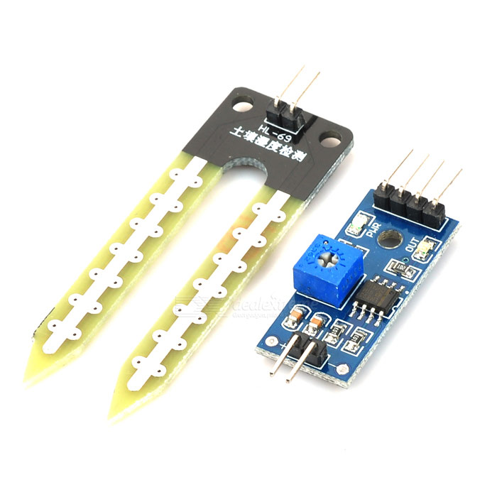
5.5 IR sensor:

An infrared sensor circuit is one of the basic and popular sensor module in an electronic device. This sensor is analogous to human’s visionary senses, which can be used to detect obstacles and it is one of the common applications in real time. This circuit comprises of the following components.
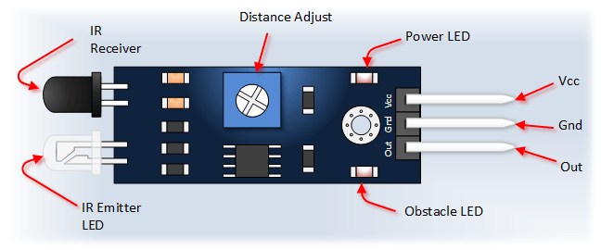

5.6 Relay Board:

A relay is an electrically operated switch. Many relays use an electromagnet to mechanically operate a switch, but other operating principles are also used, such as solid-state relays. Relays are used where it is necessary to control a circuit by a separate low-power signal, or where several circuits must be controlled by one signal. The first relays were used in long distance telegraph circuits as amplifiers: they repeated the signal coming in from one circuit and re-transmitted it on another circuit. Relays were used extensively in telephone exchanges and early computers to perform logical operations.

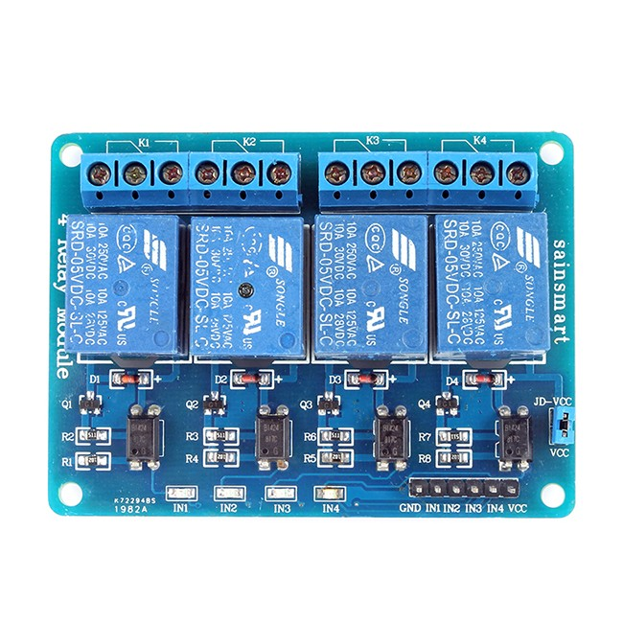

CHAPTER 6
SIMULATION RESULTS;

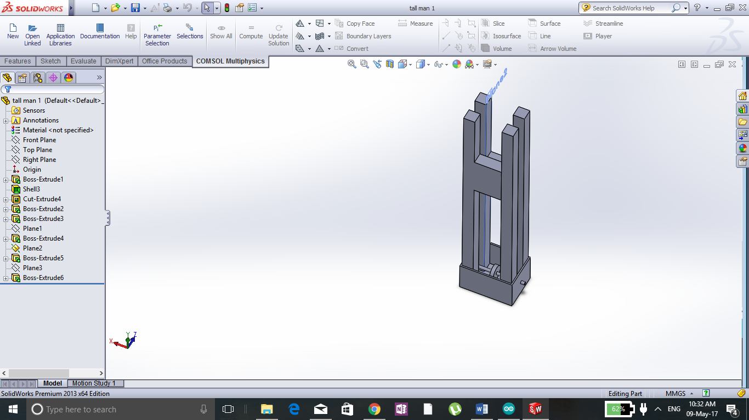

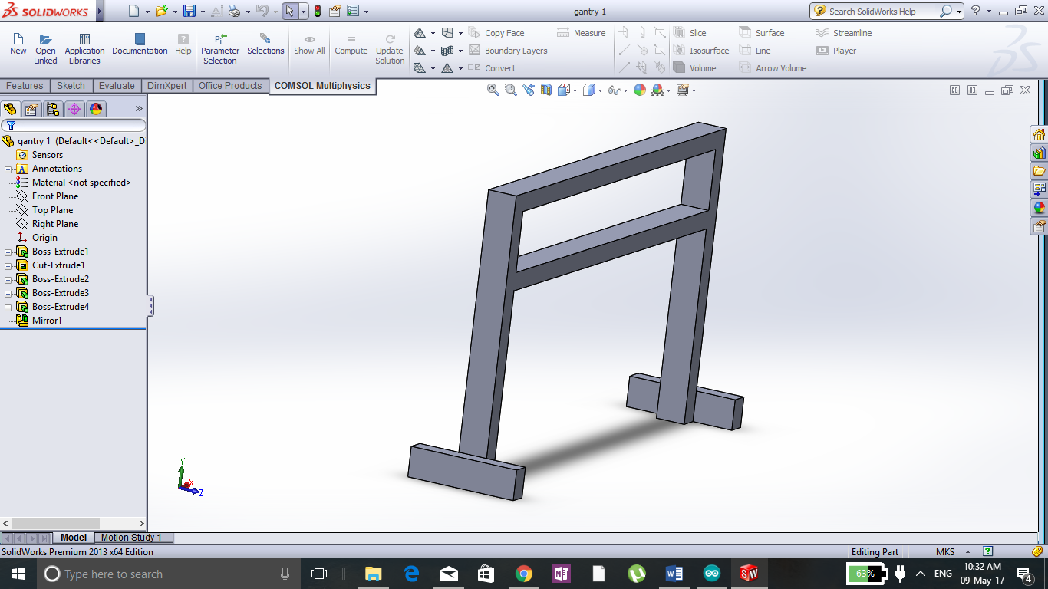

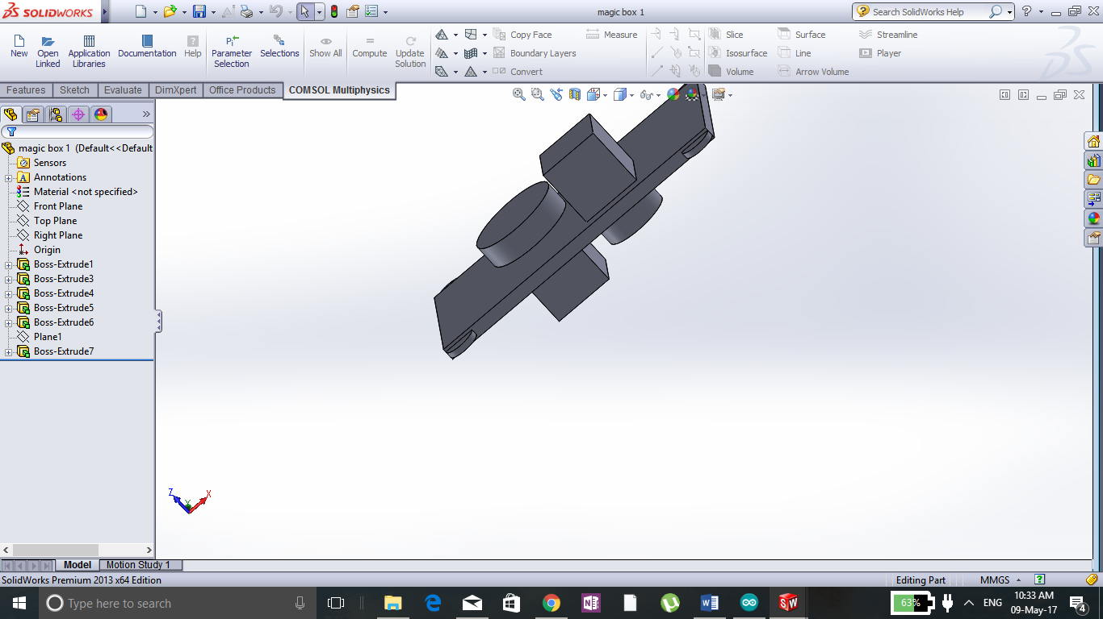

CHAPTER 7

CODING

Program for precision farming

#include <Servo.h>

int servoPin = 9;

Servo servo;

int angle = 0;

const int irsensor=7;
const int soilsensor =A0;
int sensorValue = 0;
int stepPinY=3;
int dirPinY=4;
int stepPinZ=5;
int dirPinZ=6;
int conveyor= 22;
int pump =24;
int drill=26;

void setup() {
pinMode(irsensor,INPUT);
pinMode(soilsensor,INPUT);
pinMode(conveyor,OUTPUT);
pinMode(drill,OUTPUT);
pinMode(pump,OUTPUT);
pinMode(stepPinY,OUTPUT);
pinMode(dirPinY,OUTPUT);
pinMode(stepPinZ,OUTPUT);
pinMode(stepPinZ,OUTPUT);

servo.attach(servoPin);

}
void loop() {

{ digitalWrite(conveyor, HIGH);//Illuminates the 13th Port LED

delay(5000);

digitalWrite(conveyor, LOW);

delay(5000);

}{
digitalWrite(dirPinZ,LOW);
digitalWrite(stepPinZ,HIGH);
delay(5000);
digitalWrite(stepPinZ,LOW);
delay(5000);

delay(1000);
}
{digitalWrite(pump,HIGH);
delay(6000);
digitalWrite(pump,LOW);
delay(5000);
}
{digitalWrite(dirPinZ,HIGH);

digitalWrite(stepPinZ,HIGH);
delay(5000);

delay(1000);
}{
digitalWrite(drill,HIGH);
delay(8000);
digitalWrite(drill,LOW);
delay(5000);
}
// scan from 0 to 180 degrees
for(angle = 0; angle < 180; angle++)
{
servo.write(angle);
delay(1);
}
// now scan back from 180 to 0 degrees
for(angle = 180; angle > 0; angle--)
{
servo.write(angle);
delay(1);
}
{digitalWrite(dirPinZ,LOW);
digitalWrite(stepPinZ,HIGH);
delay(1000);
digitalWrite(stepPinZ,LOW);
delay(1000);

delay(1000);}{
digitalWrite(dirPinY,LOW);
digitalWrite(stepPinY,HIGH);
delay(1000);
digitalWrite(stepPinY,LOW);
delay(1000);

delay(1000);} }

CHAPTER 8

CONCLUSION

Different agriculture robotic techniques were studied and a one stop solution was formulated for manufacturing plant crops. A CNC based manufacturing system was developed using stepper motors stepper motor drives water pumps servo motors and to control all the components relay circuit were used as switches for automatic controlling the components using Arduino mega.

CHAPTER 9

REFERENCES

- 2015 IEEE International Conference on Technological Innovations in ICT for Agriculture and Rural Development (TIAR 2015)

978-1-4799-7758-1/15/$31.00 ©2015 IEEE

Agricultural Robot for Automatic Ploughing and Seeding

- 2015 IEEE International Conference on Technological Innovations in ICT for Agriculture and Rural Development (TIAR 2015)

978-1-4799-7758-1/15/$31.00 ©2015 IEEE 49

Smart Farming System Using Sensors for Agricultural Task Automation

