**Brightening Filter (filter2D with scaled identity kernel)**



1_filter2D.jpg

* Increases the brightness of the image by scaling pixel values.
* No-filter Kernel matrix is scaled by a factor greater than 1 to get the kernel matrix for brightening
* Makes the image appear lighter without altering structure.

  
**Gaussian Blur**

1_GaussianBlur.jpg

* Smooths the image by reducing noise and detail using a Gaussian kernel.
* Useful for noise reduction and pre-processing before edge detection.
* Parameters : ksize=size of the Gaussian kernel, sigmaX and sigmaY (standard deviation in X and Y directions)

**Box Blur (Mean Blur)**

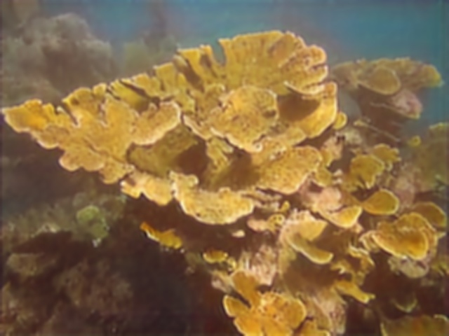

2_blur.jpg

* Smooths the image by averaging pixel values within a kernel window.
* Reduces noise and detail, resulting in a uniform blur.
* Parameters: ksize=kernel size,

Higher ksize implies higher blur

**Laplacian Edge Detection**

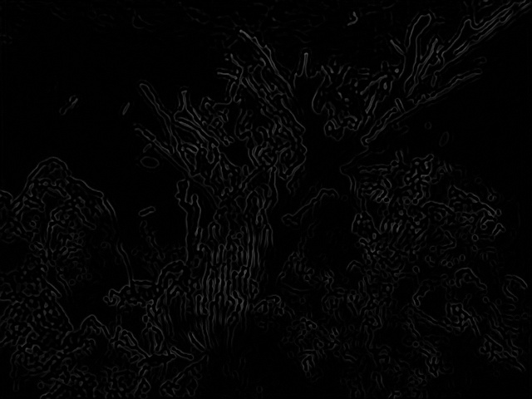

3_Laplacian.jpg

(Better observed when device is on maximum brightness)

* Works on gray scale
* Detects edges by highlighting areas of rapid intensity change.
* The Laplacian operator is used often after Gaussian blur to reduce noise.

**Bilateral Filter**

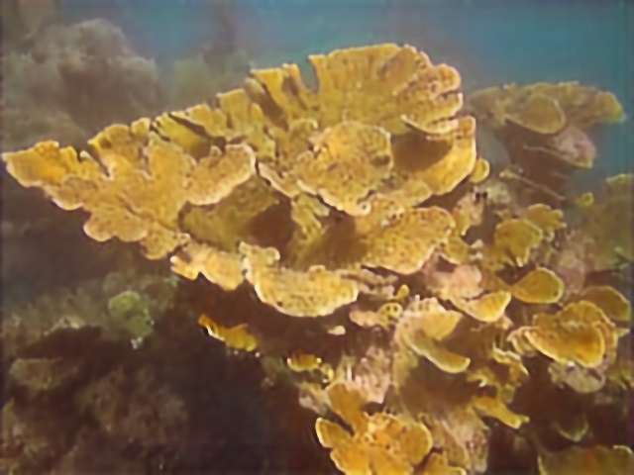

2_bilateralFilter.jpg

* Reduces noise while preserving sharp edges in the image.
* Considers both spatial proximity and pixel intensity differences.
* **Parameters:** d (diameter of pixel neighborhood), sigmaColor (color space standard deviation), sigmaSpace (coordinate space standard deviation)

**Sharpening Filter (filter2D with sharpening kernel)**

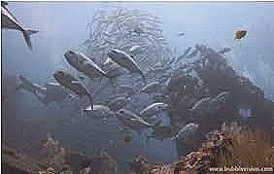

4_filter2D.jpg

* Enhances edges and fine details in the image.
* Uses a kernel that increases the centre pixel value and subtracts neighbours.