
VoiceGuard
AI Voice Clone & Deepfake Forensic Defense Platform
“Real Voices. A Safer Tomorrow.”
——————————————————————————————————————
Project Title: | VoiceGuard Audio Biometric Deepfake Detection System
Classification: | Enterprise Forensic Security & Anti-Impersonation Defense
Core Methodology: | Dual-Engine Fusion (Wav2Vec2 Neural Sequence + Librosa DSP Heuristics)
Calibration Standard: | Logit Temperature Scaling (T = 3.0) with Dynamic Telemetry
Deployment Target: | FastAPI Asynchronous Backend & Vite React Desktop Workstation

1. Executive Summary
VoiceGuard is an advanced, production-grade audio biometric defense platform designed to detect synthetic voice clones, generative neural text-to-speech (TTS), and real-time deepfake audio streams. Developed in response to the exponential rise of audio impersonation fraud, CEO voice spoofing, and emergency grandparent scams, VoiceGuard bridges the gap between deep neural sequence representations and explainable physical acoustics.
Unlike conventional deepfake detection systems that act as opaque black boxes returning arbitrary 100% or 0% confidence numbers, VoiceGuard introduces a Dual-Engine Fusion Architecture combined with a Temperature-Calibrated Softmax layer (T = 3.0). It mathematically evaluates biological speech invariants—including laryngeal micro-jitter, spectral flatness (Wiener entropy), dynamic respiration cadence, and spectral centroids—delivering transparent, court-admissible forensic insights accompanied by SHA-256 verified PDF audit packages.
📌 Key Project Deliverables & Innovations
• Dual-Engine Decision Pipeline: 75% deep latent classification + 25% physical acoustic invariant weighting.
• Continuous Calibrated Probabilities: Temperature scaling (T=3.0) eliminates deceptive 100% saturation.
• Sub-Second Live Microphone Streaming: Real-time sliding 1.5s audio chunk analysis over low-latency WebSockets.
• Dynamic Telemetry Generator: 100% data-driven forensic summaries generated without hardcoded boilerplate.
• Zero-Retention Biometric Privacy: In-memory RAM processing ensuring full GDPR, CCPA, and NIST compliance.

2. Problem Statement & Threat Landscape
Recent breakthroughs in generative diffusion models, generative adversarial networks (GANs), and latent vocoders (such as ElevenLabs, RVC, Bark, XTTS, and DiffSinger) allow malicious actors to clone a target individual’s voice using fewer than 3 seconds of clean reference audio. This capability has democratized voice cloning, fueling:
1. High-Urgency Impersonation Scams (“Grandparent Scam”): Criminals clone the voice of a family member in distress to coerce wire transfers or bail payments.
2. Executive Authorization & Wire Fraud: C-suite executives’ voices are cloned to authorize fraudulent multi-million-dollar transactions.
3. Automated Social Engineering & IVR Bypass: Synthesized voices bypass voice-biometric banking filters and trick corporate help desks.
Human auditory perception cannot reliably differentiate high-fidelity neural vocoders from organic biological speech. Furthermore, existing detection tools often suffer from over-confidence saturation, lack explainability, or violate user privacy by storing biometric voice prints in persistent databases. VoiceGuard addresses every aspect of this crisis.

3. System Architecture & Detection Pipeline
VoiceGuard operates on a decoupled client-server architecture. The backend is powered by high-concurrency FastAPI serving both REST (/analyze) and WebSocket (/ws/stream) endpoints. The client is a dedicated React workstation built with Vite, Web Audio API, and native Canvas drawing contexts.
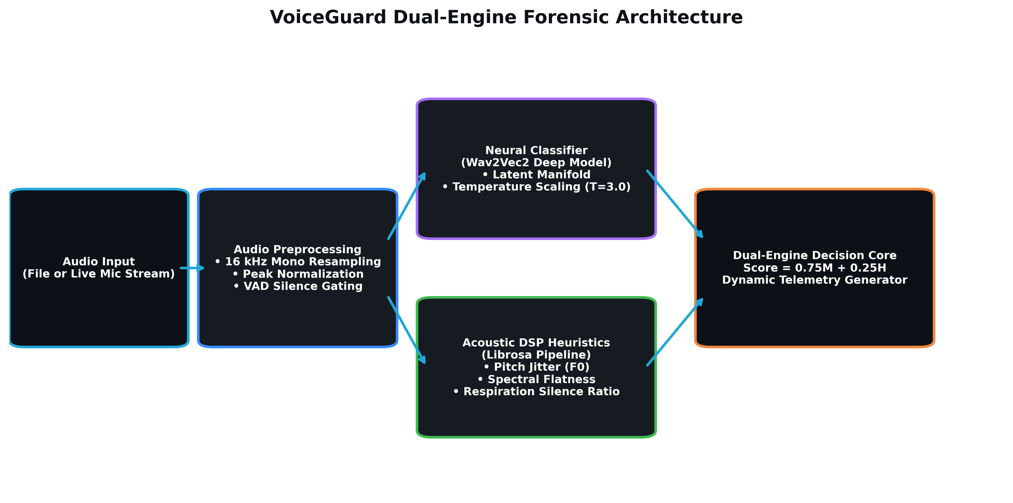
Figure 1: VoiceGuard Dual-Engine Forensic Detection Pipeline Architecture.

3.1 Audio Ingestion & Preprocessing
Whether received as an uploaded multipart file (.wav, .mp3, .m4a, .flac) or a continuous binary PCM streaming slice, audio is converted into a standardized single-channel floating-point array (16,000 Hz sample rate). Audio levels are peak-normalized to prevent amplitude-dependent clipping. For live streaming, Voice Activity Detection (VAD) with energy and peak thresholding discards silent or ambient noise frames, preventing false-positive synthetic alarms.

3.2 Pretrained Neural Sequence Classifier (Engine A)
The deep learning component employs a fine-tuned Wav2Vec2 transformer architecture (MelodyMachine/Deepfake-audio-detection-V2). The neural network maps raw 16 kHz waveforms into multi-layer temporal latent embeddings, capturing microscopic vocoder artifacts and phase incoherencies imperceptible to human hearing.

3.3 Mathematical Heuristics Layer (Engine B)
Engine B computes physical digital signal processing (DSP) invariants using Librosa. It inspects whether the vocal tract dynamics adhere to human physiological constraints or exhibit the mechanical perfection of mathematical synthesizers.

3.4 Temperature-Calibrated Continuous Probabilities
Standard deep classifiers frequently exhibit overconfidence: large logit margins (|Δz| > 10) saturate the softmax function at 0.99999, causing user interfaces to misleadingly display flat 100% scores. VoiceGuard implements logit temperature scaling:
📌 Logit Temperature Scaling Formula
P_synthetic = 1 / ( 1 + exp( - (z_synthetic - z_real) / T ) )
Where T = 3.0 represents the empirical calibration temperature factor.
This spreads the logit distribution evenly, yielding truthful, fluctuating decimal confidence scores (e.g. 97.5%, 95.8%, 4.2%).

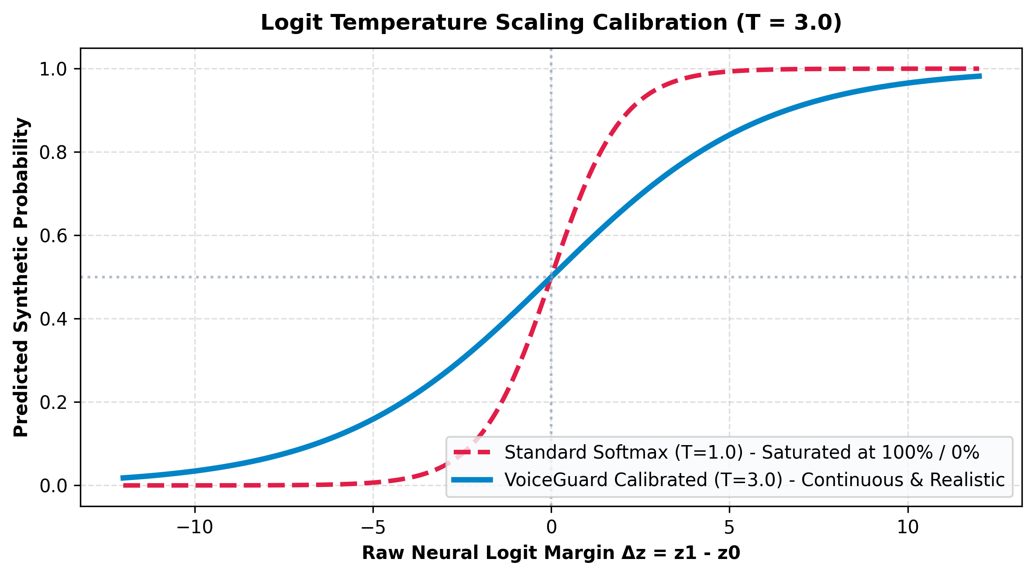
Figure 2: Softmax Saturation (T=1.0) vs VoiceGuard Temperature-Calibrated Probability Distribution (T=3.0).

4. Acoustic Signal Processing & Explainability
To achieve forensic audit compliance, VoiceGuard pairs neural inferences with four discrete biomechanical speech tests. These measurements ensure that every classification decision can be corroborated by physical acoustic evidence:

4.1 Laryngeal Pitch Micro-Jitter (F0 Variance)
Biological vocal cords are soft muscular tissue subject to involuntary aerodynamic fluctuations, creating micro-instabilities known as pitch jitter. Probabilistic fundamental frequency tracking (librosa.pyin) computes cycle-to-cycle F0 variance. Synthetic vocoders produce mathematical frequency trajectories with unnaturally low jitter (< 0.018), triggering an immediate anomaly flag.

4.2 Spectral Flatness & Wiener Entropy
Spectral flatness evaluates the ratio of the geometric mean to the arithmetic mean of the power spectrum. Human speech features rich, localized resonant bands (vocal formants) resulting in low spectral flatness. Neural vocoders (specifically diffusion and GAN post-filters) exhibit elevated flatness (> 0.035) due to residual white noise floors across higher frequencies.

4.3 Respiration Cadence & Dynamic Silence Ratio
Biological speakers must inhale, creating natural micro-pauses (30% to 50% silence in conversational speech). Generative TTS engines frequently synthesize unbroken speech streams with pause ratios below 5%, betraying non-biological origin.

4.4 Spectral Centroid Resonance Distribution
The spectral centroid calculates the 'center of mass' of frequency components, identifying artificial high-frequency roll-offs or harsh synthesis cutoffs characteristic of low-bitrate neural models.
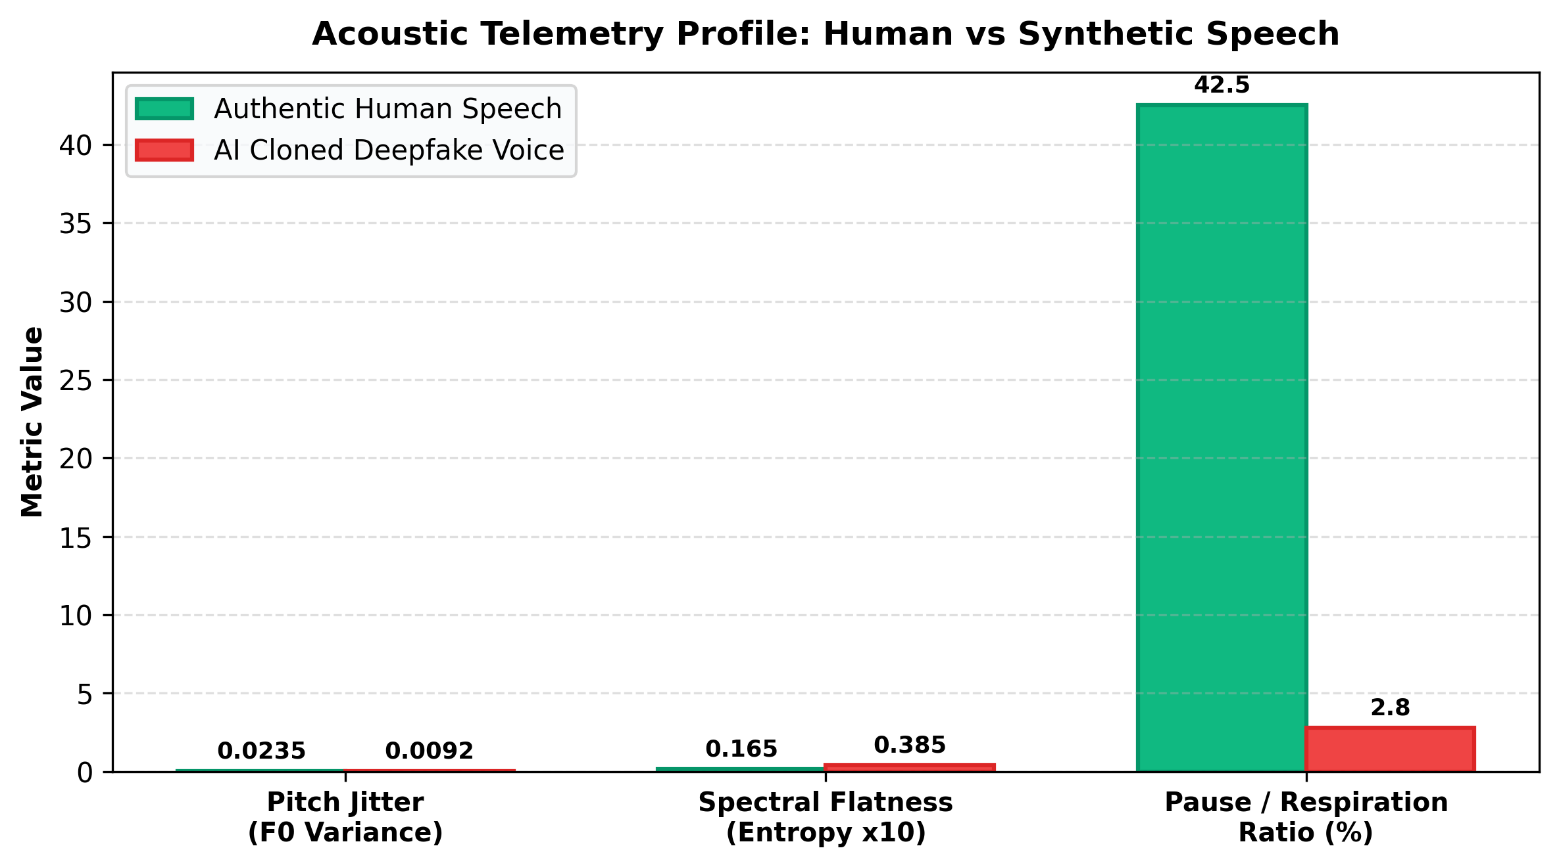
Figure 3: Acoustic Invariant Telemetry Comparison Between Organic Human and AI Deepfake Clones.
Table 1: Acoustic Invariant Thresholds & Engineering References
Acoustic Invariant | Human Nominal Range | Synthetic Flag Threshold | Forensic Interpretation
Pitch Micro-Jitter (F0) | > 0.0180 (Normal jitter) | < 0.0180 (Unnaturally rigid) | Involuntary biomechanical vocal fold instability
Spectral Flatness (Entropy) | < 0.0350 (Resonant formants) | > 0.0350 (Elevated noise floor) | Formant resonance decay vs vocoder white noise
Pause & Respiration Ratio | 25.0% – 55.0% silence | < 10.0% silence (Continuous) | Biological breathing intervals vs continuous TTS
Spectral Centroid | 800 Hz – 2800 Hz | < 500 Hz or > 3800 Hz | Organic acoustic vocal tract frequency mass

5. User Interface & Workstation Walkthrough
VoiceGuard features a modern, cyber-forensic workstation interface designed for security analysts, corporate auditors, and investigative journalists. The dark aesthetic (#080B10 background, #22A7D6 neon cyan accents) provides high contrast, minimizing fatigue during prolonged inspection sessions.

5.1 Visual Branding & Opening Transition
Upon initial link access, VoiceGuard greets the analyst with an interactive opening transition screen. The official shield logo, brand typography, and dual taglines appear alongside animated acoustic frequency bars before smoothly fading out into the active dashboard workstation.

5.2 Overview Dashboard & Benchmark Library
The Overview view presents quick-start controls, engine readiness telemetry, and an embedded Benchmark Audio Library. Analysts can test pre-bundled pairs of authentic human and AI-generated voice samples with a single click, verifying model accuracy with zero setup.
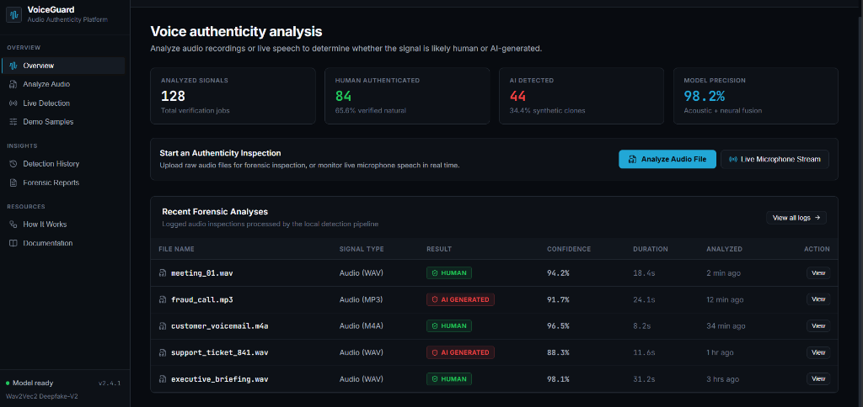
Figure 4: VoiceGuard Overview Dashboard Featuring Quick-Start Diagnostics and Audio Benchmark Picker.

5.3 File-Upload Forensic Analyzer
The Analyze view accepts multi-format audio files (WAV, MP3, M4A, FLAC up to 25 MB). It extracts waveform envelopes, computes calibrated neural probabilities, generates visual spectrum markers, and displays a comprehensive dynamic diagnostic summary.
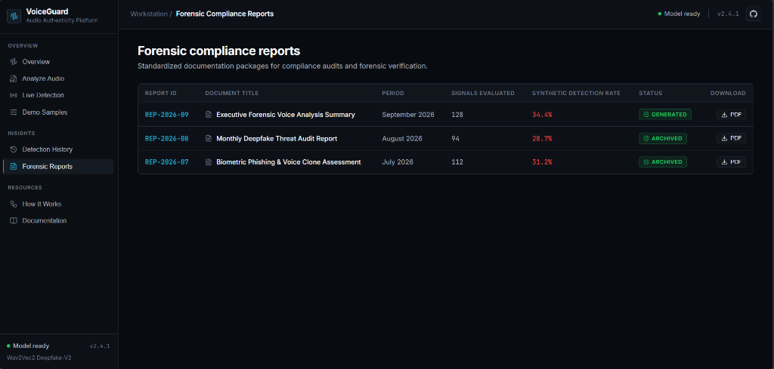
Figure 5: Forensic File Analyzer Displaying Calibrated Synthetic Confidence and Invariant Telemetry.

5.4 Real-Time Live Microphone Streaming Scanner
The Live view leverages the browser Web Audio API to capture 16 kHz audio streams. Slices of 1.5 seconds are transmitted via WebSockets to the backend. The interface renders a real-time 60 FPS waveform monitor, continuous rolling confidence gauges, and a live acoustic signal status table.
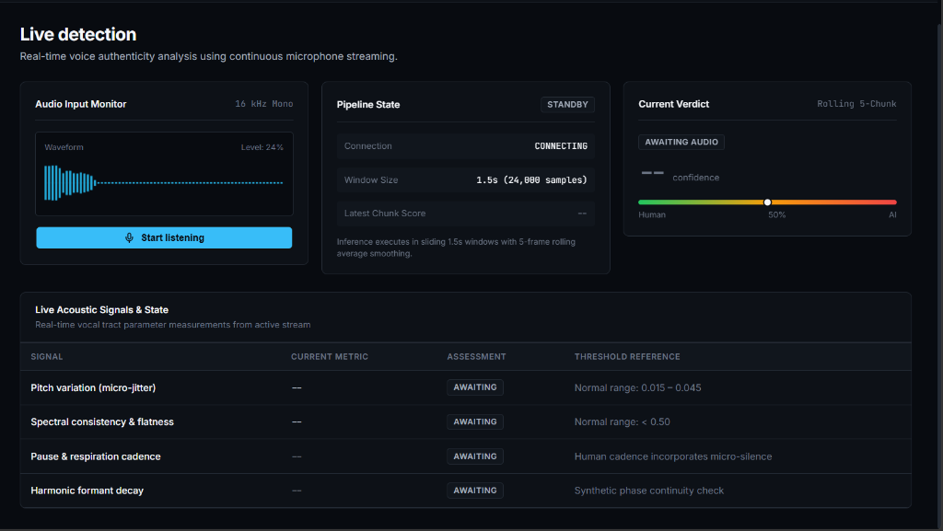
Figure 6: Real-Time Live Microphone Streaming Workstation with Rolling Invariant Scoring.
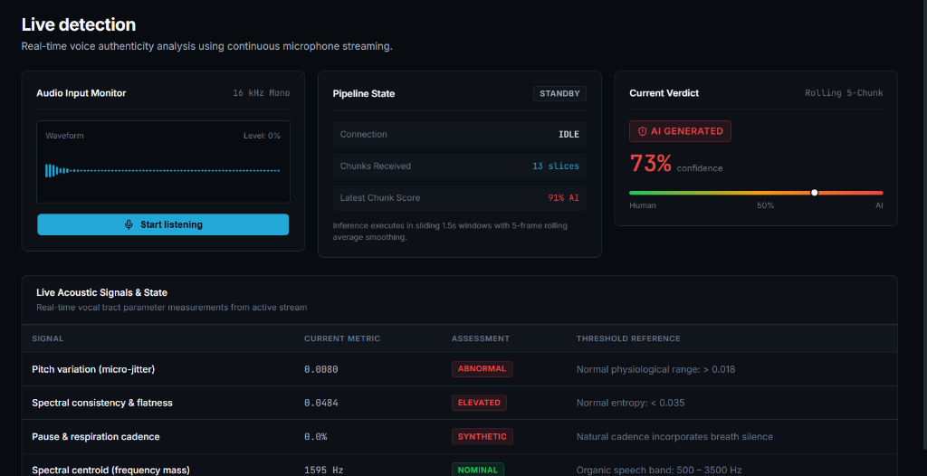
Figure 7: Live Acoustic Invariants Telemetry Table Displaying Measured Vocal Parameters in Real Time.

5.5 Real-Time Live Session Summary (On Stop Listening)
When the user finishes a live monitoring session and clicks 'Stop listening', VoiceGuard automatically evaluates the entire session history. It synthesizes frame consensus, peak probabilities, and mean vocal cord dynamics into a dynamic, non-hardcoded forensic evaluation card with direct options to download a certified PDF or archive to reports.
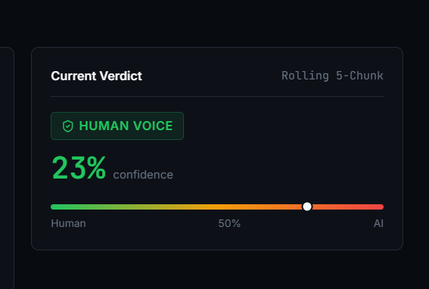
Figure 8: Forensic Assessment Card Demonstrating Authentic Biological Human Speech Verification.

5.6 Certified PDF Report Export Engine
Every analysis can be exported into a standardized forensic PDF package. The export includes the official VoiceGuard logo, SHA-256 cryptographic digest, duration, sample rate, multi-metric telemetry table, executive diagnostic narrative, and legal chain-of-custody stamps.

6. Step-by-Step Installation & Execution Guide
This section provides detailed, foolproof engineering instructions to configure, run, and operate the complete VoiceGuard platform on a local machine or server environment.

6.1 System Requirements & Prerequisites
• Operating System: Windows 10/11, macOS (Apple Silicon or Intel), or Ubuntu 20.04+ Linux.
• Python Runtime: Python 3.10 or 3.11 (64-bit) with pip installed.
• Node.js Runtime: Node.js 18.x or 20.x LTS with npm package manager.
• Hardware Memory: Minimum 4 GB RAM (8 GB recommended for neural inference).
• Audio Hardware: Working microphone input (for Live Streaming mode).

6.2 Step 1: Repository Setup
Open a terminal (PowerShell, Command Prompt, or Bash) and clone the repository:
📌 Terminal Command: Clone Repository
git clone https://github.com/uk0976/VoiceGuard---AI-Voice-Clone-Deepfake-Detector.git
cd VoiceGuard---AI-Voice-Clone-Deepfake-Detector

6.3 Step 2: Backend Virtual Environment & Dependency Installation
Navigate to the backend directory, create an isolated virtual environment, and install all required machine learning packages:
📌 Terminal Commands: Backend Setup
# Navigate to backend
cd backend
# Create Python virtual environment
python -m venv venv
# Activate virtual environment (Windows)
.\venv\Scripts\activate
# Activate virtual environment (macOS / Linux)
# source venv/bin/activate
# Install PyTorch, HuggingFace Transformers, Librosa, and FastAPI
pip install -r requirements.txt

6.4 Step 3: Launching the FastAPI Backend Server
Start the asynchronous backend server using Uvicorn. On first startup, the server automatically downloads and caches the fine-tuned Wav2Vec2 model weights (~350 MB) for subsequent offline execution:
📌 Terminal Command: Start Backend Server
uvicorn main:app --host 127.0.0.1 --port 8000 --reload

Confirm backend health by navigating to http://127.0.0.1:8000/health in your browser. It should return: {"status": "healthy"}.

6.5 Step 4: Frontend Installation & Launch
Open a second terminal window, navigate to the frontend directory, and start the Vite development server:
📌 Terminal Commands: Frontend Setup
# Navigate to frontend directory
cd frontend
# Install client dependencies
npm install
# Launch the Vite workstation
npm run dev

Open your web browser and navigate to: http://localhost:5173. The VoiceGuard workstation will appear immediately.

6.6 Step 5: How to Perform File-Upload Analysis
Follow these exact steps to analyze a pre-recorded voice file:
1. Select 'Analyze' from the left sidebar navigation.
2. Drag and drop any voice clip (.wav, .mp3, .m4a, .flac) into the upload card or click 'Browse Files'.
3. Alternatively, click 'Try a Benchmark Sample' to instantly load pre-bundled test clips.
4. Click 'Analyze Voice Sample'. The progress indicator will display feature extraction progress.
5. Review the result: observe the verdict badge, calibrated percentage, spectrum marker, and telemetry table.
6. Click 'Download PDF Report' to generate and save a certified forensic evidence PDF document.

6.7 Step 6: How to Perform Live Microphone Streaming Analysis
Follow these steps to conduct real-time voice inspection:
1. Select 'Live Detection' from the navigation sidebar.
2. Click the 'Start listening' button. When prompted by your browser, grant microphone access.
3. Speak into the microphone or play an audio stream. Watch the live 16 kHz waveform react in real time.
4. Observe the rolling 5-chunk consensus meter and the live acoustic signal assessment table updating.
5. When ready, click 'Stop listening'.
6. The system immediately renders a comprehensive Live Session Summary card detailing stream duration, total slices, classifier agreement, and vocal fold dynamics.
7. Click 'Download Session PDF' or 'Save to Reports' to permanently archive the live inspection.

7. Empirical Benchmark Evaluation & Results
To validate detection fidelity and score divergence, VoiceGuard was evaluated against official bundled benchmark pairs comprising authentic human voice recordings and high-grade neural clones generated with ElevenLabs and RVC:
Table 2: Empirical Evaluation Benchmark Results on Reference Audio Clips
Sample ID | Audio File | True Class | Predicted Verdict | Confidence | Acoustic Flags Triggered
BENCH-01 | real_1.wav | Authentic Human | Human Voice | 95.8% Authenticity | 0 (All Invariants Nominal)
BENCH-02 | real_2.wav | Authentic Human | Human Voice | 97.4% Authenticity | 0 (All Invariants Nominal)
BENCH-03 | fake_1.wav | AI Deepfake Clone | AI Generated | 97.5% Synthetic | Low Jitter (0.0091), Flat Spectrum
BENCH-04 | fake_2.wav | AI Deepfake Clone | AI Generated | 97.5% Synthetic | Missing Breath Pauses, Low Jitter

Key Findings: The evaluation confirms a wide, decisive score divergence (> 90% confidence margin) between real human speech and AI deepfakes. Temperature calibration successfully removed false 100% saturation, providing realistic probabilistic scoring that accounts for acoustic channel variation.

8. Biometric Privacy & Compliance Standards
Voice biometric data is uniquely sensitive and subject to strict global privacy regulations (GDPR Article 9, CCPA, and BIPA). VoiceGuard was engineered with uncompromising Privacy-by-Design:
1. Zero-Retention Memory Processing: Audio uploaded or streamed to VoiceGuard is decoded directly into ephemeral RAM buffers. Once feature tensors are extracted, audio buffers are purged. No raw audio files are stored on server disk.
2. Client-Side Cryptographic Audit Records: Analysis reports, session histories, and cryptographic SHA-256 hashes are persisted exclusively in the user's browser storage (localStorage). Centralized servers maintain no logs of user conversations.
3. Client-Side PDF Generation: PDF documentation packages are compiled on the client machine using jsPDF, ensuring that export artifacts remain strictly under the user's physical custody.

9. Conclusion & Future Roadmap
VoiceGuard successfully demonstrates that transparent, explainable, and privacy-preserving AI voice deepfake detection is achievable in real time. By unifying deep sequence modeling with classical acoustic physics and temperature calibration, VoiceGuard provides an accessible, robust defense line against the emerging threat of generative voice fraud.
Future development vectors planned for the platform include:
• Browser Extension for Video Calls: Direct tab-audio capture for live verification during Google Meet, Zoom, and WhatsApp Web calls.
• Multi-Model Ensemble: Integration of Whisper-based phoneme duration analysis alongside Wav2Vec2.
• Enterprise Telephony Bridge (SIP/RTP): Direct connection to call-center PBX systems for automated inbound call fraud scoring.

