Alikhan Serik

An Auction House Database

Contents
1 Business Description 3
1.1 Business background 3
1.2 Problems. Current Situation 3
1.3 The benefits of implementing a database. Project Vision 3
2 Model description 4
2.1 Definitions & Acronyms 4
2.2 Logical Scheme 4
2.3 Objects 4

Business Description

Business background
The company specializes in selling antiques and works of art through auctions. Interaction takes place between two key categories of counterparties: legitimate sellers (owners of the items) and buyers. The firm acts as an intermediary: it accepts items, assembles lots, classifies them, and determines at which auction the sale of a particular lot will be most profitable. Each auction has a strictly fixed date, location, and time, as well as its own specific focus (for example, “oil paintings created before 1900”).

Problems. Current Situation
In the current situation, record-keeping is conducted without a centralized relational DBMS, which gives rise to a number of critical problems:
- Lot number conflicts: Items sold at different auctions may have identical lot numbers. Without a strict link to a specific auction, this leads to confusion in reports.
- Duplication of participant data: The same person or company may act as both a seller and a buyer. In disparate systems, this leads to the creation of duplicate profiles and a loss of data integrity.
- Difficulties in monitoring employees: Recording the final sale price and buyer information after the auction is done manually, which increases the risk of human error and makes it difficult to audit staff performance.

the Benefits of implementing a database. Project Vision
Implementing a database designed in third normal form (3NF) will enable a complete restructuring of business processes:
- Eliminating redundancy: The “Participants” entity will combine the roles of sellers and buyers using a single master list, eliminating duplication.
- Ensuring the uniqueness of lots: The link between an item and an auction via a composite key ensures that identical lot numbers in different auctions will never overlap.
- Automating reporting: The database will enable instant comparison of the starting price and the actual sale price, assessment of event profitability, and transparent tracking of the work performed by employees who record transactions.

Model description

Definitions & Acronyms
- PK (Primary Key) — a unique identifier for a record in a table.
- FK (Foreign Key) — a field that references the primary key of another table to ensure referential integrity.
- 3NF (Third Normal Form) — a state of a database structure in which there are no transitive dependencies of non-key fields on the key.
- M:N (Many-to-Many) — a type of relationship in which multiple records from one table are linked to multiple records from another (implemented using intermediate bridge tables).
- Lot — a unit of sale, a unique number assigned to an item within a specific auction.

Logical Scheme
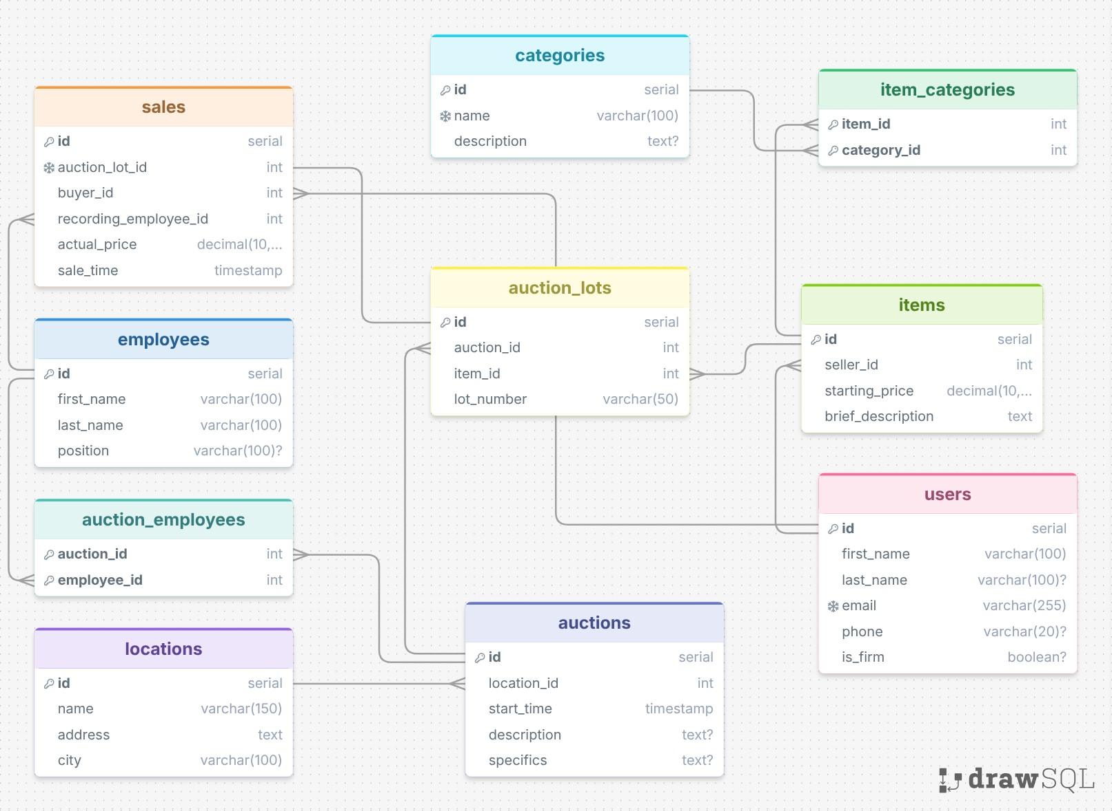

Objects

Table Name: users

Description: Stores data on participants (individuals and legal entities), who may be either sellers or buyers.

Field name | Field Description | Data Type
id | SERIAL, PK | Unique user ID
first_name | VARCHAR(100) | First name or company name (NOT NULL)
first_name | VARCHAR(100) | First name or company name (NOT NULL)
last_name | VARCHAR(100) | Last name (NULL for legal entities)
email | VARCHAR(255) | Unique email address (UNIQUE, NOT NULL)
phone | VARCHAR(20) | Phone number
is_firm | BOOLEAN | Flag: true - business, false - individual

Table Name: locations
Description: Directory of auction venues (hotels, exhibition halls, etc.).

Field name | Field Description | Data Type
id | SERIAL, PK | Unique location ID
name | VARCHAR(150) | Site name (NOT NULL)
address | TEXT | Full address (NOT NULL)
city | VARCHAR(100) | City (NOT NULL)

Table Name: auctions
Description: Information about upcoming auctions, their dates, and details.

Field name | Field Description | Data Type
id | SERIAL, PK | Unique auction ID
location_id | INTEGER, FK | Link to locations.id (NOT NULL)
start_time | TIMESTAMP | Start date and time (NOT NULL)
description | TEXT | Brief description of the event
specifics | TEXT | Auction specifics (e.g., paintings from before 1900)

Table Name: employees
Description: Auction house staff responsible for conducting auctions and recording the results.

Field name | Field Description | Data Type
id | SERIAL, PK | Employee Unique ID
first_name | VARCHAR(100) | Employee First Name (NOT NULL)
last_name | VARCHAR(100) | Employee Last Name (NOT NULL)
position | VARCHAR(100) | Job Title

Table Name: auction_employees
Description: A bridge table for the M:N relationship between auctions and employees (which employees work at which auctions).

Field name | Field Description | Data Type
auction_id | INTEGER, PK, FK | Link to auctions.id
employee_id | INTEGER, PK, FK | Link to employees.id

Table Name: categories
Description: A Reference Guide to Categories of Art and Antiques.

Field name | Field Description | Data Type
id | SERIAL, PK | Unique category ID
name | VARCHAR(100) | Category name (UNIQUE, NOT NULL)
description | TEXT | Category description

Table Name: items
Description: Items consigned for sale by their owners. These items exist independently of any specific auction until they are sold.

Field name | Field Description | Data Type
id | SERIAL, PK | Unique item identifier
seller_id | INTEGER, FK | Link to users.id (Seller) (NOT NULL)
starting_price | DECIMAL(10,2) | Starting price (NOT NULL)
brief_description | TEXT | Verbal description of the item (NOT NULL)

Table Name: item_categories
Description: A bridge table for M:N relationships between items and categories (an item can have multiple tags/categories).

Field name | Field Description | Data Type
item_id | INTEGER, PK, FK | Link to items.id
category_id | INTEGER, PK, FK | Link to categories.id

Table Name: auction_lots
Description: Linking entity. Links an item to a specific auction and assigns it a lot number.

Field name | Field Description | Data Type
id | SERIAL, PK | Unique lot identifier in the system
auction_id | INTEGER, FK | Reference to auctions.id (NOT NULL)
item_id | INTEGER, FK | Reference to items.id (NOT NULL)
lot_number | VARCHAR(50) | Lot number for this auction (NOT NULL)

Table Name: sales
Description: Auction results. Records the sale of the lot, the final price, the buyer, and the employee in charge.

Field name | Field Description | Data Type
id | SERIAL, PK | Unique transaction ID
auction_lot_id | INTEGER, FK, UNIQUE | Reference to auction_lots.id (NOT NULL, UNIQUE — each lot is sold only once)
buyer_id | INTEGER, FK | Reference to users.id (Buyer) (NOT NULL)
recording_employee_id | INTEGER, FK | Reference to employees.id (Registrar) (NOT NULL)
actual_price | DECIMAL(10,2) | Actual sale price (NOT NULL)
sale_time | TIMESTAMP | Transaction confirmation time (NOT NULL)

Comments on table relationships
- The many-to-many (M:N) relationship between Items and Categories has been successfully implemented using the intermediate table `item_categories`. This allows for flexible classification of items.
- The many-to-many (M:N) relationship between Auctions and Employees is implemented via the auction_employees table to accurately track staff at auction sites.
- The auction_lots table resolves the issue of duplicate lot numbers across different auctions. The lot_number field is unique only within the context of the (auction_id, item_id) pair.
- The sales table has a 1:1 relationship with auction_lots via a unique foreign key (UNIQUE CONSTRAINT on auction_lot_id), since a specific lot listed for sale can be marked as sold only once.

Example with data
Example of filling in the “users” table:

id | first_name | last_name | email | phone | is_firm
1 | Ivan | Ivanov | ivan@example.kz | null | false
2 | Antiques P | … | info@example.kz | null | true

