Task-1

**use-storage-example**

This project demonstrates how to create and use a custom React hook, useStorage, to manage local or session storage in a React application. It includes an interactive counter with responsive design and a clean UI.

**Features**

* Customizable storage hook: Supports both localStorage and sessionStorage.
* Fully responsive and modern UI.
* Glassmorphism-inspired design with gradient backgrounds and hover effects.
* Easy-to-use boilerplate for integrating storage logic into React projects.

**Technologies Used**

* **React**: Frontend framework.
* **JavaScript**: Core language.
* **CSS**: For responsive and styled UI.
* **Vite/Webpack**: For bundling the app (adjust based on your setup).

**Installation**

1. Clone the repository:

bash

Copy code

git clone https://github.com/yourusername/use-storage-example.git

1. Navigate to the project directory:

bash

Copy code

cd use-storage-example

1. Install dependencies:

bash

Copy code

npm install

1. Start the development server:

bash

Copy code

npm run dev

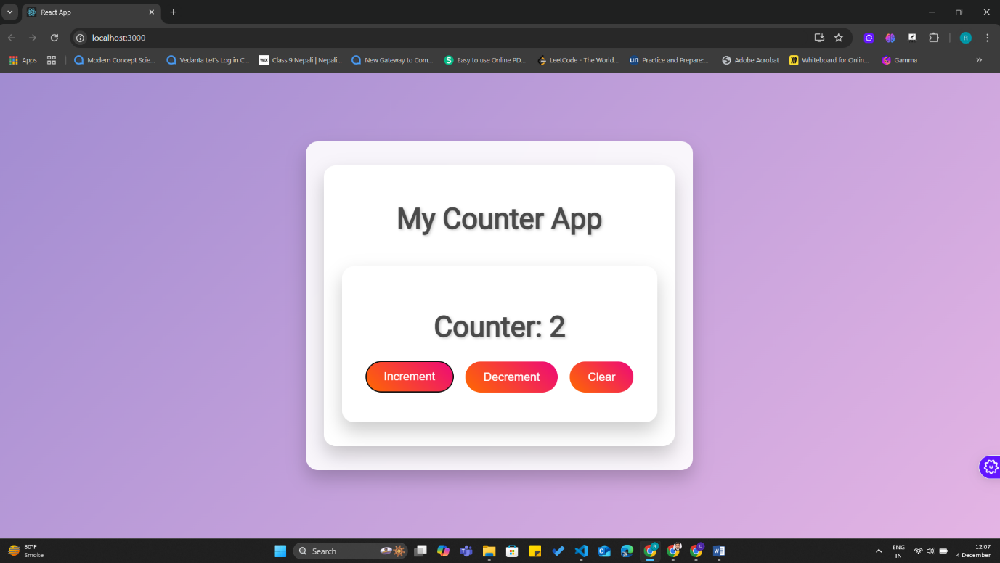**Screenshot**