BeePlan - Final Project Report

1. Project Information and Repository Access
Project Name: BeePlan - Automated Course Scheduler
Developer: Mustafa Yusuf Onur - Role: Student B
GitHub Repository Link: https://github.com/ukaganaslan/SENG383-project

Repository Content Check: When clicking the link, the following folders should be visible:
- /src - Source Code (Clean Code & Error Handling)
- /docs - Diagrams and Reports
- /video - Final Presentation Video
- README.md - Installation and Running Instructions

2. Design Diagrams: Final Versions

2.1 Class Diagram
Main class structure of the BeePlan project:

Main Classes:

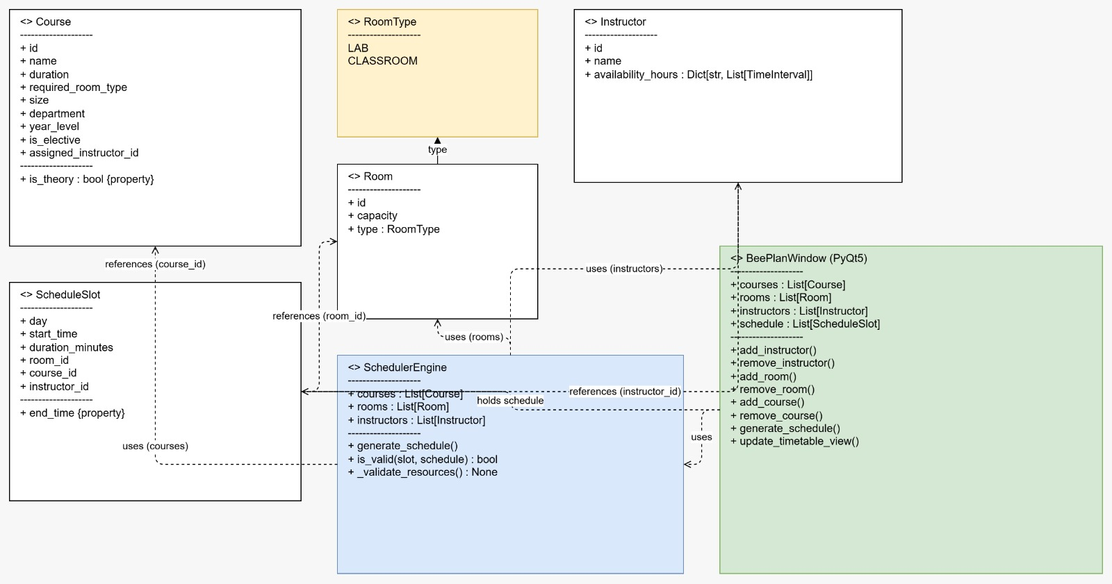

2.2 Activity Diagram
User Scenario - Course Schedule Generation:

User Flow:

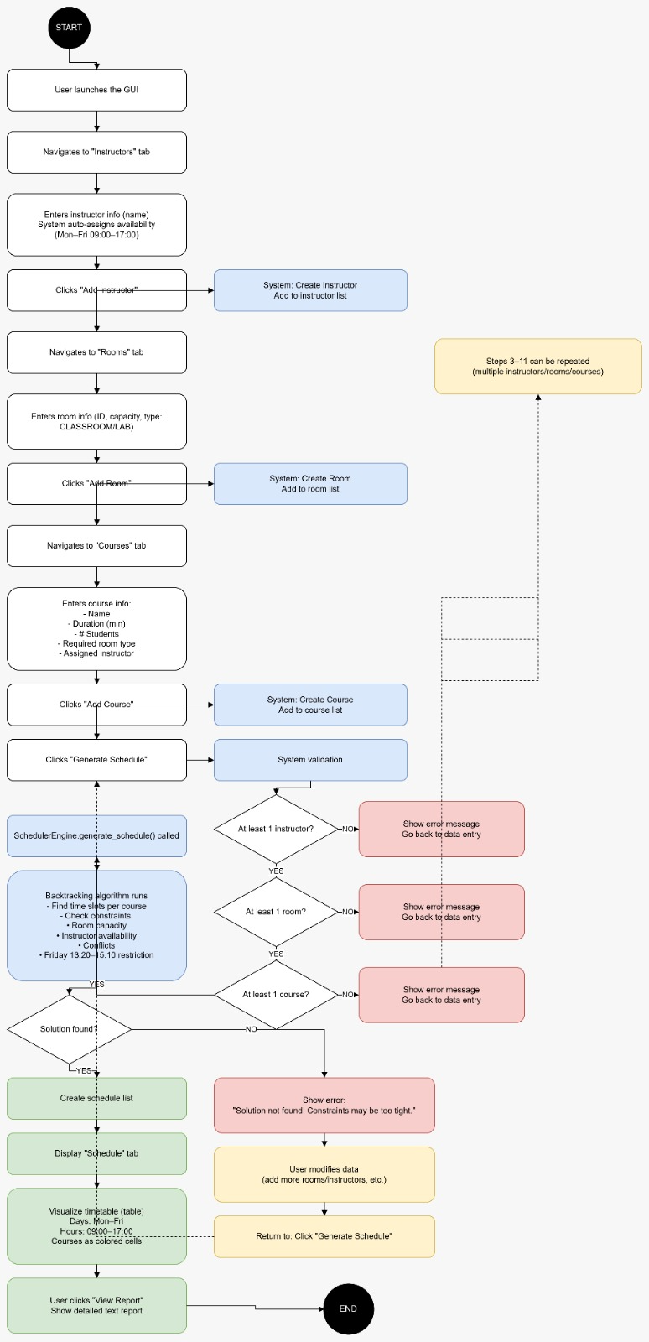

2.3 GUI Screenshots
Main Screen: 4-tab interface (Instructors, Rooms, Courses, Schedule)
- Instructors Tab:
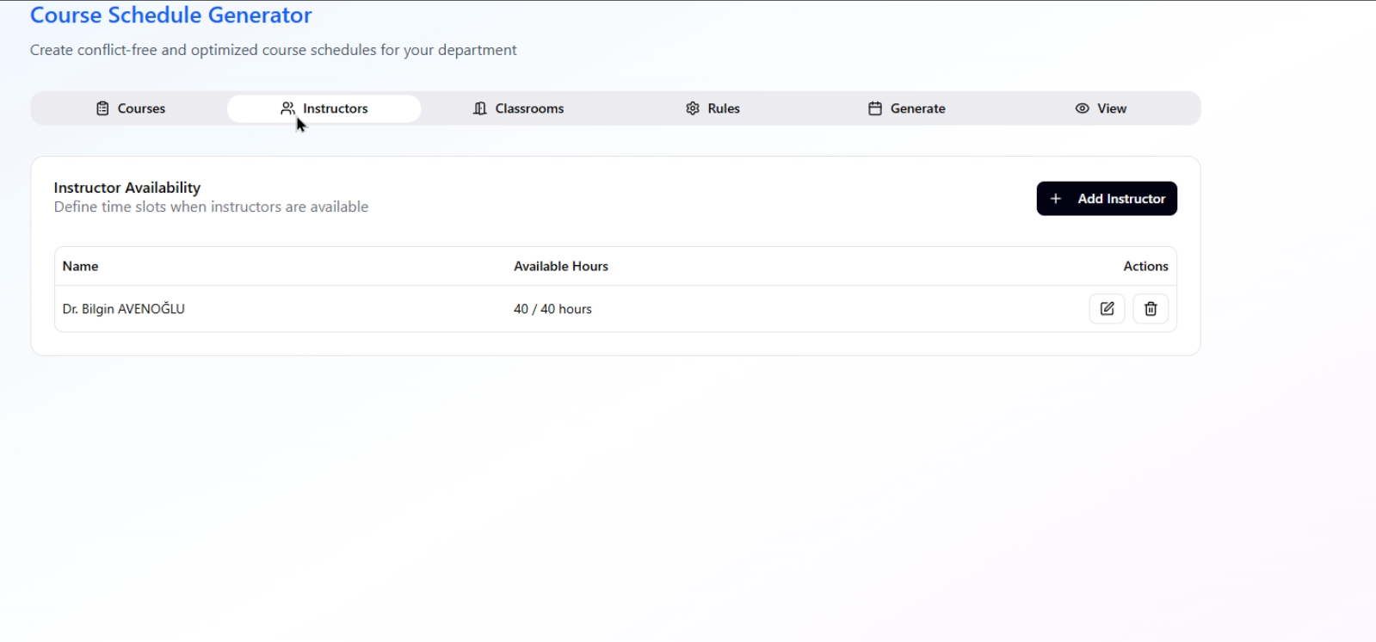
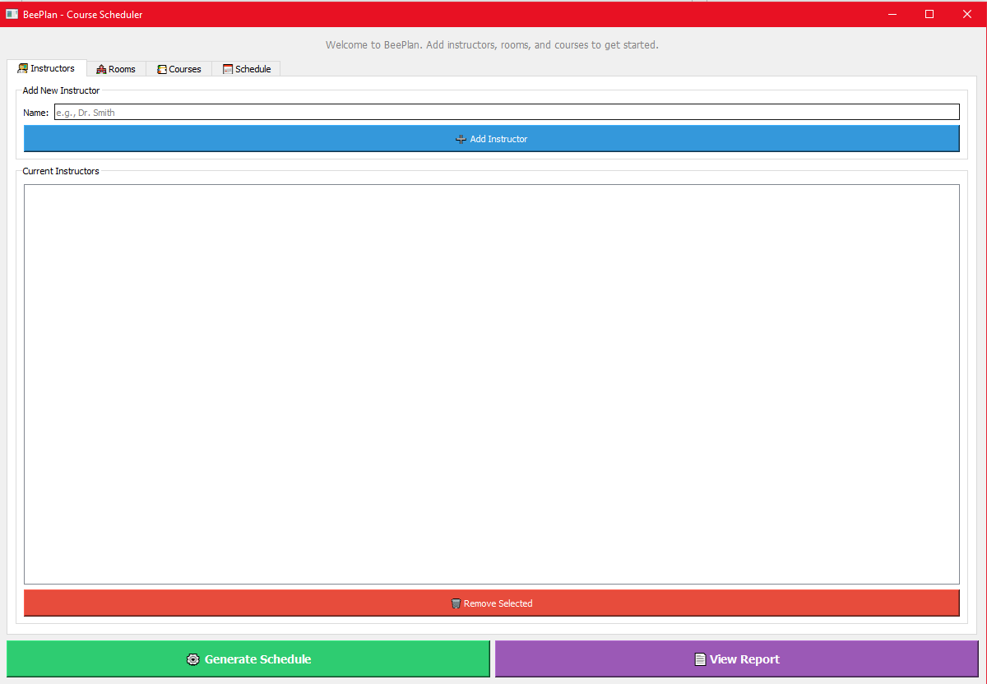

- Rooms Tab:
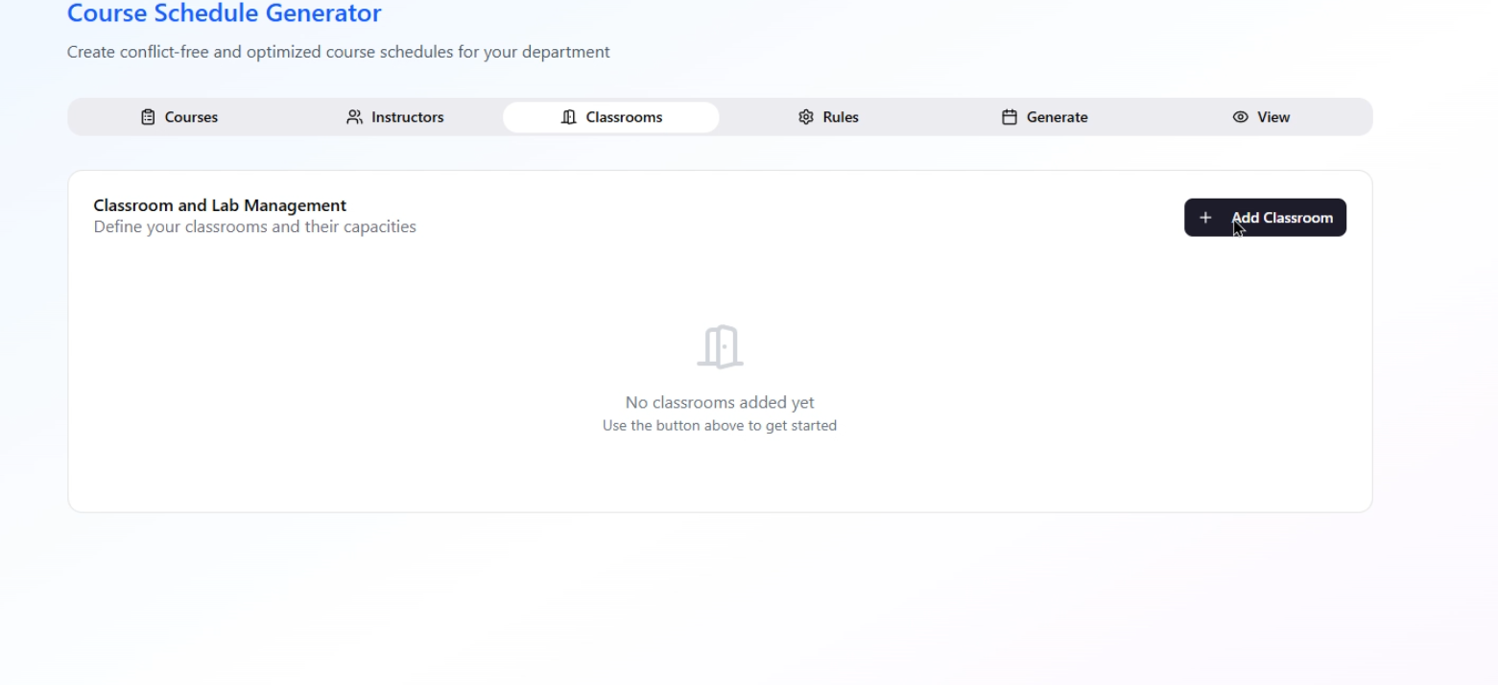
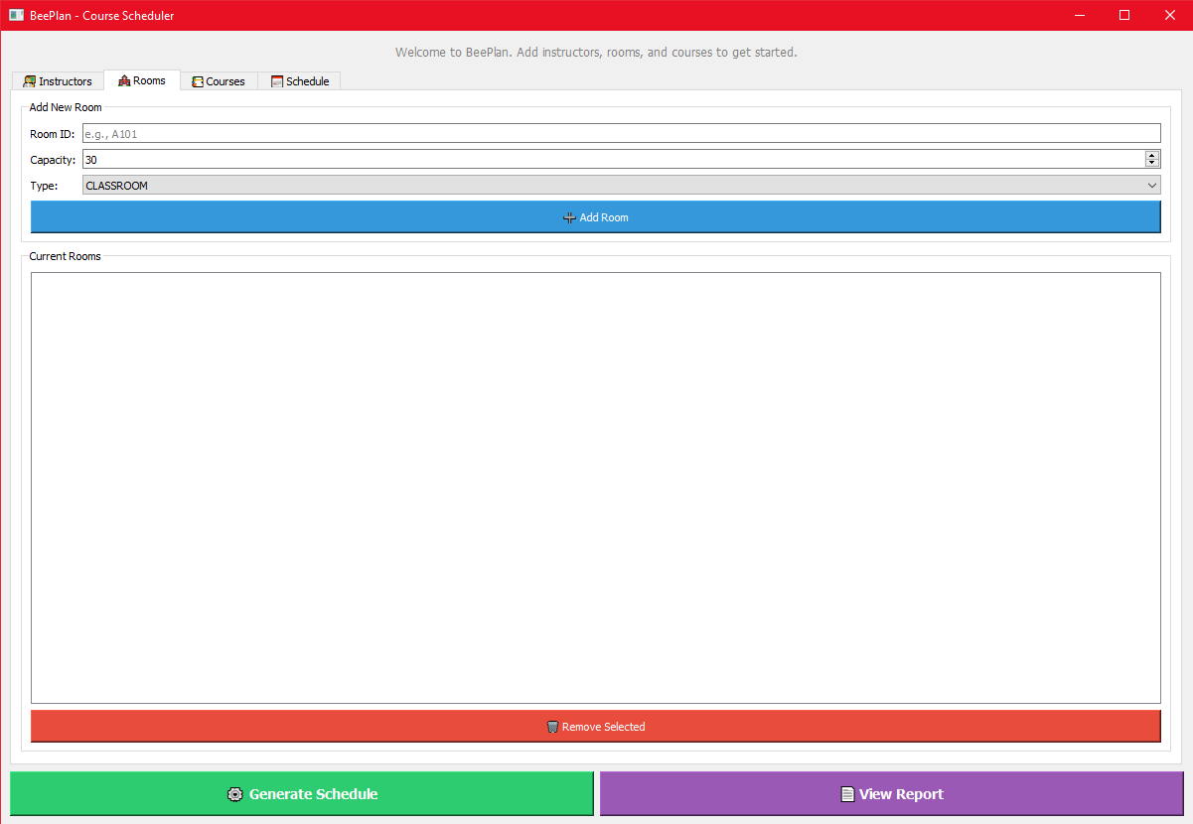

- Courses Tab:
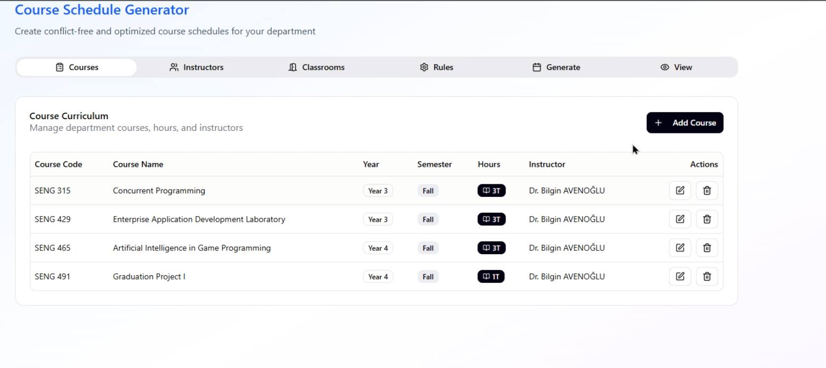
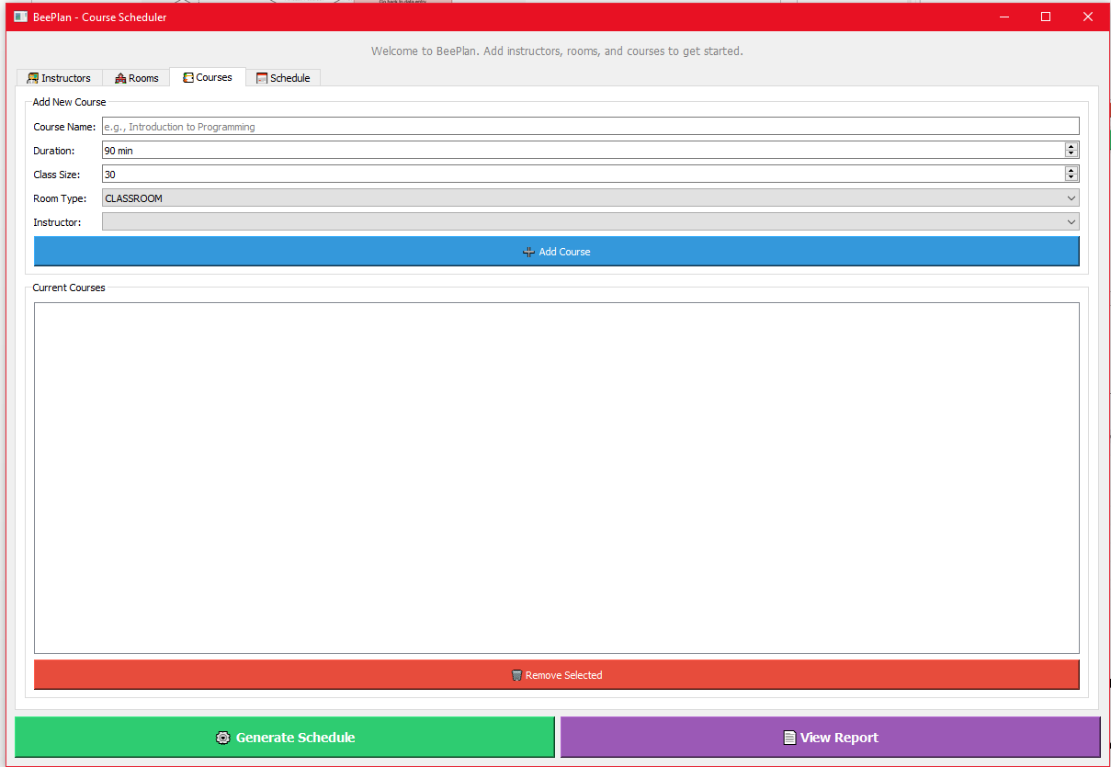

Schedule Tab:
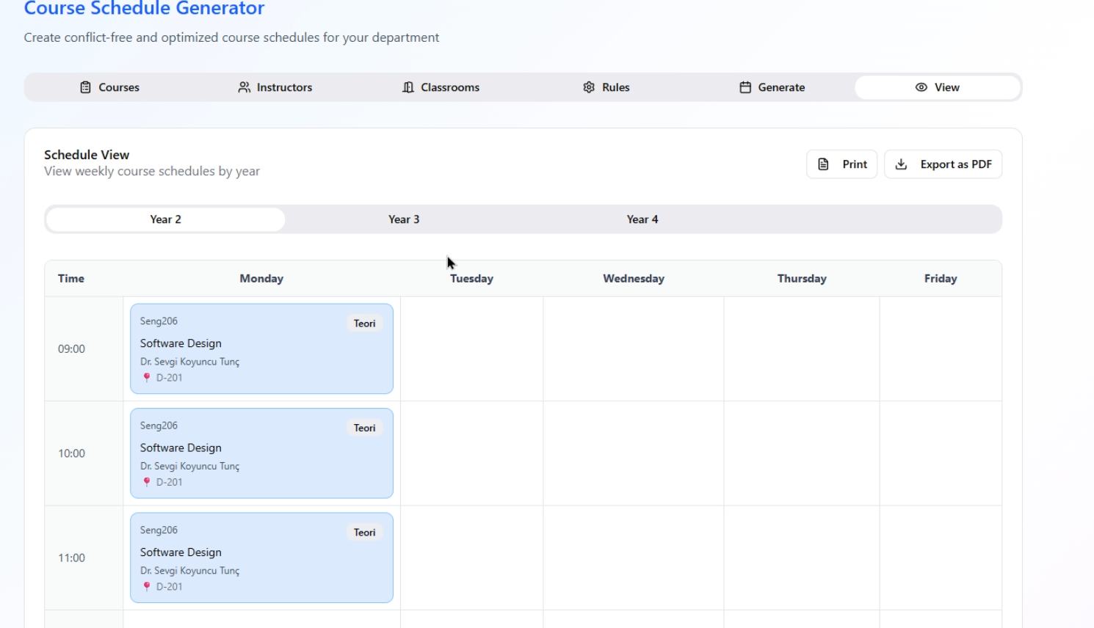
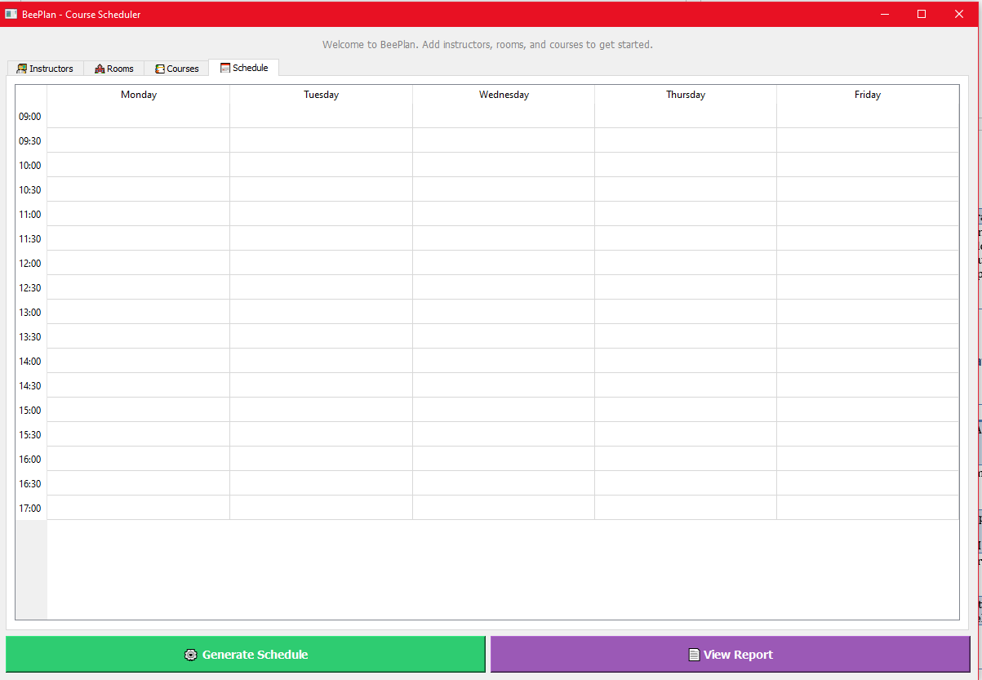

3. AI Usage Analysis (AI Usage & Prompts)
Process | Tool Used | Prompt (Command) | AI Output Analysis | Human Intervention (Revision)
GUI Design | GitHub Copilot | Create a PyQt5 GUI with tabs for adding instructors, rooms, and courses | Basic PyQt5 structure was created but Turkish labels and emojis were missing | Added Turkish labels, used emoji icons, adjusted color palette
Coding (Backtracking) | GitHub Copilot + Claude | Implement backtracking algorithm for course scheduling with constraints | Algorithm worked but instructor availability check was missing | Added availability_hours dictionary structure and updated is_valid() method
Error Handling | DeepSeek | Fix TypeError: Course.__init__() got unexpected keyword argument 'duration_minutes' | Detected that parameters were incompatible with Course dataclass | Changed duration_minutes → duration, instructor_id → assigned_instructor_id, added size parameter
Reporting | Claude (Student B) | Examine sablon.docx document and prepare a report | Template was analyzed, missing information was requested | Report was automatically generated with information obtained from user

4. V&V Test Reports (Verification & Validation)

4.1 Test Case Table
Test Case | Input | Expected Result | Actual Result
TC-01: Add Instructor | Name: "Dr. Ahmet" | Instructor added to list, default availability assigned | PASS
TC-02: Add Instructor with Empty Name | Name: "" (empty) | Error message: "Please enter instructor name!" | PASS
TC-03: Add Room | ID: A101, Capacity: 30, Type: CLASSROOM | Room added to list | PASS
TC-04: Duplicate Room ID | ID: A101 (already exists) | Error message: "Room ID already exists!" | PASS
TC-05: Add Course | 90 min, 25 students, instructor selected | Course created (duration=90) | PASS
TC-06: Generate Schedule | 1 instructor, 1 room, 1 course | Schedule successfully generated | PASS

4.2 Error Resolution with AI Tutor (DeepSeek)

Error 1: TypeError - Course Parameter Mismatch
Error Message:
TypeError: Course.__init__() got an unexpected keyword argument 'duration_minutes'

Prompt Used:
"Fix this error: TypeError: Course.__init__() got unexpected keyword argument 'duration_minutes'"

AI Solution Suggestion:
Check the Course dataclass. Parameters need to match:
- - Use duration instead of duration_minutes
- - Use assigned_instructor_id instead of instructor_id
- - Add size parameter (required)

Applied Fix:
Updated parameters in add_course() method in gui.py file.

Error 2: Instructor Availability Missing
Error Message:
SchedulingConflictError: Solution not found! Constraints may be too tight.

Prompt Used:
"Instructor availability is not set, so the schedule is not being generated. How can I fix this?"

AI Solution Suggestion:
The availability_hours dictionary is empty when creating Instructor objects.
Solution: Add default availability (Mon-Fri 09:00-17:00)

Applied Fix:
default_availability = {
"Monday": [(time(9, 0), time(17, 0))],
"Tuesday": [(time(9, 0), time(17, 0))],
...
}

4.3 Peer Review Findings
Reviewer: Student A (Partner)
Review Date: December 2025

Positive Findings:
- Clean and well-structured code with proper separation of concerns (GUI, Engine, Data)
- Effective use of dataclasses for data modeling (Course, Room, Instructor)
- Good error handling with user-friendly warning messages
- Comprehensive constraint checking in the scheduling algorithm

Issues Found and Resolved:

Issue 1: Missing Input Validation
Problem: Room capacity could be set to very low values (e.g., 1 student)
Suggestion: Add minimum capacity validation (at least 30 students)
Status: Acknowledged - Can be added in future iterations

Issue 2: Hardcoded Time Ranges
Problem: Schedule table is hardcoded to 09:00-17:00 time range
Suggestion: Make time range configurable for different institutions
Status: Acknowledged - Current implementation meets project requirements

Issue 3: Cell Span Display Bug
Problem: Course duration display in schedule table not properly spanning multiple time slots
Suggestion: Investigate PyQt5 setSpan() behavior or use alternative visualization
Status: Documented as known issue - Core scheduling logic works correctly

Overall Assessment:
The BeePlan project demonstrates strong software engineering practices. The backtracking algorithm is well-implemented and handles complex constraints effectively. The GUI is intuitive and user-friendly. Minor issues identified do not affect core functionality. Code quality: 9/10

Conclusion
The BeePlan project is a successful application that solves the course scheduling problem using a backtracking algorithm. A user-friendly interface has been provided with a PyQt5 GUI, and AI tools (Copilot, DeepSeek, Claude) were effectively used during the development process. The project was developed following clean code principles, error handling, and test-driven development approach.

