**INeuron**

Power BI Assignment 1

• **Install Power BI Desktop and share the final screenshot of the report view page which appears when power desktop starts.**

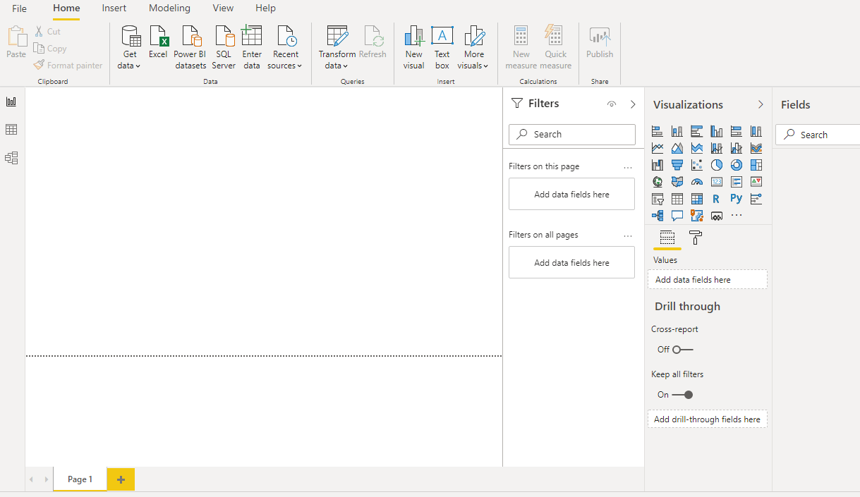

**• Prepare a document and with the following screenshot**

**− Report View**

When Power BI is loaded up, Report view is the page that is loaded. When we connect to data, this is the place where we can perform different visualizations, and prepare reports. 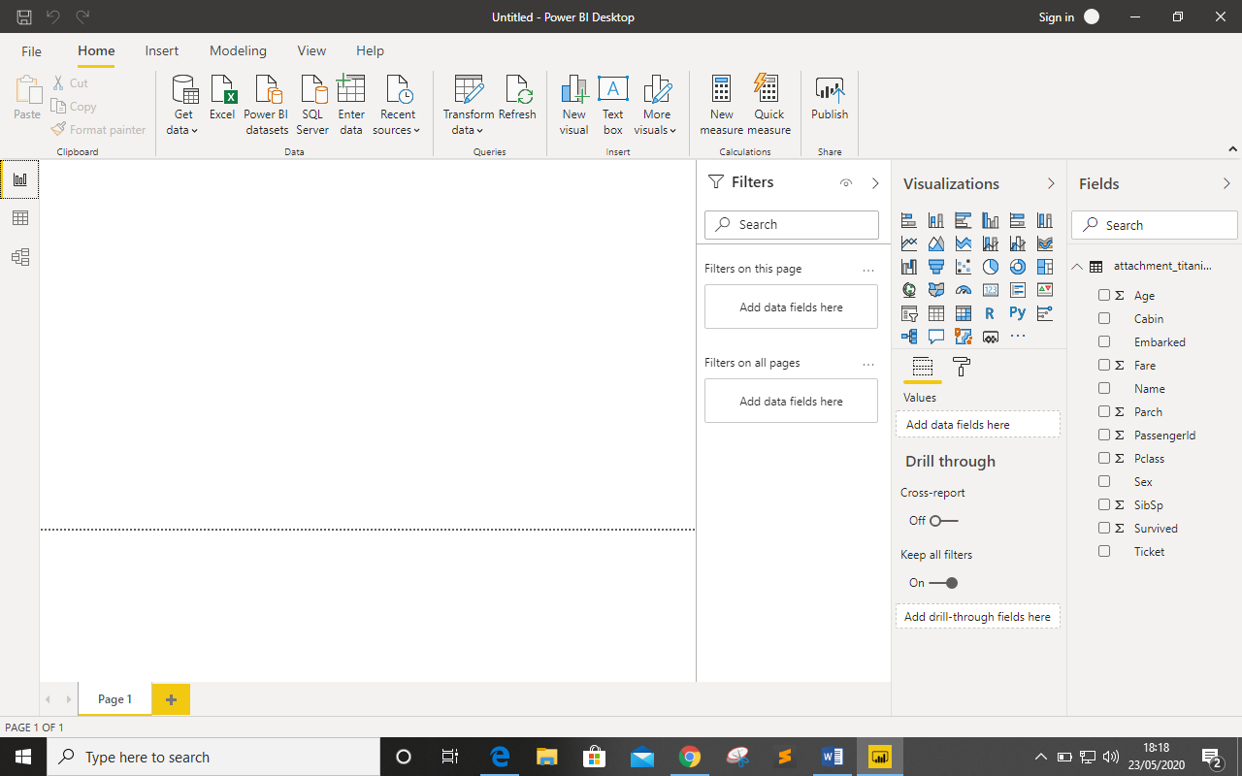

**− Data View**

After loading up the data, this is the place where we can actually see the data like, structure of the data, understand the data, and explore the data much better. This view looks similar to Power Query Editor View.

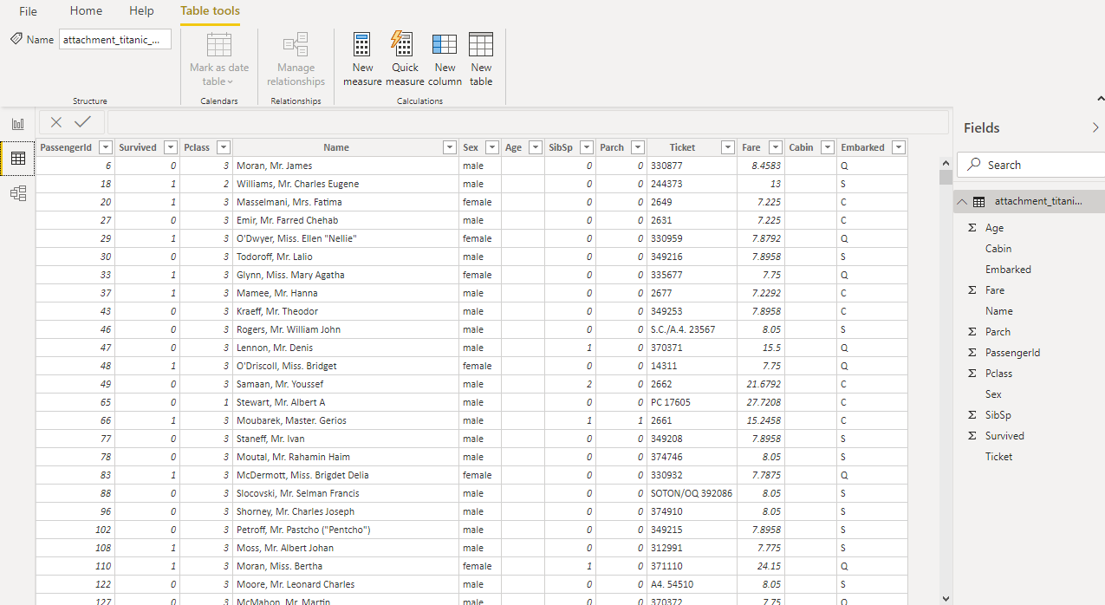

**--- Model View**

When we load a dataset which contains different sheets, we can specify relationship between different tables, sheets, and also columns. Power BI automatically detects this relationships.

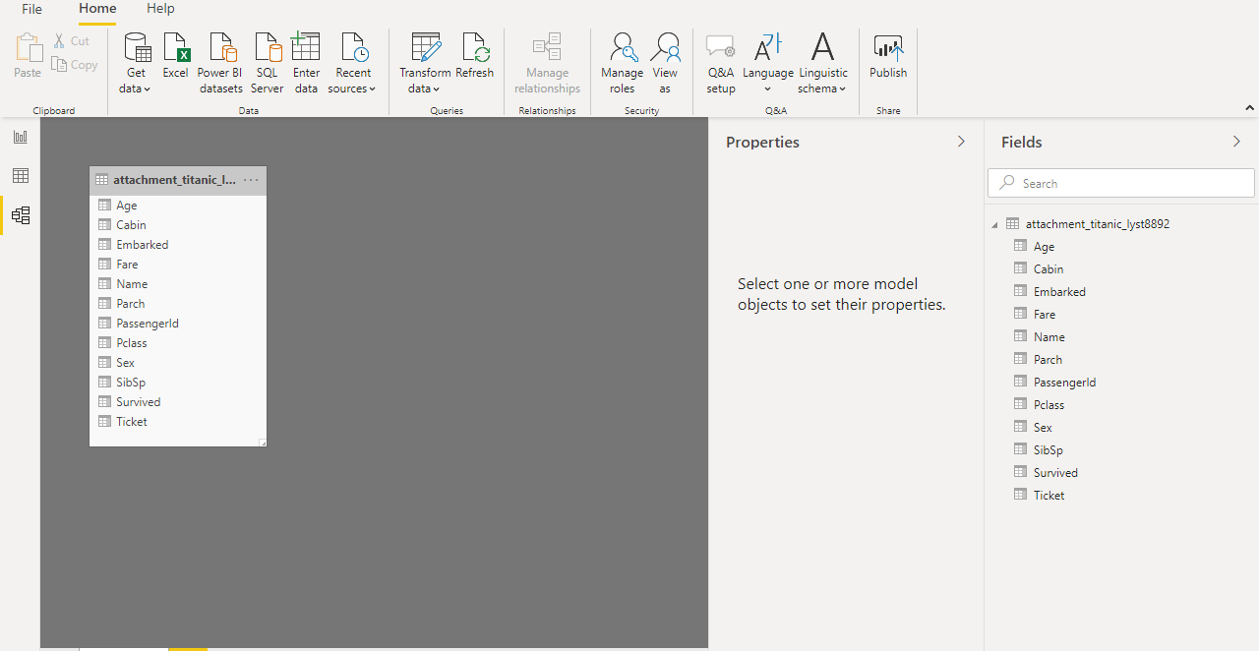

**--- Power Query Editor**

After loading the data, we will have an option to go to report view or to transform the data. Transform the data means, dropping the null values, changing the column headers, changing the data types of columns and many more things. We have three main sections of power query editor, left section where we can see the pending or existing queries, central section where we can modify the present query and right section where we can see the change committed. We can undo the changes committed.

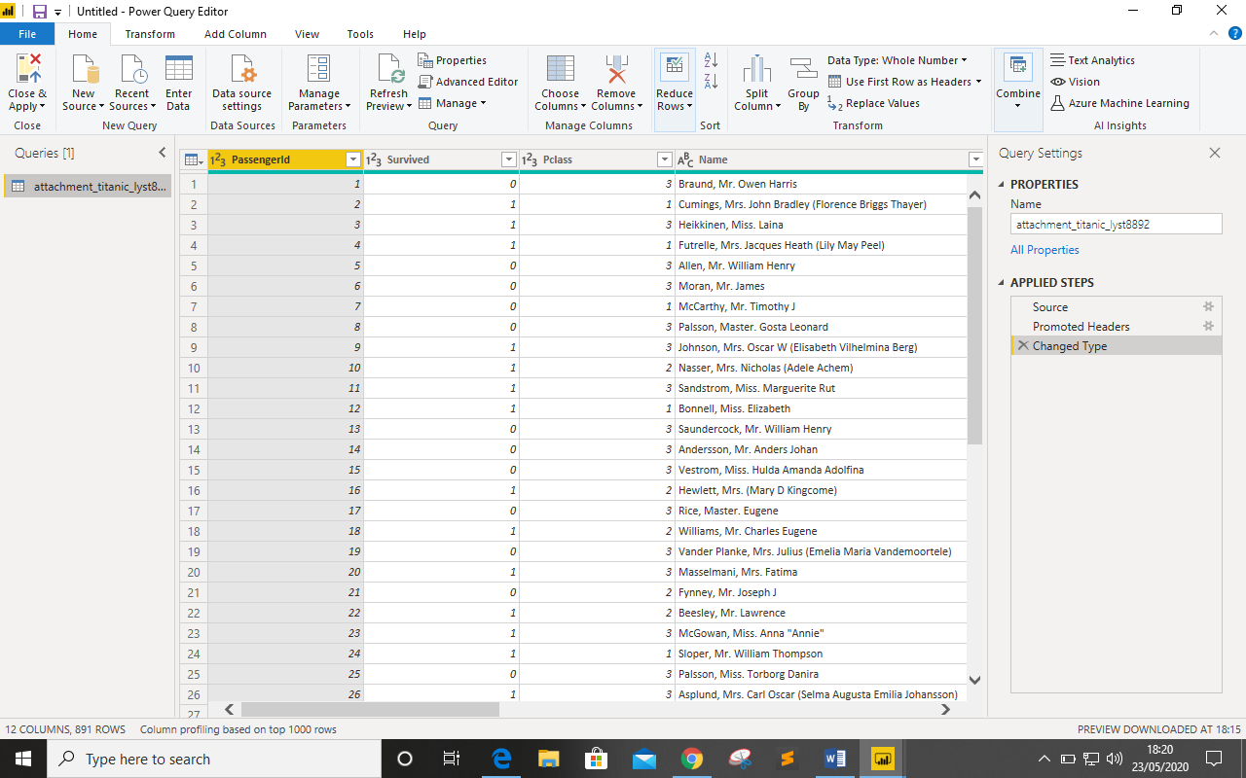

**--- Advance Query Editor**

Now in power query editor, we have prebuilt options to clean the data. If we want to do some advance cleaning or imputing median or mean, we can do it in advance query editor.

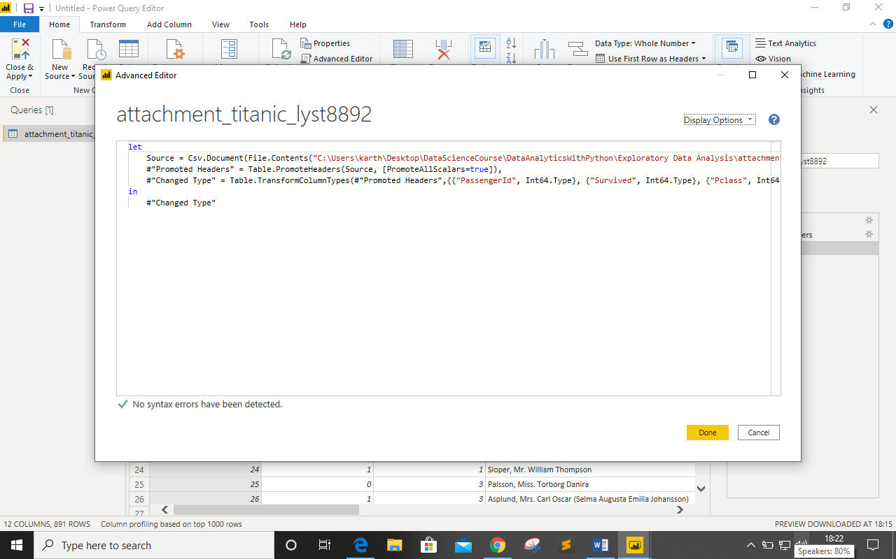

**• Prepare a document with details of the following along with their price**

**--- Power BI Desktop**

Power BI Desktop is visualization tool, where we can connect the data, transform the data, and also visualize the data. It’s is developed my Microsoft Corporation.

Prize: - **It is free** **for Individual User’s** if you have a Microsoft account.

**--- Power Bi Pro**

Power BI Pro is a full version of Power BI Desktop. Power BI pro allows us to build dashboards, unlimited viewing and consumption of reports of others.

Prize: - **9.99$ /User/Month**

**--- Power BI Premium**

Power BI Premium is another version of Power BI, where we can dedicated Cloud Storage. It has some advance BI tools, Big data analytics, and cloud and on premises reporting. It also has Advance deployment and administration tools.

Prize: - **4995$/Month/Dedicated Cloud**