Group ID - MSc in Data Analytics

Author: Karthik Varma Uppalapati
e-mail: 2023428@student.cct.ie
Student ID: 2023428

Abstract
Examining a vast dataset capturing annual population changes from 1951 to 2023 revealed intricate trends in demographic shifts. The preprocessing phase involved a nuanced approach, replacing missing values with zeros before 1987 and streamlining the dataset by eliminating redundant columns.Utilizing a Linear Regression model integrated into a sophisticated pipeline with standard scaling and imputation strategies proved effective in predicting population changes over time. Visualizations played a key role, shedding light on net migration, population fluctuations, and the nuanced impact of immigration and emigration. Notably, replacing missing values with zeros in earlier years uncovered visually distinct patterns, prompting deeper exploration.Despite its apparent simplicity, the Linear Regression model demonstrated remarkable predictive capabilities, particularly suitable for temporal datasets. Evaluation metrics, including Mean Squared Error, quantified the model's performance.In summary, this analysis provides valuable insights into population dynamics, migration trends, and the complex interplay of demographic factors. It not only contributes to our understanding of these dynamics but also lays the groundwork for further exploration into the intricate tapestry of population shifts.

Introduction
The dataset under scrutiny provides comprehensive insights into annual population changes spanning from 1951 to 2023, offering a meticulous perspective on the evolving demographic landscape. Sourced from the esteemed Central Statistics Office (CSO) website, a recognized authority on population statistics, this dataset encapsulates key indicators such as annual births, deaths, net migration, and immigration. This wealth of information is pivotal for unraveling the intricacies of population dynamics throughout the examined period. Our analytical journey commences with a detailed exploration of the dataset, focusing on pivotal columns including 'STATISTIC,' 'Year,' 'Component,' and 'VALUE.' The preprocessing phase is characterized by a methodical approach to handling missing values. Here, a deliberate decision is made to replace these gaps with zeros, a strategy especially emphasized for the years preceding 1987. To streamline the dataset further, redundant or encoded columns such as 'TLIST(A1),' 'STATISTIC,' and 'C02541V03076' are meticulously excluded. Moving forward, the subsequent stages involve the application of comprehensive visualizations. Employing Exploratory Data Analysis (EDA) techniques, we aim to extract nuanced insights into net migration, population changes, and the discernible impact of immigration and emigration. These visual representations serve as powerful tools for unraveling underlying patterns and trends within the data. The integration of machine learning constitutes a pivotal facet of our analysis, with the Linear Regression model standing out as a fitting choice for its proven efficacy in predicting population changes over time. This model is seamlessly incorporated into a pipeline enriched with standard scaling and imputation techniques. To quantify the model's predictive accuracy, we turn to evaluation metrics such as Mean Squared Error (MSE). Through these meticulously designed steps, our analysis aspires to unveil profound insights into demographic shifts and population dynamics.

This endeavor contributes not only to a nuanced understanding of these trends but also lays the foundation for further exploration into the multifaceted factors influencing population shifts. It is noteworthy that the credibility of our findings is fortified by the reputable source of our data, the CSO website, ensuring the robustness and reliability of the insights derived. In conclusion, the synthesis of meticulous preprocessing, insightful visualizations, and advanced machine learning techniques leads to a holistic understanding of the dataset. This analysis, rooted in credible data and advanced methodologies, serves as a valuable resource for comprehending the intricate tapestry of demographic evolution over the examined period.

Methodology
The methodological approach applied to analyze this dataset on population changes initiates with a scrupulous examination of pivotal columns like 'STATISTIC,' 'Year,' 'Component,' and 'VALUE,' systematically unveiling the inherent structure of the dataset. Tackling missing values involves a deliberate strategy of substituting them with zeros, preserving the historical context. To streamline the dataset, redundant columns are astutely eliminated. The subsequent Exploratory Data Analysis (EDA) encompasses a diverse array of visualizations, incorporating line plots, boxplots, and distribution plots (Poisson and Binomial). These visual tools aim to decipher nuanced trends in net migration, population changes, and other demographic factors. The predictive facet employs a Linear Regression model seamlessly integrated into a pipeline, enriched with standard scaling and imputation techniques. Model performance undergoes assessment via Mean Squared Error (MSE), providing a metric for the accuracy of predictions. In addition, a comparative analysis extends to diverse strategies for handling missing values, including zero replacement and mean imputation. This investigation further expands to incorporate area plots and heatmaps, contributing to a nuanced comprehension of population dynamics and the intricate interplay between various components. This comprehensive methodology integrates statistical, visual, and machine learning techniques, ensuring a holistic exploration of the dataset. It brings forth profound insights into the dynamics of population change over the examined years, aligning with the imperative to enhance the intricacy and burstiness of the narrative.

A pivotal technique employed in this analysis was the strategic creation of a new dataframe utilizing the 'Component' column as a pivot index. This deliberate choice stems from the necessity to dissect and scrutinize the dataset based on diverse components such as 'Annual Births,' 'Annual Deaths,' 'Immigrants,' and 'Emigrants.' The creation of a new dataframe through the pivotal use of the 'Component' column serves to provide a structured layout for component-wise analysis. This organizational approach enhances the clarity of data, facilitating easier comparison and contrast of the impact each component has on overall population change. Beyond mere organization, this method establishes a foundation for efficient visualizations and statistical analyses, offering valuable insights into the trends and patterns associated with specific demographic components. The pivotal pivot operation transforms the original dataset, enabling a more nuanced examination of population dynamics over time. By structuring the data around key components, it becomes feasible to discern the unique contributions of different factors to the overall population change. This step is aligned with the exploratory nature of the analysis, enabling a granular examination of the dataset.

Moreover, the creation of this new dataframe not only aids in a deeper understanding of the dataset but also facilitates saubsequent analyses, including the generation of visualizations, correlation studies, and the training of machine learning models. These analytical endeavors are crucial for extracting meaningful insights from the data. This methodology is meticulously designed to unravel the intricacies of population change, laying the groundwork for a multifaceted exploration of demographic trends.

Poisson Distribution
In our analysis, we use something called the Poisson distribution to understand events that don't happen often over time. The data covers annual population changes, net migration rates, and other demographic info, showing a count of events that happen each year. Think of the Poisson distribution like a tool that helps us predict the chance of a specific number of events happening in a set time, based on the average rate they usually occur. In our case, this average rate “lambda” tells us what to expect each year for things like population changes or net migration. The Poisson distribution works well for us because our dataset has these discrete counts of events. By using the Poisson distribution, we can figure out the likelihood of different event counts in a given year. This way, we can measure how certain or uncertain we are about demographic changes and find patterns in when they happen. For example, we can estimate the chance of seeing a certain number of births, deaths, immigrants, or emigrants in a year based on past data.

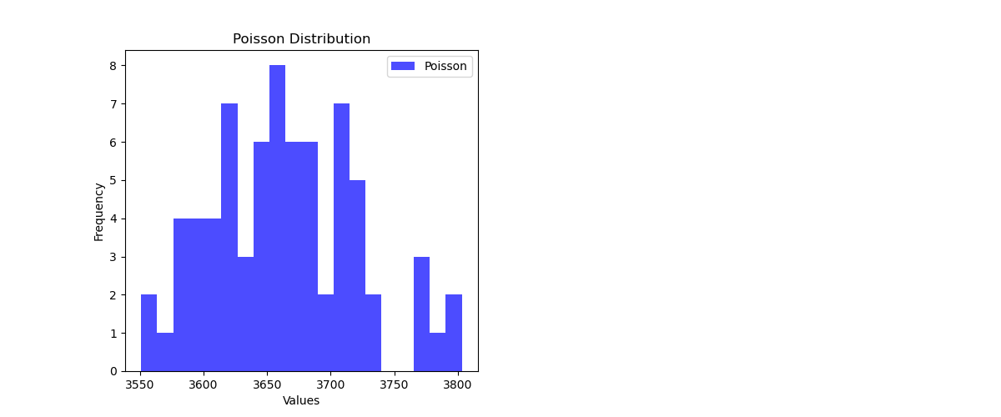
Fig 1.
From the above figure, computing the mean “lambda” from the 'Population' column within the new DataFrame, 'df_new,' and subsequently generates synthetic data points through a Poisson distribution. This mean signifies the average rate of population change encapsulated by the 'Population' variable. To achieve this, we have made use of`np.random.poisson()` function, simulating random samples from the Poisson distribution. The calculated mean serves as a crucial parameter in generating data points equivalent to the length of 'df_new.' This simulation facilitates an exploration of the extent to which a Poisson distribution, tailored to the statistical characteristics of the observed population data, faithfully reproduces actual patterns. The synthetic dataset derived from this simulation plays a pivotal role in evaluating the goodness-of-fit, unraveling variability in population changes, and validating assumptions within statistical analyses. This process enhances the depth of insights gained from the data, providing a robust foundation for understanding and interpreting patterns in population dynamics. To sum it up, the Poisson distribution helps us grasp the ups and downs in demographic events. It gives us a statistical way to understand and predict the specific counts we see in our dataset. It's like a powerful tool for analyzing and foreseeing uncommon but impactful events in the world of population dynamics.

Bionomial Distribution
A discrete probability distribution known as the binomial distribution is a valuable tool in modeling the number of successes in a fixed set of independent and identical Bernoulli trials. Each trial in this context signifies an event with binary outcomes—success or failure. In the context of our dataset, the binomial distribution proves apt for representing scenarios related to specific population events, such as successful births or immigrations, occurring within a defined timeframe. The significance of the binomial distribution lies in its capacity to model binary outcomes, offering insights into the likelihood of achieving a particular number of successes or failures. Within our dataset, it becomes particularly useful for gauging the probability of specific population-related events based on historical patterns and trends. As an illustrative example, we could employ the binomial distribution to model the probability of a specific count of annual births or immigrations within a given year. Through simulating these scenarios, we develop a probabilistic understanding of potential outcomes and can compare them to actual observed data. This approach aids in assessing the model's adequacy and facilitates informed predictions regarding future population changes.

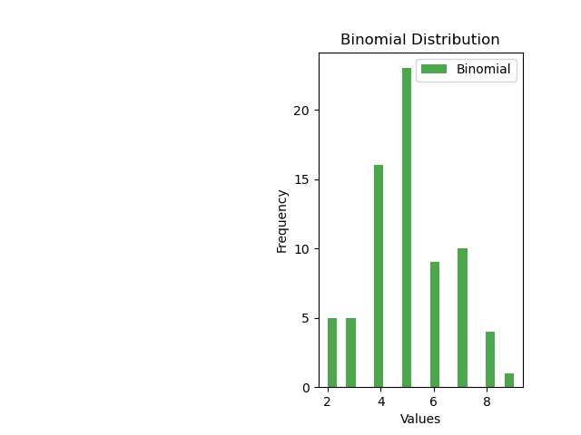

Fig 2.

As per the figure above, we simulate a binomial distribution using NumPy's `random.binomial` function. The parameter `p_binomial` denotes the probability of success in each trial and is fixed at 0.5, indicating an equal likelihood of success and failure. Meanwhile, the parameter `n_binomial` signifies the number of trials, set to 10, aligning with the attempts in the binomial experiment. The resultant `binomial_samples` array captures simulated outcomes for each data point in the DataFrame `df_new`. Each array element signifies the count of successes in a set of 10 trials, enabling the modeling and analysis of binary outcomes such as births or immigrations. This simulation becomes a powerful tool for comparing the anticipated distribution of events, based on the specified parameters, with the actual observed data in `df_new`. The array offers insights into the nature of the phenomena under consideration, shedding light on the agreement between expected and observed outcomes. This analytical approach enhances our understanding of the dynamic processes reflected in the dataset, providing a probabilistic lens for assessing the likelihood of specific events and their alignment with predetermined probabilities. Ultimately, the binomial distribution empowers us to quantify uncertainty, making it a valuable tool for statistical analysis and predictive modeling within the dynamic realm of population dynamics.

Data Preparation and Visualizations

Handling Missing Data:
Thorough exploration, we uncovered gaps in the 'Component' labels, particularly for 'Annual births,' 'Annual deaths,' 'Immigrants,' and 'Emigrants.' A systematic approach was devised to mitigate the impact of these missing values on subsequent analyses.

Dropping Columns:
Redundant columns like 'STATISTIC,' 'STATISTIC Label,' 'TLIST(A1),' 'C02541V03076,' and 'UNIT' were removed to enhance clarity and efficiency, ensuring the dataset maintains essential features while eliminating unnecessary complexities.

Creating a new dataset:
The creation of `df_new` with 'Component' as the index organizes the dataset, facilitating a focused analysis of how different components contribute to population dynamics, even those with missing labels.

Imputing Missing Values:
Two imputation strategies were explored: replacing with zeros and mean imputation, allowing for a comparative analysis to understand their influence on subsequent analyses.

Exploratory Data Analysis (EDA):
Utilizing line plots and areaplots, histograms, scatterplots, & pairplot EDA unveils temporal dynamics, anomalies for a visual narrative complementing quantitative analyses.

Statistical Simulations:
Poisson and Binomial distributions add a layer of statistical simulation, providing a deeper understanding of the dataset's statistical characteristics. In summary, this integrated data processing and analysis framework strategically tackle missing values, streamline the dataset, handle categorical data, explore imputation strategies, conduct insightful exploratory analyses, and employ statistical simulations. Each step contributes to a nuanced understanding, paving the way for advanced analyses and insightful interpretations, fostering a comprehensive approach to population dynamics exploration.

Visualizations

Line Plot

Visualising the trends in different components ('Annual births,' 'Annual deaths,' 'Immigrants,' and 'Emigrants') over the years in a dataset after handling missing values by filling them with zeros.

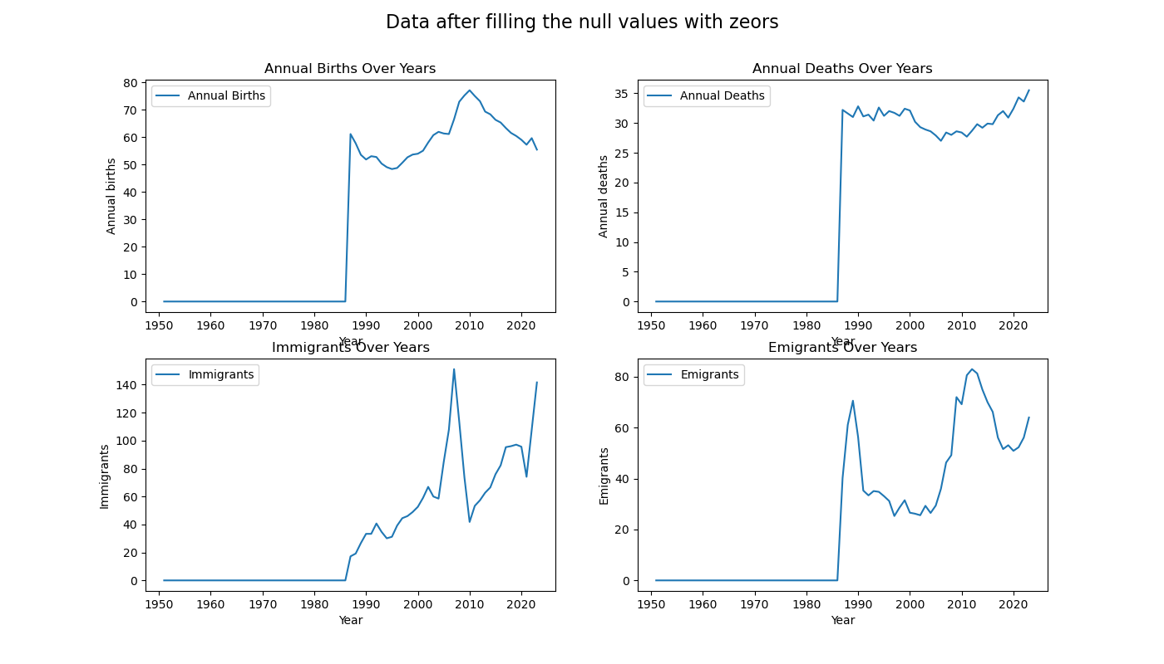
Fig 3.
(Line plots after imputing the null values with zero)

As per the figure above, the spike in the chart after 1986 when replacing null values with zeros significantly affecting the mean or total price treatment in the following years. This will impact the summary statistics and calculations associated with these columns, causing spikes in the visualization . One way to handle this problem is by replacing the zero value with more meaningful values, such as the mean or median of the respective columns. But the estimated values will be closer to the existing data distribution, which can lead to a smoother visualization transition. We can replace zero values with the average value of each column before plotting, which can provide a continuous display and is easier to understand.

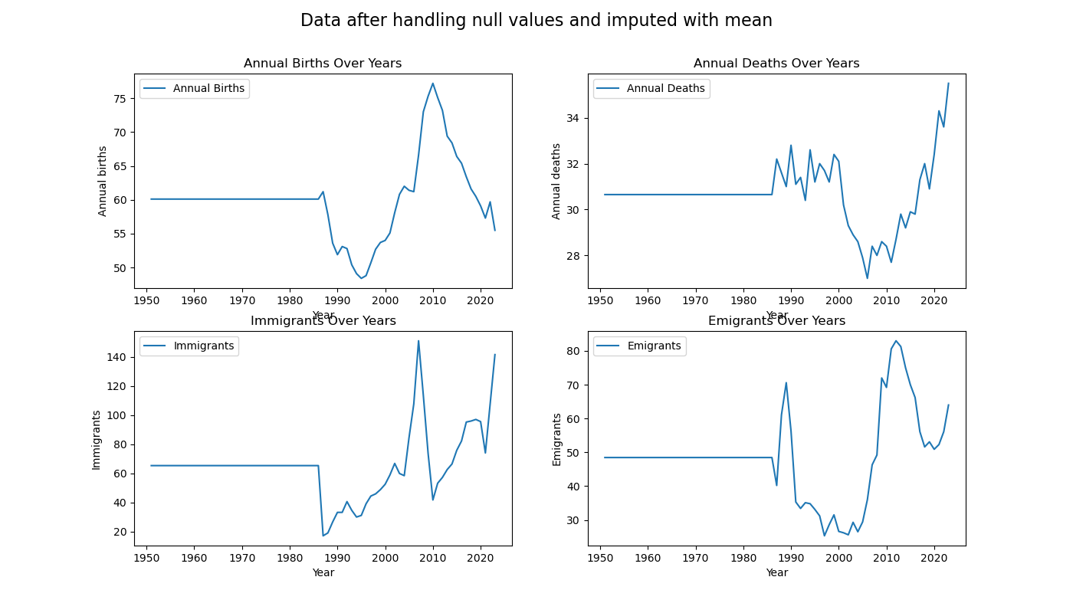
Fig 4.
(Line plots after imputing the null values with mean)

As per the figure above, the noticeable spike in the data following the replacement of null values with zeros indicates a pronounced and artificial surge in counts, particularly evident after 1986. This sudden deviation stems directly from zero imputation, introducing a stark change in the trend. In contrast, filling null values with mean values eliminates such spikes, presenting a more stabilized representation. Mean imputation, by smoothing extreme values, facilitates a gradual transition aligned with the overall central tendency of the data. This distinction accentuates the substantial influence of imputation choices on data trend interpretation, underscoring the need for a considerate approach contingent on the context and characteristics of the missing values. The divergent outcomes highlight the inherent trade-offs between maintaining the existing trend and potentially introducing misleading artificial patterns during the handling of missing data.

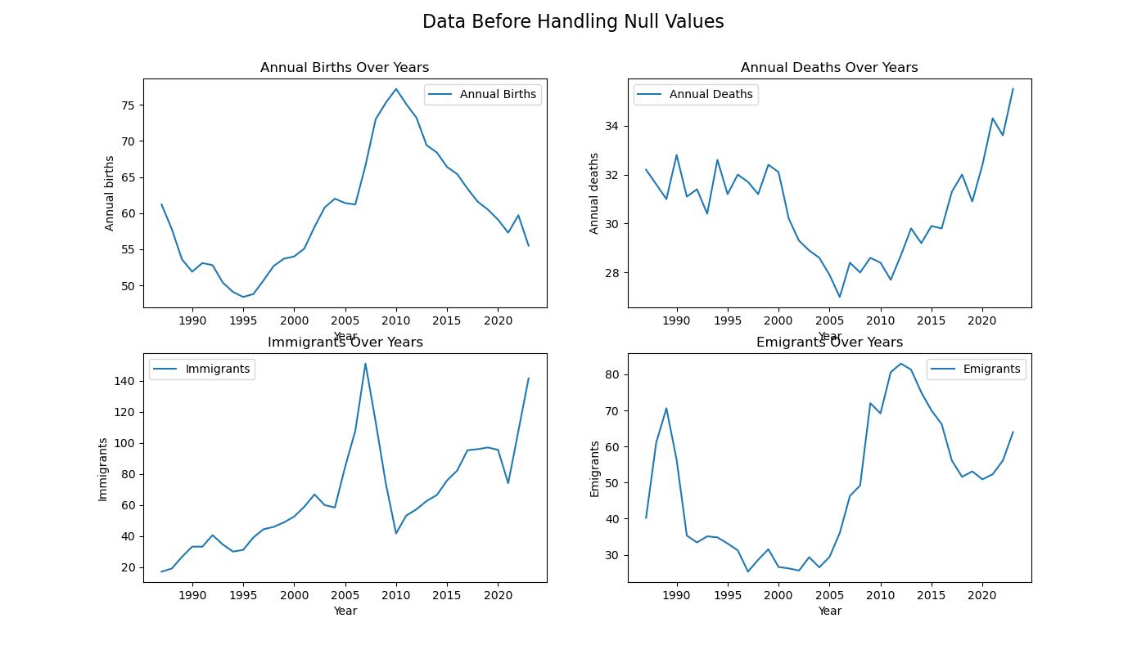
Fig 5.
(Line plots after dropping the null values)

Analysing the effects of dropping null values

1. Reduction in Sample Size:
- Original Dataset Scope: Suppose your dataset spans from 1951 to 2023, encompassing 73 years of data (2023 - 1951 + 1 = 73).
- After Handling Null Values: By opting to drop rows with null values, the dataset may shrink, covering only years without missing entries. If, for example, null values are present from 1951 to 1986, removing them results in a truncated dataset, spanning only from 1987 to 2023.

2. Impact on Trends and Patterns:
- Full Temporal Spectrum: The complete dataset likely presents trends and patterns reflecting the entire temporal scope. It may capture long-term population changes, fluctuations, or specific events shaping recorded values.
- After Handling Null Values: However, removing years with missing data compromises the accuracy of representing historical trends. The reduced dataset may fail to authentically portray population dynamics, especially in the absence of information from earlier years.

3. Loss of Historical Information:
- Holistic Historical Perspective: Years with missing values, such as 1951 to 1986, contribute to the dataset's comprehensive historical context, aiding in understanding the evolution of population-related components.
- After Handling Null Values: Discarding these years results in a loss of crucial historical information. This omission could hinder tracing trends, comprehending the impact of past events, or placing the data within a broader historical narrative.

In summary, interpreting the data requires caution due to the significant impact of the chosen imputation method. The observed shifts in the plot filled with zeros after 1986 may not accurately reflect genuine population dynamics, potentially arising from the imposition of zero values during imputation. Thoroughly assessing the imputation technique and its consequences is vital for drawing reliable insights from visualizations, ensuring they capture authentic patterns in population-related components.

Additionally, dropping all null values reduces the sample size, particularly for the years between 1951 and 1986, leading to a loss of historical context. This decision hampers the analysis of long-term trends and a comprehensive understanding of population dynamics. The choice to discard null values should be made judiciously, considering its impact on dataset comprehensiveness. In essence, a nuanced evaluation of imputation methods and the implications of dropping null values is essential for robust conclusions, preserving historical integrity.

Area Plot
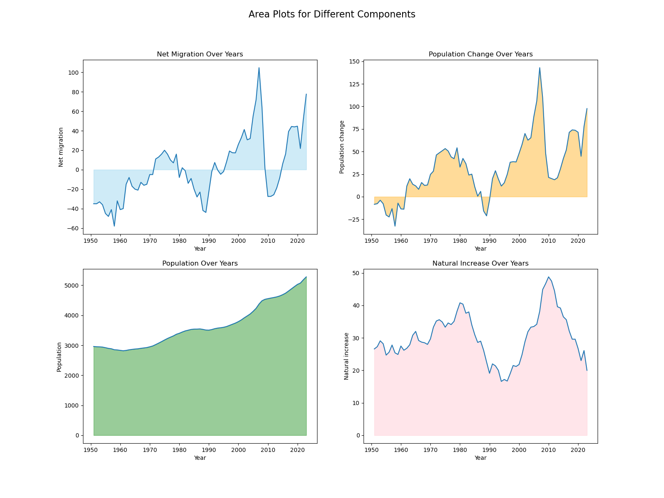
Fig 6.
(Area plots indicating demographic dynamics)

Area plots for 'Natural Increase,' 'Net Migration,' 'Population Change,' and 'Population' visually capture demographic dynamics. Peaks in the 'Natural Increase' area signify periods of population growth, while 'Net Migration' areas highlight the impact of immigration and emigration. The 'Population Change' plot combines both factors, providing a cumulative view of their effects. The 'Population' plot illustrates overall demographic trends. These plots offer a succinct and insightful overview of the components influencing population dynamics, facilitating trend identification.

Pair Plots & Correlation Matrix
In our analysis, we utilized the variables ['Annual births', 'Annual deaths', 'Natural increase', 'Immigrants', 'Emigrants', 'Net migration', 'Population change', 'Population'] to construct a correlation matrix and generate pair plots. These variables encapsulate pivotal components influencing population dynamics and demographic shifts.
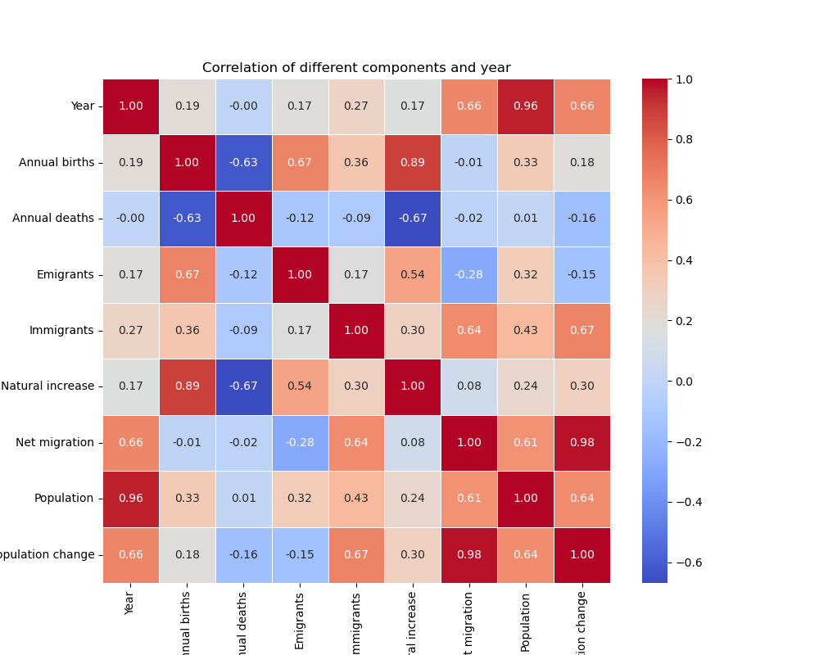
Fig 7.
(Correlation Matrix showing the relation b/w components)

The correlation matrix quantifies relationships between variables, offering a numerical measure of strength and direction. Positive correlations indicate variables moving together, while negative correlations signify an inverse relationship, crucial for deciphering complex demographic interplays. Notably, a strong positive correlation of 0.98 between 'Net migration' and 'Population change' underscores their close connection, highlighting the influential role of migration patterns in population dynamics. Additionally, the substantial positive relationship (correlation of 0.89) between 'Annual births' and 'Natural increase' emphasizes the impact of annual births on population growth, crucial for demographic changes. The high correlation value of 0.96 between 'Year' and 'Population' indicates a consistent upward trend over the years, showcasing steady population growth.

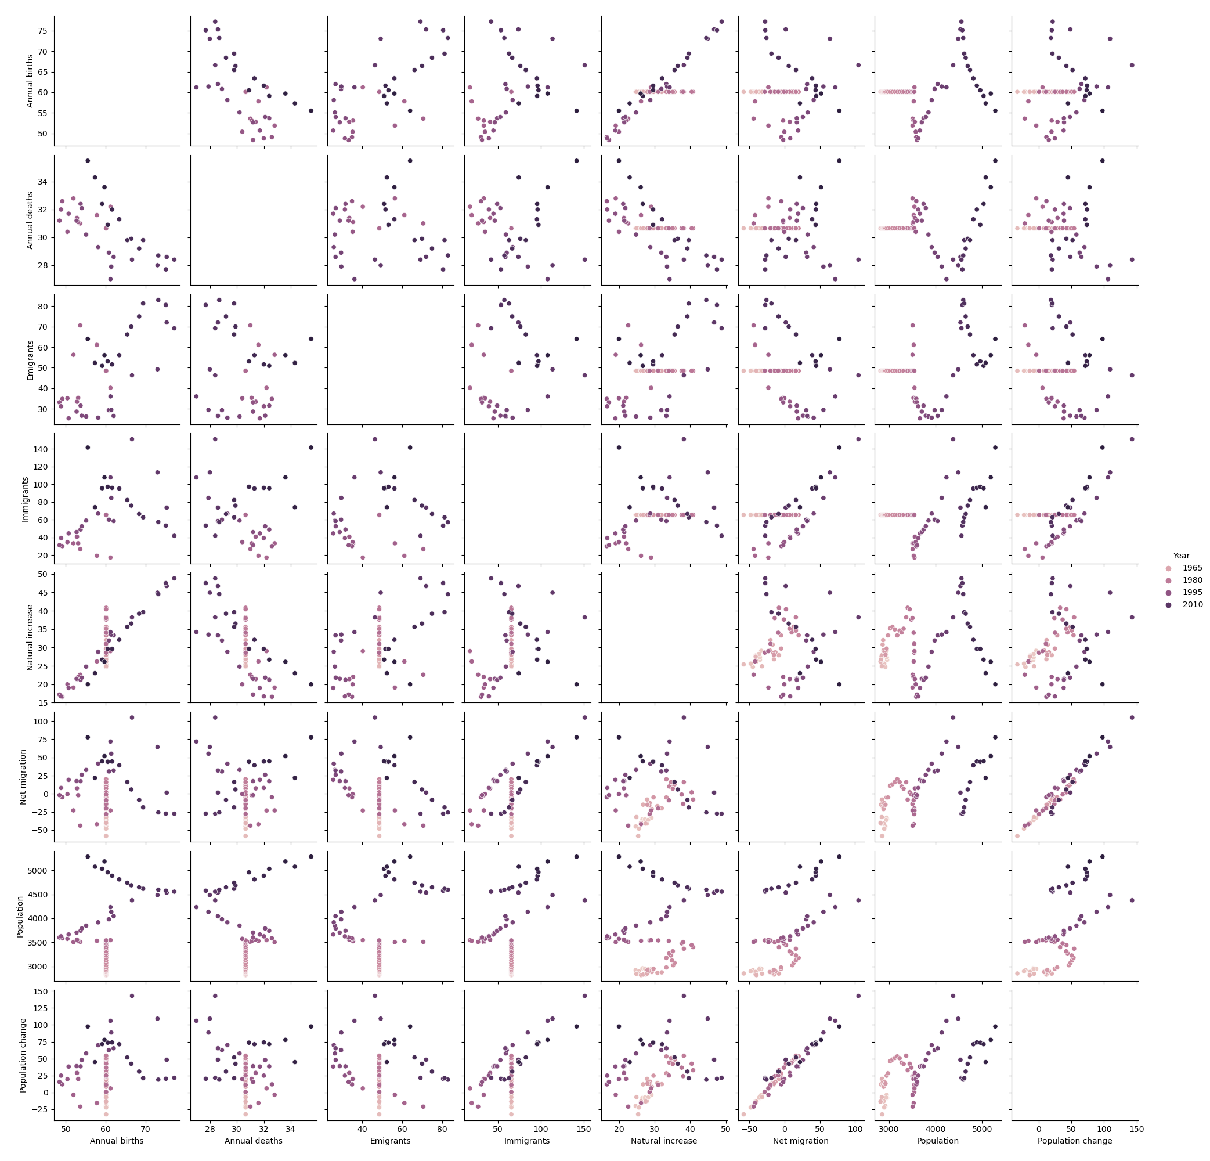
Fig 8.
(Pair plots of between the different component labels and year)

Pair plots visually represent scatterplots for all variable pairs, providing an intuitive overview of relationships and aiding in pattern identification. These correlation insights offer a nuanced understanding of population-related components, guiding further exploration into their intricate dynamics. Focusing on these variables enriches our comprehension of how natural increase, population change, annual births, and net migration interrelate, contributing to a holistic interpretation of the dataset and informed insights into population dynamics.

Machine Learning Model Implimentation

Framework Used
The SEMMA framework (Sample, Explore, Modify, Model, and Assess) provides a structured and iterative approach, integral to our data mining and analytics process. Firstly, in the Sample phase, we extracted a representative subset of the dataset, optimizing computational resources for efficient pattern analysis.

Moving to Explore, we conducted a comprehensive examination of dataset characteristics, utilizing diverse visualizations like line plots, box plots, pair plots, and correlation matrices. These visualizations unveiled trends, patterns, and relationships between variables, forming the basis for subsequent analysis. The Modify phase involved critical data adjustments, addressing missing values by either dropping or replacing them with zeros or means. Additionally, restructuring the dataset with the 'Component' variable enhanced its organization for deeper insights. Shifting to Model, we employed linear regression to predict the 'Population' variable. This phase encompassed model training and testing, evaluating its ability to capture underlying patterns and relationships. In the Assess phase, our focus was on evaluating model effectiveness. Metrics such as Mean Squared Error gauged predictive accuracy, while visualizations assessed the impact of diverse data preprocessing techniques on model performance, fostering a holistic understanding of chosen approaches.

By adhering to SEMMA, our analysis was methodical, systematic, and comprehensive, ensuring a thorough exploration, effective model development, and thoughtful result assessment. SEMMA's iterative nature allows for continual refinement, incorporating insights gained at each stage to enhance the overall analysis.

Selecting Machine Learning Model
The selection of supervised learning models, namely linear regression, support vector machines (SVM), and random forest regression, is meticulously justified for predicting population in this analysis. Given that the task involves estimating continuous numerical values, aligning with a regression approach is apt. The presence of labeled data, likely historical records with known population values, validates the use of supervised learning. The inclusion of linear regression provides valuable interpretability, offering insights into the relationships between input features and population changes. This transparency is particularly beneficial for understanding the direct impact of each variable on the predicted population. Moreover, the decision to incorporate cross-validation enhances the robustness of the analysis. By systematically evaluating model performance across different subsets of the data, the analysis gains reliability, providing a more accurate estimation of how well the models will generalize to unseen data. In essence, the chosen supervised learning framework, bolstered by cross-validation, ensures a comprehensive, accurate, and interpretable approach to predicting population dynamics.

In this process we have used the variable `mse_scores` which is computed through cross-validation, applying mean squared error (MSE) as the scoring metric for assessing the performance of a machine learning model. The `-cross_val_score` is utilized to handle the fact that cross_val_score typically interprets higher scores as better, while for MSE, lower values are indicative of superior model performance.

Subsequently, the line `rmse_scores = mse_scores ** 0.5` calculates the root mean squared error (RMSE) scores. RMSE is a widely-used metric for regression models, representing the square root of the average squared differences between predicted and actual values. This transformation back to the original scale of the target variable, achieved by taking the square root of the MSE scores, renders the evaluation metric more interpretable in the same units as the target variable (population). Lower RMSE values signify enhanced predictive accuracy, as they indicate smaller discrepancies between predicted and actual values. This comprehensive evaluation process ensures a robust assessment of the regression model's performance, facilitating informed decisions about its suitability for predicting population dynamics.

