Group 18

Author: 王斌

User Manual

Elevator

Table of Contents

System Architecture 2

buttonPanel Manual 2

elevatorPanel Manual 5

model Manual 7

overall Manual 9

## System Architecture

The system architecture is shown below:

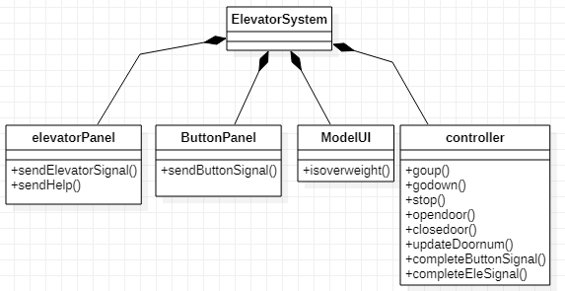

## buttonPanel Manual

The buttonPanel has 3 UI(floor1,2,3)

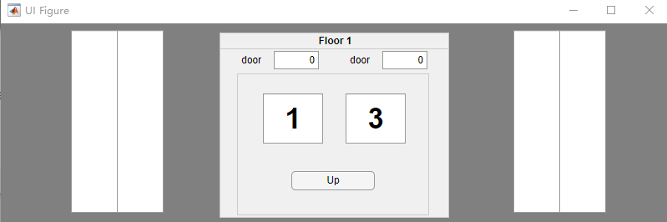

Floor1

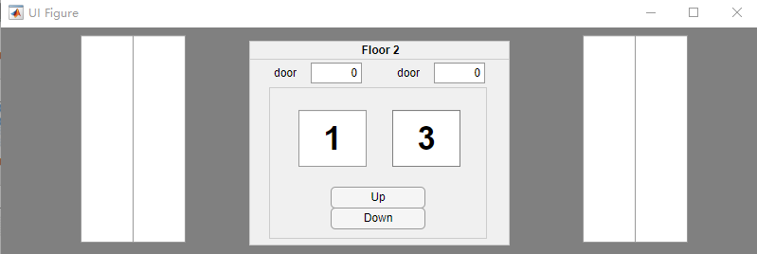

Floor2

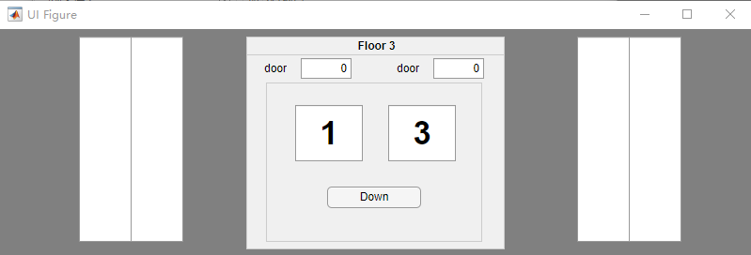

Floor3

* Every floor has two door and a button panel in which has two door editfield whose number represents the current door state(0 is closed, 1 is open) .
* On button panel, there are two big number table which represent current elevator’s floor, left one is belong to elevator1, right is belong to elevator2.
* Floor1 only has up button because customer cannot go down at floor1, floor2 has up and down button, floor 3 has only down button.
* When user press button for example floor2 up button, then the button will become green which means there is one ‘up’ call at floor2 then one elevator will finally go to this floor.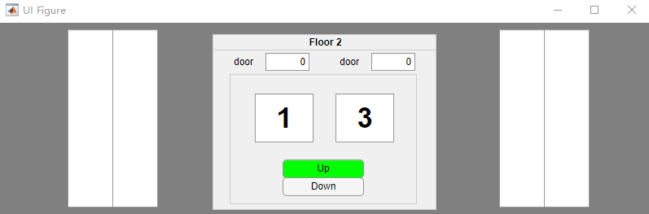
* When elevator arrive corresponding floor, the button color will recover to normal and door will open and door editfield will show 1 and become green and the elevator floor number will also updated. 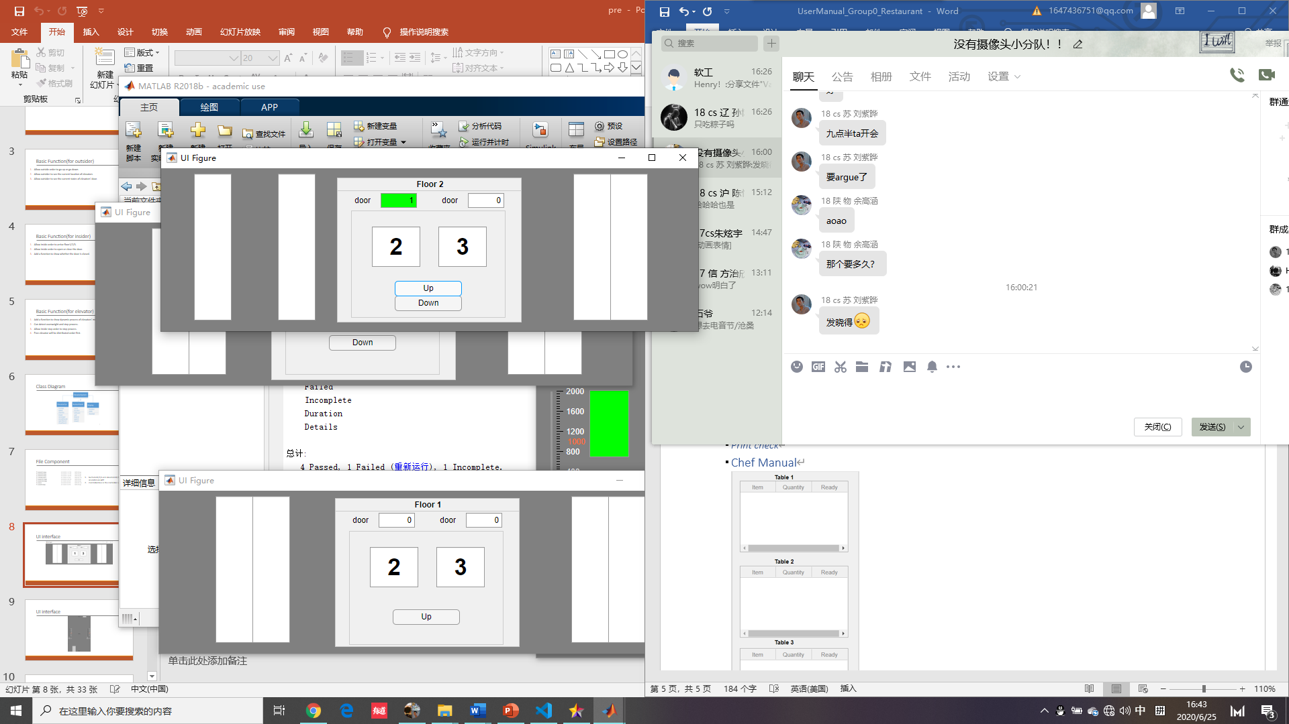

## elevatorPanel Manual

elevatorPanel has two UI(elevator1, elvator2)

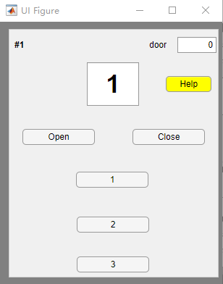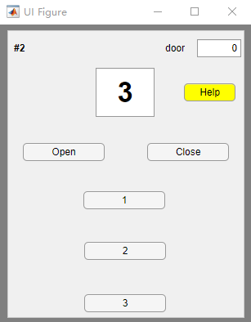

* Top-left number ”#1” means the number of the elevator
* There is one big number field which ranges from 1 to 3, representing current elevator floor.
* There is two button “open”, ”close” that is used to control the elevator door open and close.
* The door editfield means the door state, 0 is closed and 1 is open.
* There are three number button “1”, “2”, “3” meaning the floor which user wants to go.
* The Help button is used to notify the system staff there is some people are getting trouble in the elevator.
* When user wants to go a certain floor, for example from 1 to 2, then he press button2, which will go green meaning there is one floor2 call from inside elevator.

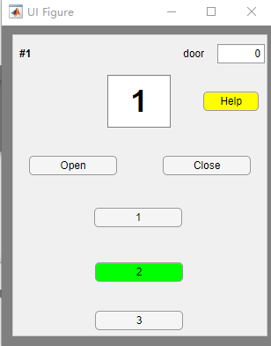

* When user press open button the door state will become 1 if the door is allowed to be open. 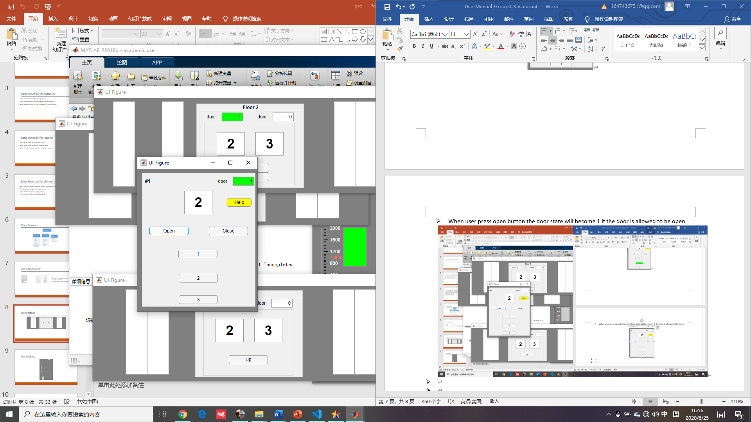
* If user press Help button, then button will become red and come out a message box that notify system staff to fix the problem of elevator, at the same time the elevator will go down and stop to work until fixed. After fixed, the help button color will recover and elevator will recover to work normally. Staff can fix the problem in model panel with problem fixed button. So if the help button is pressed the problem fixed button on model panel will become yellow from green to remind staff the elevator has problem.

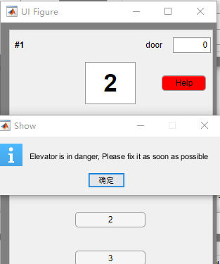

## model Manual

modelUI include two elevator and two weight slider and one problem fixed button.

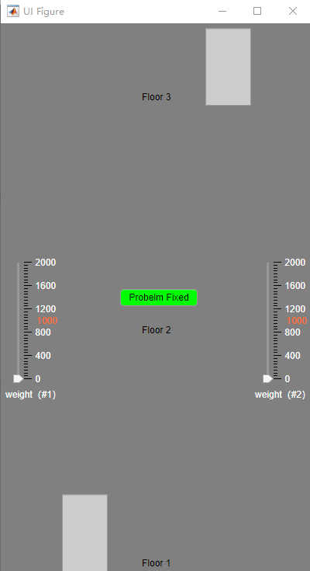

* Elevator can move and if door is need to be open then the elevator will become green, if the door is closed then the elevator will be grey.
* The weight slider unit is kg, only when the elevator is at one certain(1 or 2 or 3) floor, the slider is enabled, otherwise the slider will not be enabled.

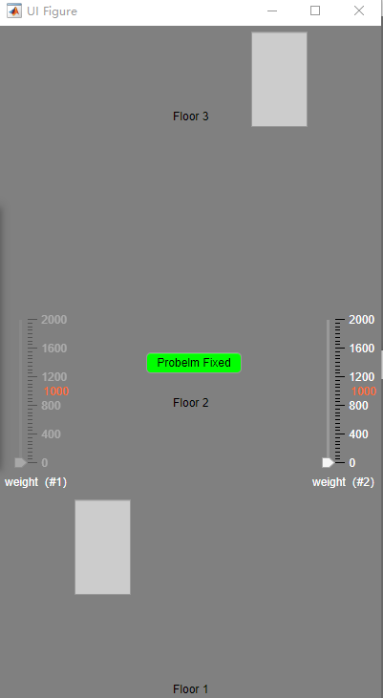

* If the weight slider exceed 1000, then the door will open and elevator will stop to work until the slider is under 1000 again, then the elevator will go back to work again. If overweight, one message box will come out showing overweight.

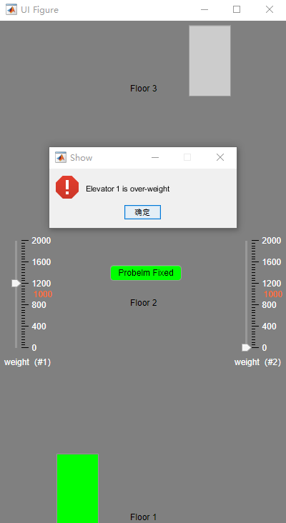

* If the help button on elevator panel is pressed, the problem fixed button will become yellow to remind the staff the elevator is in trouble, if the problem fixed button is pressed the problem will be solved and help on elevator panel’s color will go back to yellow from red and problem fixed will also go back to green which represents the system is working well.

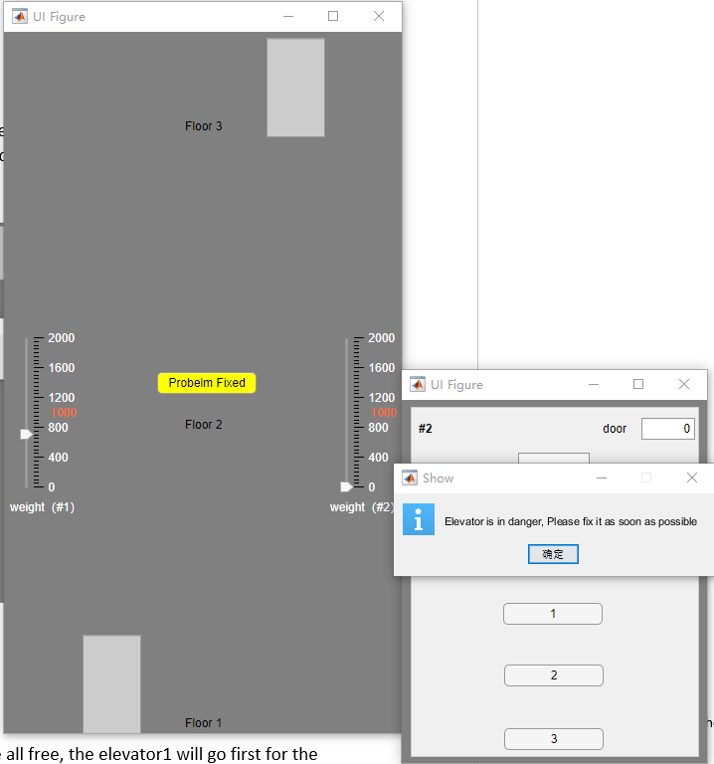

## overall Manual

The elevator system is coordinated. When two elevator are all free, the elevator1 will go first for the first target. If one elevator is working, then if the floor signal is convenient for the working elevator, then another free elevator will go. If two elevators are all working, then the target will according to elevator’s direction and floor to judge which one is responsible.