Group 18

Author: 朱炫宇

Software VALIDATION

Elevator

Table of Contents

System Architecture 2

T1: Unit Test 2

T1.1: elevator Unit Test 2

T2: Integration Test(TestApp.m) 4

T3: UPPAAL test（test if one chessboard has solution）*File: ele.xml* 7

## System Architecture

The system architecture is shown below:

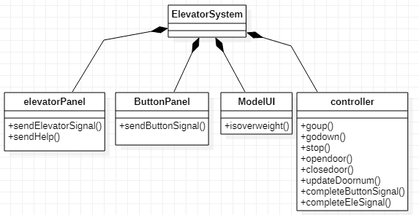

## T1: Unit Test

### T1.1: elevator Unit Test

T1.1.1: Test goupgodown() Tcover1.1.1

To ensure the elevator can normally go up and go down

function testbutton(testCase)

ctr = controllerClass;

mdlUI = modelUI;

ctr.model = mdlUI;

mdlUI.contrler = ctr;

ctr.dt1_direction = 0;

ctr.dt2_direction = 0;

ctr.target = 0;

ctr.target2 = 0;

ctr.F3_signal = 0;

ctr.F2_down_signal = 0;

ctr.F2_up_signal = 0;

ctr.F1_signal = 0;

ctr.dt1floor = 1;

ctr.dt2floor = 3;

ctr.dt1s1 = 0;

ctr.dt1s2 = 0;

ctr.dt1s3 = 0;

ctr.dt2s1 = 0;

ctr.dt2s2 = 0;

ctr.dt2s3 = 0;

for i =1:60

ctr.goup(1);

ctr.godown(2);

i=i+1;

end

ctr.updatedoornum();

testCase.verifyEqual(ctr.dt1floor,2);

testCase.verifyEqual(ctr.dt1floor,2);

end

* Coverage Criteria: Statement coverage and branch covwerage
* Test case

|  |  |
| --- | --- |
|  | Test Case T1.1.1(test inborder in hrd.m) |
| Coverage Item | Tcover1.1.1 |
| Input | ctr.dt1_direction = 0;  ctr.dt2_direction = 0;  ctr.target = 0;  ctr.target2 = 0;  ctr.F3_signal = 0;  ctr.F2_down_signal = 0;  ctr.F2_up_signal = 0;  ctr.F1_signal = 0;  ctr.dt1floor = 1;  ctr.dt2floor = 3;  ctr.dt1s1 = 0;  ctr.dt1s2 = 0;  ctr.dt1s3 = 0;  ctr.dt2s1 = 0;  ctr.dt2s2 = 0;  ctr.dt2s3 = 0;  for i =1:60  ctr.goup(1);  ctr.godown(2);  i=i+1;  end  %elevator 1 will go up from 1 to 2,elevator 2 will go down from 3 to 2.  %dt1floor should return 2  %dt2floor should return 2 |
| Expected Output | ctr.dt1floor = 2;  ctr.dt2floor = 2; |

* Test coverage: 1/1=100%
* Test result: 1 passed

## T2: Integration Test(TestApp.m)

1. Test2.1: 1楼用户按up进入电梯后按3楼，电梯行驶中未到2楼是2楼用户按up；3楼用户按down，进入电梯后按1楼， 电梯行驶中未到2楼是2楼用户按down。

testCase.press(testCase.controller.buttonAPP1.F1_UpButton); Tcover2.1.1

testCase.press(testCase.controller.eleAPP1.Button_3); Tcover2.2.2

testCase.press(testCase.controller.buttonAPP3.F3_DownButton); Tcover2.2.3

testCase.press(testCase.controller.eleAPP2.Button_4); Tcover2.2.4

testCase.press(testCase.controller.buttonAPP2.F2_UpButton); Tcover2.2.5

testCase.drag(testCase.controller.model.dt2_weight,1000,1200); Tcover2.2.6

1. Test2.2:2楼用户按up，进入电梯后按3楼；2楼用户按down，进入电梯后按1楼，电梯行驶一半乘客按help，电梯停止

testCase.press(testCase.controller.buttonAPP2.F2_UpButton); Tcover2.2.1

testCase.press(testCase.controller.eleAPP1.Button_3); Tcover2.2.2

testCase.press(testCase.controller.buttonAPP2.F2_DownButton); Tcover2.2.3

testCase.press(testCase.controller.eleAPP2.Button_4); Tcover2.2.4

testCase.press(testCase.controller.eleAPP1.HelpButton); Tcover2.2.5

Test2.3:1楼300kg的东西进来了，去2楼，2楼进去900kg的东西，又出去400kg东西，乘客进入电梯后按3楼，乘客按了help，之后按了problem fixed；1楼用户按up，电梯2下来了，进入了1200kg东西，超重了，又出去700kg东西，超重解除

1. 进入电梯2后按2楼，testCase.press(testCase.controller.buttonAPP1.F1_UpButton); Tcover2.3.1

testCase.drag(testCase.controller.model.dt1_weight,0,300); Tcover2.3.2

testCase.press(testCase.controller.eleAPP1.Button_2); Tcover2.3.3

testCase.drag(testCase.controller.model.dt1_weight,300,1200); Tcover2.3.4

testCase.drag(testCase.controller.model.dt1_weight,1200,800); Tcover2.3.5

testCase.press(testCase.controller.eleAPP1.Button_3); Tcover2.3.6

testCase.press(testCase.controller.eleAPP1.HelpButton); Tcover2.3.7

testCase.press(testCase.controller.model.ProbelmFixedButton); Tcover2.3.8

testCase.press(testCase.controller.buttonAPP1.F1_UpButton); Tcover2.3.9

testCase.drag(testCase.controller.model.dt2_weight,0,1200); Tcover2.3.10

testCase.drag(testCase.controller.model.dt2_weight,1200,500); Tcover2.3.11

testCase.press(testCase.controller.eleAPP2.Button_5); Tcover2.3.12

Coverage Criteria: branch coverage

* Test case

|  |  |
| --- | --- |
|  | Test Case T2.1 |
| Coverage Item | Tcover2.1.1 & Tcover2.1.2 & Tcover2.1.3 & Tcover2.1.4 & Tcover2.1.5 & Tcover2.1.6 |
| Input | press(testCase.controller.buttonAPP1.F1_UpButton);  press(testCase.controller.eleAPP1.Button_3);  press(testCase.controller.buttonAPP3.F3_DownButton);  press(testCase.controller.eleAPP2.Button_4);  press(testCase.controller.buttonAPP2.F2_UpButton);  drag(testCase.controller.model.dt2_weight,1000,1200); |
| Expected Output | 1楼用户按up进入电梯  进入电梯后按3楼  电梯行驶中未到2楼是2楼用户按up，电梯停下待2楼用户进入后继续行驶到3楼  3楼用户按down进入电梯  进入电梯后按1楼  电梯行驶中未到2楼是2楼用户按down，电梯停下待2楼用户进入后发生超重电梯停止。 |

* Test coverage: 6/6=100%
* Test result: 1 passed

Coverage Criteria: branch coverage

* Test case

|  |  |
| --- | --- |
|  | Test Case T2.2 |
| Coverage Item | Tcover2.2.1 & Tcover2.2.2 & Tcover2.2.3 & Tcover2.2.4 & Tcover2.2.5 |
| Input | press(testCase.controller.buttonAPP2.F2_UpButton);  press(testCase.controller.eleAPP1.Button_3);  press(testCase.controller.buttonAPP2.F2_DownButton);  press(testCase.controller.eleAPP2.Button_4);  press(testCase.controller.eleAPP1.HelpButton); |
| Expected Output | 2楼用户按up  进入电梯后按3楼  2楼用户按down  进入电梯后按1楼  电梯行驶一半乘客按help，电梯停止 |

* Test coverage: 5/5=100%
* Test result: 1 passed

|  |  |
| --- | --- |
|  | Test Case T2.3 |
| Coverage Item (Not including TCover covered in previous test case(s)) | Tcover2.3.1& Tcover2.3.2& Tcover2.3.3& Tcover2.3.4& Tcover2.3.5& Tcover2.3.6& Tcover2.3.7& Tcover2.3.8& Tcover2.3.9& Tcover2.3.10& Tcover2.3.11& Tcover2.3.12& |
| Input | press(testCase.controller.buttonAPP1.F1_UpButton);  drag(testCase.controller.model.dt1_weight,0,300);  press(testCase.controller.eleAPP1.Button_2);  drag(testCase.controller.model.dt1_weight,300,1200);  drag(testCase.controller.model.dt1_weight,1200,800);  press(testCase.controller.eleAPP1.Button_3);  press(testCase.controller.eleAPP1.HelpButton);  press(testCase.controller.model.ProbelmFixedButton);  press(testCase.controller.buttonAPP1.F1_UpButton);  drag(testCase.controller.model.dt2_weight,0,1200);  drag(testCase.controller.model.dt2_weight,1200,500);  press(testCase.controller.eleAPP2.Button_5); |
| Expected Output | Test2.3:  1楼300kg的东西进入电梯1，  去2楼，  2楼进去900kg的东西，超重了  又出去400kg东西，超重解除  乘客进入电梯后按3楼，  乘客按了help，  之后按了problem fixed；  1楼用户按up，  电梯2下来了，  进入了1200kg东西，超重了  又出去700kg东西，超重解除  进入电梯2后按2楼 |

## T3: UPPAAL test（test if one chessboard has solution）*File: ele.xml*

UPPAAL version: 4.0.15

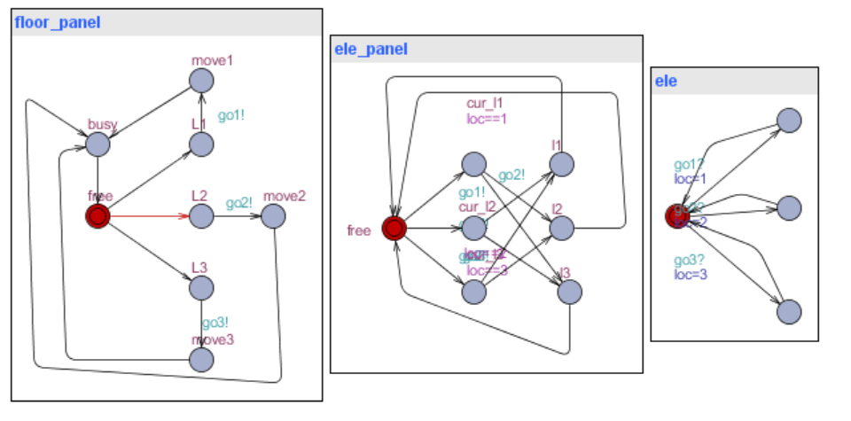

The floor_panel is the current three floors panel to let user press up and down. The ele_panel is the current inside panel for passenger to move to another floor. The ele is the current floor the elevator in.

UPPAAL main interface

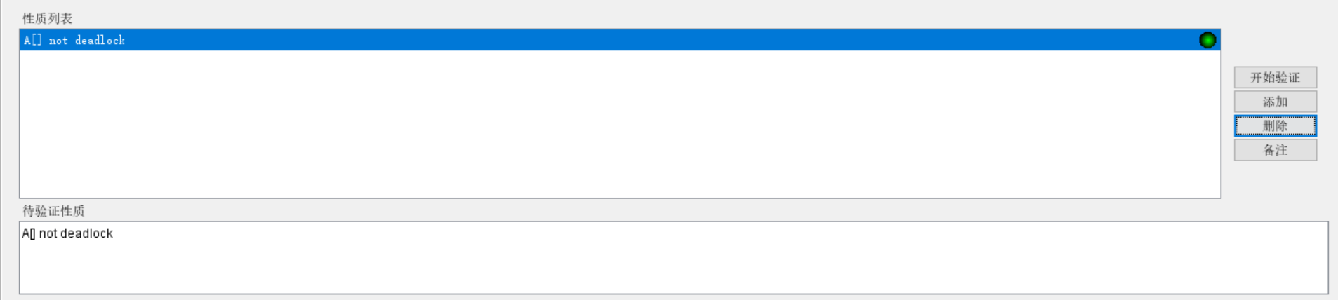

Query: test if the elevator won’t be dead lock.