Project Design Phase-II
Data Flow Diagram & User Stories
Date | 31 January 2025
Team ID | SWTID-2026-5382
Project Name | Streamlining IT Procurement: Automating Standard Laptop Orders with Flow Designer
Maximum Marks | 4 Marks

Data Flow Diagrams:
A Data Flow Diagram (DFD) represents how information moves through the standard laptop procurement system. It shows the employee request, approval, ServiceNow workflow processing, creation of the catalog task, Hardware team assignment, and status updates.
DFD Level 0 – Standard Laptop Procurement Automation
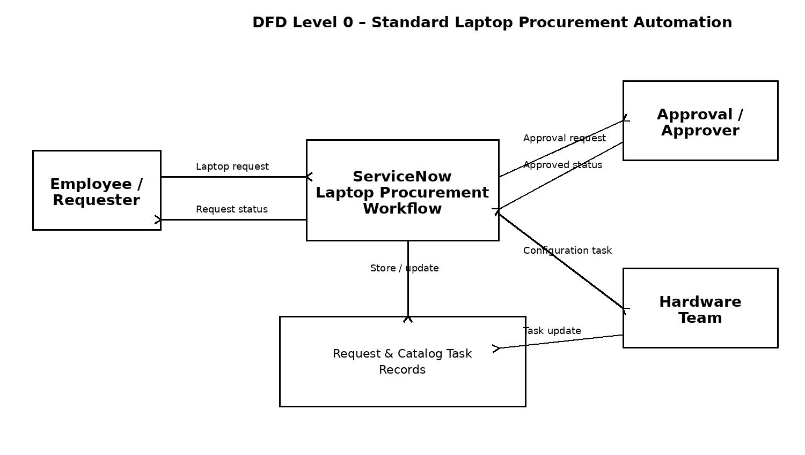

User Stories
The following user stories define the functional requirements for the Standard Laptop procurement automation workflow.
User Type | Functional Requirement  (Epic) | User Story  Number | User Story / Task | Acceptance criteria | Priority | Release
Employee / Requester | Standard Laptop Request | USN-1 | As an employee, I can place a Standard Laptop request through the Service Catalog. | A Standard Laptop request record is created successfully. | High | Sprint-1
Employee / Requester | Approval | USN-2 | As an employee, I can have my Standard Laptop request submitted for approval. | The request shows the required approval status and approver information. | High | Sprint-1
IT Procurement Team | Approval-based Automation | USN-3 | As an IT procurement team member, I can use the approved request to start the automated procurement workflow. | The workflow proceeds when the request is approved. | High | Sprint-1
IT Procurement Team | Catalog Task Automation | USN-4 | As an IT procurement team member, I can automatically create a Catalog Task after approval. | A Catalog Task is created for the requested item with the configured task details. | High | Sprint-1
Hardware Team | Task Assignment | USN-5 | As a Hardware team member, I can receive the laptop configuration task automatically. | The Catalog Task assignment group is set to Hardware. | High | Sprint-1
Hardware Team | Task Standardization | USN-6 | As a Hardware team member, I can see a clear standard description for the laptop configuration task. | The task contains the short description and description for laptop configuration. | Medium | Sprint-2
Employee / Requester | Request Tracking | USN-7 | As an employee, I can view the request and its updated task status. | The request and requested-item records show the current workflow/task information. | Medium | Sprint-2

Workflow represented by the user stories:
Standard Laptop request → Approval → Flow Designer automation → Catalog Task creation → Hardware assignment → Laptop configuration → Request/task status update.

Project Workflow & Access Details
Project Workflow Mapping
Stage | ServiceNow Component | Expected Result
1. Request | Service Catalog – Standard Laptop | User places the laptop order.
2. Approval | Request / Approvers | Request is approved.
3. Automation | Flow Designer – Standard Laptop Task | Approved request triggers the flow.
4. Task Creation | Create Catalog Task | Configuration task is created.
5. Assignment | Assignment Group = Hardware | Hardware team receives the task.
6. Verification | Requested Item → Catalog Tasks | Short description and assignment are visible.

Project Access Details
Team ID | SWTID-2026-5382
Demo URL | https://drive.google.com/file/d/1Cc44w6XjC1cd4XsVB3OEvv0k43aeyCIx/view?usp=sharing
GitHub Repository | https://github.com/ukchelliah-png/Automating-Standard-Laptop-Orders-ServiceNow

The DFD and user stories are aligned with the project workflow: the ServiceNow Service Catalog is used to place the Standard Laptop order, approval is completed on the request, and Flow Designer creates and assigns the Catalog Task to the Hardware group.

