Project Design Phase-II
Technology Stack (Architecture & Stack)
Date | 31 January 2025
Team ID | SWTID-2026-5382
Project Name | Streamlining IT Procurement: Automating Standard Laptop Orders with Flow Designer
Maximum Marks | 4 Marks

Technical Architecture:
The architecture below represents the actual ServiceNow workflow used in the project. It includes the user interface, Service Catalog, approval process, Flow Designer automation, Catalog Task creation, Hardware assignment, and ServiceNow records.
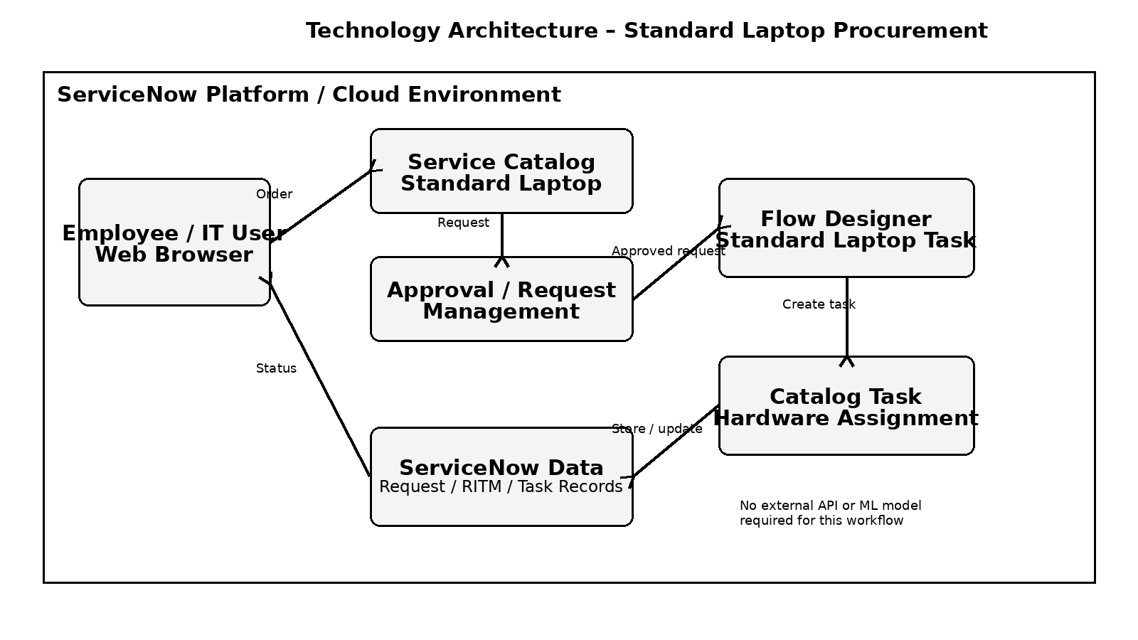

Table-1 : Components & Technologies
S.No | Component | Description / Technology
1 | User Interface | ServiceNow web interface used by employees/IT users to access the Service Catalog and requests. Technology: ServiceNow web UI / browser.
2 | Application Logic-1 | Standard Laptop Service Catalog item used to place the laptop request. Technology: ServiceNow Service Catalog.
3 | Application Logic-2 | Approval handling for the submitted Standard Laptop request. Technology: ServiceNow request/approval workflow.
4 | Application Logic-3 | Automated creation of the laptop configuration task after approval. Technology: ServiceNow Flow Designer.
5 | Database / Records | Request, Requested Item (RITM), and Catalog Task records used by the workflow. Technology: ServiceNow platform data records.
6 | Cloud Database | The project does not specify a separate external cloud database. Request and task data are maintained within the ServiceNow platform.
7 | File Storage | No separate file-storage component is required by the documented workflow.
8 | External API-1 | No external API is specified or required in the documented Standard Laptop workflow.
9 | External API-2 | No second external API is specified or required in the documented workflow.
10 | Machine Learning Model | Not applicable. The project workflow is rule/workflow based and does not use a machine-learning model.
11 | Infrastructure (Server / Cloud) | ServiceNow platform environment accessed through a web browser. No separate application server configuration is specified in the project.

Table-2: Application Characteristics
S.No | Characteristics | Description / Technology
1 | Open-Source Frameworks | No separate open-source application framework is specified in the project. The implementation uses ServiceNow platform capabilities.
2 | Security | Access is controlled through ServiceNow users/roles and the platform's request and approval controls. No additional security framework is specified in the project.
3 | Scalable Architecture | The workflow is centralized in ServiceNow Flow Designer and can automate repeated Standard Laptop requests without manually creating each Catalog Task.
4 | Availability | The solution is accessed through the ServiceNow platform. The project does not specify a separate load-balancer or distributed-server configuration.
5 | Performance | Automation reduces manual processing by creating the Catalog Task after approval and assigning it to Hardware. No specific requests-per-second or cache/CDN requirement is specified.

Project Access Details
Team ID | SWTID-2026-5382
Demo URL | https://drive.google.com/file/d/1Cc44w6XjC1cd4XsVB3OEvv0k43aeyCIx/view?usp=sharing
GitHub Repository | https://github.com/ukchelliah-png/Automating-Standard-Laptop-Orders-ServiceNow

