Project Design Phase
Solution Architecture
Date | 15 February 2025
Team ID | SWTID-2026-5382
Project Name | Streamlining IT Procurement: Automating Standard Laptop Orders with Flow Designer
Maximum Marks | 4 Marks

Solution Architecture:
The solution architecture bridges the identified IT procurement problem with the ServiceNow technology solution. It describes how the Standard Laptop request moves from the Service Catalog through approval and Flow Designer automation to Catalog Task creation and Hardware assignment.
• Provide a clear structure for the ServiceNow-based procurement workflow.
• Show the interaction between the requester, Service Catalog, approval process, Flow Designer, and Hardware team.
• Define the major solution components and how they work together.
• Provide a practical architecture for managing and delivering the automated workflow.
Solution Architecture Diagram
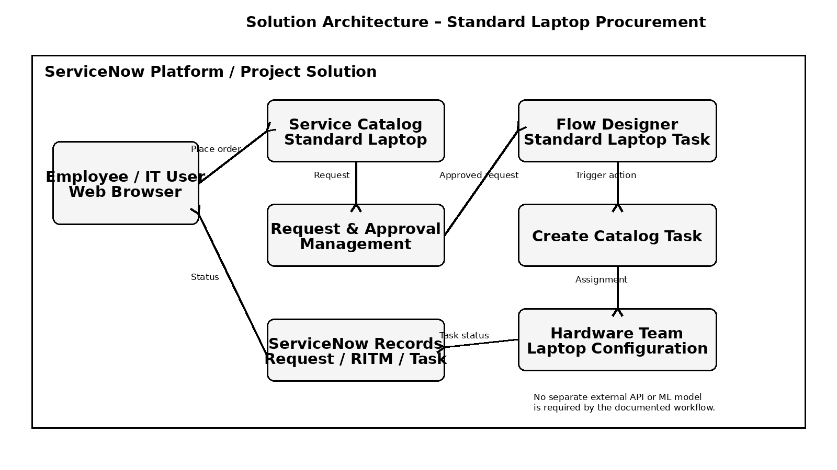
Figure 1: Architecture and data flow of the Standard Laptop procurement automation

Architecture Component Description
Component | Role in Solution | Technology / Platform
Employee / IT User | Places the Standard Laptop request and views request/task status. | ServiceNow Web Interface
Service Catalog | Provides the Standard Laptop catalog item and accepts the order. | ServiceNow Service Catalog
Request & Approval | Stores the request and manages the approval required before fulfillment. | ServiceNow Request / Approval
Flow Designer | Triggers the automation after the Service Catalog request and controls the workflow. | ServiceNow Flow Designer
Catalog Task | Creates the laptop configuration task with standardized task information. | ServiceNow Catalog Task
Hardware Team | Receives the assigned task and performs laptop configuration. | ServiceNow Assignment Group: Hardware
ServiceNow Records | Stores request, Requested Item, and Catalog Task information. | ServiceNow Platform Data

End-to-End Architecture Flow
1. Employee selects Standard Laptop from the Service Catalog and places the request.
2. ServiceNow creates the request and sends it through the required approval process.
3. After approval, the Standard Laptop Task Flow Designer flow is triggered.
4. Flow Designer creates a Catalog Task using the Requested Item record.
5. The task is populated with the laptop configuration description and assigned to the Hardware group.
6. The Hardware team receives the task and performs the required configuration.
7. Request and task records retain the workflow status for verification.

Project Access Details
Team ID | SWTID-2026-5382
Demo URL | https://drive.google.com/file/d/1Cc44w6XjC1cd4XsVB3OEvv0k43aeyCIx/view?usp=sharing
GitHub Repository | https://github.com/ukchelliah-png/Automating-Standard-Laptop-Orders-ServiceNow

