Project Planning Phase
Project Planning – Product Backlog, Sprint Planning, Stories & Story Points
Date | 15 February 2025
Team ID | SWTID-2026-5382
Project Name | Streamlining IT Procurement: Automating Standard Laptop Orders with Flow Designer
Maximum Marks | 5 Marks

Product Backlog, Sprint Schedule, and Estimation (4 Marks)
The following backlog is tailored to the Standard Laptop procurement automation project. The story points and sprint allocation are planned estimates for the project workflow.
Sprint | Functional Requirement (Epic) | User Story Number | User Story / Task | Story Points | Priority | Team Members
Sprint-1 | Standard Laptop Request | USN-1 | As an employee, I can select the Standard Laptop item from the Service Catalog and place a request. | 3 | High | P. Chelliah
Sprint-1 | Request & Approval | USN-2 | As an employee, I can submit the Standard Laptop request for approval and view its approval status. | 2 | High | R. Bovasprem
Sprint-1 | Request Records | USN-3 | As an IT user, I can view the created Requested Item for the Standard Laptop request. | 2 | Medium | R. Aravinth
Sprint-2 | Flow Automation | USN-4 | As an IT procurement team member, I can trigger the Standard Laptop Task flow from the Service Catalog request. | 3 | High | C. Ganesh
Sprint-2 | Catalog Task Creation | USN-5 | As an IT procurement team member, I can automatically create a Catalog Task after the request is approved. | 3 | High | K. Govindharaja
Sprint-2 | Task Standardization | USN-6 | As a Hardware team member, I can receive a Catalog Task with the standard laptop configuration description. | 2 | Medium | P. Chelliah
Sprint-3 | Hardware Assignment | USN-7 | As a Hardware team member, I can receive the configuration task automatically through the Hardware assignment group. | 3 | High | R. Bovasprem
Sprint-3 | Workflow Verification | USN-8 | As an IT user, I can verify the created Catalog Task under the Requested Item. | 2 | Medium | R. Aravinth
Sprint-3 | Status Tracking | USN-9 | As an employee, I can view the updated request/task information after the workflow runs. | 2 | Medium | C. Ganesh
Sprint-4 | Testing & Demo | USN-10 | As a project team member, I can test the complete request-to-Hardware workflow and prepare the project demo. | 3 | High | K. Govindharaja
Sprint-4 | Documentation | USN-11 | As a project team member, I can document the final workflow, architecture, requirements, and implementation evidence. | 2 | Medium | P. Chelliah
Sprint-4 | Final Validation | USN-12 | As a project team, we can validate that approved Standard Laptop requests create and assign the required Catalog Task. | 3 | High | All Team Members

Planned Project Tracker, Velocity & Burndown Chart
Sprint | Total Story Points | Duration | Sprint Start Date | Sprint End Date (Planned) | Story Points Completed (Planned) | Sprint Release Date (Planned)
Sprint-1 | 9 | 6 Days | 17 Feb 2025 | 22 Feb 2025 | 9 | 22 Feb 2025
Sprint-2 | 8 | 6 Days | 24 Feb 2025 | 01 Mar 2025 | 8 | 01 Mar 2025
Sprint-3 | 7 | 6 Days | 03 Mar 2025 | 08 Mar 2025 | 7 | 08 Mar 2025
Sprint-4 | 8 | 6 Days | 10 Mar 2025 | 15 Mar 2025 | 8 | 15 Mar 2025

Velocity
Planned total backlog = 32 story points. With a planned 4-sprint schedule, the average planned velocity is 8 story points per sprint.
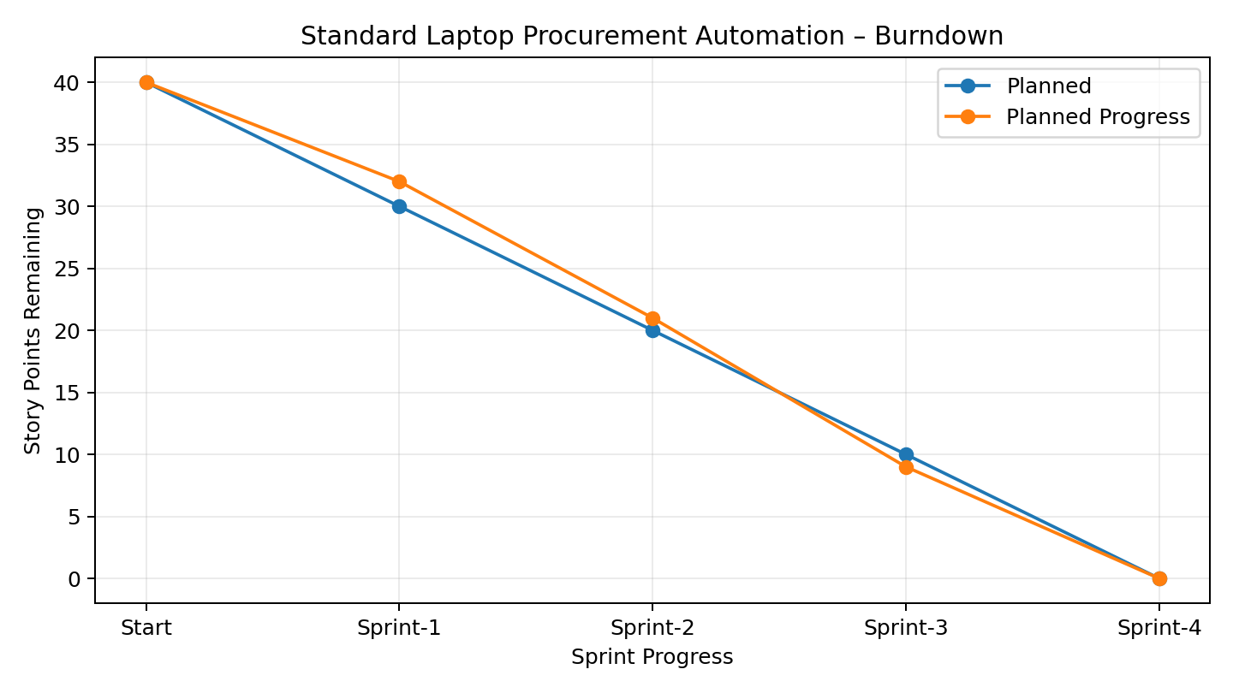
Burndown Chart – Planned project progress

Planning Note
The sprint dates, story points, priorities, and completion values in this document are planned project-management values prepared for the template. They are not presented as actual historical completion records.

Project Access Details
Team ID | SWTID-2026-5382
Demo URL | https://drive.google.com/file/d/1Cc44w6XjC1cd4XsVB3OEvv0k43aeyCIx/view?usp=sharing
GitHub Repository | https://github.com/ukchelliah-png/Automating-Standard-Laptop-Orders-ServiceNow

