Plex index's
&
RemIdx

The Remote Indexer

This document is a MUST READ document EVERY TIME YOU UPDATE this program.

Table of Contents
About Plex 2
What is RemIdx 3
Authors 3
What is Indexes 3
The problem 3
The program 4
System Requirements 4
Remote Indexer Workstation 4
How it works 4
Installation 6
PMS Bundle Agent 6
PMS Bundle Agent Installation 6
PMS Bundle Agent configuration 6
List of networks that are allowed without auth 8
Remote Indexer 8
Dependencies 8
Configuration 8
Anti-Vira Solution 9
Directory layout 9
Using it 10
More than one 11
Known issues 11
Version 0.0.1.3: 11
General Issue: 11
Uninstall 11

About Plex

Plex is, at least as the writer of this documents thinks, the best of all media centers out there, due to the following:

- It's free
- It supports streaming towards multiple devices native
- IOS
- Android
- LG Smart TV
- Google TV
- Samsung Smart devices

and lot's of others

It also allows you to share your medias to either your-self, when on the road, or friends
Plex can be found here: http://plex.tv/

What is RemIdx
- RemIdx is a free open-source program, that adds to your Plex experience.
- RemIdx can be found here: https://github.com/ukdtom/RemIdx
- RemIdx will take the burden of your Plex server, if indexing is a problem
- RemIdx can be stopped/started at any time, and will continue where it left off

Authors
RemIdx was originally an idea by dane22, and is currently maintained by dane22 and srazer, both Plex Community members

Also check out our other solutions, like:

- Find Unmatched Items
- FindMissing Files
- Str2Utf-8

What is Indexes

Indexes, at least as I see it, is that Plex has implemented a new functionality, allowing you the
following things:

- In your player, if the player support it, when doing a fast forward, they will see small snapshots of the movie, allowing the user to quickly determine where to go, instead of relying on movie timestamps
- In the Plex Web administration pages, when signed in to myPlex, you can see what people using your server is watching, and follow their progress via thumbnails of the movie. In short, indexes is a small file, that contains snapshots of pictures in your medias at regular intervals

Plex has an article about them here: https://plexapp.zendesk.com/hc/en-us/articles/201725267-What-are-media-index-files-in-Plex-

The problem

If you have a large section within Plex, and decide to switch on indexing, or if you have indexing turned on, and bulk add a lot of new medias, you might end up with your Plex Server not responding, due to a heavy workload on the server, until all medias has been indexed, and this could take days!
Naturally the time frame of this all depends on both the amount of items in your section, as well as the duration of the individual items, and the power of your server.
(But community reports are telling about +15 days for the task to complete, and most people can't live without their Plex for more than 5 sec. so it's a problem)
And naturally, having Plex running on a Low-Powered NAS makes Indexing not an option at all.

The program

System Requirements

Since this is a two-headed beast, requiring both a plug-in running on your PMS, as well as a remote workstation, I'm happy to say, that PMS wise, all platforms should be supported, but currently only tested on QNAP.
It is highly recommended, that the PMS and the Remote Indexer are connected via cable, and not wireless

Remote Indexer Workstation

This little program needs the following:

- ffmpeg must be installed on the workstation running this program
- Python 2.7 must be installed on this workstation . (And it must be version 2.7)

How it works

The program will do the following:

- When a media is refreshed, the agent bundle named RemIdx.bundle will detect this, and check if an Index exists
- If an index already exists, it'll simply exit
- If an index does not exists, it'll notify the Remote Indexer
- The Remote Indexer will then do the following:
- add the media to it's Queue
- Process the Queue one by one, and do the following:
- Stream down the media, and generate a bunch of thumbs
- generate a bif file of above
- Slam the PMS RemIdx agent on the PMS about the fact, that a Bif-file is ready
- PMS agent will then do the following:
- Query the Remote Indexer about available Bif-files for download, and then fetch them one by one
- Add them to the library
- Tell the Remote Indexer to remove them from it's storage
- The Remote Indexer will then do the following:
- Remove the Bif-File

And then the story starts all over

Note:
If the Remote Indexer is not up and running, when doing a refresh on the PMS, requests will be discarded.

Installation

PMS Bundle Agent

PMS Bundle Agent Installation
After downloading this app, you must extract it, and will end up with a directory that looks like this:

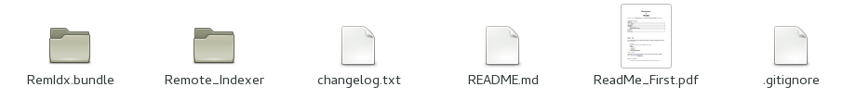
Then you must locate the correct Plug-In directory on your PMS, so follow the guide here:
https://plexapp.zendesk.com/hc/en-us/articles/201106098-How-do-I-find-the-Plug-Ins-folder-
After locating it, copy the folder named RemIdx.bundle to that folder, and restart your PMS

PMS Bundle Agent configuration
After the agent has been installed, and your PMS has been restarted, the agent must be configured, and to do so, you must access the Web Administration of PMS, and there select Settings(the tools icon) on the top right:

http://<IP address of your PMS>:32400/web/index.html#!/settings



Then make sure, that you on the top left selected “Plex Media Server”, and then the “Agents”

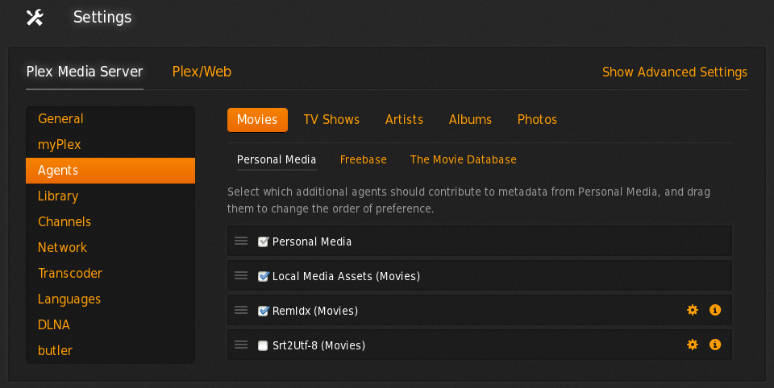
Now under the “Personal Media” for the Movies, you should find an entry named RemIdx.
Make sure it's enabled, and at the bottom.
Then click on the little gear icon for it, and in the dialog that opens, fill out the missing gaps.

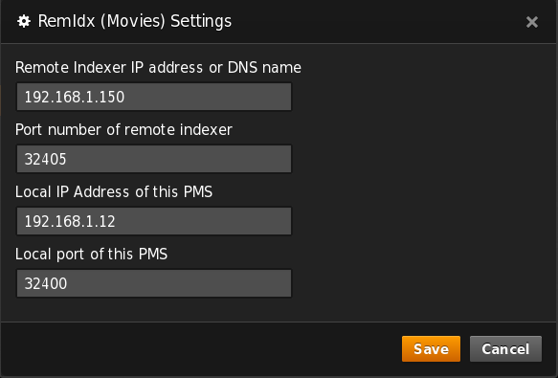
It is important, that you for the entry named “Local IP Address of this PMS” not use the loopback address, but the actual LAN address of your PMS. In my case it was 192.168.1.12
Click save, and you're done with the Agent configuration, and must now select “Freebase” and “The Movie Database” leafs, and enable RemIdx, as well as doing the same for the TV-Shows

List of networks that are allowed without auth
If you have set local lan restrictions in your PMS, then it's vital that you add an exception for the workstation running the Remote Indexer, as well as for both the loopback address, and the LAN address of the PMS
Like my Remote Indexer having an IP address of 192.168.1.150 with a mask of 255.255.255.0, and my PMS is having the address of 192.168.1.12, then you must enter the following:
192.168.1.150/255.255.255.255, 192.168.1.12/255.255.255.255, 127.0.0.1/255.255.255.255
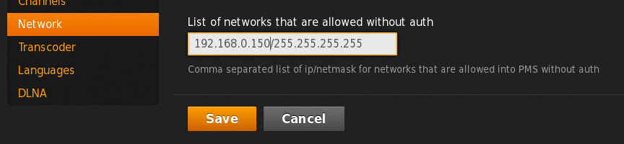

Remote Indexer

Dependencies
Before starting the Remote Indexer, you'll need the following:
Python 2.7.x found here: http://www.python.org/downloads/
(Above only if not running on Windows)
FFMPEG, found here: http://www.ffmpeg.org/download.html
After downloading and installing above, you'll have to find the exact path to the FFMPEG executable, including it's name
In my case, running OpenSuse, it's : /usr/bin/ffmpeg

Configuration
During the first launch of the Remote Indexer, the configuration Wizard will start, and ask you some questions, like:

Path to FFMPEG
Here you enter the exact path to the FFMPEG executable that you downloaded from above
Path will be validated, and if you enter it incorrectly, you'll be prompted again

Local port
The Remote Indexer is actually a webserver, and will listen on every IP address you have on the remote Workstation/Server, but it needs a port to use, that is not only not used by anything else, but also can slip through any firewall you might have installed on the Remote Indexer Workstation/Server
I recommend to use port 32405, but you have to let that be allowed your self on your firewall, and also on any Anti-Vira solution running

FFMPEG Threads
If the workstation/server where you run the Remote Indexer has like a 4 Core CPU, and you only want to use like 2 or 3 cores for the Screen Snapshot creation, then this is where you adjust it.
If set to auto, all cores will be used, if set to 2, then 2 cores will be used and so on....

Debug level
If this is set to anything other than none, then a log file will be created in the same directory as the RemIdx.py file.
If doing troubleshooting, I recommend setting it to debug
Manually editing the settings
The settings are stored in a file named RemIdx.ini, that will be created the first time this program is run
Running configuration Wizard
To run the configuration wizard again, simply delete the file named RemIdx.ini

Anti-Vira Solution
If you on the box that is running the Remote Indexer, also is running an Anti-Vira solution, then I strongly suggest, that you exclude the Remote Indexer directory, since the Indexer will create 1000's of temporary jpeg files, and scanning those will slow down the process.
Also, if your solution includes http scanning as well, I strongly suggest, that you exclude your PMS server, since the actual medias will be streamed down via HTTP protocol

Directory layout
After starting the Remote Indexer, some directories will be created when they are needed, in the same directory as the Remote Indexer.
- Queue : This directory holds information about medias waiting to be indexed
- Work : This directory holds information about the media that is currently been indexed
- Tmp : This directory contains temporary screen shots from the media
- Out : This directory holds the created index file, while waiting for the PMS to pick it up

Using it
On the remote workstation, open up a terminal/command prompt, and navigate to the extracted directory/Remote_Indexer.
If running Windows, type: <Path to RemIdx>\RemIdx.exe
If running Linux or Mac, type:
Then type : <Path to python> RemIdx.py

You should now see a picture looking like this:
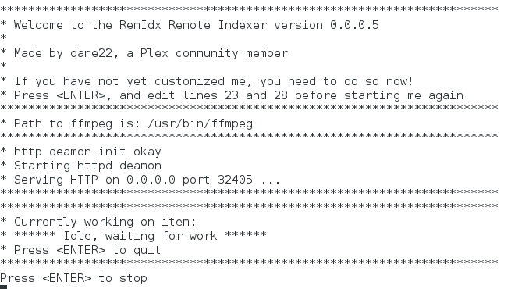
Your Remote Indexer is now ready to work, and all you have to do now, is in PMS WebAdmin to refresh either a section, or an individual movie.
If you decide to close down the Remote Indexer, it'll continue where it left off next time you power it on again.
If you refresh items on your PMS, while the Remote Indexer is not running, those items will not be added to the Queue

More than one
If you have more than one PMS running, you can install the bundle agent on them all, and one Remote Indexer will serve them all.

More than one Remote Indexer for a single PMS is however not supported

Known issues

Version 0.0.1.4:
- When doing a refresh of a single TV episode, all episodes in that TV-Serie will be queued, if they are missing an index
- If this program has finished creating an index for a media, and uploaded it to your PMS, Automatic Index Generation on the PMS will be switched back on. It will be on for about 1 sec. If you happen to add a new media during that exact second, then the new media might be indexed by the PMS :-(

General Issue:
When the RemIdx.bundle is launched on your PMS, it'll disable the Automatic Index generation, since it's now taken over.
This is not a bug, but working as intended

Uninstall
If you decide not to use RemIdx anymore, then delete the RemIdx.bundle directory on your PMS, and restart PMS.
On the local workstation, delete the Remote_Indexer directory

