EXP 10:
Software Requirements Prioritization using MoSCoW Analysis for Library Management System

Aim:
To analyze, prioritize, and categorize the functional requirements of a Library Management System using the MoSCoW method based on user impact and feasibility constraints.

procedure:
- Open Spreadsheet: Launch Google Sheets or MS Excel and create a new blank sheet. Add Headers: Set Row 1 headers as: Req ID, Requirement Description, MoSCoW Category, Impact on Users, and Feasibility & Justification.
- List Requirements: Enter all 10 library system requirements into the table. Categorize Requirements: Assign each requirement to Must-Have, Should-Have, Could-Have, or Won’t-Have based on operational need and feasibility.
- Add Justifications: Write a short explanation for each item detailing its user impact and technical effort.
- Format & Export: Apply bold headers, auto-fit columns, add text wrapping, and save or download as .xlsx or PDF for submission.

Output:
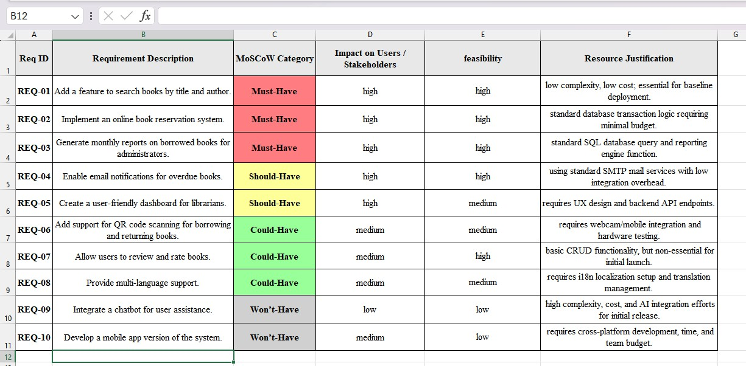

Result: Thus, All 10 requirements for the Library Management System were successfully
analyzed, categorized, and documented in Google Sheets/Excel using the MoSCoW method. Each requirement was evaluated based on user impact and technical feasibility to establish a clear development priority list.

