EXP 8:
Cyclomatic Complexity of a Flow Graph
Aim:
To design a control flow graph for a given problem (finding the largest of three numbers) and calculate its cyclomatic complexity using the Raptor flowchart tool to determine the number of independent paths in the program.
procedure:
1. Initialize the Inputs: Launch Raptor and place three sequential Input symbols directly below the Start node. Configure them to prompt the user and store the values into variables A, B, and C.
2. Establish the Primary Condition: Drag a Selection symbol (diamond) onto the flowline. Set its condition to A > B. This acts as the first predicate node, splitting the program's control flow into a "Yes" path and a "No" path.
3. Construct Nested Branching: o On the Yes path (meaning A is currently the largest), place a second Selection symbol with the condition A > C. o On the No path (meaning B is currently the largest), place a third Selection symbol with the condition B > C.
4. Assign the Outputs: Place four Output symbols at the terminals of these nested branches to cover every possible outcome: o Yes path of A > C: Output "A is largest". o No path of A > C: Output "C is largest". o Yes path of B > C: Output "B is largest". o No path of B > C: Output "C is largest".
5. Execute: Run the flowchart using the Play button to test the logic with different numbers.
6. Calculate Complexity: Count the total decision diamonds to find your predicate nodes (𝑃 = 3). Apply the cyclomatic complexity formula: 𝑉(𝐺) = 𝑃 + 1.
7. Conclusion: The complexity is 3 + 1 = 4, which proves there are exactly 4 independent paths in the flowchart.

Output:
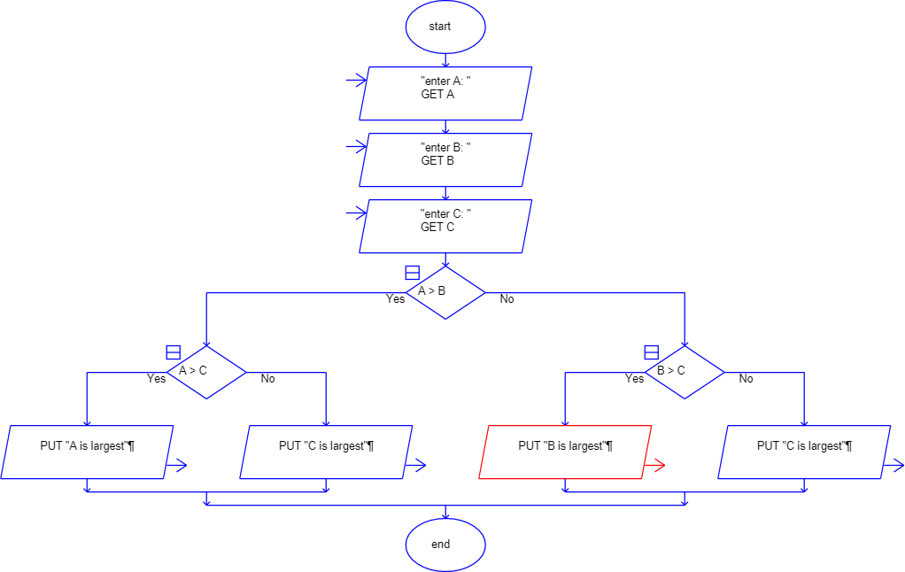
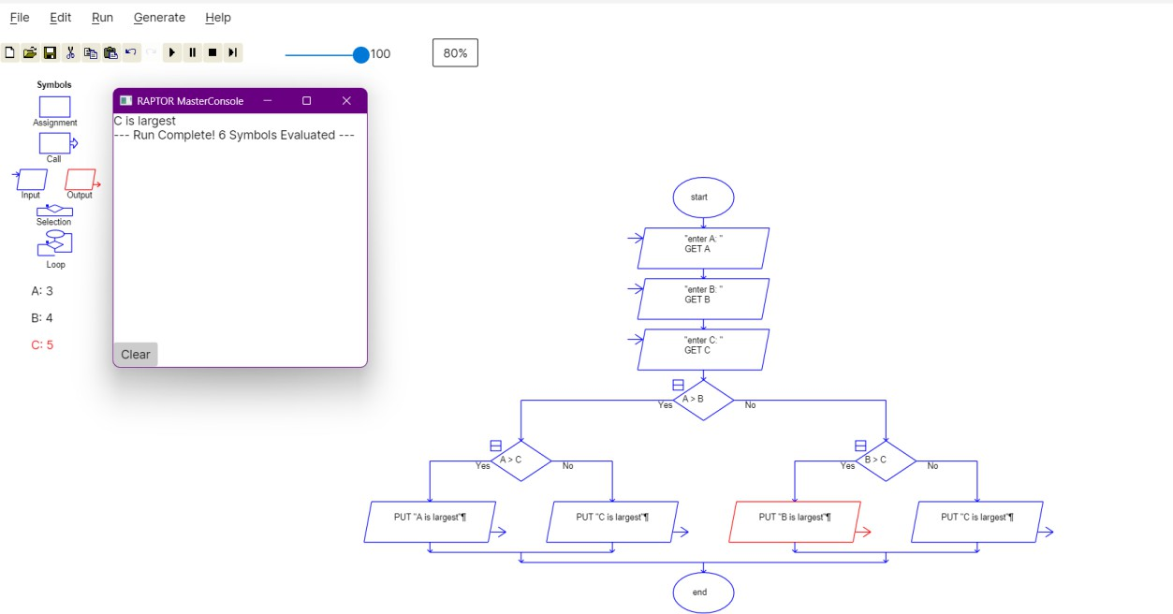

Result: The control flow graph for finding the largest of three numbers was successfully designed and executed in the Raptor tool. The cyclomatic complexity was calculated as 4, confirming the existence of four independent execution paths.

