EXP 9:
Scrum Project Management and Sprint Lifecycle Execution in Jira

Aim:
Implementation of Agile Development Framework using Jira: Backlog Management, Sprint Planning, and Execution

procedure:
- Log In: Access the Atlassian Cloud portal and log into your Jira account.
- Create Project: Select Projects from the menu and create a new project using the Scrum template.
- Add Backlog Items: Open the Backlog tab and create 5 tasks (e.g., user registration, login API, database schema).
- Prioritize & Plan Sprint: Reorder items by priority and drag 4 of them from the Backlog container into Sprint 1.
- Start Sprint: Set the sprint duration to 1 week, click Start sprint, and capture Screenshot 1 of the Board in the To Do state.
- Track & Complete: Drag tasks across to In Progress and Done, capture Screenshot 2 of the completed board state, and click Complete sprint.

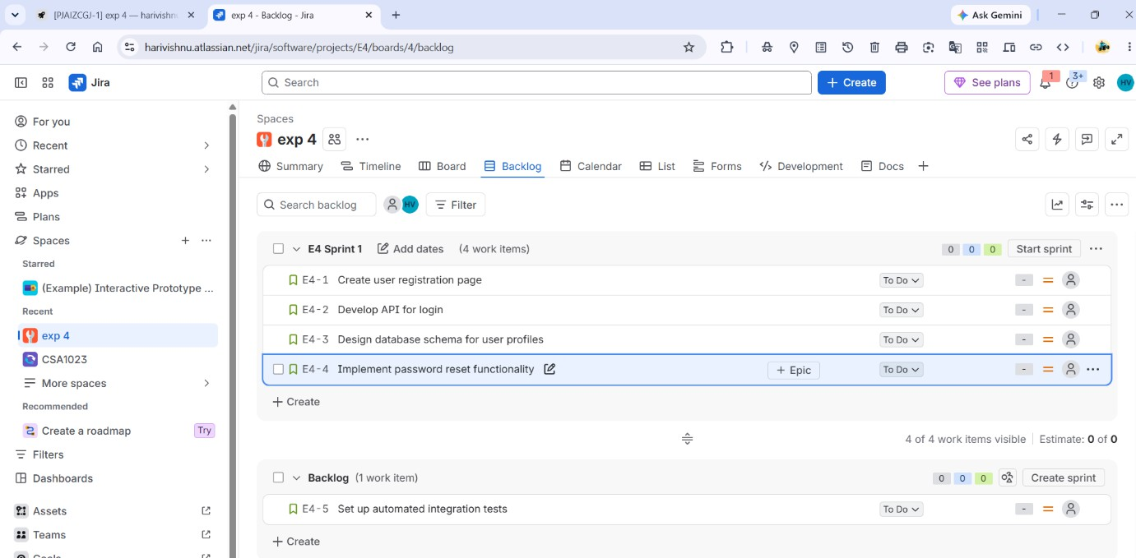
Output:

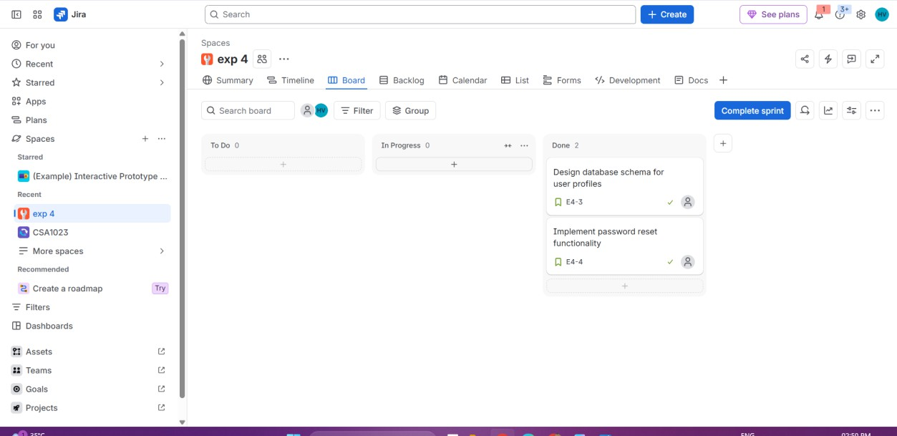

Result: Thus, A Scrum project was successfully created in Jira, and a prioritized backlog was established. A 1-week sprint was planned, started, tracked through the board, and completed with all required screenshots captured.

