EXP- 1:
Create a Kanban Board (Jira/Trello) Aim
To create and simulate a Kanban workflow using Jira or Trello.
Procedure :
- Login to Jira/Trello.
- Create a new Kanban board.
- Create columns: To Do, In Progress, Done.
- Add 2 to 3 tasks.
- Move tasks across columns to simulate workflow.
- Observe task progress.
Output:
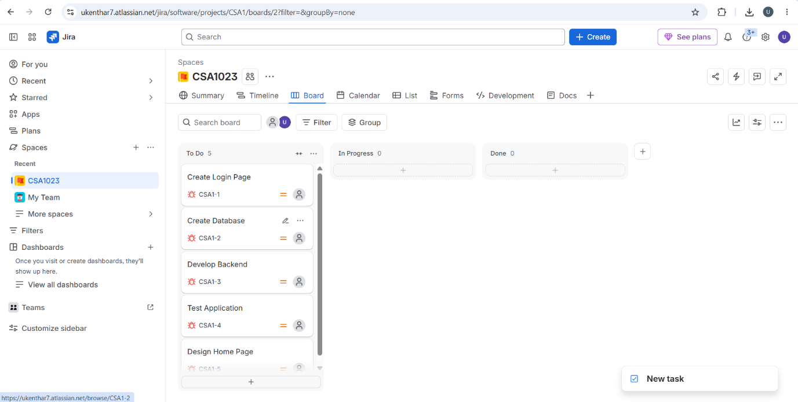
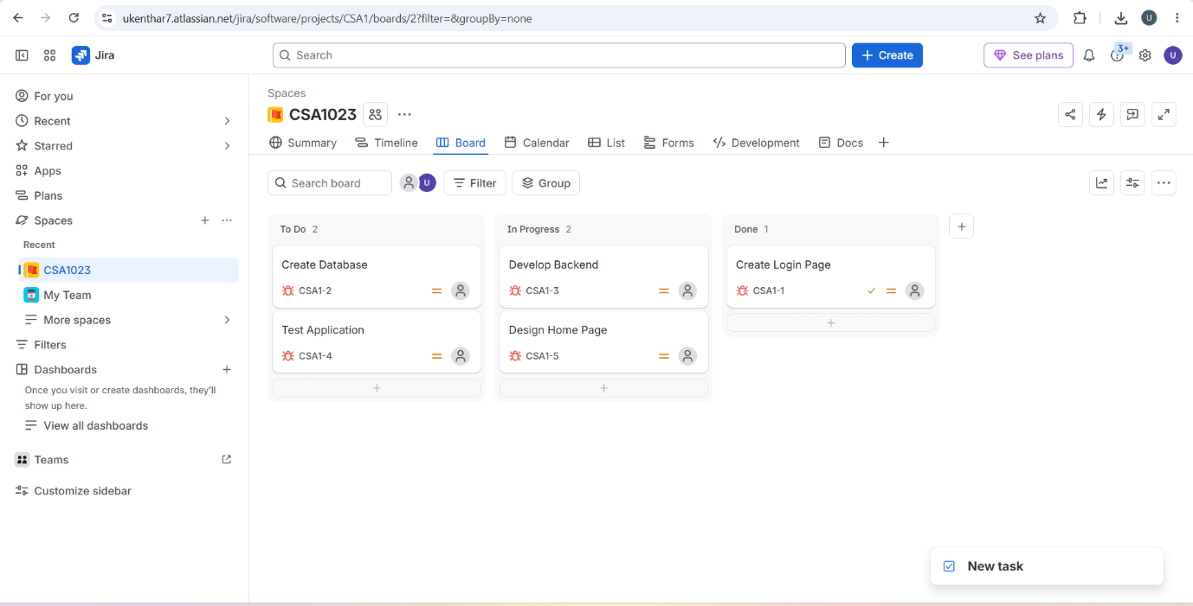

Result:
Thus, The Kanban board has created successfully and simulated workflow by moving tasks across stages.

