SERVERLESS • EVENT-DRIVEN • AWS
S3 Event-Driven
Automation with Lambda
Implementation and verification report
Prepared by
Nimmanapalli Ukesh Reddy
USN: 23BTRCT091
HCL ID: HCLTFP2264810
Department: CSE*
Amazon S3 | AWS Lambda | Amazon CloudWatch Logs
AWS Region: Asia Pacific (Mumbai) — ap-south-1

Executive Summary
This project demonstrates a serverless event-driven workflow. When a new object is uploaded to an Amazon S3 bucket, an S3 ObjectCreated notification invokes an AWS Lambda function. The function parses the event record and writes structured details about the uploaded object to its execution logs. Amazon CloudWatch Logs provides the evidence used to verify the run.
VERIFIED RESULT
A real upload of test-upload.txt triggered the Lambda function. CloudWatch Logs showed the event message, object details, and START / END / REPORT execution records.

Project Objectives
- Create a private S3 bucket to receive test uploads.
- Create a Python Lambda function to process S3 event records.
- Configure S3 object-created events to invoke the function.
- Test the event flow with a real file upload.
- Use CloudWatch Logs to confirm execution and inspect the event data.
- Capture implementation evidence for technical documentation and a GitHub portfolio.

Technology and Resource Summary
Resource | Configuration / role
Amazon S3 bucket | ukesh-s3-lambda-automation
AWS Region | Asia Pacific (Mumbai), ap-south-1
Lambda function | s3-upload-event-processor
Runtime | Python 3.14, as shown in the execution log
Test object | test-upload.txt — 194 bytes
Logging | Amazon CloudWatch Logs

Architecture and Event Flow
1. Upload — A user uploads a file to the private S3 bucket.
2. Event — S3 emits an ObjectCreated event for the new object.
3. Invocation — The event invokes s3-upload-event-processor.
4. Processing — The handler reads the bucket, URL-decodes the object key, records the size, and creates a UTC timestamp.
5. Verification — The function prints a structured JSON record to CloudWatch Logs.
Amazon S3 → ObjectCreated event → AWS Lambda → CloudWatch Logs

Implementation Details

1. Create the S3 bucket
A general-purpose S3 bucket named ukesh-s3-lambda-automation was created in the Mumbai region. Public access is not needed for this workflow, so the bucket should remain private.
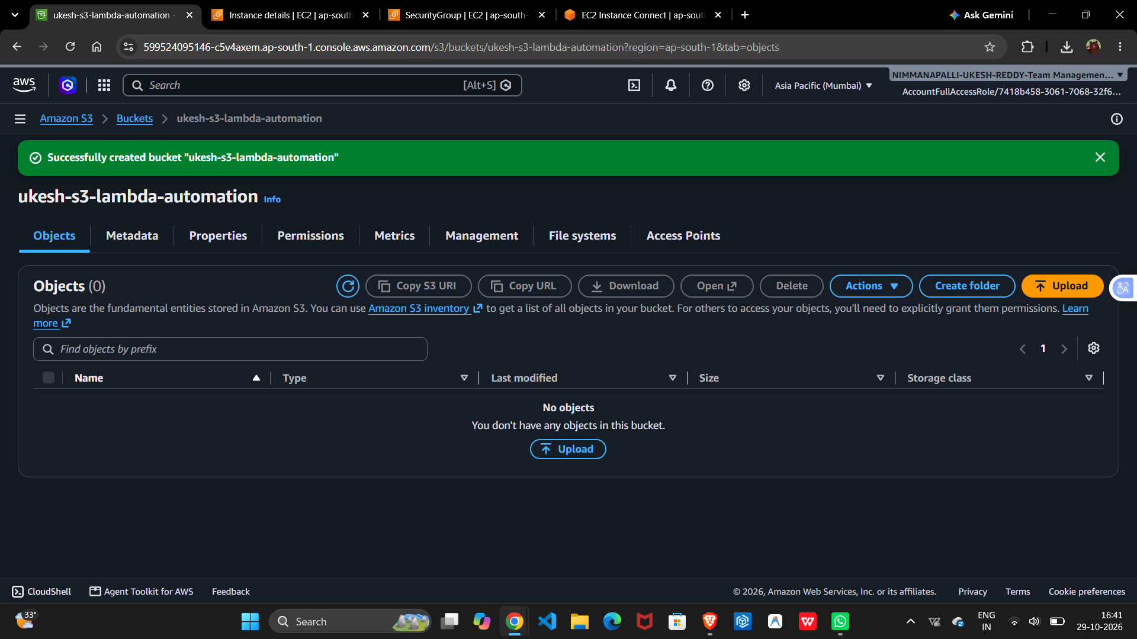
Figure 1. S3 bucket created successfully in ap-south-1.

2. Create the Lambda function
The function s3-upload-event-processor was created from scratch using the Python runtime. Its execution role provides the basic permissions needed to write logs to CloudWatch.
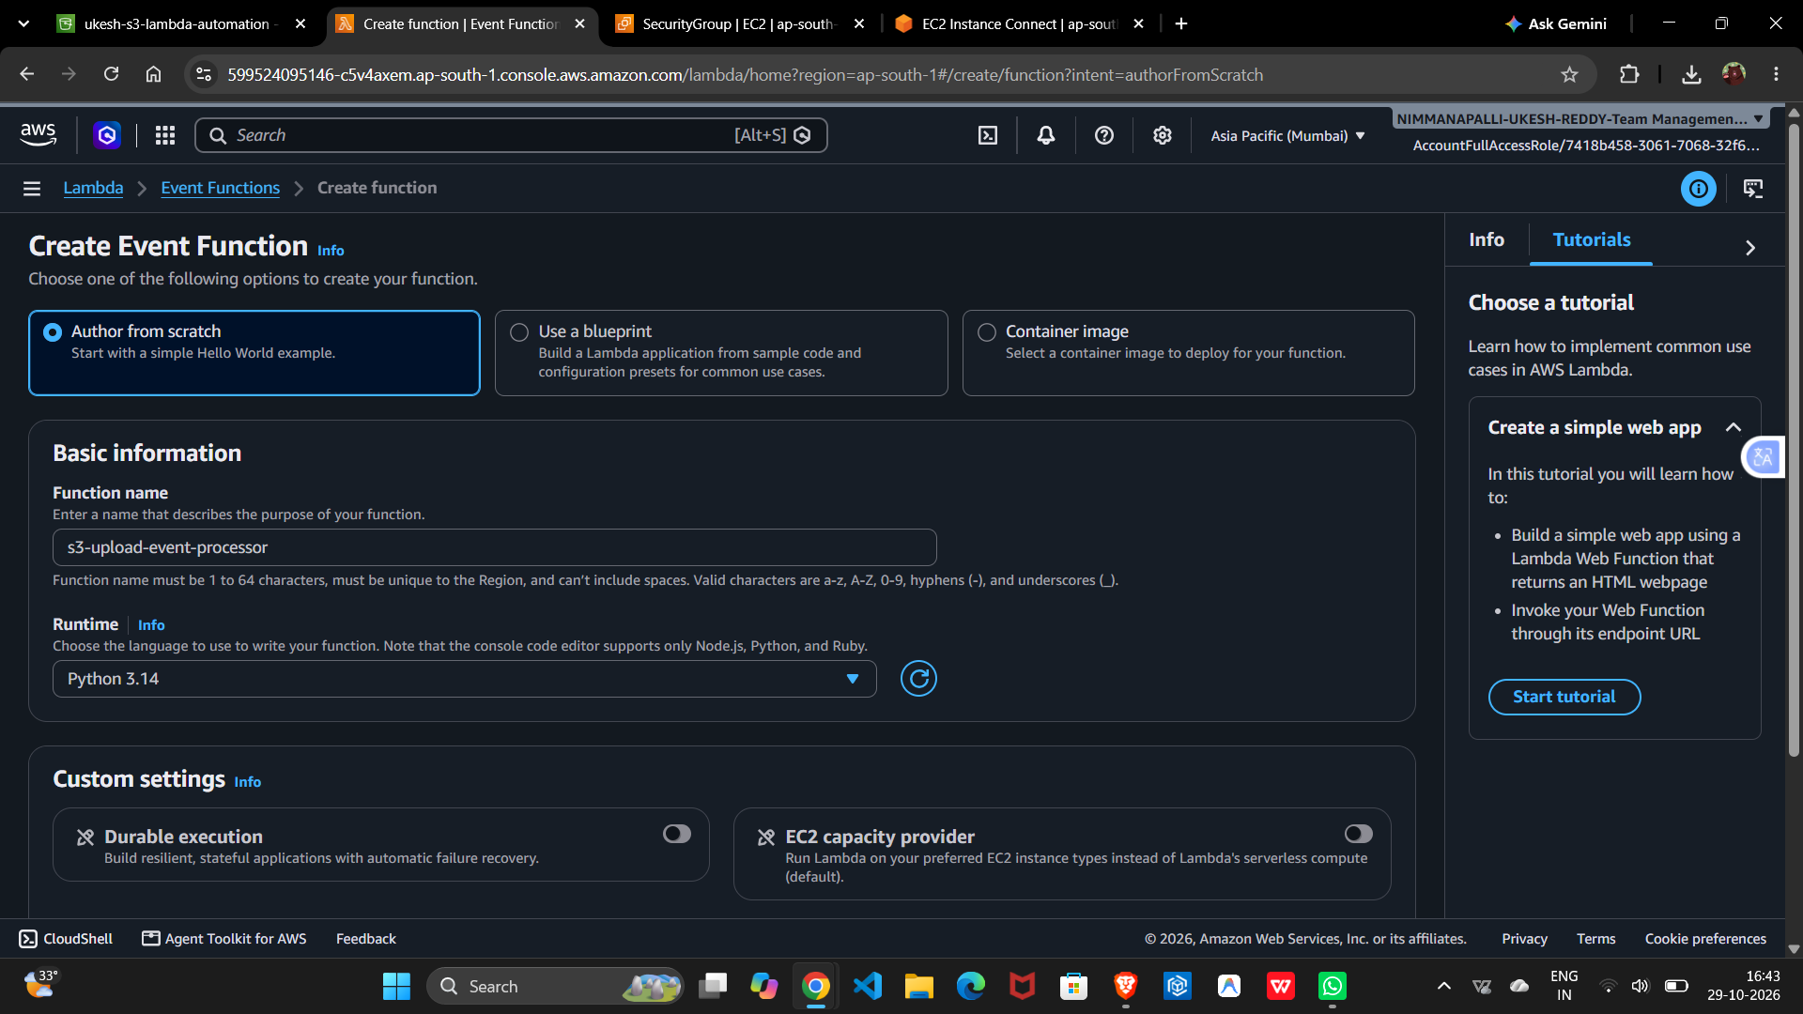
Figure 2. Lambda function configuration before creation.
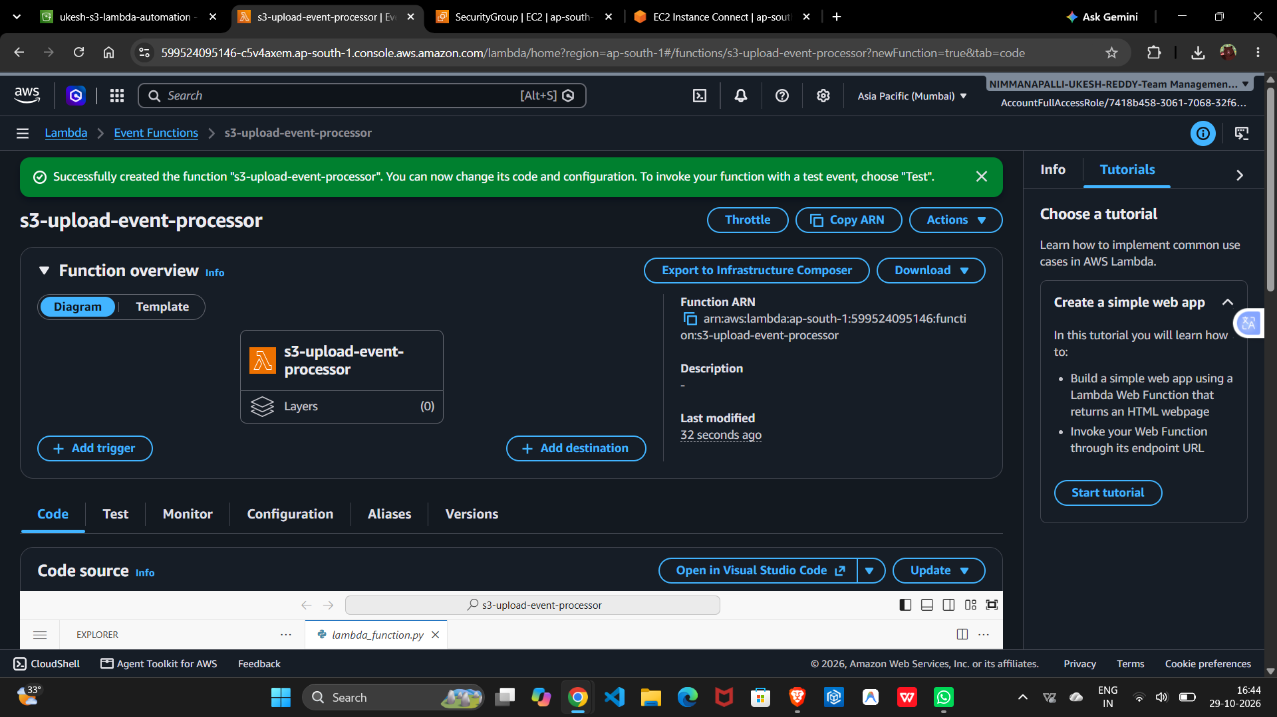
Figure 3. Lambda function successfully created.

3. Deploy the event handler
The deployed handler processes each record in the S3 event. It logs a message and a JSON object containing the event type, bucket name, decoded file name, object size in bytes, and UTC processing time.
import json
import urllib.parse
from datetime import datetime, timezone

def lambda_handler(event, context):
print("S3 upload event received")
for record in event.get("Records", []):
bucket = record["s3"]["bucket"]["name"]
key = urllib.parse.unquote_plus(record["s3"]["object"]["key"])
size = record["s3"]["object"].get("size", 0)
result = {
"event": "ObjectCreated",
"bucket": bucket,
"file_name": key,
"file_size_bytes": size,
"processed_at_utc": datetime.now(timezone.utc).isoformat()
}
print(json.dumps(result))
return {"statusCode": 200, "body": json.dumps({"message": "S3 event processed successfully"})}
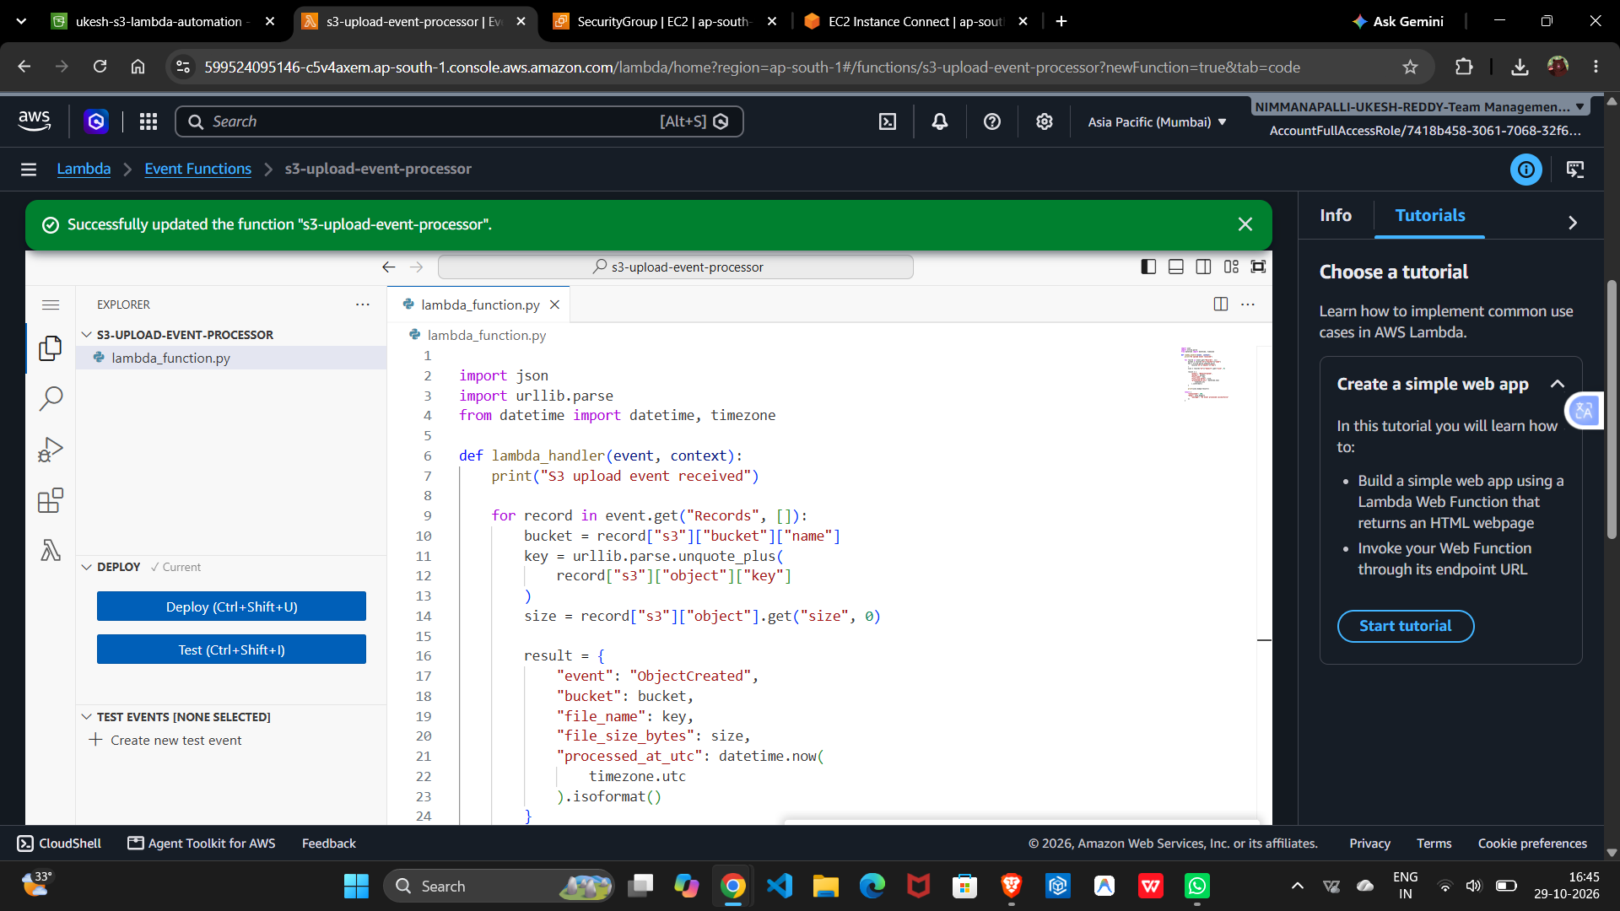
Figure 4. Lambda code deployed successfully in the console.

4. Configure the S3 trigger
An S3 trigger was attached to the Lambda function for object-created events in ukesh-s3-lambda-automation. The function only logs event information and does not write output objects to the same bucket, avoiding a recursive trigger loop.
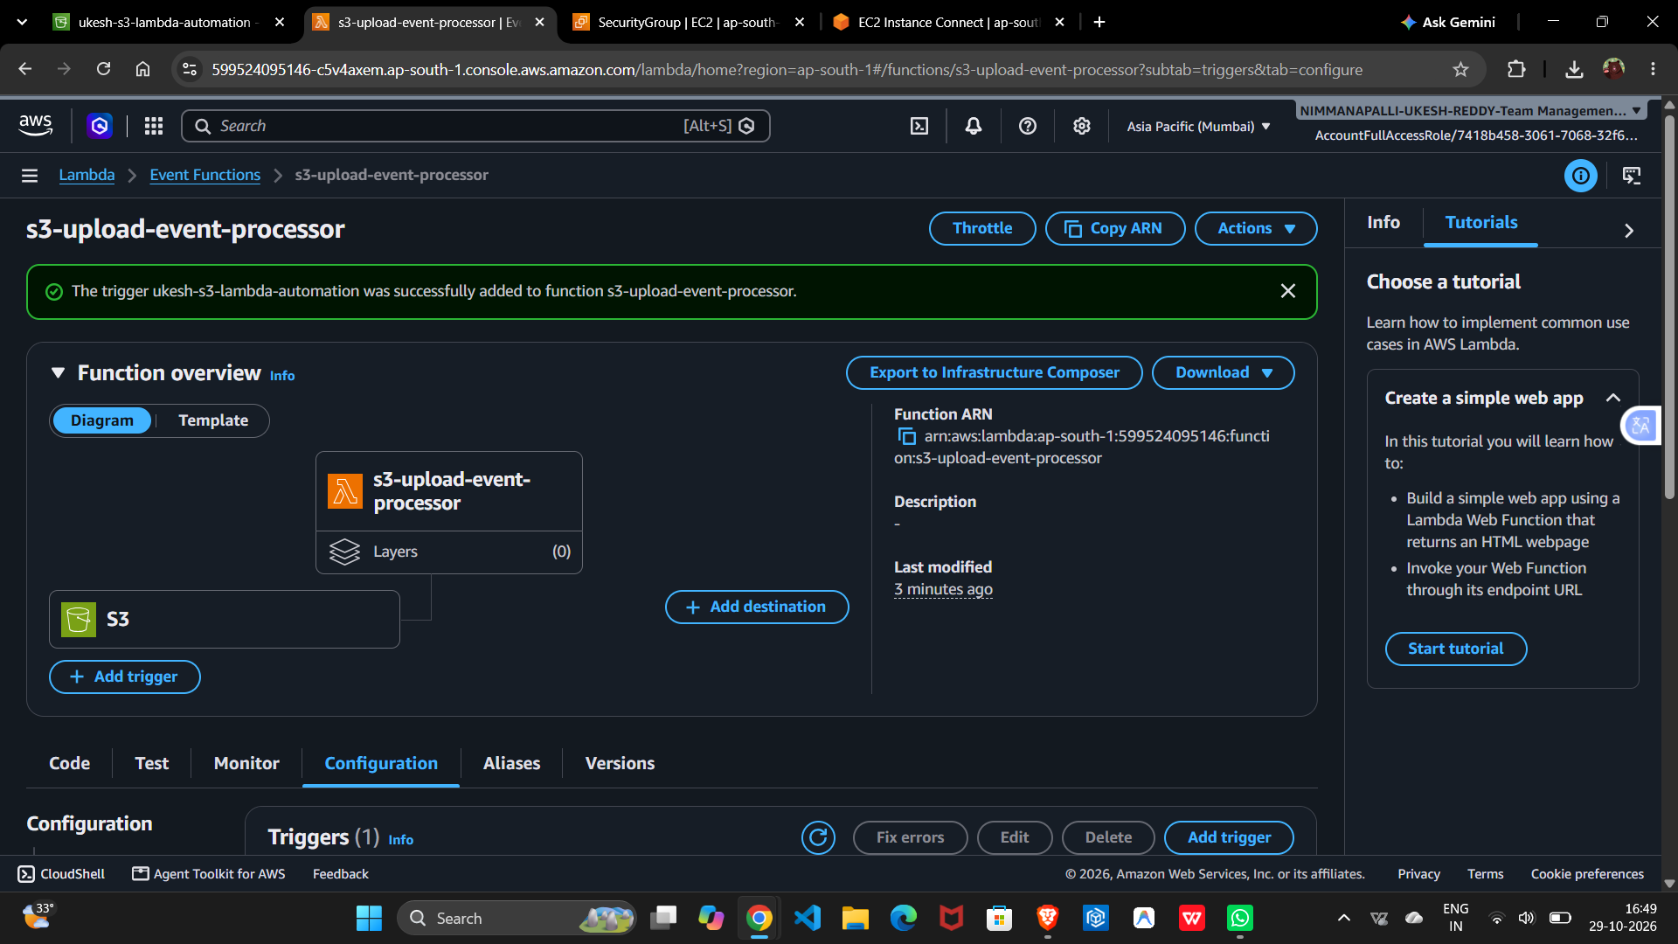
Figure 5. AWS console confirms the S3 trigger was successfully added.

Testing and Results

Test procedure
- Download or create the small text file named test-upload.txt.
- Upload it to the ukesh-s3-lambda-automation bucket.
- Open the Lambda function's CloudWatch log stream.
- Confirm the event message and JSON object details appear in the logs.

Observed results
- S3 upload status: Succeeded.
- Test object: test-upload.txt.
- Reported object size: 194 bytes.
- Lambda log message: S3 upload event received.
- Structured log included the bucket name, object key, and file_size_bytes.
- CloudWatch log stream included START, END, and REPORT records for the invocation.
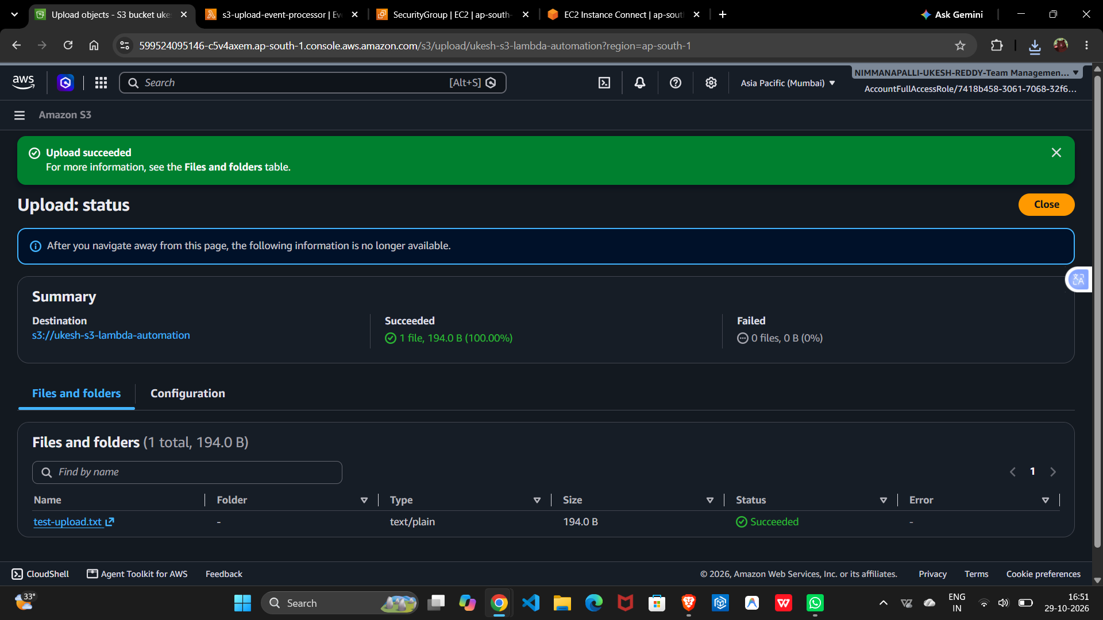
Figure 6. S3 confirms that test-upload.txt uploaded successfully.
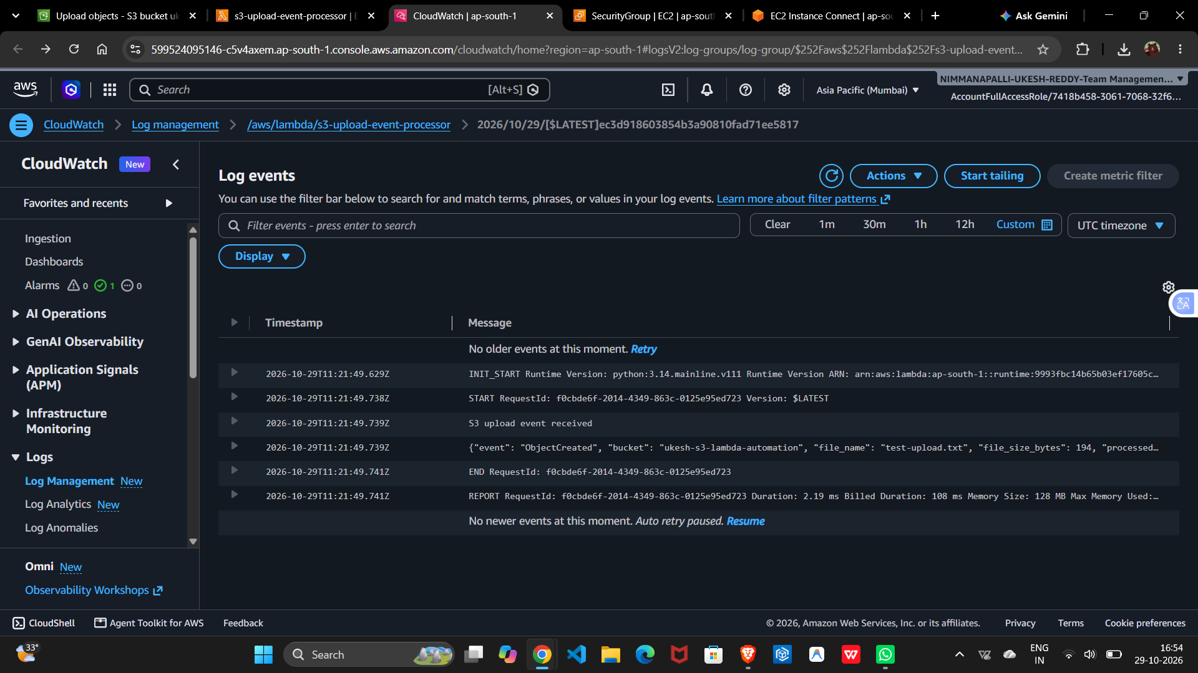
Figure 7. CloudWatch Logs show the S3 event was processed by Lambda.

Security, Reliability, and Cost Notes
- Keep the S3 bucket private; this project does not require public object access.
- Do not commit AWS credentials, access keys, session tokens, passwords, or private keys to GitHub.
- Use least-privilege permissions for the Lambda execution role and S3 invocation permission.
- The current function does not write to S3. If output-writing is added later, use a separate output bucket or carefully scoped event filters to prevent recursive invocations.
- Review AWS Billing for charges. Delete unused resources when the project is no longer needed.

Future Improvements
- Add structured exception handling and clearer failure logs.
- Create unit tests with representative S3 event JSON.
- Add CloudWatch alarms or metrics for failures and invocation counts.
- Use a separate output bucket if processed files are generated.
- Automate deployment and resource provisioning using AWS SAM, CloudFormation, or Terraform.

Conclusion
The end-to-end test succeeded: uploading a file to Amazon S3 automatically invoked the Lambda function, and CloudWatch Logs recorded the event and object details. This project demonstrates core serverless concepts including event notifications, function invocation, structured logging, and verification through managed observability tools.

