DATA ENGINEERING LAB
SQL, Linux, AWS and Azure Practical Record

Submitted by
N UKESH REDDY
Program: B.Tech – Computer Science Engineering
University: Jain (Deemed-to-be University), Bengaluru

Practical Record | October 2026

Task 1: SQL GROUP BY and HAVING

Question
Write an SQL query to group employees by department and display the department name, number of employees, and average salary. Show only departments having more than 2 employees and an average salary greater than 35,000.

SQL Query
SELECT
department AS department_name,
COUNT(*) AS no_of_employees,
ROUND(AVG(salary), 2) AS avg_salary
FROM employees
GROUP BY department
HAVING COUNT(*) > 2
AND AVG(salary) > 35000;

Output / Result
The screenshot shows two departments satisfying the conditions: IT has 3 employees with an average salary of 45,000.00, and Finance has 3 employees with an average salary of 40,000.00.
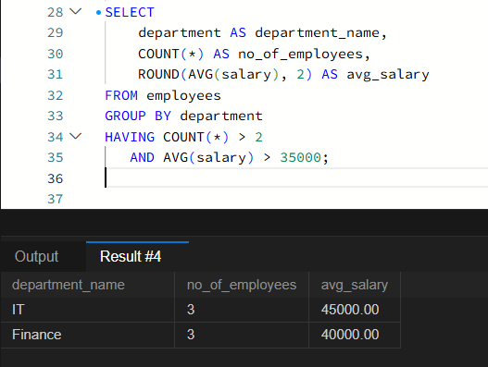
Figure 1.1: SQL query and grouped department output

Task 2: Linux File Content and Line Count

Question
Create a file named numbers.txt, enter the values 10, 20, 30, 40, and 50 on separate lines, display the file content, and count the number of lines.

Commands
printf "10\n20\n30\n40\n50\n" > numbers.txt
cat numbers.txt
wc -l numbers.txt
wc -l < numbers.txt

Output / Result
The terminal screenshot shows the five values in numbers.txt. The line-count command returns 5 (displayed as “5 numbers.txt” when the filename is included, and “5” when input is redirected).
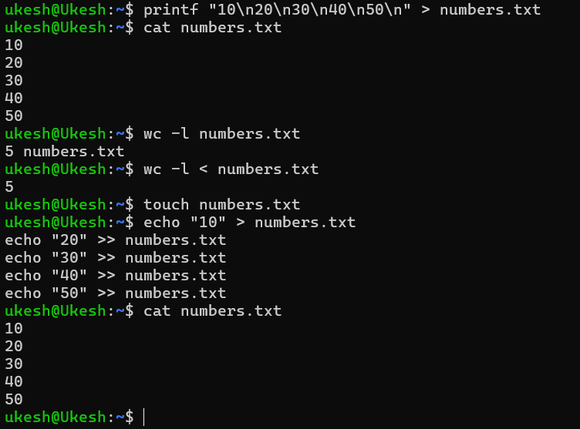
Figure 2.1: Linux file contents and line-count output

Task 3: AWS RDS Database Configuration

Question
Create or inspect an Amazon RDS database instance, identify its database engine, status, instance class, database name, endpoint, and port, and connect to it to execute a SQL query.

Configuration Observed
- DB instance identifier: database-2
- Engine: MySQL Community
- Status: Available
- Region: Asia Pacific (Mumbai), ap-south-1
- DB instance class: db.t4g.micro
- Database name: mysql
- Port: 3306
- Public access: No (private instance)

Output / Result
The screenshots document the RDS instance configuration and show that the database instance is available. The live SQL connection and query execution are not included because connectivity was not completed. Therefore, this task is recorded as partially completed; no SQL output is claimed.
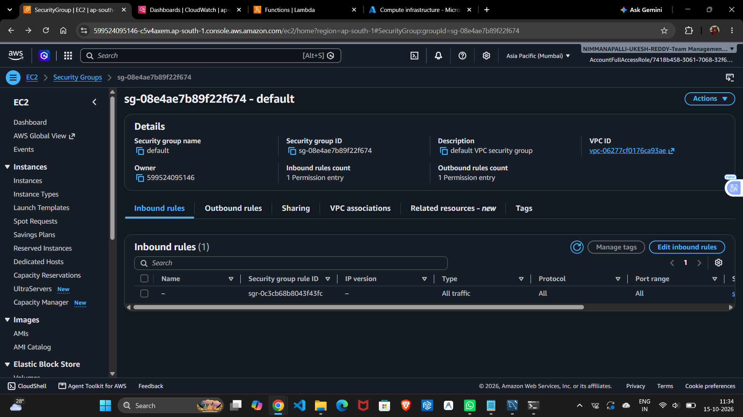
Figure 3.1: AWS RDS database instance details
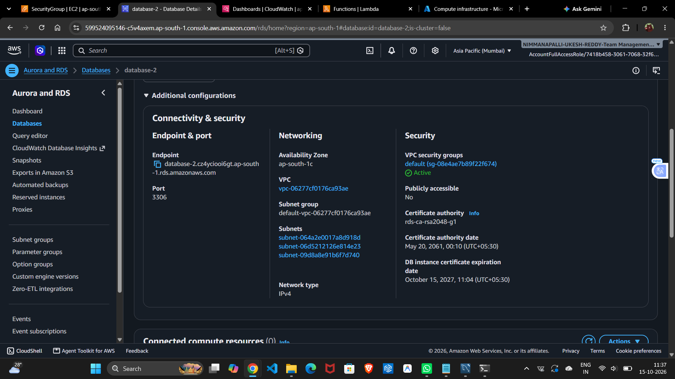
Figure 3.2: RDS configuration and connectivity settings
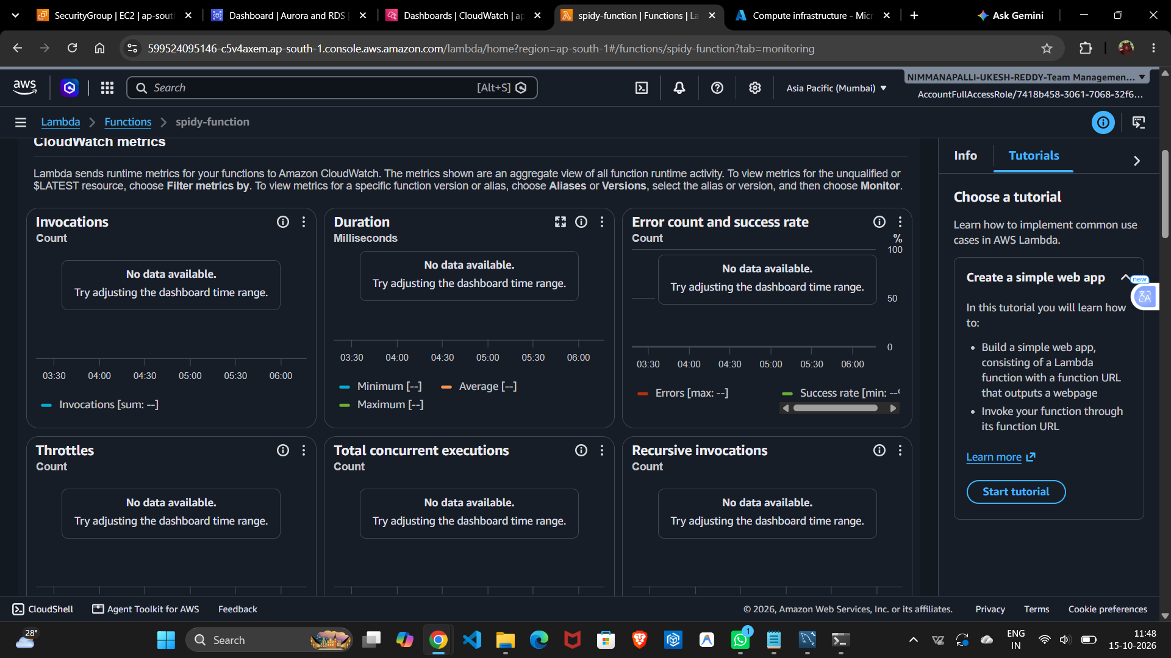
Figure 3.3: Additional AWS database console evidence

Task 4: AWS CloudWatch Metrics and Logs

Question
Use Amazon CloudWatch to inspect monitoring metrics and logs for an AWS Lambda function, and capture evidence of function activity.

Procedure
Opened the Lambda function monitoring view and reviewed the available invocation, duration, error, throttle, and concurrency metrics. Then opened the function's CloudWatch log group to inspect its execution events.

Output / Result
The monitoring view displayed no metric data for the selected time range. The CloudWatch log stream contained a Lambda execution with the message “file uploaded successfully”, followed by the START, END, and REPORT records. This provides evidence of a function invocation in the logs.
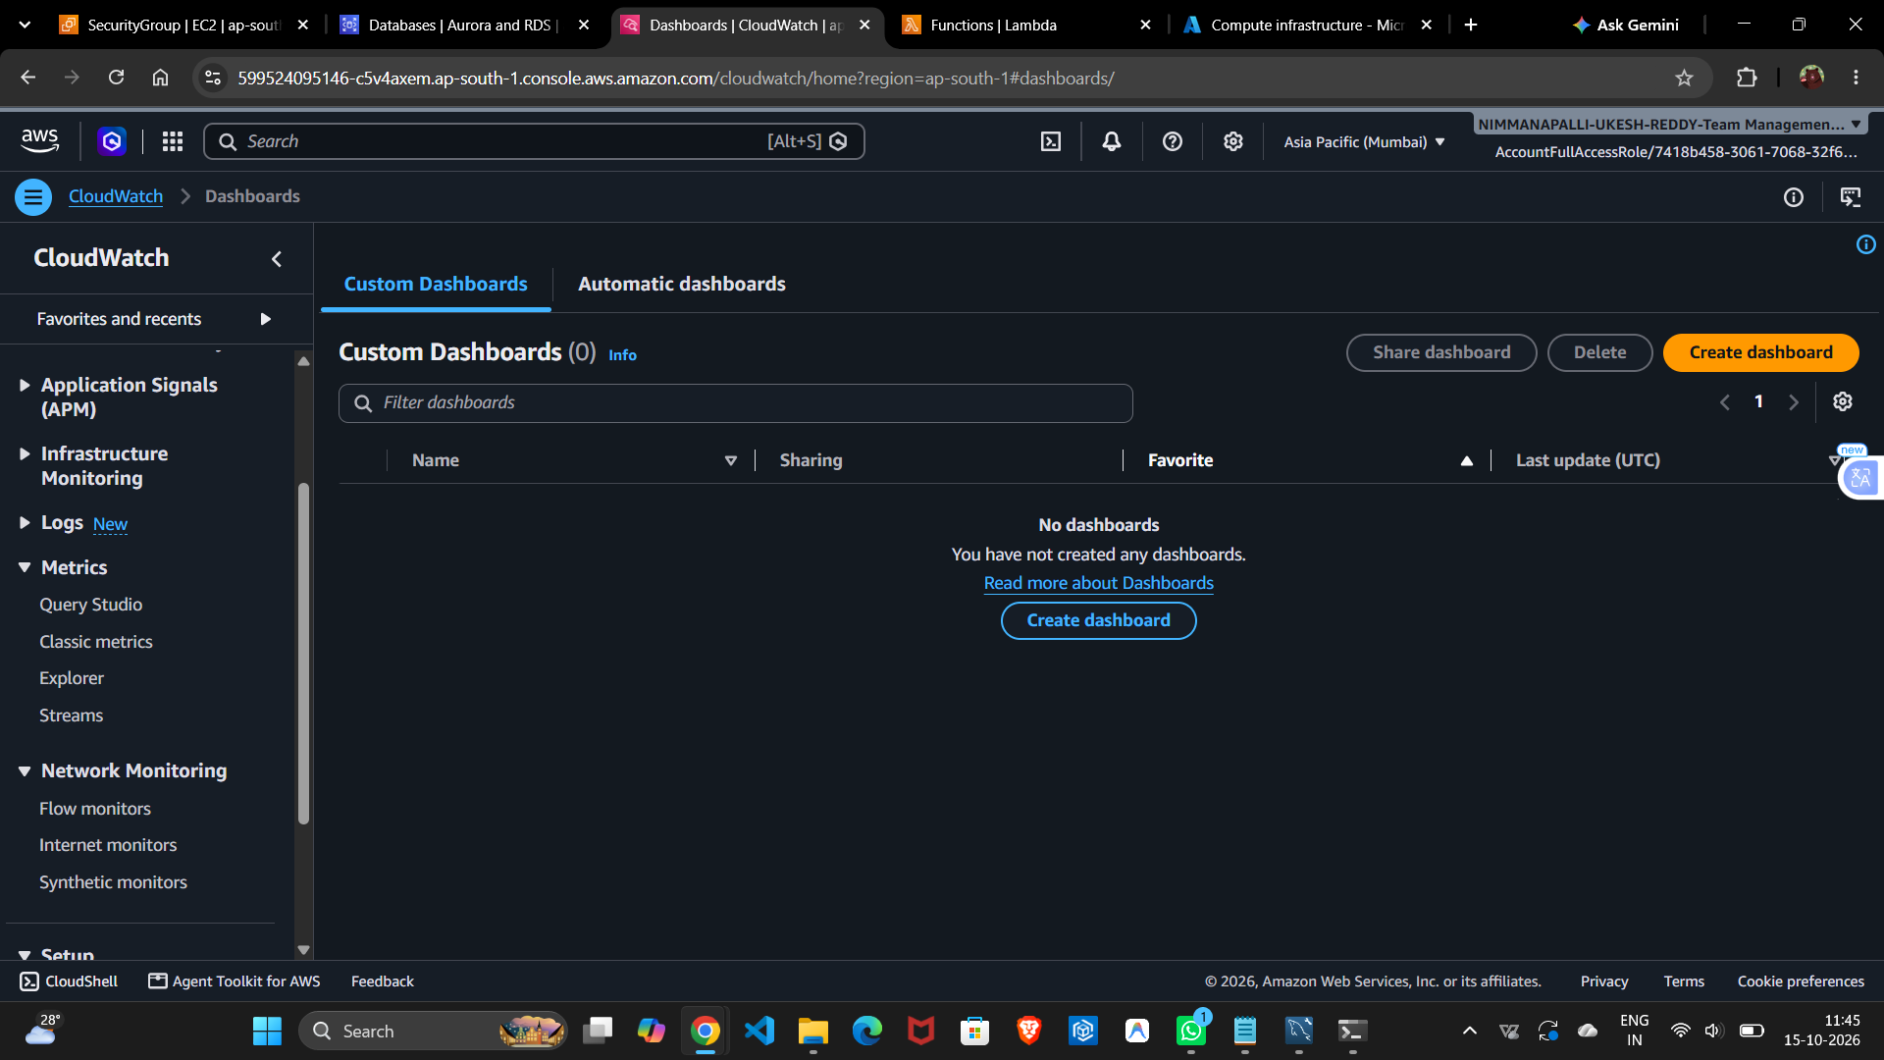
Figure 4.1: CloudWatch console view
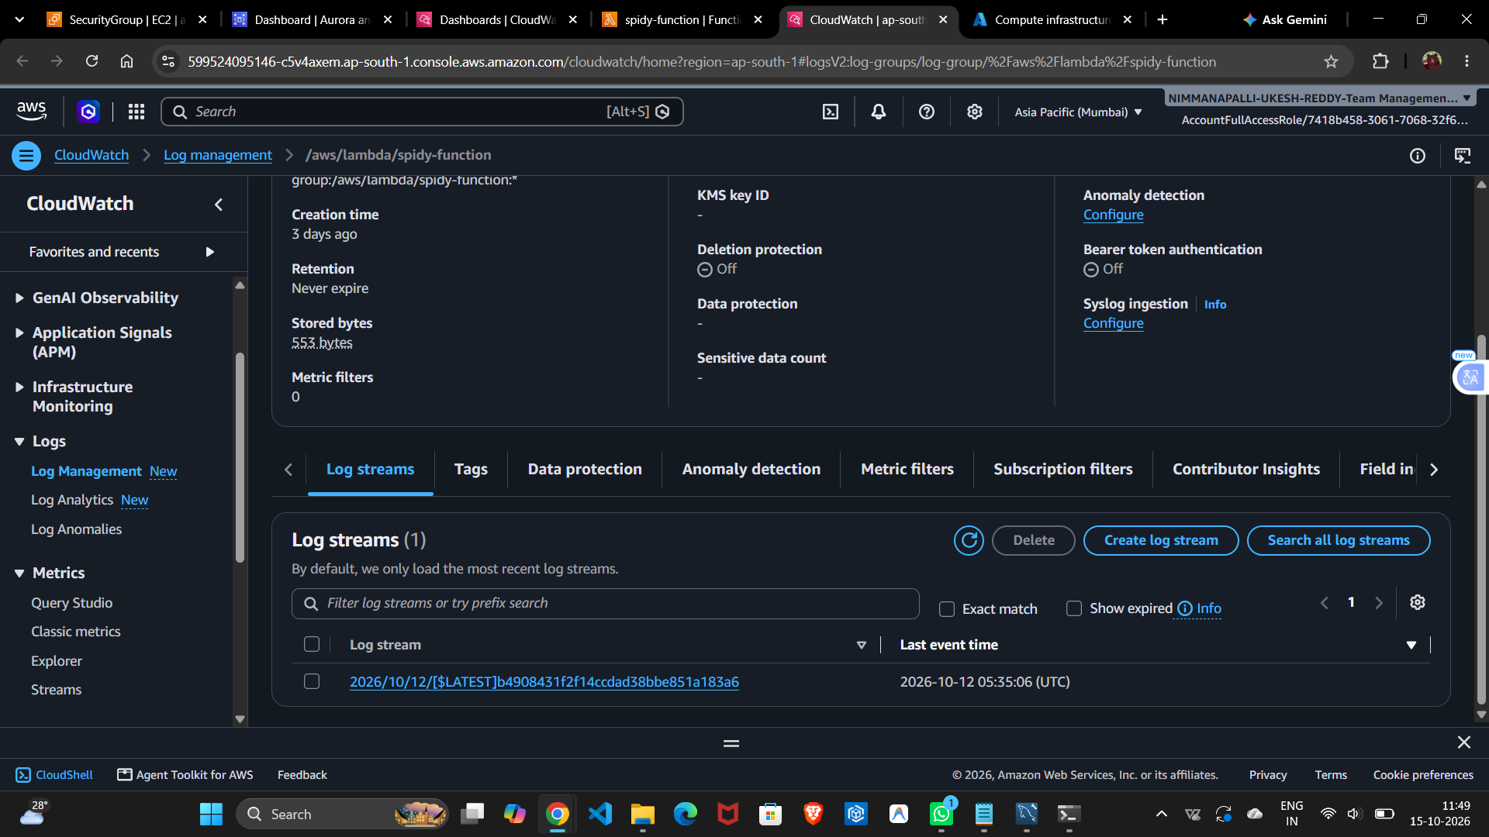
Figure 4.2: AWS Lambda / CloudWatch evidence
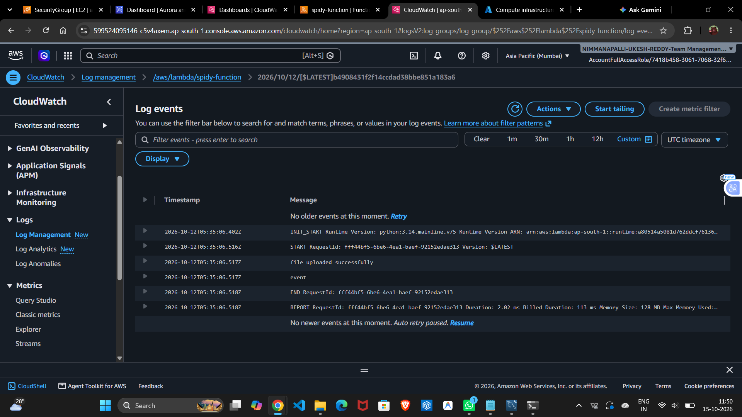
Figure 4.3: CloudWatch and Lambda console evidence

Task 5: Azure Virtual Machine Configuration

Question
Inspect an Azure virtual machine and record its operating system, region, status, size, IP addresses, network configuration, and inbound security rules.

Configuration Observed
- Virtual machine: virtual1
- Resource group: ECOMMERCE1
- Status: Running
- Operating system: Ubuntu 24.04 (Linux)
- Region: India South Central, Zone 1
- Size: Standard B2ats v2 (2 vCPUs, 1 GiB memory)
- Public IP address: 172.198.162.127
- Private IP address: 172.16.0.4
- Virtual network: vnet-indiasouthcentral-1
- Network security group: virtual1-nsg

Output / Result
The screenshots show the Azure virtual machine configuration and network security settings. Inbound rules include SSH on TCP port 22 and HTTP on TCP port 80 from Any source. For security, SSH access should be restricted to a trusted source IP or an approved access method when possible.
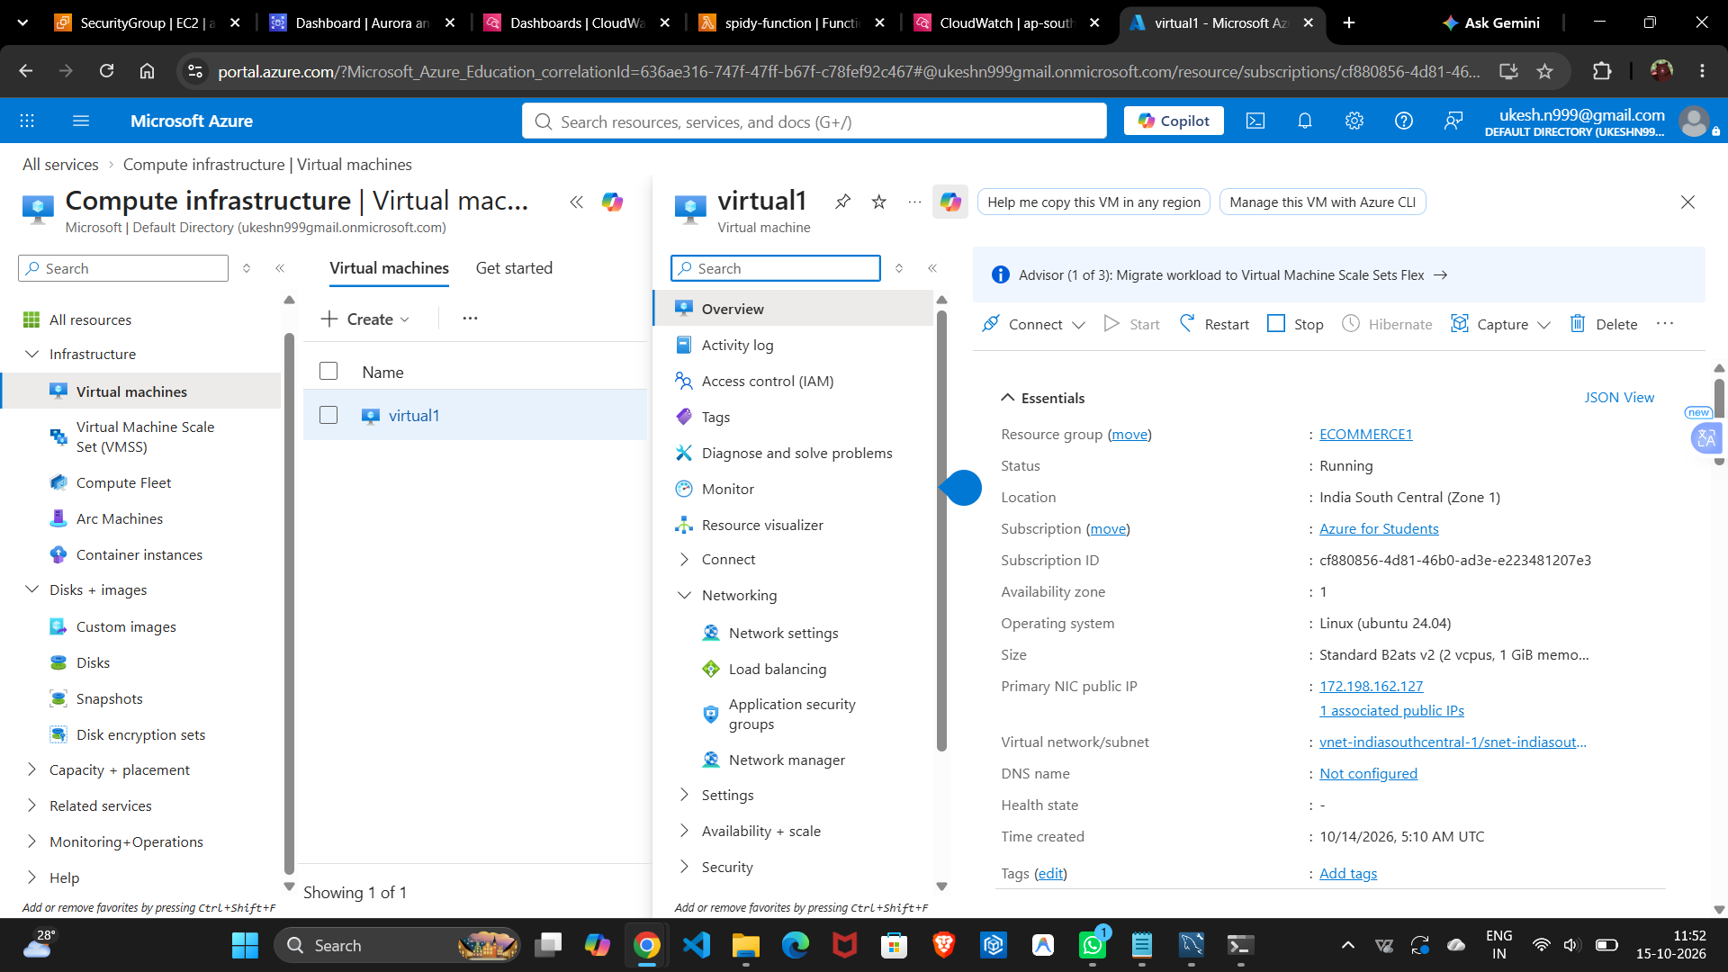
Figure 5.1: Azure portal virtual machine / resource view
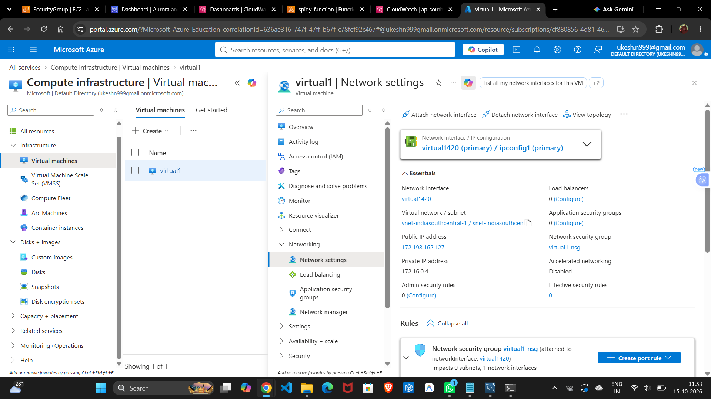
Figure 5.2: Azure virtual machine configuration
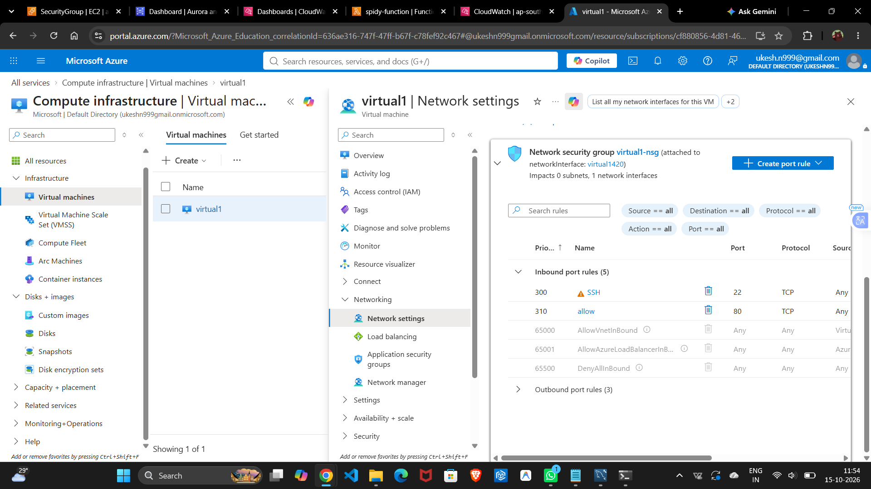
Figure 5.3: Azure networking and security configuration

