N UKESH REDDY
USN: 23BTRCT091
HCL ID: HCLTFP2264810
DEPARTMENT: CSE

SECTION A — ADVANCED SQL

Question 1: Database Design and Advanced Queries
Question / Task: Use SQL joins to display employee, department and manager names; find employees earning above their department average; and identify the second-highest salary.
Answer:
- Use primary and foreign keys to represent relationships between employees, departments and managers.
- Use INNER JOIN or LEFT JOIN according to whether unmatched rows should be retained.
- Use a correlated subquery or a department-wise AVG() subquery to compare each employee’s salary with the department average.
- Find the second-highest distinct salary using DENSE_RANK() or by selecting the maximum salary below the maximum salary.
1(a) Screenshot — joins / employee details
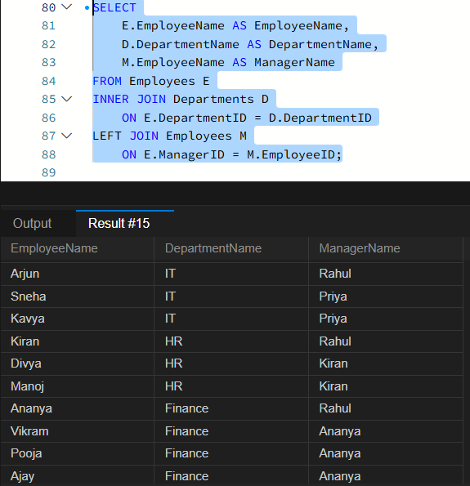
1(b) Screenshot — salary query output
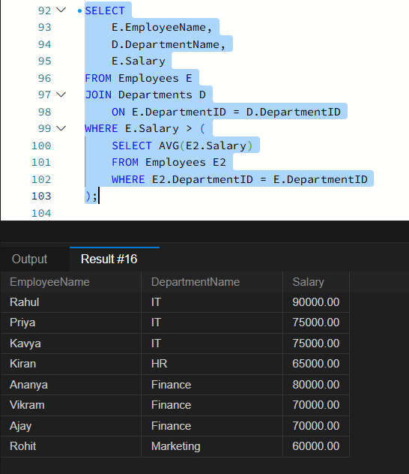
1(c) Screenshot — additional SQL output
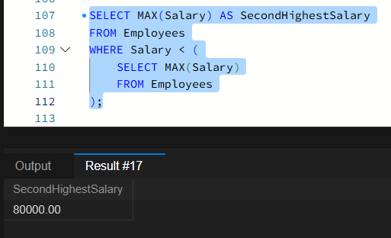

Question 2: Sales Analytics and Query Optimization
Question / Task: Calculate product revenue, monthly revenue and month-over-month growth, and explain query optimization.
Answer:
- Calculate item revenue as quantity multiplied by unit price, then use SUM() to calculate total revenue.
- Group results by product to calculate revenue by product.
- Group transaction dates by year and month to calculate monthly revenue.
- Compare monthly revenue with the previous month using LAG(); calculate percentage change only when the previous value is non-zero.
- Use execution plans and appropriate indexes to identify and reduce expensive scans and joins.
2(a) Screenshot — sales query output
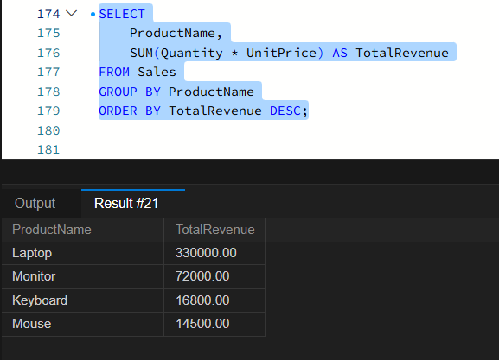
2(b) Screenshot — analytics result
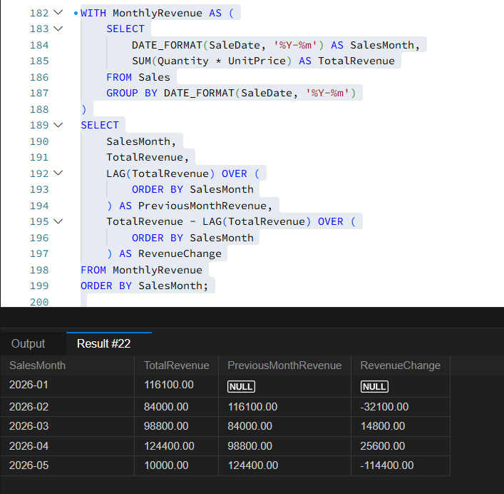

Question 3: SQL Troubleshooting
Question / Task: Use execution plans and indexing to improve a query, and identify duplicate customer email addresses.
Answer:
- Inspect the execution plan for table scans, expensive joins, sorts and inaccurate row estimates.
- For frequent filters on DepartmentID and Salary, evaluate a composite index on (DepartmentID, Salary).
- Identify duplicate email addresses using GROUP BY Email and HAVING COUNT(*) > 1.
- Compare query performance before and after changes to confirm that optimization helped.
3(a) Screenshot — SQL records / query
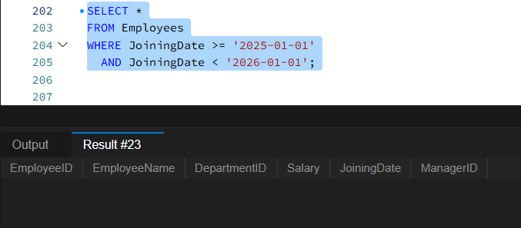
3(b) Screenshot — query output
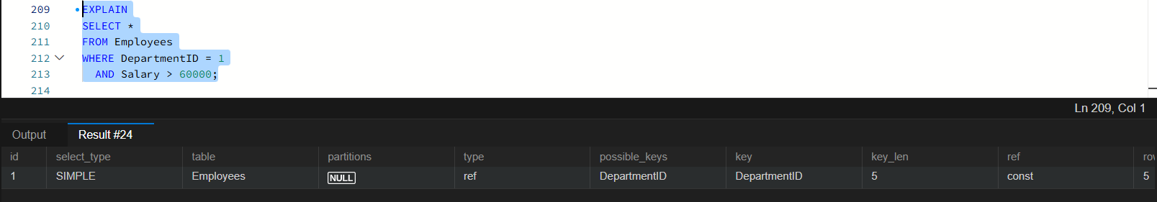
3(c) Screenshot — duplicate check
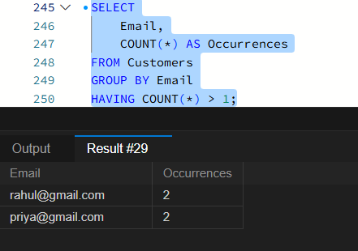

SECTION B — LINUX

Question 4: Log Analysis
Question / Task: Search logs for errors, show the last 20 error entries, count errors, and extract errors for a specified date.
Answer:
- Use grep 'ERROR' filename to locate error entries.
- Use tail -n 20 filename | grep 'ERROR' to filter the last 20 lines.
- Use grep -c 'ERROR' filename to count matching lines.
- Redirect date-matched error lines to an output file for later review.
4(a) Screenshot — log-analysis commands
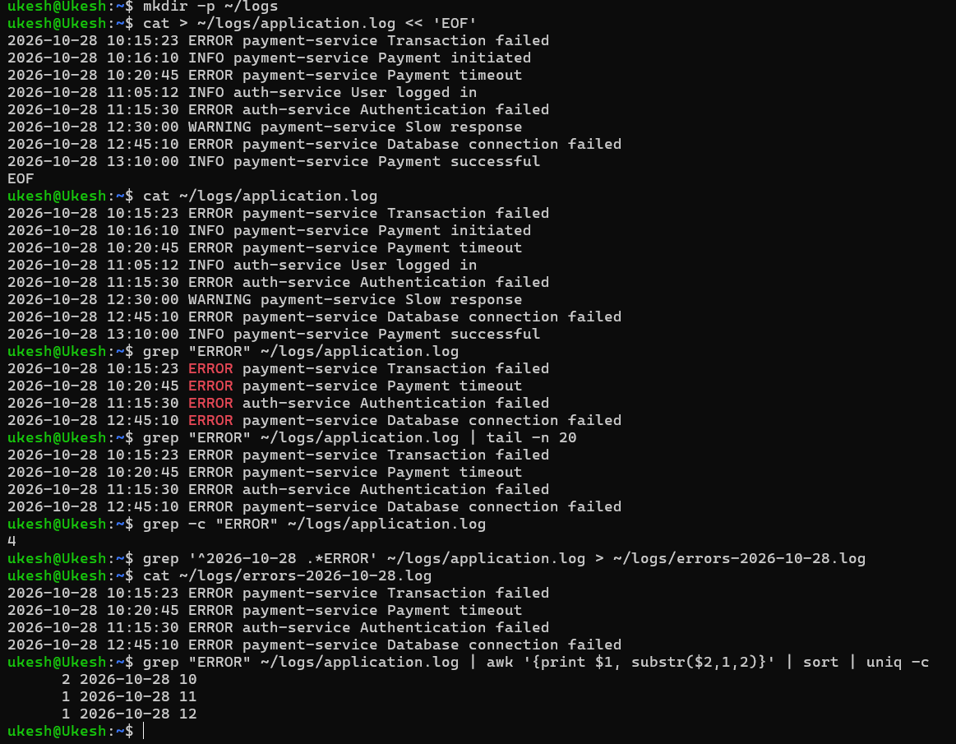

Question 5: Permissions and System Troubleshooting
Question / Task: Set group permissions and inspect CPU, memory, disk usage and large files.
Answer:
- Use groupadd and chgrp to create a group and assign a file to it.
- Use chmod 640 to grant the owner read/write, the group read-only, and others no access.
- Use ps or top to identify CPU-intensive processes.
- Use free -h and df -h to inspect memory and filesystem usage.
- Use find with a size condition to locate large files.
5(a) Screenshot — permissions / system checks
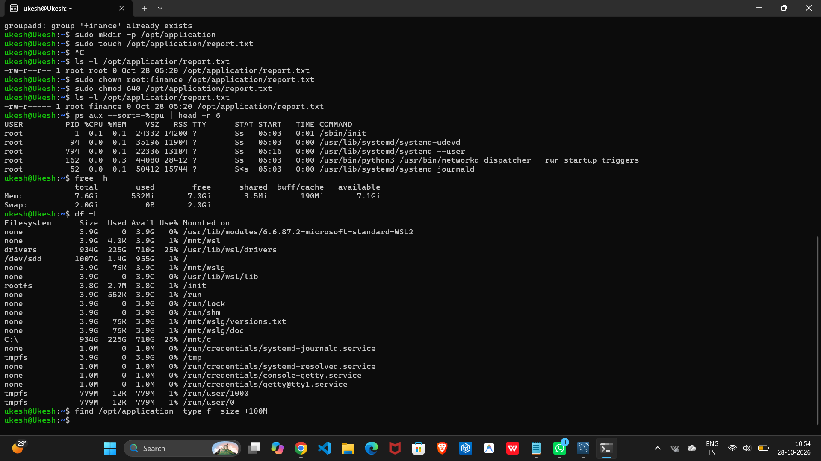

Question 6: Bash Scripting
Question / Task: Write a backup script that validates input, checks the source directory, creates a timestamped compressed archive and reports success or failure.
Answer:
- Check the number of command-line arguments before starting.
- Confirm that the source directory exists and create the backup destination when needed.
- Include a timestamp in the archive filename to avoid overwriting older backups.
- Use tar with compression to create the archive.
- Check the command exit status and print a clear success or error message.
6(a) Screenshot — backup script execution
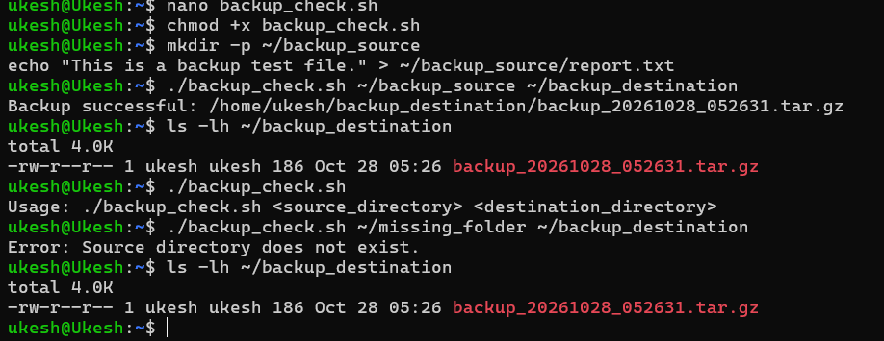

SECTION C — PYSPARK DATA ENGINEERING

Question 7: PySpark DataFrame Operations
Theory:
- PySpark is the Python API for Apache Spark and supports distributed processing of large datasets.
- A DataFrame stores data in named columns with defined data types.
- printSchema() displays the schema; show(5) displays the first five rows.
- filter() selects rows matching a condition, withColumn() creates or updates a column, and groupBy() with agg() calculates grouped summaries.

7(a): Define the schema and display the first five records.
Question / Task: Create a DataFrame with EmployeeID, EmployeeName, Department, Salary and JoiningDate, then display the schema and first five rows.
Answer:
- An explicit schema defines column names and types and helps ensure consistent data handling.
- The output confirms the DataFrame loaded and displays five sample records.
7(a) Screenshot
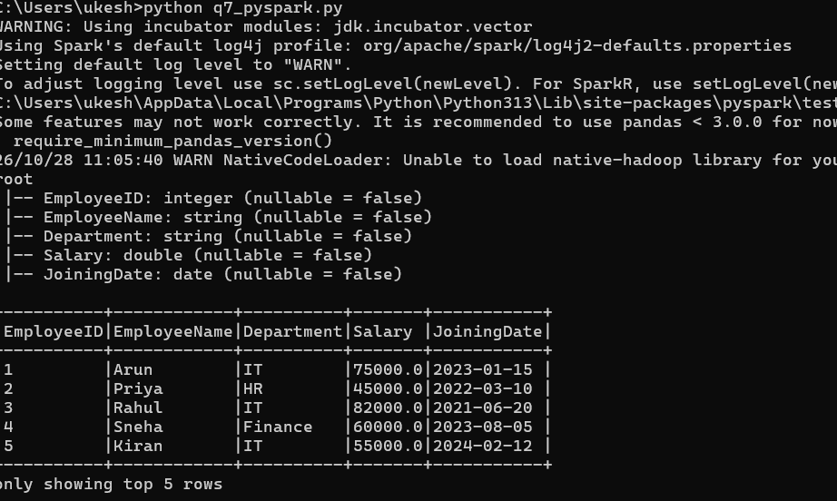

7(b): Filter employee records by salary.
Question / Task: Display only employees whose salary satisfies the specified condition.
Answer:
- filter() or where() applies a Boolean condition to return matching rows.
- The output should contain only records that meet the salary condition.
7(b) Screenshot
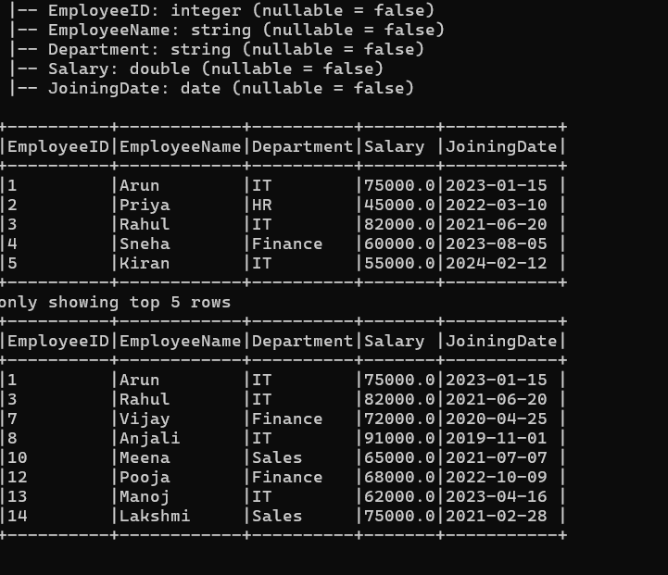

7(c): Calculate annual salary.
Question / Task: Add an AnnualSalary column based on monthly Salary.
Answer:
- Use withColumn('AnnualSalary', col('Salary') * 12) to calculate annual salary.
- The new column is added while the original DataFrame columns are retained.
7(c) Screenshot
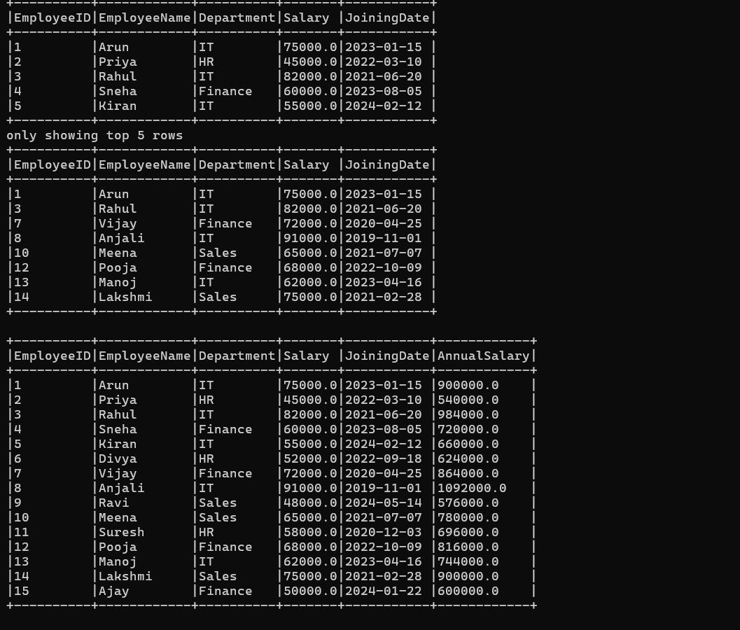

7(d): Department-wise summary.
Question / Task: Group employees by Department and calculate average salary and employee count.
Answer:
- Use groupBy('Department') followed by agg() with avg('Salary') and count('*').
- The output compares average salary and employee count across departments.
7(d) Screenshot
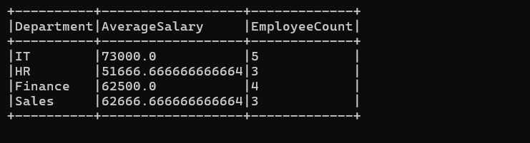

Question 8: Data Cleaning and Aggregation
- Read the CSV with header enabled and define appropriate column types.
- Remove duplicate transactions using a suitable transaction identifier.
- Handle missing required values by removing invalid rows or applying a justified replacement rule.
- Use groupBy() and aggregate functions to summarize cleaned data.

Question 9: PySpark Joins and Performance
- Join Customers and Orders on CustomerID to combine customer and order details.
- Use a left anti join to find customers without matching orders.
- A broadcast join can improve performance when one input is small enough to fit in executor memory.
- Spark transformations are lazy; actions such as show(), count() and write trigger execution.

SECTION D — AWS CLOUD SERVICES

Question 10: S3 and IAM Security
Question / Task: Create a private S3 bucket, upload a sample report, apply least-privilege access and verify that unauthorized access is denied.
Answer:
- Enable S3 Block Public Access and keep the bucket private.
- Enable server-side encryption for stored objects.
- Use an IAM policy scoped to the required bucket or object actions only.
- Test with a principal without permission and confirm the request is denied; review access settings and logs.
10(a) Screenshot — S3 bucket/file upload
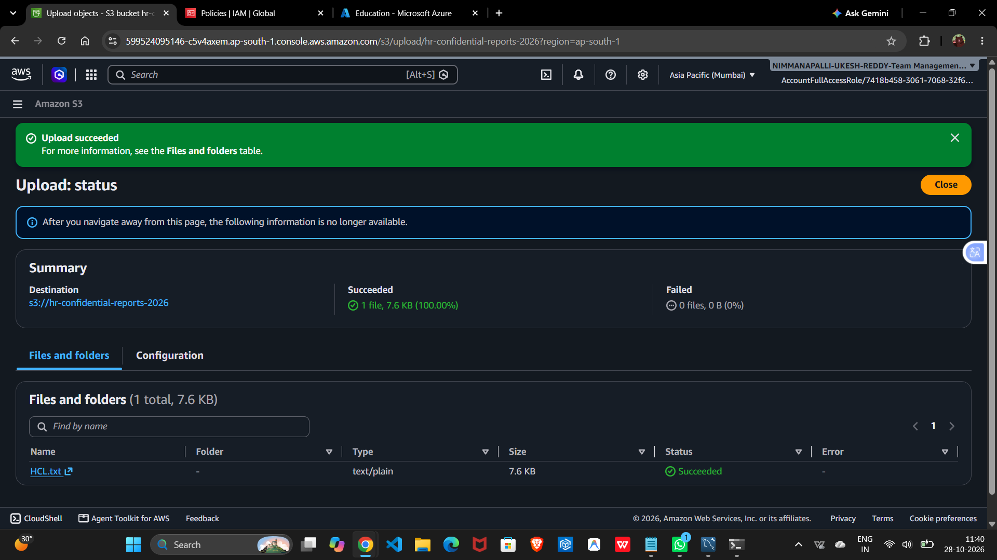

Question 11: EC2 Troubleshooting and CloudWatch
Question / Task: Troubleshoot an EC2 instance and configure CloudWatch monitoring for CPU utilization above 85%.
Answer:
- Check the EC2 instance state and both system and instance status checks.
- Review security-group rules, network ACLs, subnet route tables and the correct connection address.
- Use instance/system logs or boot diagnostics to investigate startup or connectivity problems.
- In CloudWatch, select the EC2 CPUUtilization metric and create an alarm with a threshold greater than 85%.
- Set the statistic and period (for example, five minutes), configure evaluation periods, and add an alarm action if required.
- Check the alarm state and metric graph to verify monitoring.
11(b) Screenshot — CloudWatch alarm
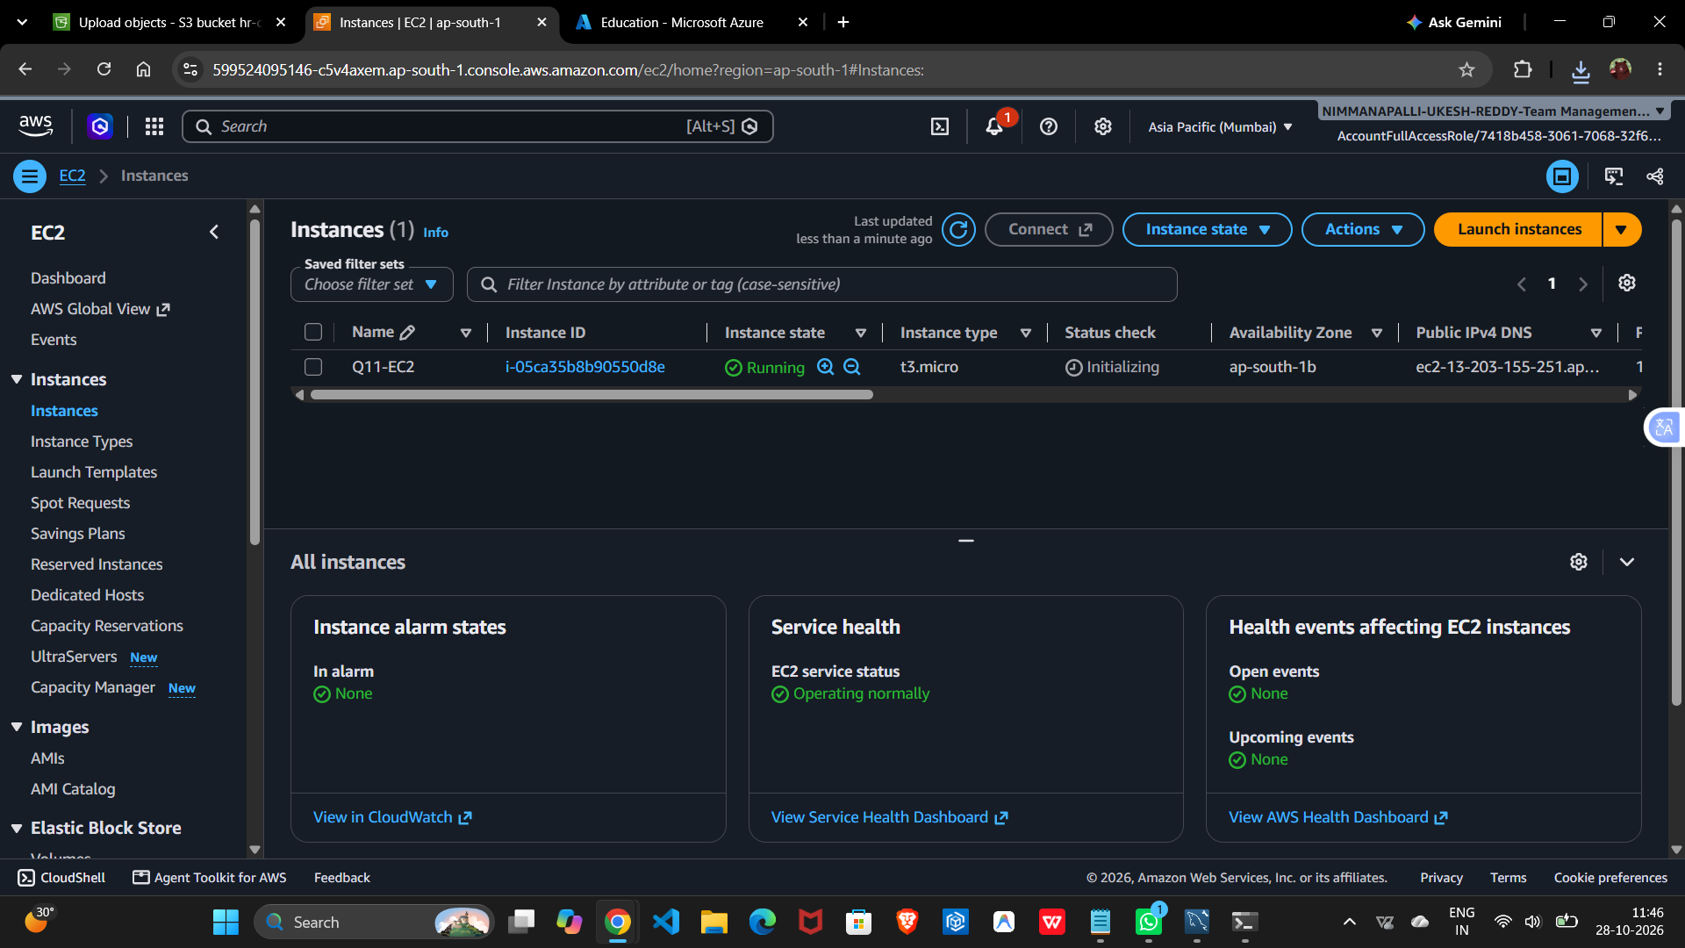
11(c) Screenshot — CloudWatch / monitoring evidence
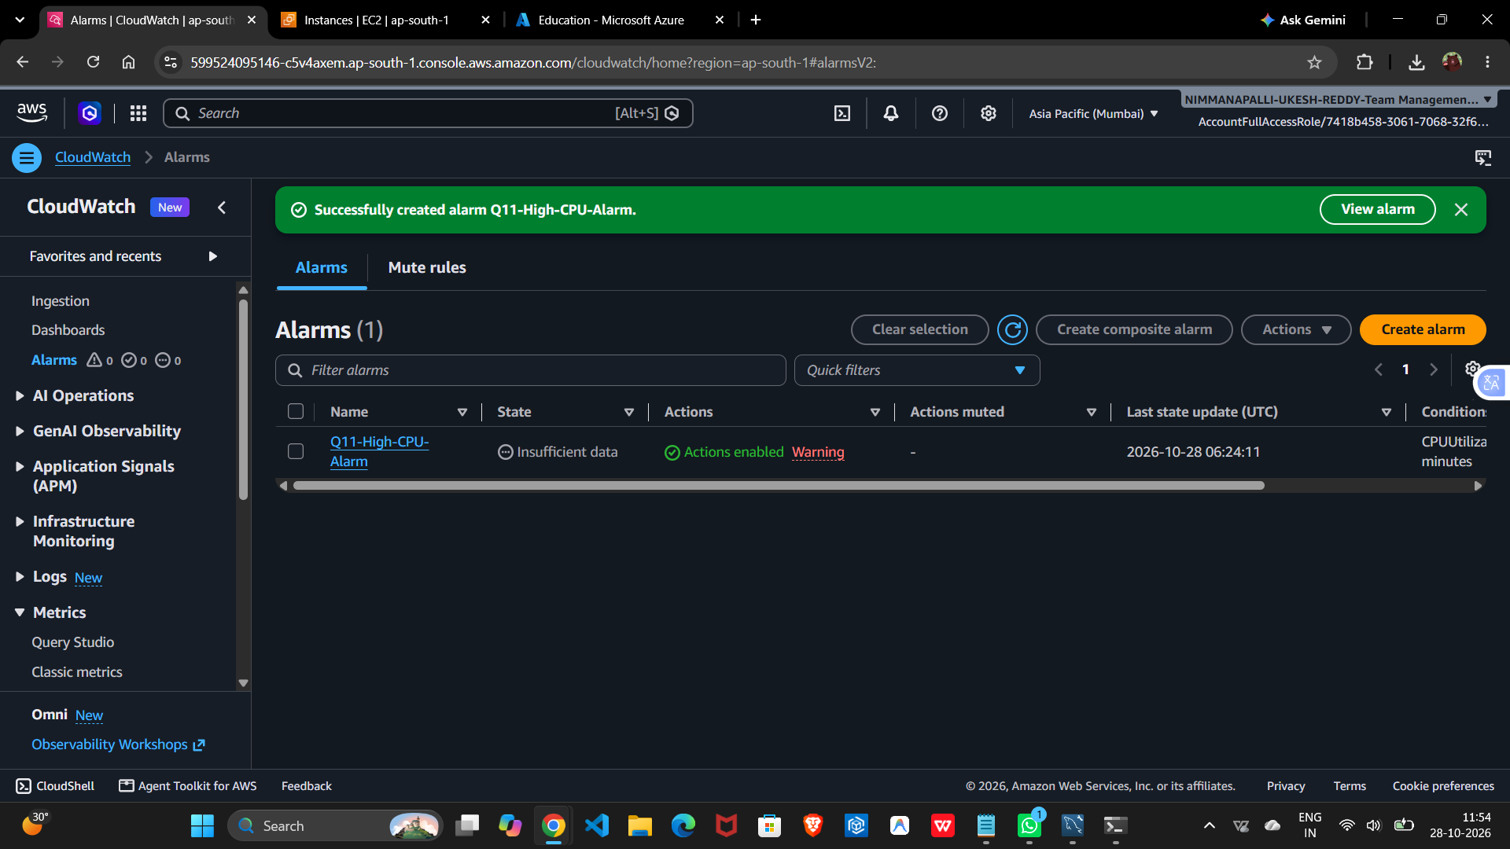

Question 12: Event-Driven Processing
Question / Task: Use Lambda to process a CSV uploaded to S3 and configure an S3 ObjectCreated event to invoke the function.
Answer:
- Create a Lambda function to validate and process the uploaded CSV.
- Configure an S3 ObjectCreated trigger for the input bucket and relevant object prefix/suffix.
- Grant the Lambda execution role only the permissions required to read the input and write results or logs.
- Use CloudWatch Logs to inspect execution and errors.
12(a) Screenshot — Lambda / trigger
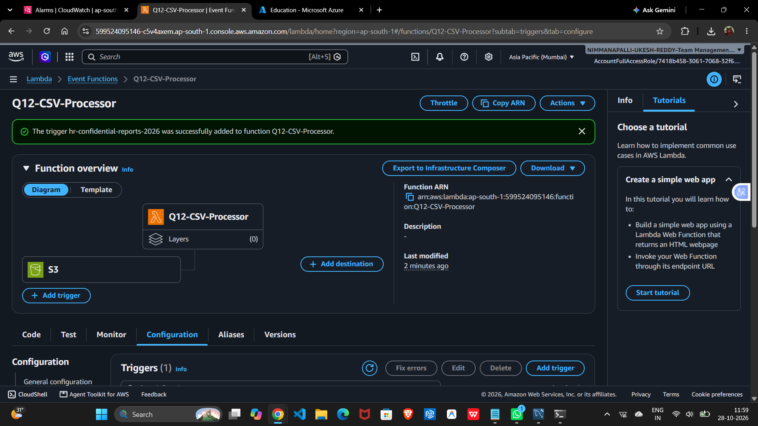
12(b) Screenshot — execution evidence
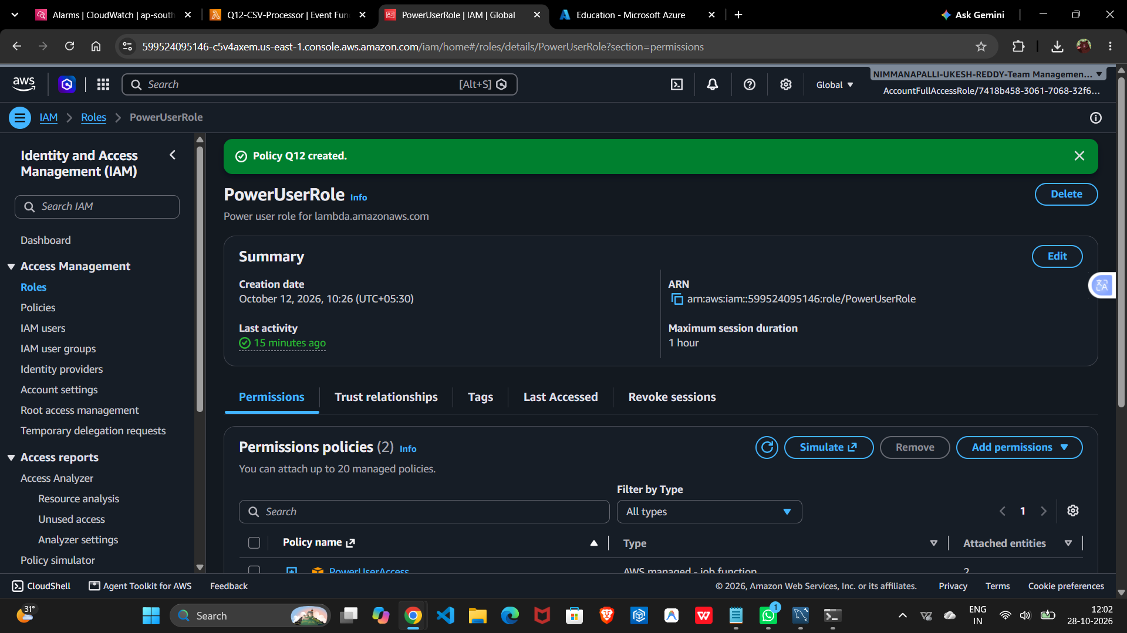

SECTION E — AWS STEP FUNCTIONS

Question 13: State Machine Design
Question / Task: Design a workflow that validates input, transforms data, calculates sales, stores results and sends a notification.
Answer:
- Use a Choice state to route valid and invalid input.
- Connect transformation, calculation, storage and notification states in the required order.
- Route invalid input to a failure or handling state.
- Use Retry for transient errors and Catch to route failures to a recovery or logging state.
13(a) Screenshot — state machine
13(b) Screenshot — workflow execution
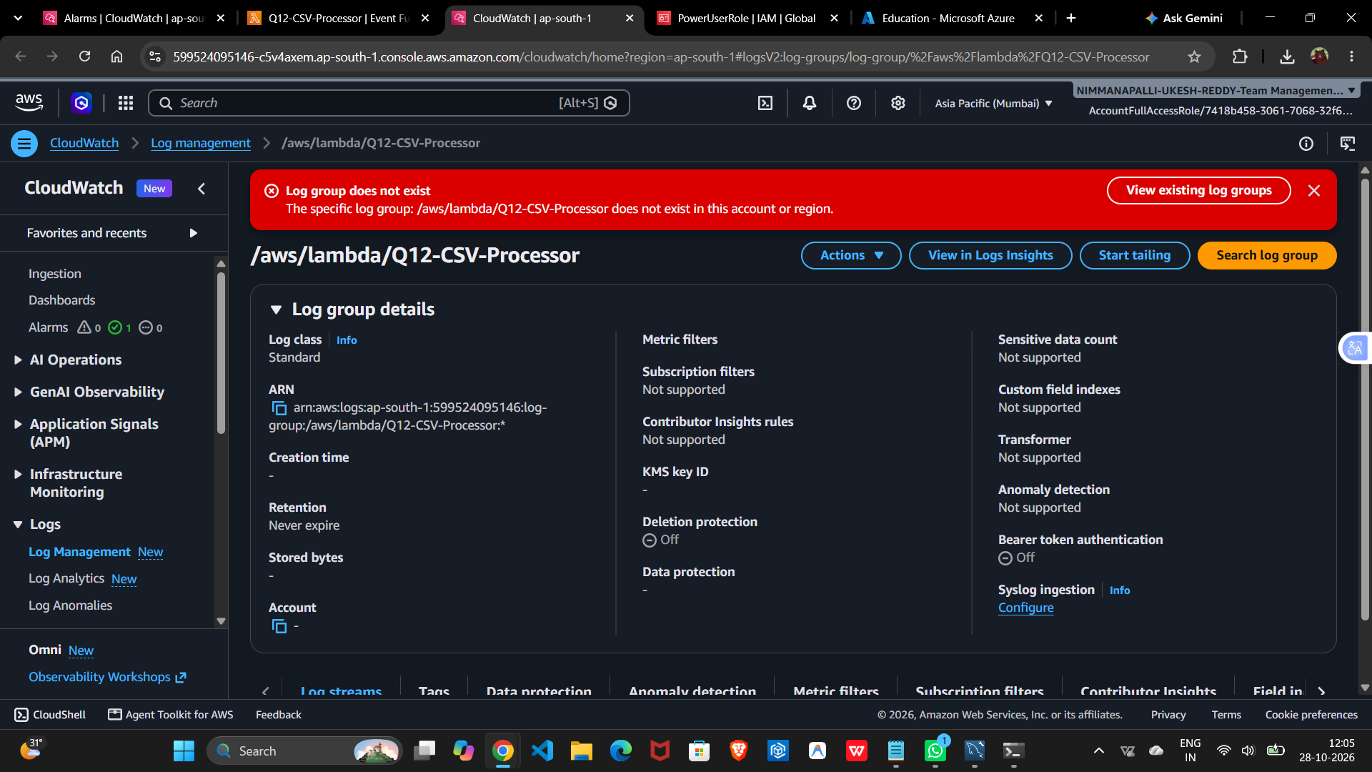

Question 14: Step Functions Implementation
Question / Task: Implement ValidateFile → TransformData → LoadResults, with invalid input rejected and error handling configured.
Answer:
- Use a Choice state to check the validation flag and route invalid files to a Fail state.
- Configure Retry on TransformData for transient failures.
- Configure Catch on LoadResults to route errors to a recovery/logging state.
- Use ResultPath or the state input/output contract to preserve needed data between states.
14(a) Screenshot — state machine implementation
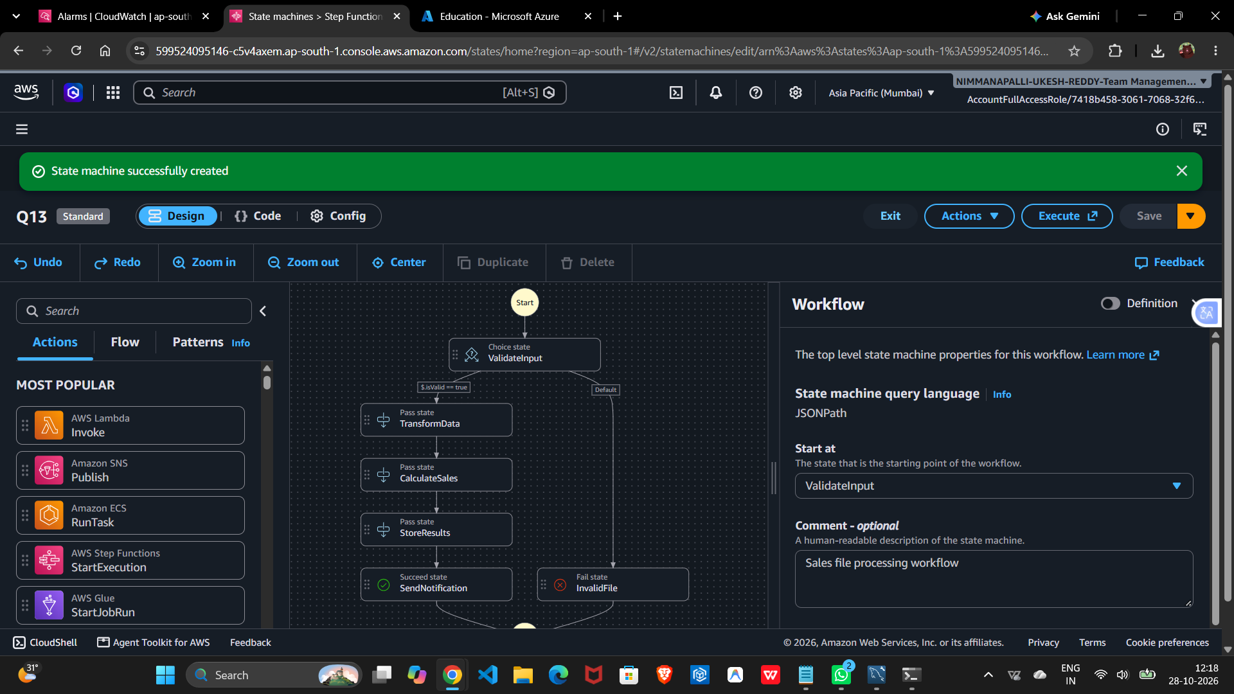
14(b) Screenshot — execution/error path
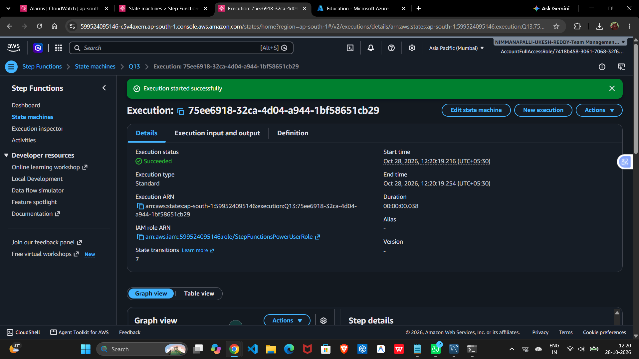

SECTION F — MICROSOFT AZURE

Question 15: Azure Data Lake Storage and Security
Question / Task: Configure Azure Data Lake Storage Gen2, upload a dataset, manage access using Microsoft Entra ID and RBAC, and verify unauthorized access is denied.
Answer:
- Create a storage account with hierarchical namespace enabled.
- Create a private container/filesystem and upload the sample dataset.
- Microsoft Entra ID identifies users and groups; Azure RBAC assigns data roles such as Storage Blob Data Reader at an appropriate scope.
- Grant only the permissions needed and avoid anonymous/public access.
- Verify access using an authorized account and confirm an unauthorized account cannot read the dataset.
15(a) Screenshot — storage / container
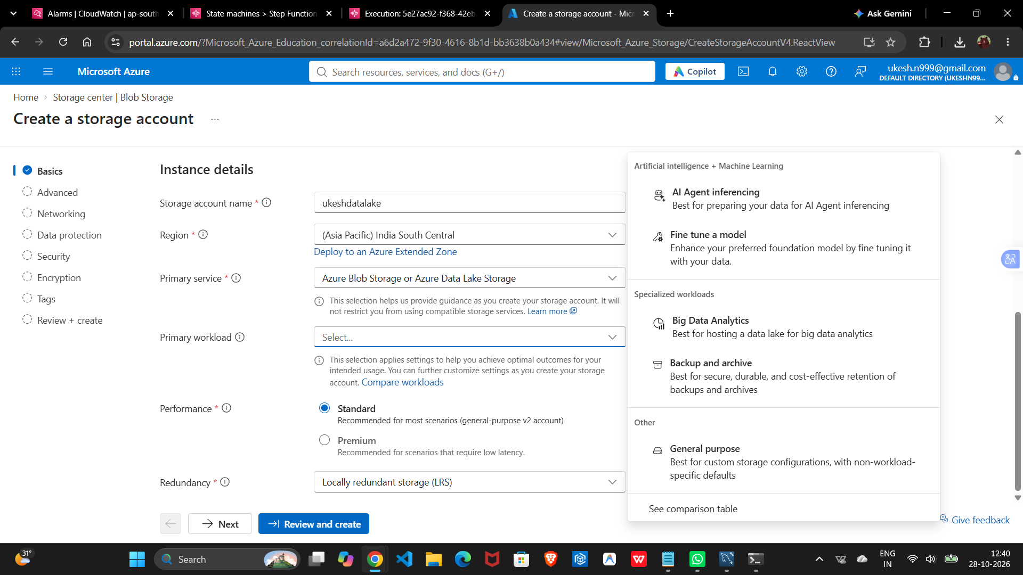
15(b) Screenshot — uploaded dataset
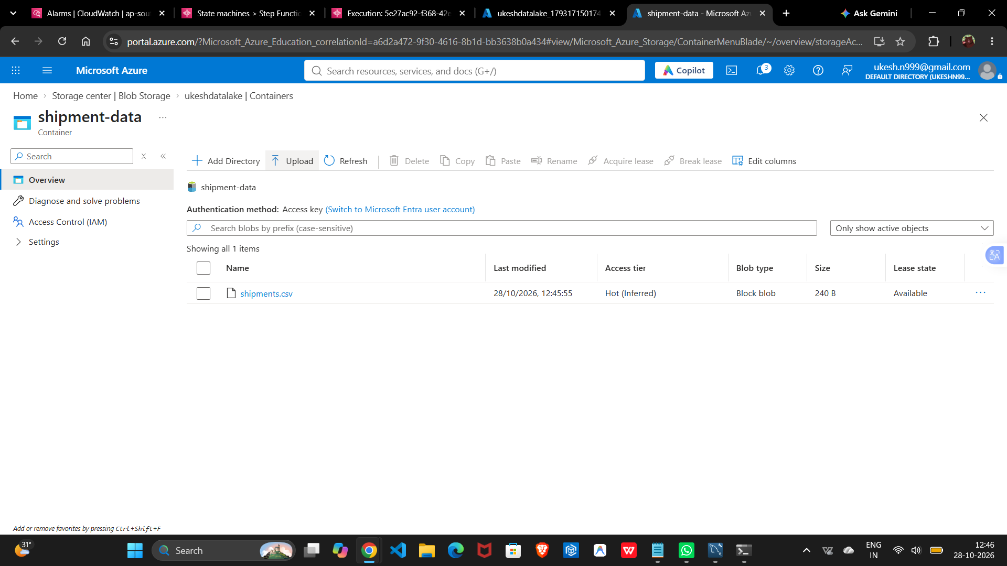

Question 16: Azure VM Troubleshooting
Question / Task: Verify VM provisioning and power state, inspect networking and troubleshoot securely without exposing the VM publicly.
Answer:
- Check the VM Overview for provisioning state, power state and status checks.
- Review boot diagnostics and VM logs if startup fails.
- Inspect Network Security Group rules, subnet routing and Network Watcher diagnostics.
- Use Azure Bastion or another approved private access path instead of exposing management ports publicly.
- Restrict any temporary rule to the required source and remove it after troubleshooting.

Question 17: Azure Data Integration
Question / Task: Use Azure Data Factory to copy a CSV into ADLS Gen2, organize output by ingestion date, handle malformed/missing values, monitor the pipeline and validate completeness.
Answer:
- Create linked services for the source and ADLS Gen2 destination.
- Create source and sink datasets and configure a Copy Data activity in a pipeline.
- Use a date-based folder path or dynamic expression to organize ingested files by ingestion date.
- Configure fault-tolerant handling for incompatible rows where appropriate and define a policy for missing values.
- Publish and run the pipeline, monitor activity output, and validate that the expected records/files arrived.
17(a) Screenshot — Data Factory pipeline/dataset
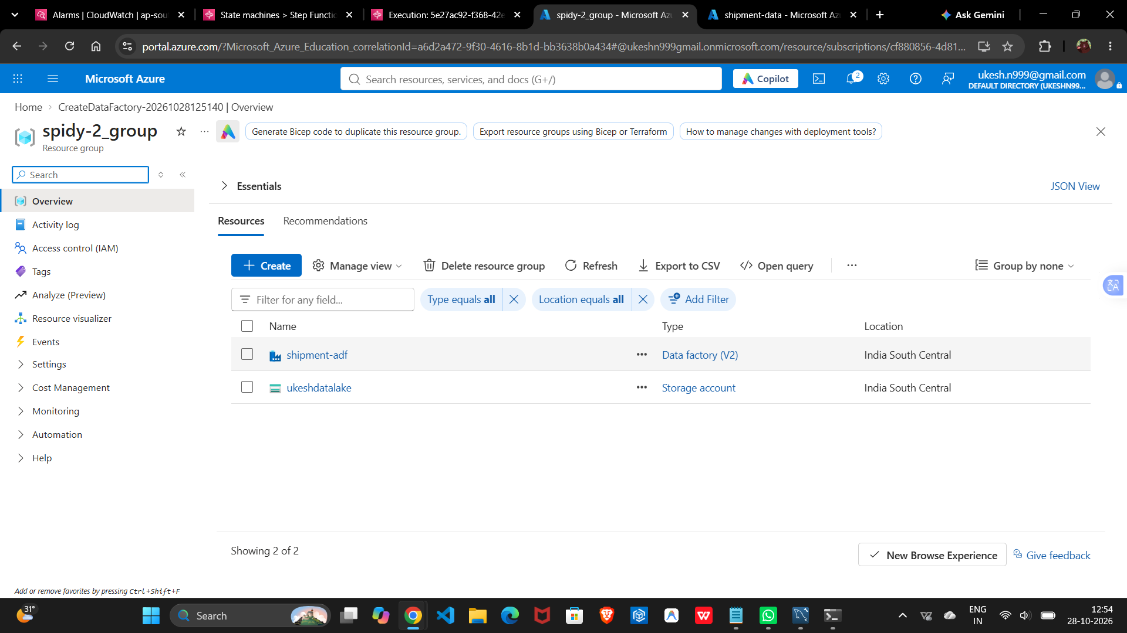
17(b) Screenshot — validation/run evidence
