Assignment 2

Task

1. Create Jenkin master
2. Configure Git
3. Configure Maven
4. Using SCM clone git repository
5. Using Maven Build the project
6. After building the project deploy it

Jenkin master is created

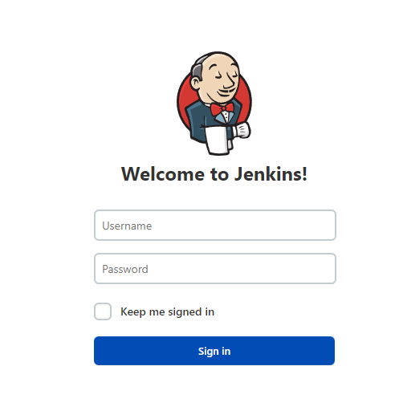

2.configure Git

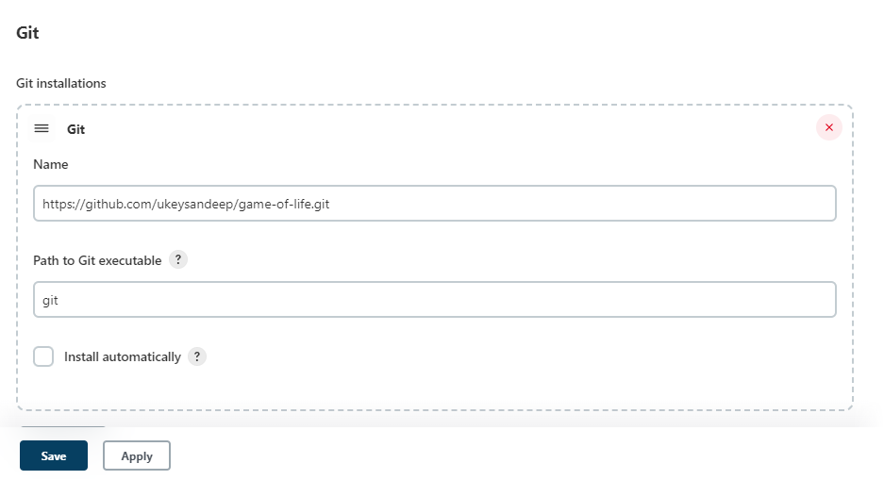

Above configuration of git will allow us to clone mentioned repository to our cutome workspace

Configure Maven

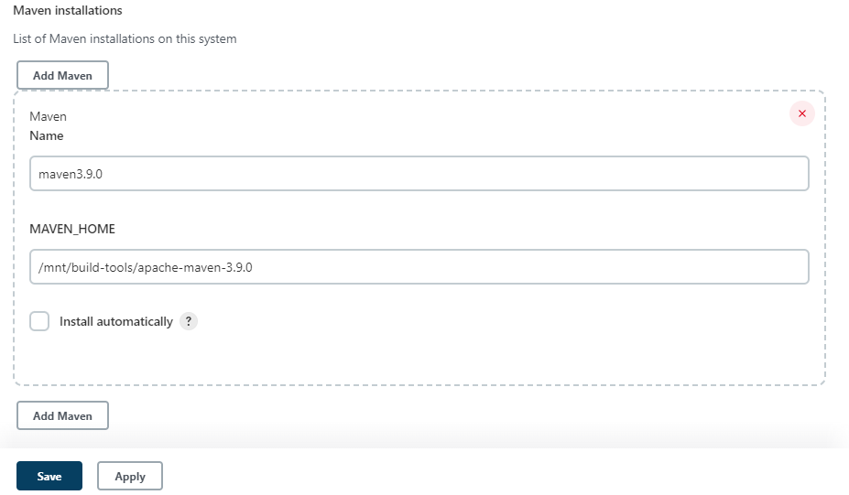

Above maven configuration allow us to use this mavne version to build the project

Now create new project

Set Discard old builds and custom working directory 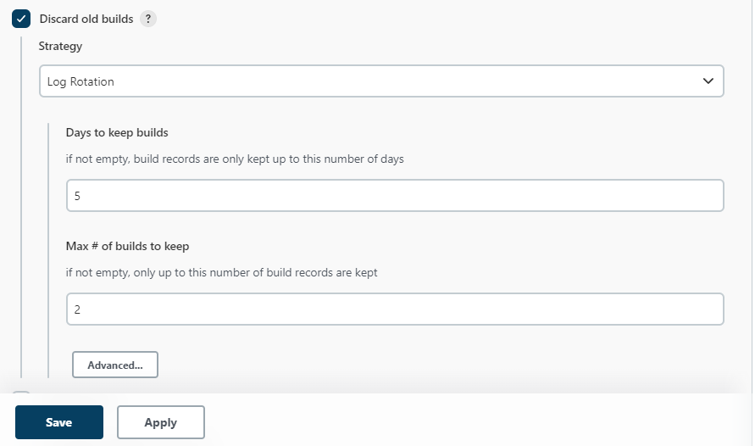

Set Git repositories

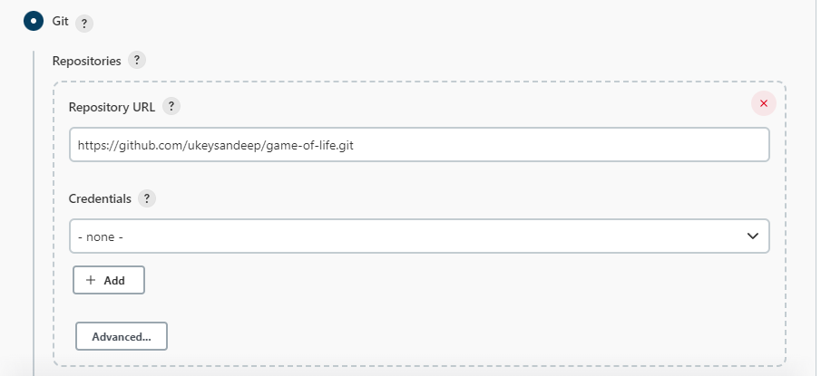

Set Maven version for building project

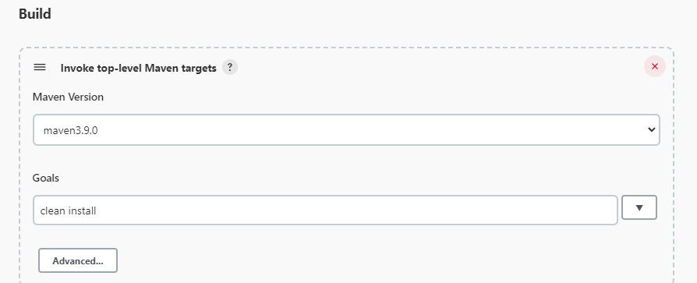

After doing all this you will be set to build the software

Now click on build now

Below is the console output of above Task

----------------------------------------------------------------------------------------------------

Started by user [sandeep](http://13.233.130.212:8080/jenkins/user/sandeep)

Running as SYSTEM

Building in workspace /root/.jenkins/workspace/test-1

[WS-CLEANUP] Deleting project workspace...

[WS-CLEANUP] Deferred wipeout is used...

The recommended git tool is: NONE

No credentials specified

Cloning the remote Git repository

Cloning repository <https://github.com/ukeysandeep/game-of-life.git>

> git init /root/.jenkins/workspace/test-1 # timeout=10

Fetching upstream changes from <https://github.com/ukeysandeep/game-of-life.git>

> git --version # timeout=10

> git --version # 'git version 2.39.1'

> git fetch --tags --force --progress -- <https://github.com/ukeysandeep/game-of-life.git> +refs/heads/*:refs/remotes/origin/* # timeout=10

> git config remote.origin.url <https://github.com/ukeysandeep/game-of-life.git> # timeout=10

> git config --add remote.origin.fetch +refs/heads/*:refs/remotes/origin/* # timeout=10

Avoid second fetch

> git rev-parse refs/remotes/origin/master^{commit} # timeout=10

Checking out Revision f6da974ac6a7766d70944b7cb36cf39078283866 (refs/remotes/origin/master)

> git config core.sparsecheckout # timeout=10

> git checkout -f f6da974ac6a7766d70944b7cb36cf39078283866 # timeout=10

Commit message: "Update pom.xml"

First time build. Skipping changelog.

[test-1] $ /mnt/build-tools/apache-maven-3.9.0/bin/mvn clean install

[INFO] Scanning for projects...

**[WARNING]**

**[WARNING] Some problems were encountered while building the effective model for com.wakaleo.gameoflife:gameoflife-build:jar:1.0-SNAPSHOT**

**[WARNING] Reporting configuration should be done in <reporting> section, not in maven-site-plugin <configuration> as reportPlugins parameter.**

**[WARNING]**

**[WARNING] Some problems were encountered while building the effective model for com.wakaleo.gameoflife:gameoflife-core:jar:1.0-SNAPSHOT**

**[WARNING] Reporting configuration should be done in <reporting> section, not in maven-site-plugin <configuration> as reportPlugins parameter.**

**[WARNING]**

**[WARNING] Some problems were encountered while building the effective model for com.wakaleo.gameoflife:gameoflife-web:war:1.0-SNAPSHOT**

**[WARNING] Reporting configuration should be done in <reporting> section, not in maven-site-plugin <configuration> as reportPlugins parameter.**

**[WARNING]**

**[WARNING] Some problems were encountered while building the effective model for com.wakaleo.gameoflife:gameoflife:pom:1.0-SNAPSHOT**

**[WARNING] Reporting configuration should be done in <reporting> section, not in maven-site-plugin <configuration> as reportPlugins parameter. @ line 302, column 40**

**[WARNING]**

**[WARNING] It is highly recommended to fix these problems because they threaten the stability of your build.**

**[WARNING]**

**[WARNING] For this reason, future Maven versions might no longer support building such malformed projects.**

**[WARNING]**

[INFO] ------------------------------------------------------------------------

[INFO] Reactor Build Order:

[INFO]

[INFO] gameoflife [pom]

[INFO] gameoflife-build [jar]

[INFO] gameoflife-core [jar]

[INFO] gameoflife-web [war]

[INFO]

[INFO] -----------------< com.wakaleo.gameoflife:gameoflife >------------------

[INFO] Building gameoflife 1.0-SNAPSHOT [1/4]

[INFO] from pom.xml

[INFO] --------------------------------[ pom ]---------------------------------

[INFO]

[INFO] --- clean:3.2.0:clean (default-clean) @ gameoflife ---

[INFO]

[INFO] --- enforcer:1.0:enforce (enforce-versions) @ gameoflife ---

[INFO]

[INFO] --- jacoco:0.7.2.201409121644:prepare-agent (jacoco-initialize) @ gameoflife ---

[INFO] argLine set to -javaagent:/root/.m2/repository/org/jacoco/org.jacoco.agent/0.7.2.201409121644/org.jacoco.agent-0.7.2.201409121644-runtime.jar=destfile=/root/.jenkins/workspace/test-1/target/jacoco.exec

[INFO]

[INFO] --- surefire:2.11:test (unit-tests) @ gameoflife ---

[INFO] No tests to run.

[INFO] Surefire report directory: /root/.jenkins/workspace/test-1/target/surefire-reports

-------------------------------------------------------

T E S T S

-------------------------------------------------------

Results :

Tests run: 0, Failures: 0, Errors: 0, Skipped: 0

[INFO]

[INFO] --- easyb:1.4:test (default) @ gameoflife ---

[INFO] /root/.jenkins/workspace/test-1/src/test/stories does not exists. Skipping easyb testing

[INFO]

[INFO] --- surefire:2.11:test (integration-tests) @ gameoflife ---

[INFO] No tests to run.

[INFO] Surefire report directory: /root/.jenkins/workspace/test-1/target/surefire-reports

-------------------------------------------------------

T E S T S

-------------------------------------------------------

Results :

Tests run: 0, Failures: 0, Errors: 0, Skipped: 0

[INFO]

[INFO] --- jacoco:0.7.2.201409121644:report (jacoco-site) @ gameoflife ---

[INFO] Skipping JaCoCo execution due to missing classes directory:/root/.jenkins/workspace/test-1/target/classes

[INFO]

[INFO] --- install:3.1.0:install (default-install) @ gameoflife ---

[INFO] Installing /root/.jenkins/workspace/test-1/pom.xml to /root/.m2/repository/com/wakaleo/gameoflife/gameoflife/1.0-SNAPSHOT/gameoflife-1.0-SNAPSHOT.pom

[INFO]

[INFO] --------------< com.wakaleo.gameoflife:gameoflife-build >---------------

[INFO] Building gameoflife-build 1.0-SNAPSHOT [2/4]

[INFO] from gameoflife-build/pom.xml

[INFO] --------------------------------[ jar ]---------------------------------

[INFO]

[INFO] --- clean:3.2.0:clean (default-clean) @ gameoflife-build ---

[INFO]

[INFO] --- enforcer:1.0:enforce (enforce-versions) @ gameoflife-build ---

[INFO]

[INFO] --- resources:3.3.0:resources (default-resources) @ gameoflife-build ---

[INFO] Copying 2 resources

[INFO]

[INFO] --- jacoco:0.7.2.201409121644:prepare-agent (jacoco-initialize) @ gameoflife-build ---

[INFO] argLine set to -javaagent:/root/.m2/repository/org/jacoco/org.jacoco.agent/0.7.2.201409121644/org.jacoco.agent-0.7.2.201409121644-runtime.jar=destfile=/root/.jenkins/workspace/test-1/gameoflife-build/target/jacoco.exec

[INFO]

[INFO] --- compiler:3.1:compile (default-compile) @ gameoflife-build ---

[INFO] No sources to compile

[INFO]

[INFO] --- resources:3.3.0:testResources (default-testResources) @ gameoflife-build ---

[INFO] skip non existing resourceDirectory /root/.jenkins/workspace/test-1/gameoflife-build/src/test/resources

[INFO]

[INFO] --- compiler:3.1:testCompile (default-testCompile) @ gameoflife-build ---

[INFO] No sources to compile

[INFO]

[INFO] --- surefire:2.11:test (default-test) @ gameoflife-build ---

[INFO] Tests are skipped.

[INFO]

[INFO] --- surefire:2.11:test (unit-tests) @ gameoflife-build ---

[INFO] No tests to run.

[INFO] Surefire report directory: /root/.jenkins/workspace/test-1/gameoflife-build/target/surefire-reports

-------------------------------------------------------

T E S T S

-------------------------------------------------------

Results :

Tests run: 0, Failures: 0, Errors: 0, Skipped: 0

[INFO]

[INFO] --- easyb:1.4:test (default) @ gameoflife-build ---

[INFO] /root/.jenkins/workspace/test-1/gameoflife-build/src/test/stories does not exists. Skipping easyb testing

[INFO]

[INFO] --- jar:3.3.0:jar (default-jar) @ gameoflife-build ---

[INFO] Building jar: /root/.jenkins/workspace/test-1/gameoflife-build/target/gameoflife-build-1.0-SNAPSHOT.jar

[INFO]

[INFO] --- surefire:2.11:test (integration-tests) @ gameoflife-build ---

[INFO] No tests to run.

[INFO] Surefire report directory: /root/.jenkins/workspace/test-1/gameoflife-build/target/surefire-reports

-------------------------------------------------------

T E S T S

-------------------------------------------------------

Results :

Tests run: 0, Failures: 0, Errors: 0, Skipped: 0

[INFO]

[INFO] --- jacoco:0.7.2.201409121644:report (jacoco-site) @ gameoflife-build ---

[INFO] Analyzed bundle 'gameoflife-build' with 0 classes

[INFO]

[INFO] --- install:3.1.0:install (default-install) @ gameoflife-build ---

[INFO] Installing /root/.jenkins/workspace/test-1/gameoflife-build/pom.xml to /root/.m2/repository/com/wakaleo/gameoflife/gameoflife-build/1.0-SNAPSHOT/gameoflife-build-1.0-SNAPSHOT.pom

[INFO] Installing /root/.jenkins/workspace/test-1/gameoflife-build/target/gameoflife-build-1.0-SNAPSHOT.jar to /root/.m2/repository/com/wakaleo/gameoflife/gameoflife-build/1.0-SNAPSHOT/gameoflife-build-1.0-SNAPSHOT.jar

[INFO]

[INFO] ---------------< com.wakaleo.gameoflife:gameoflife-core >---------------

[INFO] Building gameoflife-core 1.0-SNAPSHOT [3/4]

[INFO] from gameoflife-core/pom.xml

[INFO] --------------------------------[ jar ]---------------------------------

[INFO]

[INFO] --- clean:3.2.0:clean (default-clean) @ gameoflife-core ---

[INFO]

[INFO] --- enforcer:1.0:enforce (enforce-versions) @ gameoflife-core ---

[INFO]

[INFO] --- resources:3.3.0:resources (default-resources) @ gameoflife-core ---

[INFO] skip non existing resourceDirectory /root/.jenkins/workspace/test-1/gameoflife-core/src/main/resources

[INFO]

[INFO] --- jacoco:0.7.2.201409121644:prepare-agent (jacoco-initialize) @ gameoflife-core ---

[INFO] argLine set to -javaagent:/root/.m2/repository/org/jacoco/org.jacoco.agent/0.7.2.201409121644/org.jacoco.agent-0.7.2.201409121644-runtime.jar=destfile=/root/.jenkins/workspace/test-1/gameoflife-core/target/jacoco.exec

[INFO]

[INFO] --- compiler:3.1:compile (default-compile) @ gameoflife-core ---

[INFO] Changes detected - recompiling the module!

[INFO] Compiling 5 source files to /root/.jenkins/workspace/test-1/gameoflife-core/target/classes

[INFO]

[INFO] --- resources:3.3.0:testResources (default-testResources) @ gameoflife-core ---

[INFO] skip non existing resourceDirectory /root/.jenkins/workspace/test-1/gameoflife-core/src/test/resources

[INFO]

[INFO] --- compiler:3.1:testCompile (default-testCompile) @ gameoflife-core ---

[INFO] Changes detected - recompiling the module!

[INFO] Compiling 10 source files to /root/.jenkins/workspace/test-1/gameoflife-core/target/test-classes

[INFO]

[INFO] --- surefire:2.11:test (default-test) @ gameoflife-core ---

[INFO] Tests are skipped.

[INFO]

[INFO] --- surefire:2.11:test (unit-tests) @ gameoflife-core ---

[INFO] Surefire report directory: /root/.jenkins/workspace/test-1/gameoflife-core/target/surefire-reports

-------------------------------------------------------

T E S T S

-------------------------------------------------------

Running com.wakaleo.gameoflife.domain.WhenYouCreateANewUniverse

Tests run: 11, Failures: 0, Errors: 0, Skipped: 0, Time elapsed: 0.296 sec

Running com.wakaleo.gameoflife.domain.WhenYouPrintAGrid

Tests run: 3, Failures: 0, Errors: 0, Skipped: 0, Time elapsed: 0.012 sec

Running com.wakaleo.gameoflife.domain.WhenYouCreateACell

Tests run: 6, Failures: 0, Errors: 0, Skipped: 0, Time elapsed: 0.016 sec

Running com.wakaleo.gameoflife.domain.WhenYouReadAGridFromAString

Tests run: 8, Failures: 0, Errors: 0, Skipped: 0, Time elapsed: 0.024 sec

Running com.wakaleo.gameoflife.domain.WhenYouCreateAGrid

Tests run: 16, Failures: 0, Errors: 0, Skipped: 0, Time elapsed: 0.04 sec

Running com.wakaleo.gameoflife.domain.WhenYouPlayTheGameOfLife

Tests run: 5, Failures: 0, Errors: 0, Skipped: 0, Time elapsed: 0.014 sec

Results :

Tests run: 49, Failures: 0, Errors: 0, Skipped: 0

[INFO]

[INFO] --- easyb:1.4:test (default) @ gameoflife-core ---

[INFO] Using easyb dependency org.easyb:easyb-core:jar:1.6:compile

[INFO] Using easyb dependency org.easyb:easyb-composite-groovy:pom:1.2:compile

[INFO] Using easyb dependency org.codehaus.groovy:groovy-all:jar:2.3.6:compile

[INFO] Using easyb dependency org.easyb:easyb-ast:jar:1.1:compile

[INFO] Using easyb dependency commons-cli:commons-cli:jar:1.2:compile

[INFO] Using easyb dependency commons-lang:commons-lang:jar:2.5:compile

[java] Running counting things story (/root/.jenkins/workspace/test-1/gameoflife-core/src/test/stories/CountingThings.story)

[java] Scenarios run: 1, Failures: 0, Pending: 0, Time elapsed: 0.928 sec

[java] Running multiplying things story (/root/.jenkins/workspace/test-1/gameoflife-core/src/test/stories/MultiplyingThings.story)

[java] Scenarios run: 1, Failures: 0, Pending: 1, Time elapsed: 0.07 sec

[java] 2 total behaviors ran with no failures

[java] Writing JUnit report to /root/.jenkins/workspace/test-1/gameoflife-core/target/surefire-reports/TEST-behavior.CountingThings.xml

[java] JUnit report written to /root/.jenkins/workspace/test-1/gameoflife-core/target/surefire-reports/TEST-behavior.CountingThings.xml

[java] Writing JUnit report to /root/.jenkins/workspace/test-1/gameoflife-core/target/surefire-reports/TEST-behavior.MultiplyingThings.xml

[java] JUnit report written to /root/.jenkins/workspace/test-1/gameoflife-core/target/surefire-reports/TEST-behavior.MultiplyingThings.xml

[INFO]

[INFO] --- jar:3.3.0:jar (default-jar) @ gameoflife-core ---

[INFO] Building jar: /root/.jenkins/workspace/test-1/gameoflife-core/target/gameoflife-core-1.0-SNAPSHOT.jar

[INFO]

[INFO] --- surefire:2.11:test (integration-tests) @ gameoflife-core ---

[INFO] Surefire report directory: /root/.jenkins/workspace/test-1/gameoflife-core/target/surefire-reports

-------------------------------------------------------

T E S T S

-------------------------------------------------------

Running com.wakaleo.gameoflife.integration.WhenYouStoreGamesInADatabase

Tests run: 2, Failures: 0, Errors: 0, Skipped: 0, Time elapsed: 0.215 sec

Results :

Tests run: 2, Failures: 0, Errors: 0, Skipped: 0

[INFO]

[INFO] --- jacoco:0.7.2.201409121644:report (jacoco-site) @ gameoflife-core ---

[INFO] Analyzed bundle 'gameoflife-core' with 5 classes

[INFO]

[INFO] --- install:3.1.0:install (default-install) @ gameoflife-core ---

[INFO] Installing /root/.jenkins/workspace/test-1/gameoflife-core/pom.xml to /root/.m2/repository/com/wakaleo/gameoflife/gameoflife-core/1.0-SNAPSHOT/gameoflife-core-1.0-SNAPSHOT.pom

[INFO] Installing /root/.jenkins/workspace/test-1/gameoflife-core/target/gameoflife-core-1.0-SNAPSHOT.jar to /root/.m2/repository/com/wakaleo/gameoflife/gameoflife-core/1.0-SNAPSHOT/gameoflife-core-1.0-SNAPSHOT.jar

[INFO]

[INFO] ---------------< com.wakaleo.gameoflife:gameoflife-web >----------------

[INFO] Building gameoflife-web 1.0-SNAPSHOT [4/4]

[INFO] from gameoflife-web/pom.xml

[INFO] --------------------------------[ war ]---------------------------------

**[WARNING] Parameter 'manifest' is unknown for plugin 'maven-war-plugin:2.1.1:war (default-war)'**

[INFO]

[INFO] --- clean:3.2.0:clean (default-clean) @ gameoflife-web ---

[INFO]

[INFO] --- enforcer:1.0:enforce (enforce-versions) @ gameoflife-web ---

[INFO]

[INFO] --- resources:3.3.0:resources (default-resources) @ gameoflife-web ---

[INFO] Copying 1 resource

[INFO] The encoding used to copy filtered properties files have not been set. This means that the same encoding will be used to copy filtered properties files as when copying other filtered resources. This might not be what you want! Run your build with --debug to see which files might be affected. Read more at <https://maven.apache.org/plugins/maven-resources-plugin/examples/filtering-properties-files.html>

[INFO]

[INFO] --- jacoco:0.7.2.201409121644:prepare-agent (jacoco-initialize) @ gameoflife-web ---

[INFO] argLine set to -javaagent:/root/.m2/repository/org/jacoco/org.jacoco.agent/0.7.2.201409121644/org.jacoco.agent-0.7.2.201409121644-runtime.jar=destfile=/root/.jenkins/workspace/test-1/gameoflife-web/target/jacoco.exec

[INFO]

[INFO] --- compiler:3.1:compile (default-compile) @ gameoflife-web ---

[INFO] Changes detected - recompiling the module!

[INFO] Compiling 2 source files to /root/.jenkins/workspace/test-1/gameoflife-web/target/classes

[INFO]

[INFO] --- resources:3.3.0:testResources (default-testResources) @ gameoflife-web ---

[INFO] skip non existing resourceDirectory /root/.jenkins/workspace/test-1/gameoflife-web/src/test/resources

[INFO]

[INFO] --- compiler:3.1:testCompile (default-testCompile) @ gameoflife-web ---

[INFO] Changes detected - recompiling the module!

[INFO] Compiling 3 source files to /root/.jenkins/workspace/test-1/gameoflife-web/target/test-classes

[INFO]

[INFO] --- surefire:2.11:test (default-test) @ gameoflife-web ---

[INFO] Tests are skipped.

[INFO]

[INFO] --- surefire:2.11:test (unit-tests) @ gameoflife-web ---

[INFO] Surefire report directory: /root/.jenkins/workspace/test-1/gameoflife-web/target/surefire-reports

-------------------------------------------------------

T E S T S

-------------------------------------------------------

Running com.wakaleo.gameoflife.webtests.controllers.WhenSpawningANewGeneration

Tests run: 2, Failures: 0, Errors: 0, Skipped: 0, Time elapsed: 0.951 sec

Running com.wakaleo.gameoflife.webtests.controllers.WhenDisplayingTheHomePage

Tests run: 2, Failures: 0, Errors: 0, Skipped: 0, Time elapsed: 0.004 sec

Running com.wakaleo.gameoflife.webtests.controllers.WhenCreatingANewGame

Tests run: 3, Failures: 0, Errors: 0, Skipped: 0, Time elapsed: 0.118 sec

Results :

Tests run: 7, Failures: 0, Errors: 0, Skipped: 0

[INFO]

[INFO] --- easyb:1.4:test (default) @ gameoflife-web ---

[INFO] /root/.jenkins/workspace/test-1/gameoflife-web/src/test/stories does not exists. Skipping easyb testing

[INFO]

[INFO] --- war:2.1.1:war (default-war) @ gameoflife-web ---

[INFO] Packaging webapp

[INFO] Assembling webapp [gameoflife-web] in [/root/.jenkins/workspace/test-1/gameoflife-web/target/gameoflife]

[INFO] Processing war project

[INFO] Copying webapp resources [/root/.jenkins/workspace/test-1/gameoflife-web/src/main/webapp]

[INFO] Webapp assembled in [118 msecs]

[INFO] Building war: /root/.jenkins/workspace/test-1/gameoflife-web/target/gameoflife.war

[INFO] WEB-INF/web.xml already added, skipping

[INFO]

[INFO] --- surefire:2.11:test (integration-tests) @ gameoflife-web ---

[INFO] Surefire report directory: /root/.jenkins/workspace/test-1/gameoflife-web/target/surefire-reports

-------------------------------------------------------

T E S T S

-------------------------------------------------------

Results :

Tests run: 0, Failures: 0, Errors: 0, Skipped: 0

[INFO]

[INFO] --- jacoco:0.7.2.201409121644:report (jacoco-site) @ gameoflife-web ---

[INFO] Analyzed bundle 'gameoflife-web' with 2 classes

[INFO]

[INFO] --- serenity:1.8.4:aggregate (serenity-reports) @ gameoflife-web ---

[INFO] current_project.base.dir: /root/.jenkins/workspace/test-1/gameoflife-web

[INFO] Generating test results for 0 tests

[INFO] 0 requirements loaded after 122 ms

[INFO] 0 related requirements found after 122 ms

[INFO] Generating test outcome reports: false

[INFO] Starting generating reports: 153 ms

[INFO] Configured report threads: 5

[INFO] Test results for 0 tests generated in 1261 ms

[INFO]

[INFO] --- install:3.1.0:install (default-install) @ gameoflife-web ---

[INFO] Installing /root/.jenkins/workspace/test-1/gameoflife-web/pom.xml to /root/.m2/repository/com/wakaleo/gameoflife/gameoflife-web/1.0-SNAPSHOT/gameoflife-web-1.0-SNAPSHOT.pom

[INFO] Installing /root/.jenkins/workspace/test-1/gameoflife-web/target/gameoflife.war to /root/.m2/repository/com/wakaleo/gameoflife/gameoflife-web/1.0-SNAPSHOT/gameoflife-web-1.0-SNAPSHOT.war

[INFO] ------------------------------------------------------------------------

[INFO] Reactor Summary for gameoflife 1.0-SNAPSHOT:

[INFO]

[INFO] gameoflife ......................................... SUCCESS [ 7.930 s]

[INFO] gameoflife-build ................................... SUCCESS [ 3.919 s]

[INFO] gameoflife-core .................................... SUCCESS [ 10.394 s]

[INFO] gameoflife-web ..................................... SUCCESS [ 8.929 s]

[INFO] ------------------------------------------------------------------------

[INFO] BUILD SUCCESS

[INFO] ------------------------------------------------------------------------

[INFO] Total time: 32.328 s

[INFO] Finished at: 2023-03-06T13:31:24Z

[INFO] ------------------------------------------------------------------------

Finished: SUCCESS

----------------------------------------------------------------------------------------------------

As our build is successful now we can deploy it on server

For this we need to copy war file to our apache tomcat folder and need to put it into webapps folder

With above command our gameoflife.war file is created

/mnt/test-1/gameoflife-web/target/gameoflife.war

We need to copy this file to apache tomcat server in webapps folder

/mnt/server/apache-tomcat-9.0.73/webapps/gameoflife.war

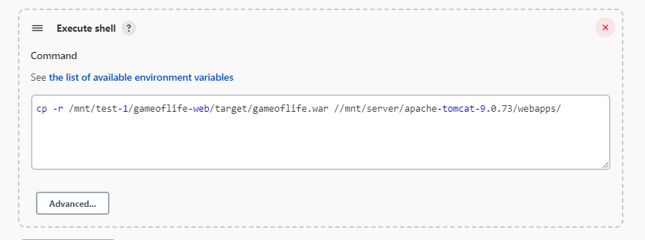

After copying this file we need to start the apache tomcat server

After starting the server we need to access the public ip of the machine with port no 8080 with application name

For example

<http://13.233.130.212:8080/gameoflife/>

after this you will be able to see your application running on web browser

