Assignment 3

Task to do

Install httpd server using Jenkins

Pull index.html from git hub

Deploy index.html on httpd server

Following is the script for downloading httpd server

Copying index.html file to httpd server

Giving permission to the index.html file for accessibility

Starting httpd server so we can see index.html file on browser

yum install httpd -y

cp -r /mnt/httpd/index.html /var/www/html/

chmod 777 -R /var/www/html/

systemctl start httpd

below image show to pulling index.html form git hub

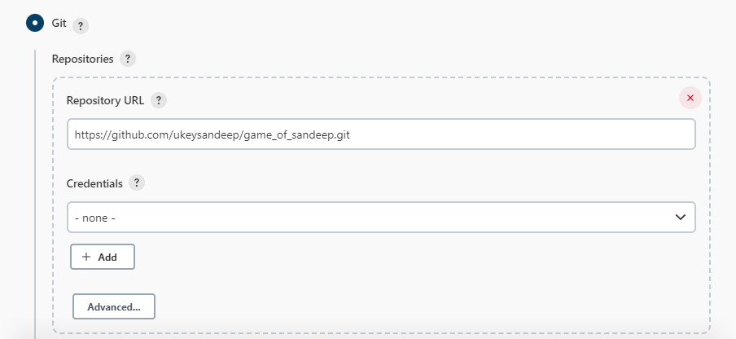

Below script shows installation of httpd server

Copying index.html file to httpd server

Starting httpd server

Changing permission of index.html file for access

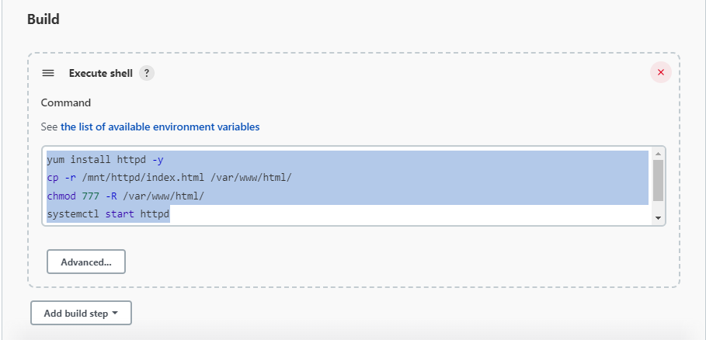

Master branch index.html

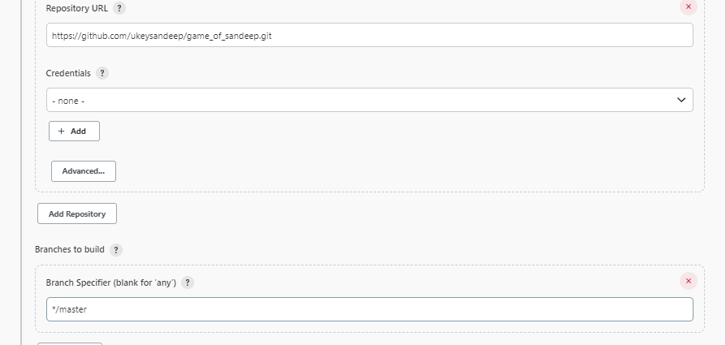

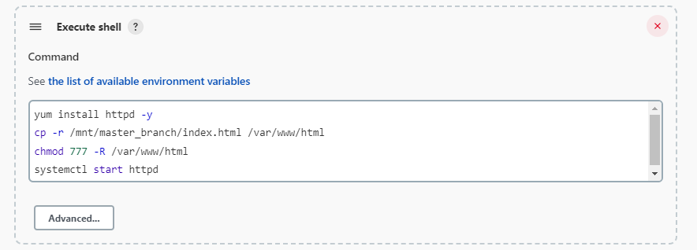

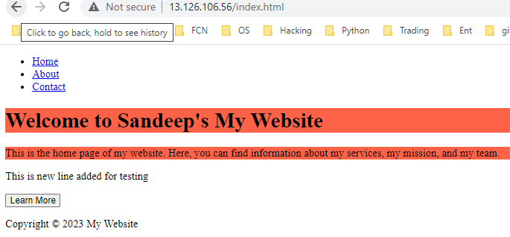

Q-1-23 branch

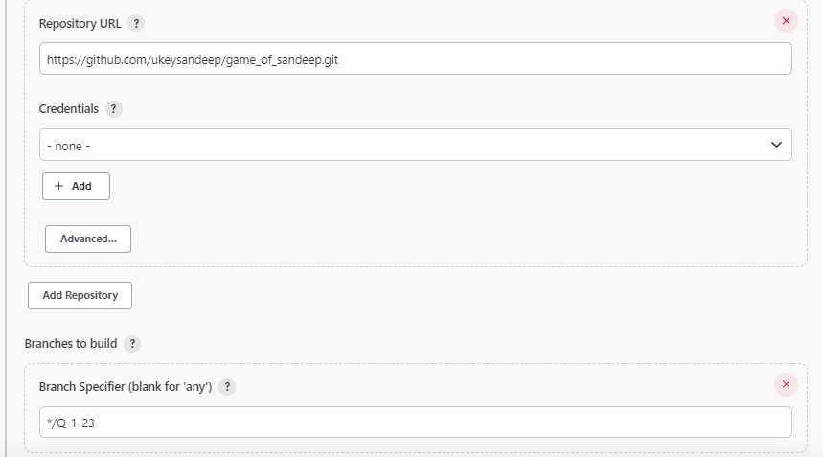

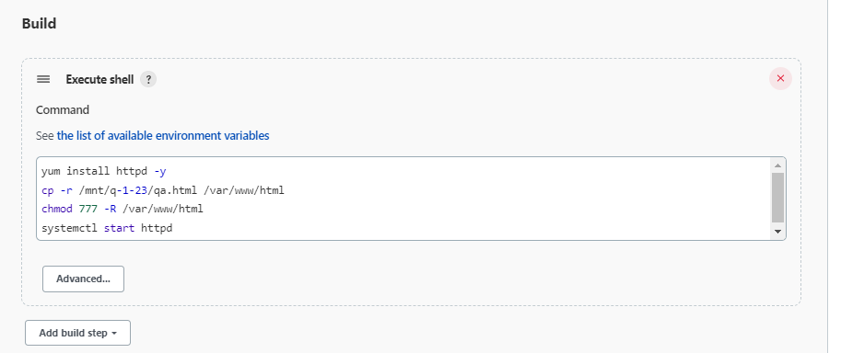

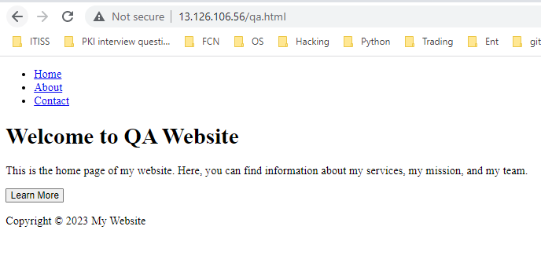

Q-2-23

