Umar Khan

Professor Susan Nachawati

CECS 100

12/5/2015

**Array Assignment**

**Multiple Choice**

1. B- size declarator
2. A- element
3. C- 0
4. D- Size of array minus one
5. C- Parallel arrays
6. C- Rows and columns

**True or False**

1. False
2. True

**Short Answer**

1. An off-by-one error occurs when a loop iterates one time too many or one time too few.
2. A) 10

B) 0

C) 9

1. A) 3

B) 1

1. Balances[187]

**Algorithm Workbench**

1. Constant integer size = 4

Declare string names = “Einstein”, “Newton”, “Copernicus”, “Kepler”

1. Declare integer n.

int name [] = new int [n]

Constant integer size = 20

For (i=1, i<n, i++)

Display name [i]

End For

1. Declare integer n.

int name [] = new int [n]

Constant integer size = 20

For (i=1, i<n, i++)

Set numberArray2 [i] = numberArray1 [i]

End For

1. 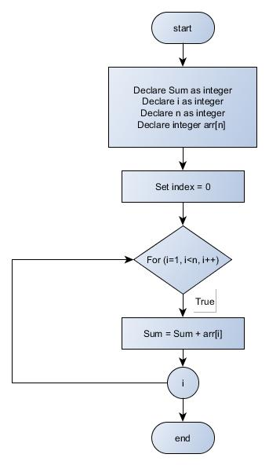

1. Declare integer n.

int name [] = new int [n]

Constant integer size = 100

For (i=1, i<n, i++)

Set secondArray [i] = firstArray1 [i]

End For

**Debugging Exercise**

1. It has off-by-one error. The loop has no boundary.

It should be:

For index= 0 to size -1

1. The pseudocode does not initialize the variable highest so the code will not do the comparison. Highest variable should be initialized to work out the pseudocode.