Umar Khan

Professor Susan Nachawati

CECS 100

10/27/15

Hmw6

**Multiple Choice**

1. Decision-c

3. Decision-b

5. Relational-a

7. If then else-b

9. Multiple alternative decision-d

11. logical-b

13. OR-b

15. Flag-a

**True/False**

1. False

3. False

5. True

**Short Answers**

1. Conditionally executed means when only that condition is true for the execution. It is also called

3. Multiple Alterative Structure

5. The OR operator executes the condition if even only one of them is true.

7. A flag is a Boolean variable that signals when some condition exists in the program.

**Algorithm Workbench**

1. If x > 100

Set y = 20

Set z = 40

End if

2. If a > 12

Set b = 0

Set c =1

End if

4.

If score < 60 Then

Display "Your grade is F."

Else If score < 70 Then

Display "Your grade is D."

Else If score < 80 Then

Display "Your grade is C."

Else If score < 90 Then

Display "Your grade is B."

Else

Display "Your grade is A."

End if

7.

If speed > = 24

Display “Speed is Normal”

Else if speed > 56

Display “Speed is abnormal”

Else if speed < 24

Display “Speed is abnormal”

End if

10.

If minimum then

Set hours = 10

End if

**Debugging Exercise**

1.

Module checkEquality(Integer num1, Integer num2)  
If num1 == num2 Then  
     Display “The values are equal.”  
Else  
      Display “The values are NOT equal.”  
End If  
End Module

2.

Module resetTemperature(Real Ref temp)  
If NOT (temp == 32.0) Then  
     Set temp = 32.0  
End If  
End Module

3.

If value < lower OR value > upper Then  
     Display “The value is outside the range.”  
Else  
     Display “The value is within range.”  
End If  
End Module

**Programming Exercise**

**Tree Diagram**

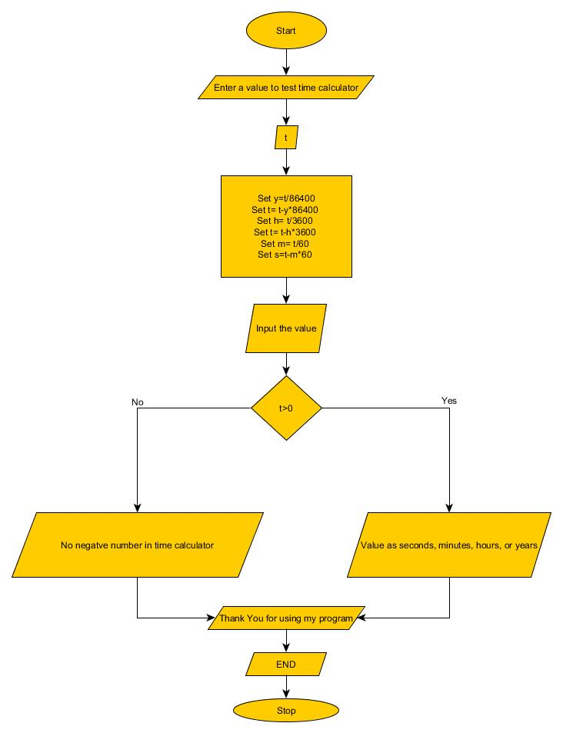**Flowchart**

**Pseudo Code**

Output “Enter a value to test time calculator”

Input “t”

Process “Set y=t/86400

Set t= t-y*86400

Set h= t/3600

Set t= t-h*3600

Set m= t/60

Set s=t-m*60”

Process

“If y >0

Output “y + years”

If h > 0

Output “h + hours”

If m > 0

Output “m + minutes”

If s > 0

Output “s + seconds”

Else if t < 0

Output “No negative numbers in time calculator”

**Java Code**

Code

/*

* Umar Khan

* CECS 100

* Time Calculator Java Code

* 10/27/2015

*/

**import** java.util.Scanner;

**public** **class** Hmw6 {

**public** **static** **void** main(String[] args) {

// **TODO** Auto-generated method stub

Scanner ME = **new** Scanner(System.***in***);

**int** t,y,h,m,s;

System.***out***.println("Enter a value to test the time calculator");

t= ME.nextInt();

y=(t/86400); //conversion for the years

t= t-y*86400;

h= t/3600;//conversion for the hours

t= t-h*3600;

m= t/60;//conversion for minutes

s=t-m*60;

**if** (y>0)

System.***out***.println(y + " Years");

**if** (h>0)

System.***out***.println(h + " Hours");

**if** (m>0)

System.***out***.println(m + " Minutes");

**if** (s>0)

System.***out***.println(s + " Seconds");

**else** **if** (t<0)

System.***out***.println("No negative numbers for the time calculator");

System.***out***.println("Thank You for using my program");

System.***out***.println("END");

}//end main

}//end module

Multiple Outputs

Enter a value to test the time calculator

2601

43 Minutes

21 Seconds

Thank You for using my program

END

Enter a value to test the time calculator

-3

No negative numbers for the time calculator

Thank You for using my program

END