Umar Khan

Professor Susan Nachawati

CECS 100

11/4/2015

While Loop Homework

**Tree Diagram**

**Flowchart**

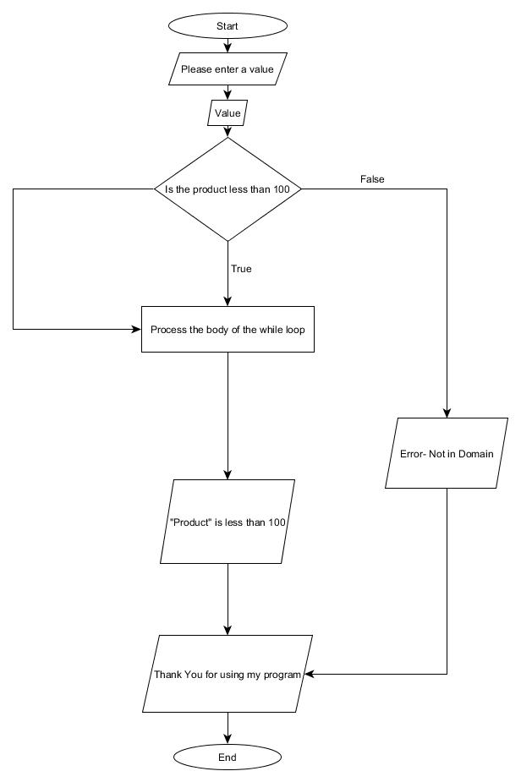

**Pseudocode**

Declare Integer product

Declare Integer num

Product

Do while product < 100

                Display “Please enter any value”

                Input num

                Product = num*10

Processing While Loop

Display product

**Java Code**

import java.util.Scanner;

public class H7 {

public static void main(String[] args) {

// TODO Auto-generated method stub

int num;// initializing for input

int product;//intializing for product

Scanner ME= new Scanner(System.in);

System.out.println("Please Enter a value");

num= ME.nextInt();// declaring the keyboard to get the input from the user

product= 10*num;// setting the product formula

while (product>00);// using while loop

{System.out.println(product + " is less than 100 ");

product++;

}

System.out.println("Thank You for using my program");

}// end of main

}//end of class