|  |  |
| --- | --- |
| **Course Number and Name:**  CECS 211: Principles of Computer Engineering I | |
| **Semester and Year:**  Fall 2016 | |
| **Name of Students:**  Umar Khan, Alexander Wall | **Name of Lab Instructor:**  Joshua Hayter |
| **Date of Report Submitted:**  09/15/2016 | **Grade:** |

Section 1: Calculations by Hand

|  |  |
| --- | --- |
| **IT** | 3.1128mA |
| **I1** | 3.1128Ma |
| **I2** | 589 μA |
| **I3** | 1.26 mA |
| **I4** | 1.26 mA |
| **VR1** | 3.1128 V |
| **VR2** | 2.77 V |
| **VR3** | 2.77 V |
| **VR4** | 2.77 V |
| **VR5** | 3.1128 V |

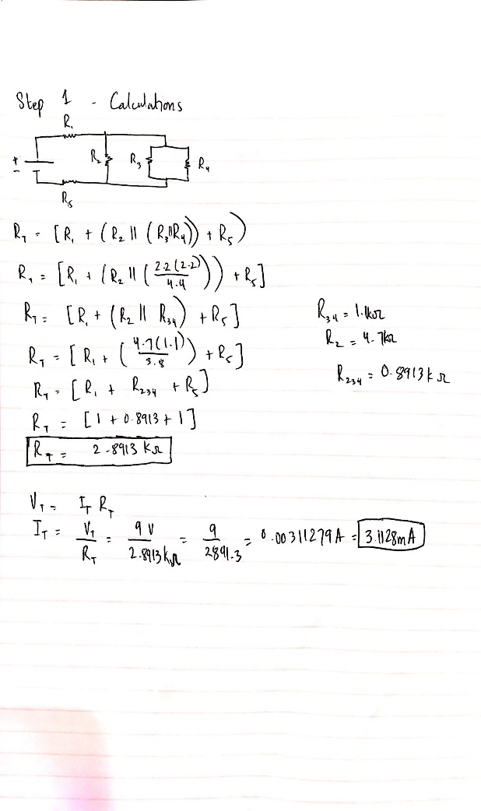

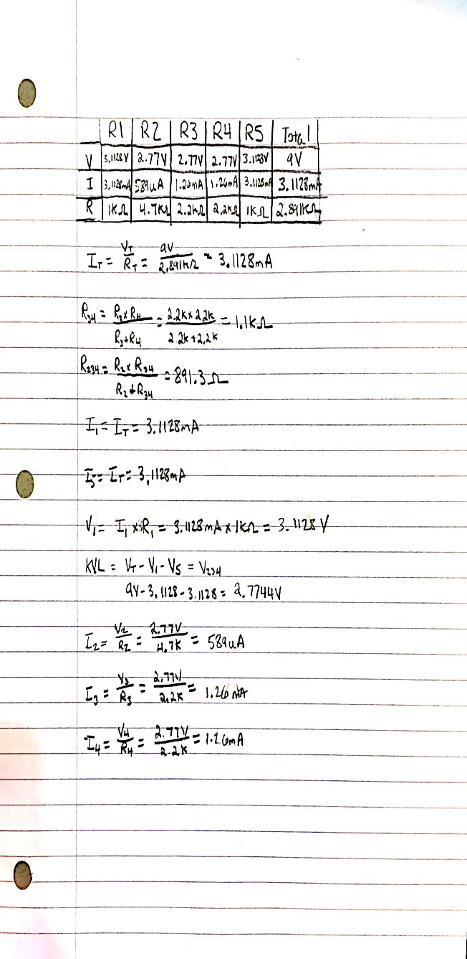Calculations for the values above are below:

Section 2: Multisim Screenshot

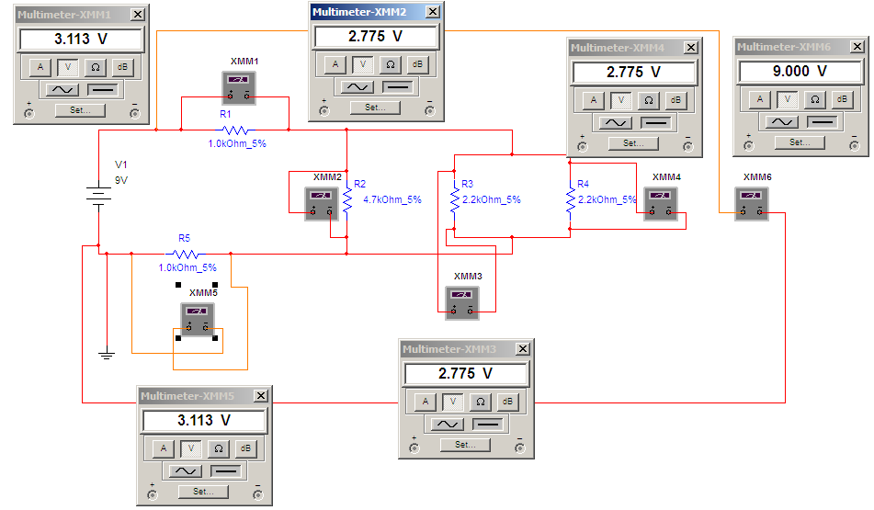

Section 3: Snapshot of the Circuit

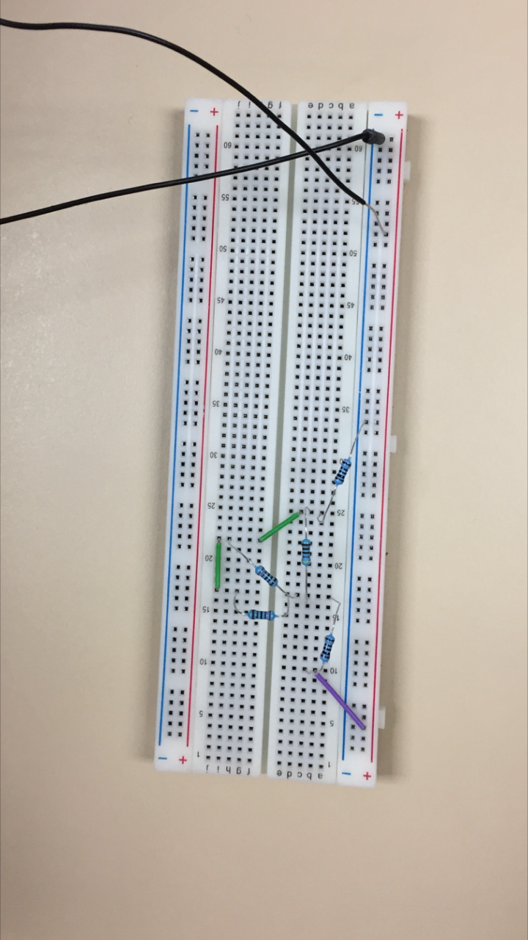

Section 4: Measurements from DMM

|  |  |
| --- | --- |
| **Measure with ohmmeter of DMM** | **Resistance** |
| R1 | 0.92 kΩ |
| R2 | 4.3 kΩ |
| R3 | 2.1 kΩ |
| R4 | 2.2 kΩ |
| R5 | 0.93 kΩ |
| RT | 2.78 kΩ |
| **Measure with current meter of DMM** | **Current** |
| IT | 3.23 mA |
| I1 | 3.27 mA |
| I2 | 623 μA |
| I3 | 1.27 mA |
| I4 | 1.22 mA |
| **Measure with voltmeter of DMM** | **Voltage** |
| VR1 | 3.01 V |
| VR2 | 2.68 V |
| VR3 | 2.68 V |
| VR4 | 2.68 V |
| VR5 | 3.01 V |