Umar Khan / Alex Wall

Professor Joshua Hayter

CECS 211

27 September 2016

Lab 5

**Mesh Analysis**

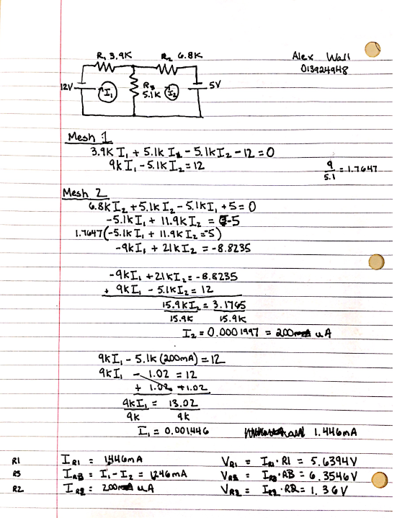

**Schematic**

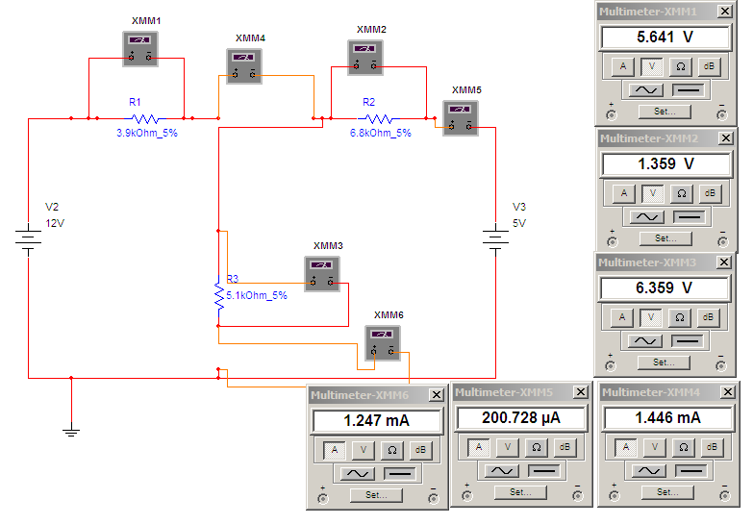

**BreadBoard**