Umar Khan/ Alex Wall

Professor Joshua Hayter

CECS 211

11 October 2016

Lab 6

Section 1:

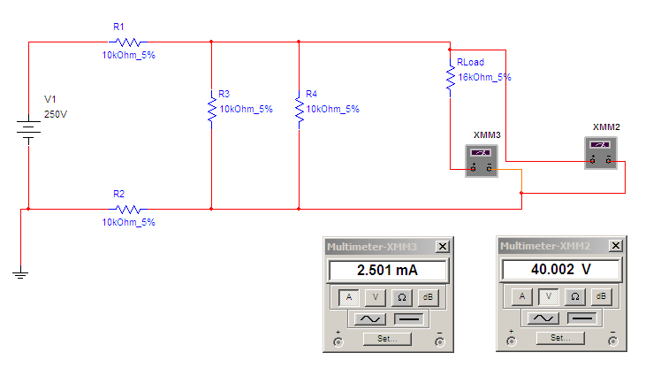

Section 2:

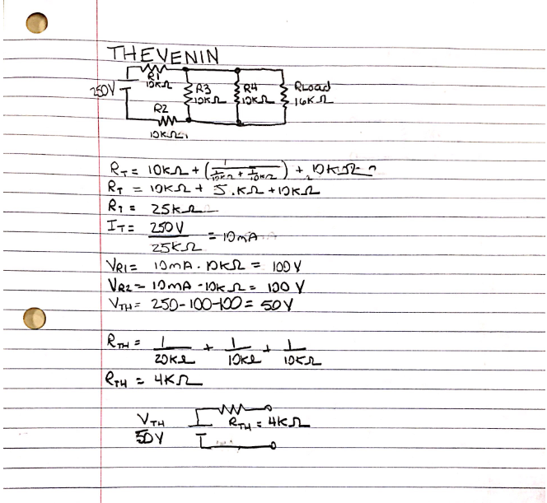

Section 3:

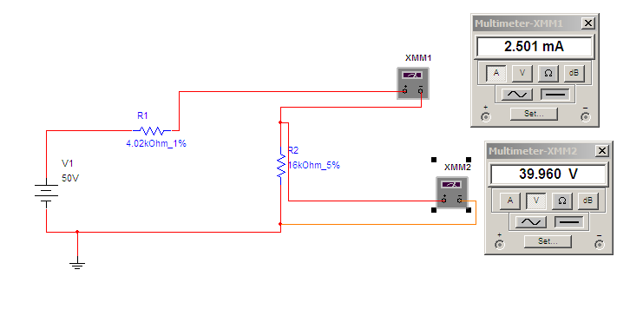

Section 4:

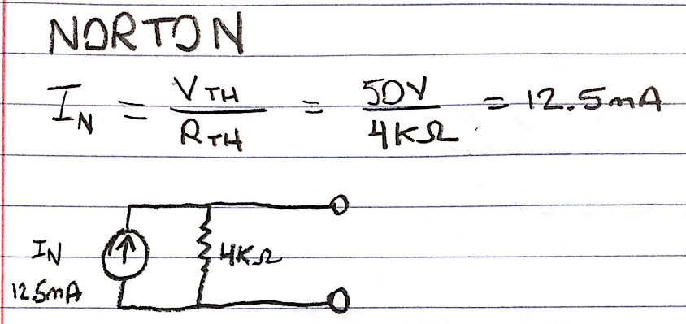

Section 5:

