Umar Khan / Alex Wall

Professor Joshua Hayter

CECS 211

1st November 2016

Lab 9

**Section 1:**

**Analysis of Experiment 1**

1. The 1000microFarrad capacitor and the 220ohm resistor.
2. Stage 1 Current = 40mA to 0mA

Stage 2 Current = 0mA

Stage 3 Current = 40mA to 0mA

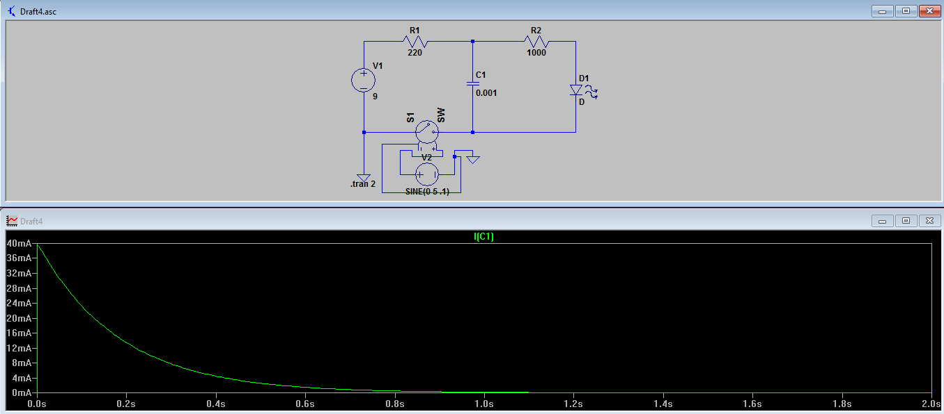

**Analysis of Experiment 2**

|  |  |  |  |
| --- | --- | --- | --- |
|  | Single Capacitor Circuit | Series Capacitor Circuit | Parallel Capacitors Circuit |
| Capacitor1 Value | 1000microFarrad | 1000microFarrad | 1000microFarrad |
| Capacitor2 Value | N/A | 1000microFarrad | 1000microFarrad |
| Capacitance Total | 1000microFarrad | 500microFarrad | 2000microFarrad |
| Time for LED to turn off after switch open | 10 seconds | 7 seconds | 45 seconds |

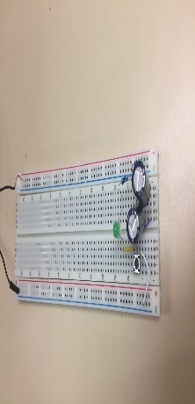

**Section3**