Assignment#7 –CECS228

1. Draw these graphs.

**a)** *K*8   
**b)** *K*2,7   
**c)** *K*4,6

**d)** *C*8   
**e)** *W*8

2. How many vertices and how many edges do these graphs have?

a) Kn   
b) Cn

c) Wn

d) Km,n   
e) Qn

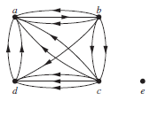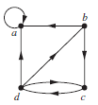  
3. i) determine the number of vertices and edges and find the in-degree and out-degree of each vertex for the given directed multigraph.   
 ii) Determine the sum of the in-degrees of the vertices and the sum of the out-degrees of the vertices directly. Show that they are both equal to the number of edges in the graph.  
a. b.

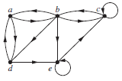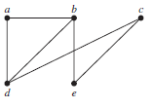4. Represent the following graphs with  
i) an adjacent list  
ii) an adjacent matrix  
iii) an incidence matrix  
a. b.

5. Represent each of these graphs with an adjacency matrix.

a) K4 b) K1,4

d) C4 e) W4 f ) Q3

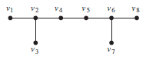6. Determine whether the given pair of graphs is isomorphic. Exhibit an isomorphism or provide a rigorous argument that none exists.  
a.   
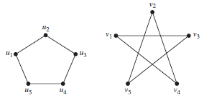  
b.   
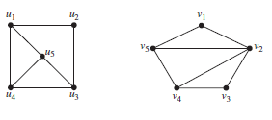  
c.  
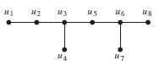

7. Does each of these lists of vertices form a path in the following graph? Which paths are simple? Which are circuits? What are the lengths of those that are paths?

a) a, b, e, c, b b) a, d, a, d, a

c) a, d, b, e, a d) a, b, e, c, b, d, a  
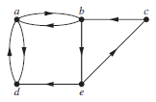

8. Determine whether each of these graphs is strongly connected and if not, whether it is weakly connected.  
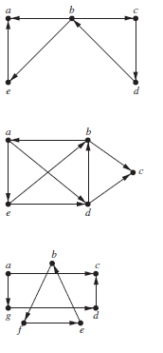  
9. Which of these graphs are trees?  
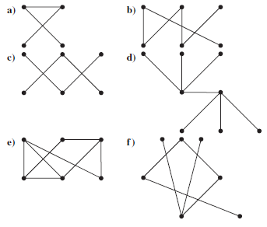

10. Answer these questions about the rooted tree illustrated.

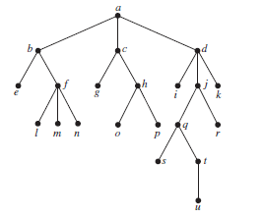

**a)** Which vertex is the root?

**b)** Which vertices are internal?

**c)** Which vertices are leaves?

**d)** Which vertices are children of *j*?

**e)** Which vertex is the parent of *h*?

**f )** Which vertices are siblings of *o*?

**g)** Which vertices are ancestors of *m*?

**h)** Which vertices are descendants of *b*?