CECS 228 Name:

Lab 10 ID: Date:  
Objective:

* Be able to construct a graph
* Be able to recognize some special types of graphs
* Be able to understand some graph terminology
* Be able to represent graph by list and matrices.

Exercise 1: Determine whether the graph shown has directed or undirected edges, whether it has multiple edges, and whether it has one or more loops. Use your answers to determine the type of graph

a.

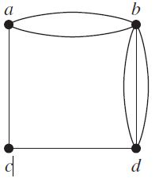

b.

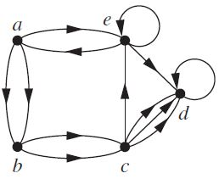

c.

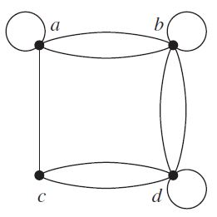

Exercise 2:  
Draw these graphs.

a) C7

b) W7

c ) Q4

d) K2,6

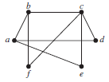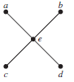Exercise 3:  
Determine whether the graph is bipartite.  
a) b) c)

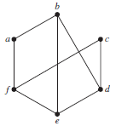

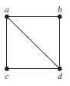Exercise 4:  
Represent the following graphs with  
i) an adjacent list  
ii) an adjacent matrix  
iii) an incidence matrix

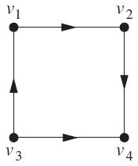

Exercise 5: Draw an undirected graph represented by the given adjacency matrix

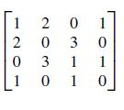

Exercise 6: Find the adjacency matrix of the given directed multigraph with respect to the vertices listed in alphabetic order.

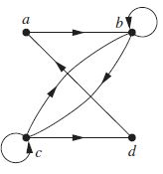

Exercise 7:  
i) Determine the number of vertices and edges and find the in-degree and out-degree of each vertex for the given directed multigraph.  
ii) Determine the sum of the in-degrees of the vertices and the sum of the out-degrees of the vertices directly. Show that they are both equal to the number of edges in the graph.  
  
