CECS 228 Name:

Lab 13.2 ID: Date:  
Objective:

* Be able to determine whether two graphs are isomorphic
* Be able to determine connectivity of a graph.

Exercise 1:  
Determine whether the given pair of graphs is isomorphic. Exhibit an isomorphism or provide a rigorous argument that none exists.  
a.

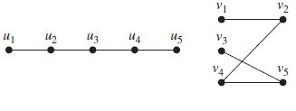

b.

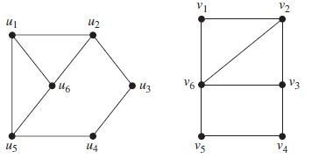

Exercise 2:  
Are the simple graphs with the following adjacency matrices isomorphic?  
a.

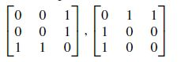

b.

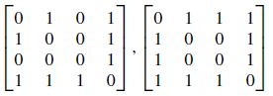

Exercise 3:  
Does each of these lists of vertices form a path in the following graph? Which paths are simple? Which are circuits? What are the lengths of those that are paths?  
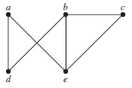

a) a, e, b, c, b   
  
  
b) a, e, a, d, b, c, a

c) e, b, a, d, b, e   
  
  
d) c, b, d, a, e, c  
  
  
  
Exercise 4:  
Determine whether the given graph is connected.  
a.  


b.   


Exercise 5:  
Determine whether this graph is strongly connected and if not, whether it is weakly connected.

a.

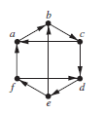

b.

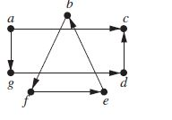

Exercise 6: Use paths either to show that these graphs are not isomorphic or to find an isomorphism between these graphs.

