CECS 228 Name:

Lab 14.1 ID: Date:  
Objective:

* Be able to recognize a tree
* Be able to compute various properties of a tree

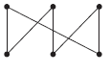Exercise 1:  
Which of these graphs are trees? If not, explain why not.  
a. b.

Exercise 2:

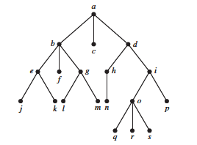  
a) Which vertex is the root?

b) Which vertices are internal?

c) Which vertices are leaves?

d) Which vertices are children of j?

e) Which vertex is the parent of h?

f ) Which vertices are siblings of o?

g) Which vertices are ancestors of m?

h) Which vertices are descendants of b?