CECS 228 Name:

Lab 3.1 ID: Date:  
Objective:

* Be able to determine set and subset
* Be able to determine the power set of a set
* Be able to use set operations (union, intersection, & Cartesian Product)

Exercise 1:   
Determine whether each of these statements is true or false. Explain your reasoning.

|  |  |
| --- | --- |
| a) 0 ∈ ∅ False. The empty set has no element | c) {0} ⊂ ∅ False. The empty set has no subset other than the empty set itself. |
| b) ∅ ∈ {0} False. There is not an element ∅ in the set {0} | d) ∅ ⊂ {0} True. The empty set is a subset of any set. |
| e) {0} ∈ {0} False. There is not an element {0} in the set {0} | f ) {0} ⊂ {0} False. {0} is not a proper subset of {0} |

Exercise 2:  
Define the sets A, B, C, and D as follows:

A = {-3, 0, 1, 4, 17}

B = {-12, -5, 1, 4, 6}

C = {x ∈ Z: x is odd}

D = {x ∈ Z: x is positive}

For each of the following set expressions, if the corresponding set is finite, express the set using roster notation. Otherwise, indicate that the set is infinite.  
a) A ∪ (B ∩ C)   
{-5, -3, 0, 1, 4, 17}  
b) A ∪ C   
infinite  
c) A ∩ B   
{1, 4}  
d) A ∪ (C ∩ D)   
infinite

Exercise 3:  
Draw the Venn diagrams for each of these combinations of the sets A, B, and C.  
a) A ∩ (B − C)

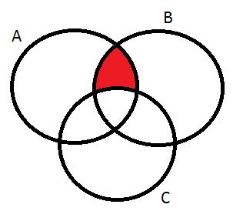

b) (A ∩ B) ∪ (A ∩ C)

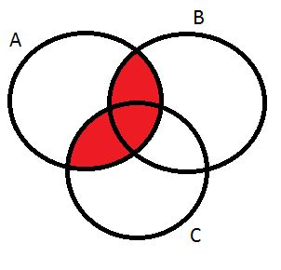

c) (A ∪ B) ∩ (A ∪ C)

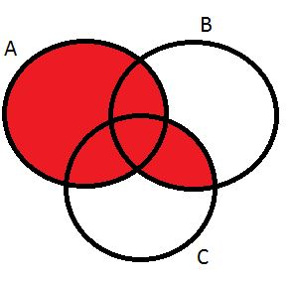

Exercise 4:   
a. If S = {1,2,3}, then what is P(S)?   
P(S) = {∅, {1}, {2}, {3}, {1, 2}, {1, 3}, {2, 3}, {1, 2, 3}}

b. What is the power set of the set S = {1, 2, 3, 4}?  
P(S) = {∅, {1}, {2}, {3}, {4}, {1, 2}, {1, 3}, {1, 4}, {2, 3}, {2, 4}, {3, 4},  
 {1, 2, 3}, {1, 2, 4}, {1, 3, 4}, {2, 3, 4}, {1, 2, 3, 4}}

c. How many elements does the power set of S = {1, 2, 3, 4, 5, 6} have?  
26 = 64 elements