CECS 262
LAB 3
EXAMINING THE LOOP & JUMP INSTRUCTIONS
Student Name: Umar Khan
Student ID: 014477331
Tasks:
- Write and assemble a program to add number 10 thirty times (sum=300/012CH). Put the sum in registers R0 (low byte) and R1 (high byte). Screen-shot the final results in R0 and R1. Loop instruction is required for this task.
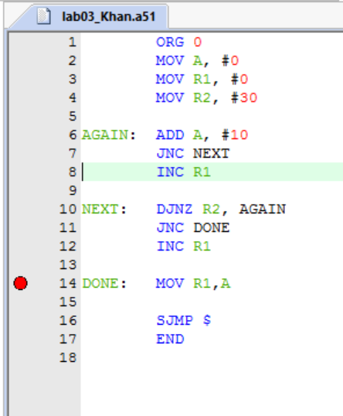
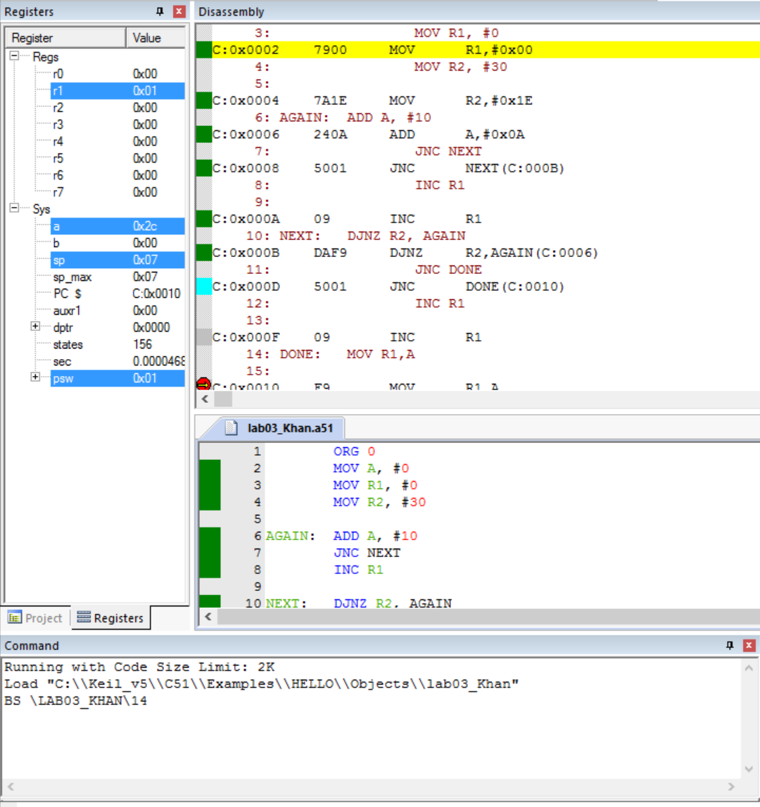

- Write and assemble a program to determine if R4 contains the value 0. If so, load the value 66H to the accumulator; otherwise, load value 88H to the accumulator. Then use nested loop to complement A (use instruction CPL A) 1000 times. Screen-shot the final result in A.(make sure the value of R4 shows in your screen-shot)
