CECS 262: Lab 6
Name: Khan, Umar
Student ID: 014477331
Part I: Enter, compile and simulate chasingcat.c listed below and screenshot the results into the report.
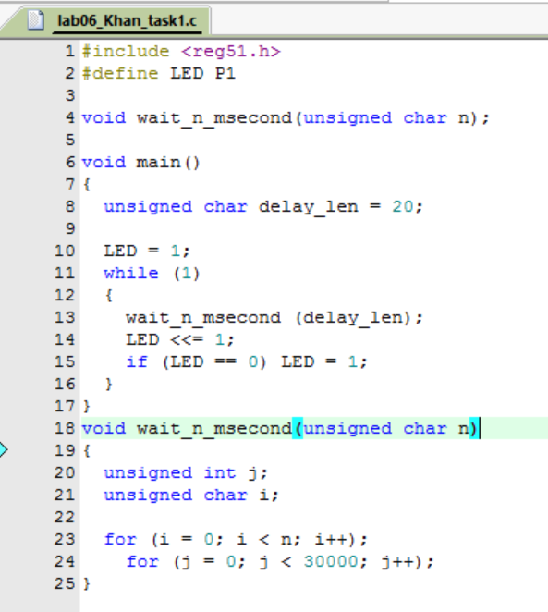
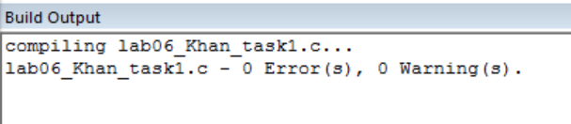
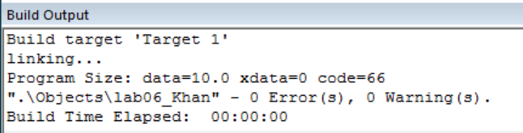
Part II: Parallel I/O Programming
Purpose:
The purpose of this part is to help students learn how to program 8051 I/O Port.
Tasks:
Modify chasingcat.c in part I so that it performs the following functions:
- When the on-board dip switch pin 0 is on, the on-board LEDs display the following bouncing patterns: One light starts from the left outmost LED, move toward right one position at a time until it reaches the right most LED; then it start to move to left one position at a time until it reaches the left most LED, then repeat the sequence. One complete sequence of displays is shown below. (A filled circle represent a lighted LED)
•οοοοοοο, ο•οοοοοο, οο•οοοοο, οοο•οοοο, οοοο•οοο, οοοοο•οο, οοοοοο•ο,οοοοοοο•, οοοοοο•ο, οοοοο•οο, οοοο•οοο, οοο•οοοο, οο•οοοοο, ο•οοοοοο.

- When the on-board dip switch pin 1 is on and pin 0 is off, the on-board LEDs start to count up from 0 to 255 (display the binary value of those numbers) and repeat.

- When the on-board dip switch pin 2 is on and pin 0 and 1 are off, the on-board LEDs start to count down from 255 down to 0 (display the binary value of those numbers) and repeat.

- When multiple pins are on for pin 0, 1, 2, the pins on the right has higher priority. When all three pins: pin 0, 1, 2, are off, flash all the LEDs.

